Itinerary

7-Day Nuratau Mountain Hiking & Homestay
Day 1 – Bukhara → Sentob Village
At 9:00 AM, meet your driver at the tour starting point in Bukhara and depart for Sentob village. Arrival is expected by lunchtime. Your host family will welcome you and introduce the homestay facilities so you can settle in comfortably.
Most local homes feature spacious fruit gardens with traditional tapchans beneath walnut trees, perfect for relaxing during the summer. Enjoy a homemade lunch with your host family.
In the afternoon, explore Sentob village on foot. Visit the local mosque, the ruins of an ancient fortress, and admire the traditional stone-built houses—Sentob is one of the few villages where nearly all homes are constructed using local rock. Strolling through the village offers a wonderful opportunity to observe traditional rural life and interact with friendly locals.
Later, enjoy free time with your host family. You may help with or observe daily household activities, including dinner preparation. Dinner and overnight stay at the homestay.

Day 2 – Sentob Village Hiking: Kadvan Valley or Fazilman Plateau
After breakfast, meet your local mountain guide for a full-day hike. Two hiking options are available:
- Kadvan Valley – 15 km (7.5–8 hours round trip)
- Fazilman Plateau – 22 km (approx. 10 hours)
The hike begins through Sentob Valley, passing an old watermill, ancient fortress ruins, and Arabic rock inscriptions. The trail follows a clear mountain stream with small waterfalls, lush vegetation, and natural pools suitable for swimming. A picnic lunch prepared by the homestay will be provided.
The area is rich in birdlife and plant diversity. Commonly spotted species include Spotted Flycatcher, Asian Paradise Flycatcher, Mistle Thrush, Eurasian Blackbird, Persian Nuthatch, Blue Rock, Chukar, and occasionally owl species.
Return to Sentob via the same route.
Note: Hiking routes may be adjusted in spring due to high water levels.
Dinner and overnight at the homestay.

Day 3 – Sentob → Majerum Village
After breakfast, begin a scenic guided hike to Majerum village
(11 km / 3.5–4 hours). The trail passes through the buffer zone of the Nuratau Nature Reserve, offering beautiful landscapes and opportunities to observe local wildlife.
Upon arrival, settle in homestay. In the afternoon, enjoy a two-hour hike into the nature reserve to visit the legendary Juniper tree , believed to have been planted by soldiers of Alexander the Great. The sacred tree and nearby mosque are important local pilgrimage sites.
Return to the homestay for dinner and overnight stay.

Day 4 – Majerum → Lake Aydarkul → Hayat Village
After an early breakfast, depart Majerum at 9:00 AM by car toward Hayat village. Lake Aydarkul, where you may swim (season permitting), walk along the shore, or observe aquatic birdlife such as pelicans, cranes, ducks, and geese. Fishermen from nearby villages are often seen along the lake.
Continue to Hayat village, arriving by lunchtime. Your host, Parda Musaev, a warden of the nearby Nature Reserve, will welcome you. The homestay features six separate guest rooms decorated with traditional carpets and kupacha mattresses.
In the afternoon, explore the village with your guide. Visit the breeding enclosure for the critically endangered Severtsov’s wild sheep (approx. 2,000 inhabit the Nuratau valleys). Continue hiking to the ruins of Shaxi Korgon Fortress, where abandoned homes tell the story of Soviet-era resettlement.
Relax in the homestay’s shady garden by the mountain stream. Dinner and overnight in Hayat.

Day 5 – Hayat → Uhum Village
After breakfast, meet your mountain guide for a hike to Upper Uhum village (12 km). The route passes through Guzar mountain passes (5.4 km / approx. 3.5 hours one way).
Enjoy panoramic views of Karaul Peak and Hayat village from the pass. Along the way, observe local life—women baking bread in tandir ovens, weaving carpets, and making kurpacha mattresses. Visit ancient irrigation canals and a petroglyph site showing traces of early settlements.
A picnic lunch will be provided. In the afternoon, arrive at homestay in Uhum village. Dinner and overnight stay.

Day 6 – Uhum → Asraf Village
After breakfast, begin your guided hike to Asraf village (11 km / approx. 4 hours). Luggage will again be transported by donkey.
Pass through Ukhum Valley and visit an old community watermill still in operation, using a hydro pump without electricity. Continue through Mushibirion Valley, passing the ruins of the Mongol fortress Qorgoni Honkeldi, before completing the final stretch to Asraf.
Upon arrival, enjoy lunch with your host family. Spend the afternoon relaxing under walnut trees or exploring village life. In the evening, you may help prepare traditional plov using local vegetables and mountain herbs. Overnight in Asraf.

Day 7 – Asraf → Samarkand
After breakfast, enjoy a guided morning hike along the buffer zone of the Nuratau Nature Reserve toward Eski Forish village (11 km round trip / approx. 4 hours). The trail offers stunning views of Lake Aydar and the vast Kyzylkum steppe.
Visit ancient petroglyphs and the ruins of a medieval lookout point once used to monitor nomadic movements across the plains.
Return to Asraf for a farewell lunch with your host family. In the afternoon, transfer to Samarkand, marking the end of the tour.

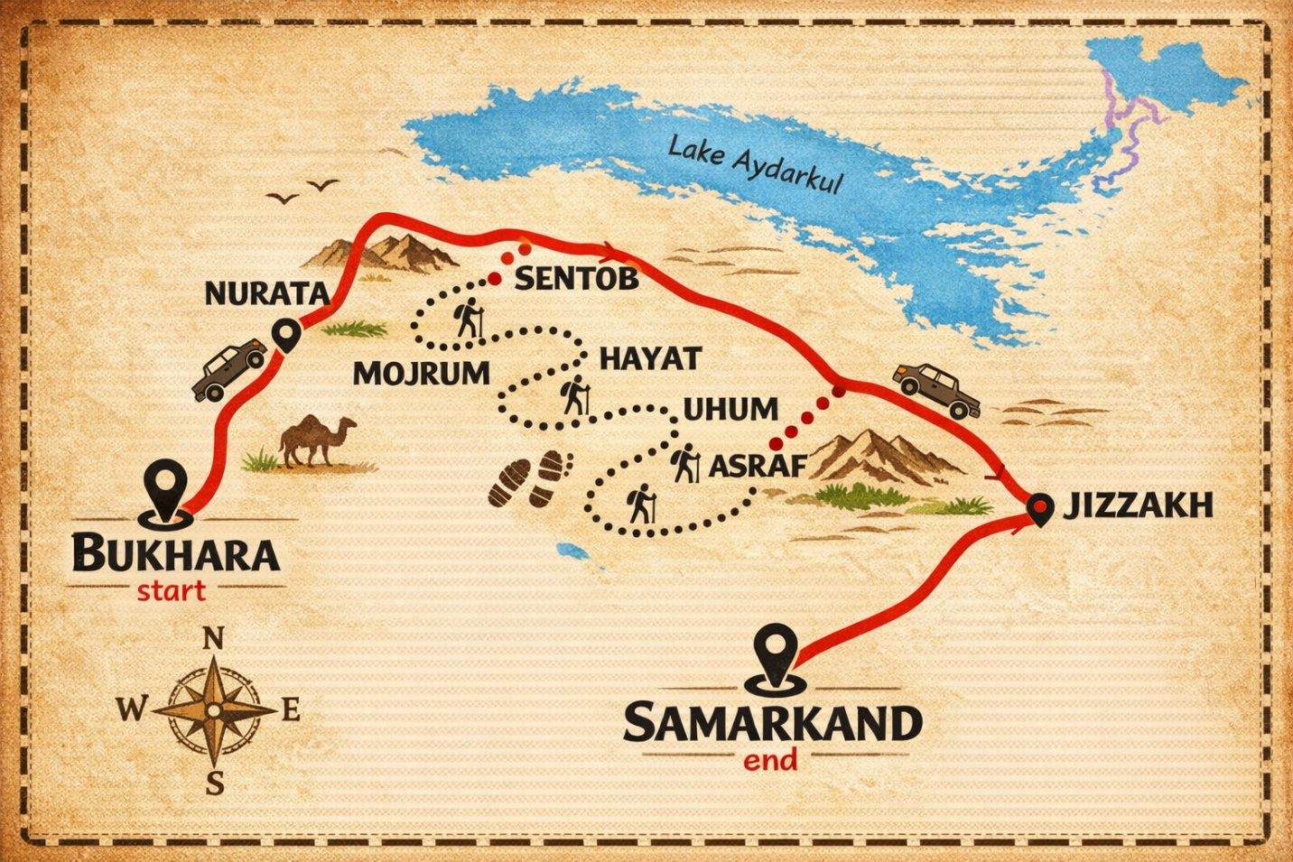
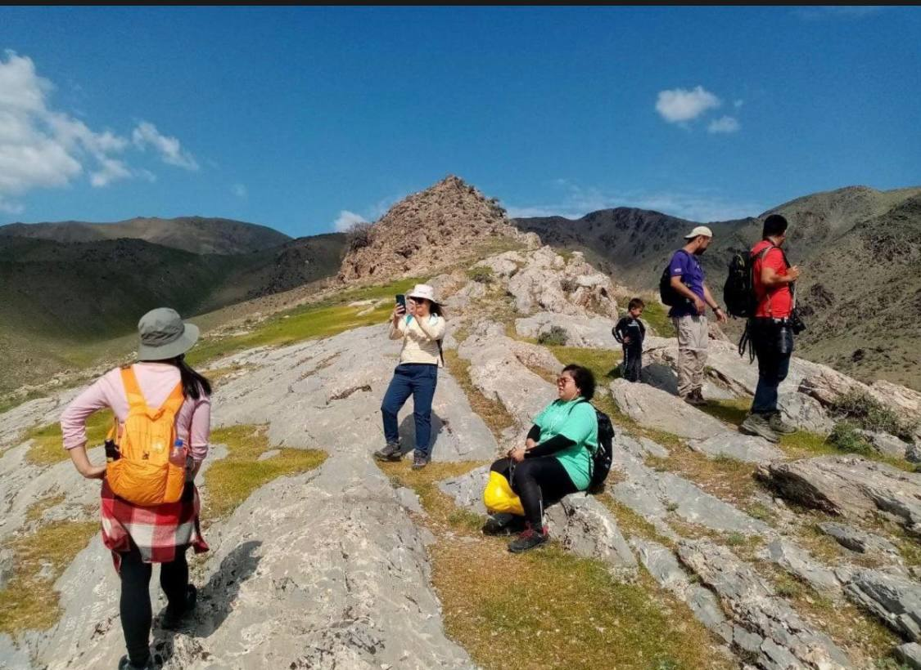
Perfect! Here’s your full 7-day Nuratau Mountains Hiking & Homestay program, rewritten in a clean, consistent, professional style that’s ready for your website or brochure:

7-Day Nuratau Mountains Hiking & Homestay Program

Day 1 – Bukhara → Sentob Village
At 9:00 AM, meet your driver and depart from Bukhara to Sentob village. Arrive by lunchtime and settle into your homestay surrounded by fruit gardens.
Explore the village on foot:
- Visit the mosque and ancient fortress ruins
- Admire traditional stone-built houses
- Observe local life and meet friendly villagers
Enjoy a home-cooked lunch and dinner with your host family. Overnight in Sentob.

Day 2 – Sentob Village: Mountain Hiking
After breakfast, meet your local guide for a full-day hike. Choose between:
- Kadvan Valley – 15 km / 7.5–8 hours round trip
- Fazilman Plateau – 22 km / approx. 10 hours
Hike along mountain streams, past waterfalls and natural pools. Enjoy birdwatching and rich mountain flora. A picnic lunch is provided.
Return to the homestay for dinner and overnight.
Note: Routes may be adjusted in spring for safety due to high water levels.

Day 3 – Sentob → Majerum Village
After breakfast, hike to Majerum village (11 km / 3.5–4 hours) through the Nuratau Nature Reserve.
Highlights include:
- The legendary juniper tree
- A historic mosque and ancient irrigation systems
- Immersion in village life with local farmers
Dinner and overnight at homestay.

Day 4 – Majerum → Lake Aydarkul → Hayat Village
Depart Majerum at 9:00 AM by car through the Kyzylkum steppe toward Hayat village.
Stop at Lake Aydarkul for swimming, walking, or birdwatching.
In Hayat village:
- Visit the Severtsov’s wild sheep enclosure
- Hike to Shaxi Korgon fortress ruins
- Explore Hayat Valley’s flora and fauna
Relax in the homestay garden. Dinner and overnight in Hayat.

Day 5 – Hayat → Uhum Village
After breakfast, meet your guide for a hike to Upper Uhum village (12 km).
Along the trail:
- Pass Guzar and Sari Bedak passes with panoramic mountain views
- Observe women baking bread, weaving carpets,
- Visit ancient irrigation canals and petroglyph sites
Picnic lunch en route. Arrive at homestay for dinner and overnight stay.

Day 6 – Uhum → Asraf Village
After breakfast, hike to Asraf village (11 km / approx. 4 hours) through Ukhum Valley.
Highlights include:
- Visiting a traditional watermill powered by a hydro pump
- Passing the Mushibirion Valley and Mongol fortress ruins (Qorgoni Honkeldi)
- Evening activity: cook traditional plov with the host family
Overnight in Asraf village.

Day 7 – Asraf → Samarkand
After breakfast, enjoy a morning hike to Eski Forish village (11 km round trip):
- Marvel at Lake Aydar and the Kyzylkum steppe
- See ancient petroglyphs and a medieval lookout point
Return to Asraf for farewell lunch. Transfer to Samarkand, completing your 7-day adventure.

7-Day Village to Village Hiking Tour in
€1,260.00
2 x €630.00
Tour Includes
- 🏡 6 nights in local homestays
- 🍽️ 6 breakfasts, 7 lunches, 6 dinners (veg/vegan options available)
- 🗺️ Guided hikes with a local mountain escort (Day 2–7)
- 🚗 Transfers:
  - Bukhara → Sentob
  - Sentob → Hayat via Lake Aydarkul
  - Asraf → Samarkand

