**Test plan for**

# Design tests for Jira

**1** **Introduction**

1.1 Scope

*1.1.1* *In Scope*

*1.1.2* *Out of Scope*

1.2 Quality Objective

1.3 Roles and Responsibilities

**2** **Test Methodology**

2.1 Overview

2.2 Test Levels

2.3 Defect management

2.4 Suspension Criteria and Resumption Requirements

2.5 Entry Criteria

2.6 Test Completeness

**3** **Test Deliverables**

**4** **Resource & Environment Needs**

4.1 Testing Tools

4.2 Test Environment

**5** **Terms/Acronyms**

# Introduction

This test plan describes the testing approach and overall framework that will drive the testing of some basic functionalities of JIRA. The test objective is to verify that the basic functionalities of JIRA works according to the specifications after the new features are implemented.

## Scope

### In Scope

The scope of this test project covers only functional requirements and features. The following features/functions of the Application Under Test (AUT) will be tested:

* Login
* Logout
* Browse projects
* Create issues
* Browse issues
* Edit issues

### Out of Scope

The following functions/features are Out of Scope for this project:

Other feature/functions on the site:

* Comments
* Modifying issue statuses
* More options (Log work, attach files, move)

Non-functional requirements:

* User interface (ease of access)
* Website security (profile data security)
* Performance

Testing on other operating systems:

* Linux
* Mobile OS (iOS, Android)

## Quality Objective

The objective of the test is to verify that the functionalities defined in the scope section work, according to the specifications/requirements, after implementing the new project and issue features.

## Roles and Responsibilities

Development Team:

* Ödön: Senior software architect
* Rudolf: Medior software architect
* Frank: Junior software architect
* Rhonda: Junior software architect

Test Leader, people manager: Rita

Test Team:

* Timi: Manual Tester
  + Browse Projects
  + Create Issue function
* Levente: Automation Tester
  + Browse Projects
  + Edit Issues function
* Milán: Manual Tester
  + Browse Projects
  + Browse Issues function

# Test Methodology

## Overview

Test methodology used:

* Agile methodology: during development of new features, testers take part in testing existing features on a System Testing test level.

Test approach:

* Regression-averse: testing existing functions in the AUT using functional (automated) regression tests.

## Test Levels

The Testing Levels primarily depends on the scope of the project, time and budget constraints.

Test Level:

* System Testing

Test Types:

* Regression Testing
* Black Box Testing

## Defect management

*Bug tracking process flowchart*

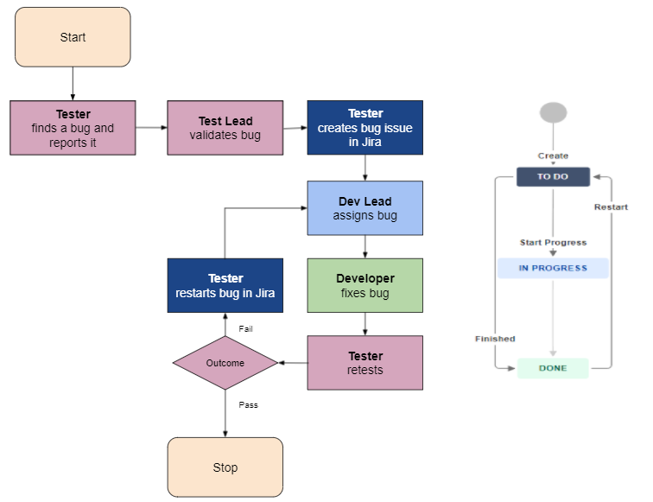

The bugs are reported in the Jira bug tracking tool. It should contain the following informations:

* **ID:** Unique identification number of the defect.
* **Summary:** Short and clear description of the bug.
* **Reporter:** The tester who found the bug.
* **Description:** Detailed description of the defect, including comprehensive steps supported by attachments (see below) with which the developer can reproduce the defects.
* **Priority:** The relative importance of a defect. It is based on impact and urgency.
* **Environment:** Platform and operating system used.
* **Attachment:** Screenshots, screen capture videos.
* **Assignee:** Senior software architect, Ödön, who will allocate the bugs to the rest of the team.

| **Priority** | **Impact & Urgency** | **Resolution** |
| --- | --- | --- |
| Highest | Immediately.  When a bug corrupts every functionality that the software has to offer. The whole team comes together immediately to find the root cause behind the bug. | 4 hours |
| High | As soon as possible.  Bug must be resolved at the earliest as it affects the software greatly and renders it unusable until it is resolved. | 24 hours |
| Medium | At your earliest convenience.  Bug can be fixed in the normal course of development and testing. | 3 days |
| Low | In this sprint.  The bug has minimum impact on the use of the software. | 7 days |
| Lowest | Bug can be fixed at a later date. Other, more serious bugs take priority. | 14 days |

## Suspension Criteria and Resumption Requirements

Suspension criteria define the criteria to be used to suspend all or part of the testing procedure while Resumption criteria determine when testing can resume after it has been suspended.

The test process should be suspended in the following scenarios:

* If there are 40% failed test cases, testing should be suspended until developers fix the defects.
* Dependent systems are unavailable during execution.
* A defect is introduced that cannot allow any further testing.

## Test Entry Criteria

* Availability of test environment, necessary test tools and test data.
* Previously executed test cases should be present for regression testing so that their results can be used as a benchmark for current behaviour.
* New features are developed and implemented therefore the unintended side-effects can be tested.

## Test Completeness

The following criterias must be completed before testing can be deemed complete:

* All test cases are executed.
* Medium, High, and Highest priority bugs are fixed.

# Test Deliverables

Here mention all the Test Artifacts that will be delivered during different phases of the testing lifecycle.

The following test artifacts will be delivered during different phases of the testing process:

* Test plan
* Test cases
* Summary report using Jira Dashboard
* Defect Management matrix

# Resource & Environment Needs

## Testing Tools

The following tools are used during the project:

| Test Management Tool | Zephyr Scale extension for JIRA |
| --- | --- |
| Bug Tracking and reporting tool | JIRA (Version 8.14.0.) |
| Automation Tool | Selenium IDE (Version 3.17.0.) extension for Google Chrome |
| Other tools | Google Docs |

## Test Environment

Testing will be conducted in a testing environment on the JIRA website.

Minimum hardware requirements for testing:

* Dual-Core CPU (Intel, AMD)
* 4 GB Ram
* SSD or HDD
* Min. 1024x768 resolution screen

Software requirements (in addition to client-specific software):

* Microsoft Windows 10
* Web browser (Google Chrome) in incognito mode
* Microsoft Office 2013 and above

# Terms/Acronyms

Make a mention of any terms or acronyms used in the project

| **TERM/ACRONYM** | **DEFINITION** |
| --- | --- |
| API | Application Program Interface |
| AUT | Application Under Test |