AI-Driven Healthcare & Insurance Analytics
IBM SkillsBuild Data Analytics with AI Academic Internship Program
Conducted by BharatCares in Association with AICTE

Important: The CA Hospital Dataset Q1 2025 is a synthetic dataset generated for educational purposes. It does not represent real patient records or any specific healthcare organisation. All findings are analytical observations only and must not be used for medical decisions or insurance policy changes.
1. Abstract
This project presents an end-to-end analytics application built on the CA Hospital Dataset Q1 2025, a synthetic healthcare dataset containing 70,000 insurance claim and billing records. The project covers data inspection, cleaning, feature engineering, exploratory data analysis (EDA), machine learning model development with leakage prevention, AI-generated insights, and an interactive Streamlit dashboard. A Logistic Regression model was trained to predict claim approval status (Paid vs Denied), achieving 91.4% accuracy and a ROC-AUC of 0.576 with pre-outcome features only. The dashboard presents all findings through 11 interactive pages. All results are derived from the actual dataset — no values were fabricated.
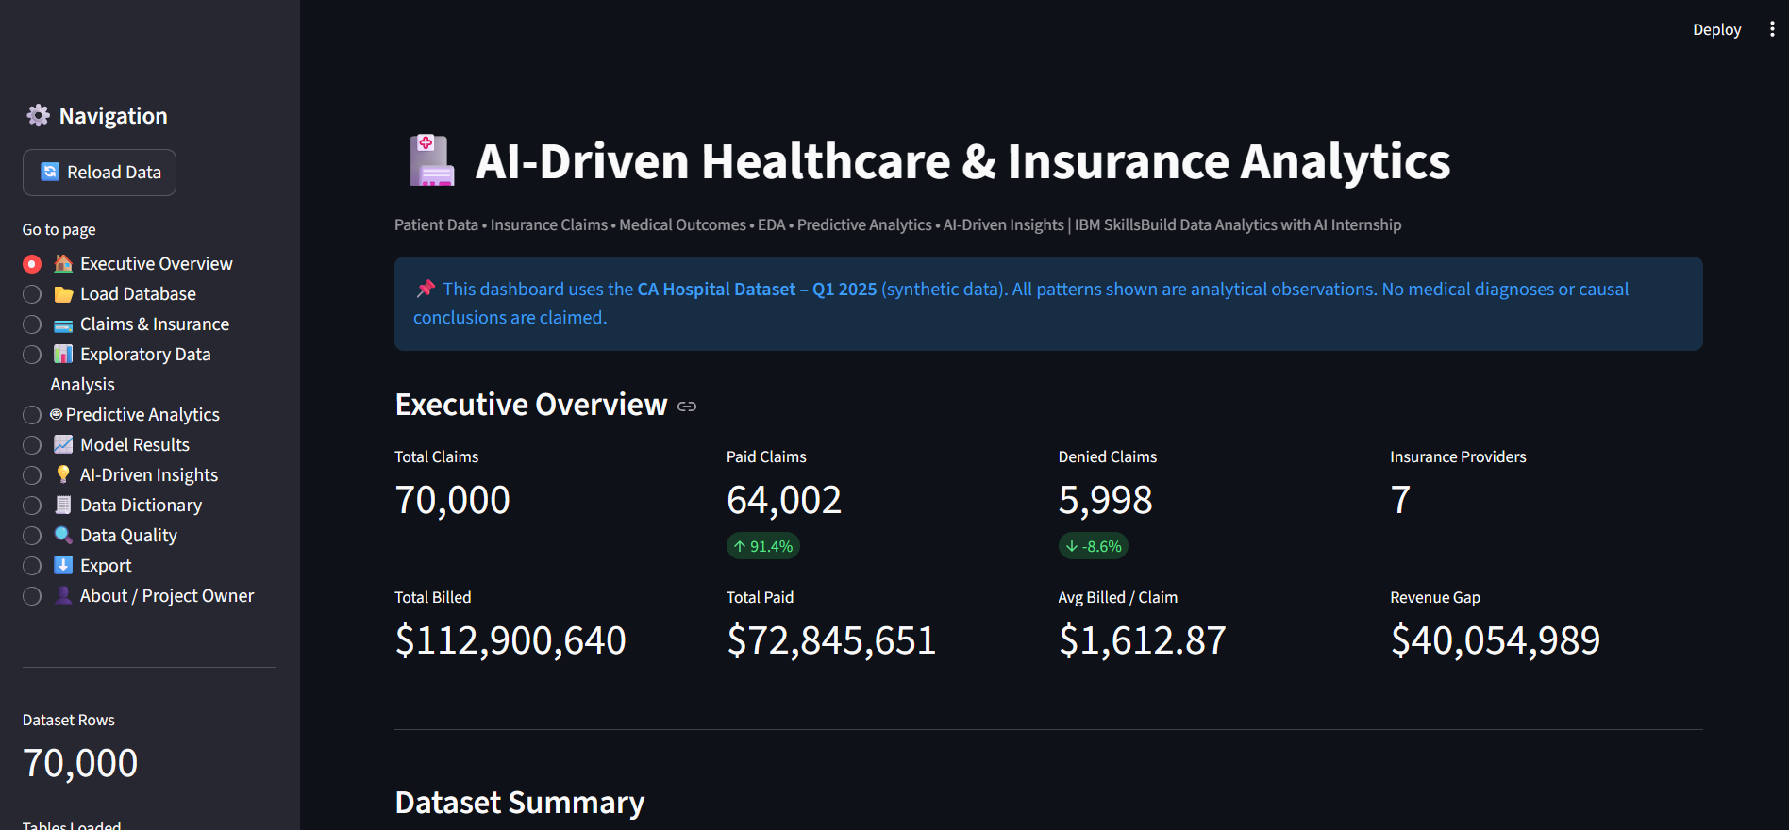
2. Problem Statement
Healthcare organisations face significant operational challenges in claims management: claim denials represent lost revenue and increased administrative burden; billing errors and duplicate submissions are common and preventable; prior authorisation requirements create friction; and manual review of 70,000+ claims per quarter is not scalable. This project answers: Can data analytics and machine learning help identify patterns in healthcare claims that support operational decision-making?
3. Dataset
Name: CA Hospital Dataset – Q1 2025 | Source: Kaggle (rajkumarpadmanabhan/ca-hospital-dataset-q1-2025) | Type: Synthetic | File: claims_and_billing.csv | Rows: 70,000 | Columns: 11 | Period: January – May 2025
Columns: billing_id (PK), patient_id (FK), encounter_id (FK), insurance_provider (7 categories), payment_method (Insurance/Selfpay), claim_id, claim_billing_date, billed_amount (USD), paid_amount (USD), claim_status (TARGET: Paid/Denied), denial_reason (post-outcome — excluded from ML).
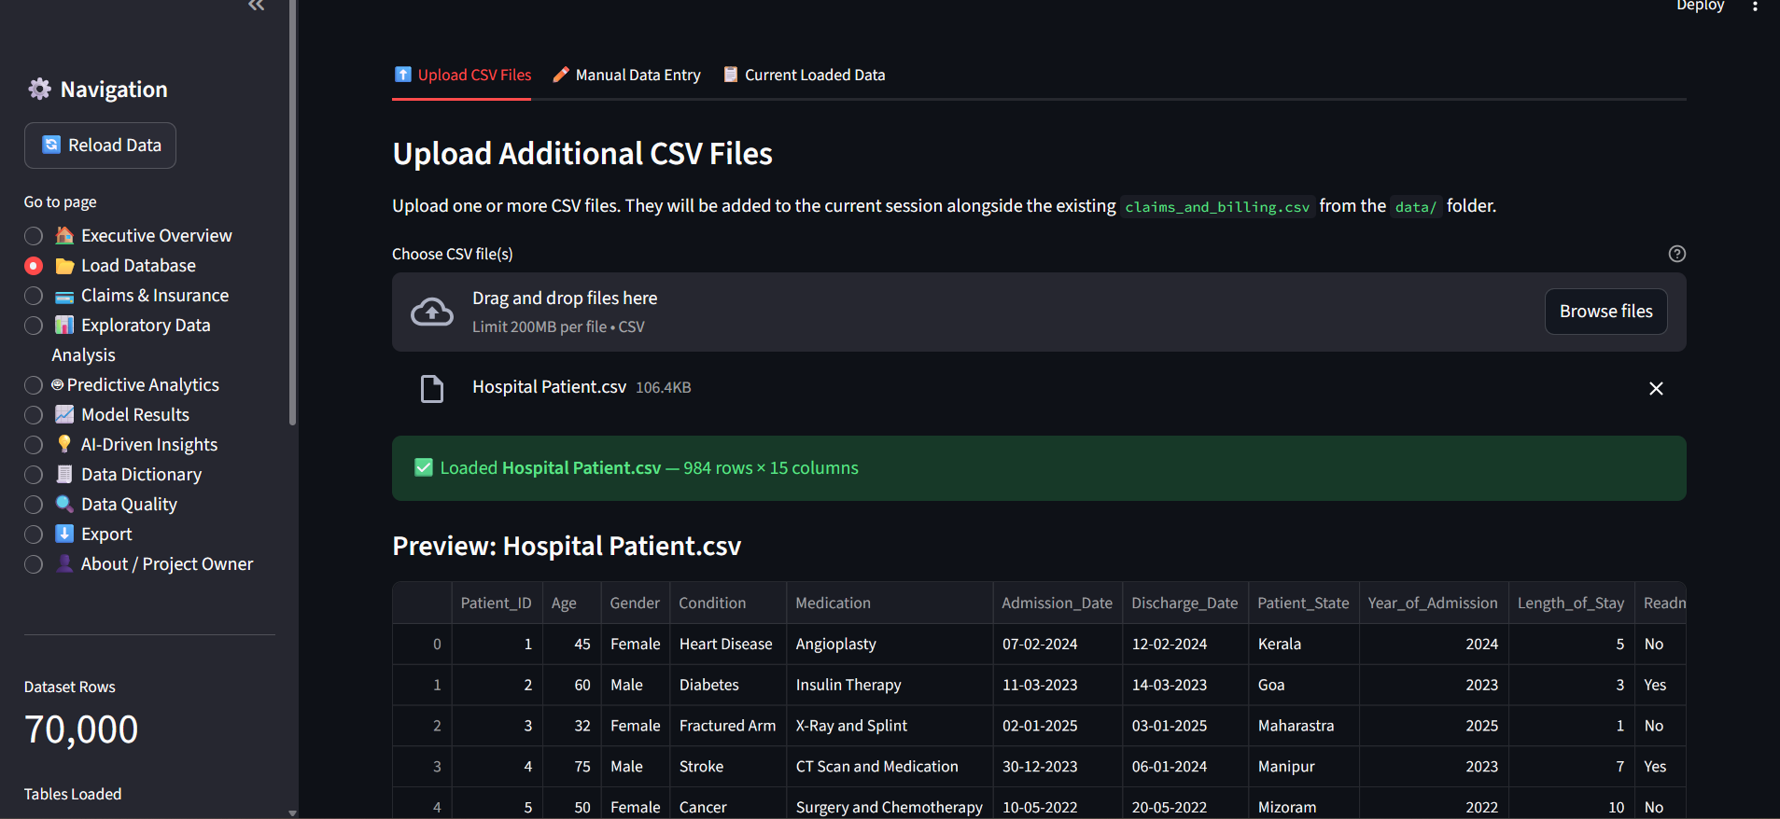
4. Data Cleaning
The cleaning pipeline (pipeline.py, Phase 3) parsed claim_billing_date from string to datetime64 format (DD-MM-YYYY HH:MM). Zero duplicate rows were found. The 64,002 null values in denial_reason are expected behaviour — this column is only populated for denied claims, not a data quality issue. Final row count: 70,000 (unchanged after cleaning).

5. Exploratory Data Analysis
Key findings from EDA (10 charts generated):
- Claim Status: 64,002 Paid (91.43%) / 5,998 Denied (8.57%) — highly imbalanced dataset.
- Financial: Total billed $112,900,639.84; total paid $72,845,650.54; revenue gap $40,054,989.30; payment rate 64.5%.
- Providers: 7 providers with near-equal distribution (~14% each). Medicaid has the highest denial rate at 9.24%.
- Billing: Right-skewed distribution — mean $1,612.87 > median $1,214.11. Range: $100.07 to $38,191.35.
- Denial Reasons: 14 categories. Top 3: Duplicate Claim (472), Prior Authorization Required (457), Service Not Covered (437).
- Monthly Trends: March 2025 was the peak month with 20,960 claims and $33.8M billed.
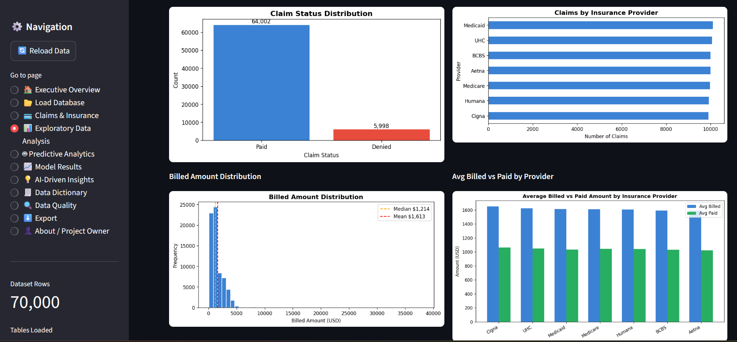
6. Feature Engineering
Features engineered: date parts (claim_year, claim_month, claim_dayofweek, claim_quarter from claim_billing_date); financial ratios (payment_ratio = paid/billed, unpaid_amount, high_cost_flag = billed > 75th percentile); patient-level aggregates (patient_claim_count, patient_total_billed). The denial_flag (derived from claim_status) was created for EDA only and explicitly excluded from ML to prevent target leakage.
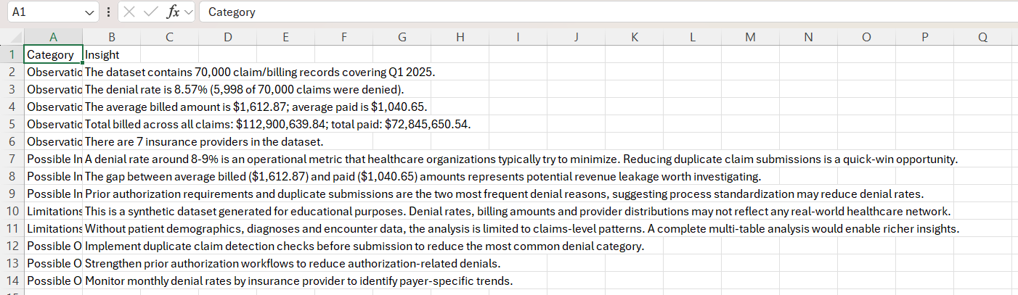
7. Machine Learning Methodology
Task: Binary classification — predict claim_status (Paid / Denied). Algorithm: Logistic Regression (scikit-learn). Split: 80/20 stratified (56,000 train / 14,000 test). Two variants trained: Variant A (default weights, primary) and Variant B (balanced weights, higher sensitivity for Denied class).
Leakage Prevention — Excluded Columns:
- denial_reason — post-outcome (only populated after claim is denied)
- paid_amount — post-outcome (only known after claim processing)
- billing_id, claim_id, patient_id, encounter_id — identifiers with no predictive signal
Features Used (7 pre-outcome predictors): insurance_provider, payment_method, billed_amount, feat_claim_year, feat_claim_month, feat_claim_dayofweek, feat_claim_quarter.
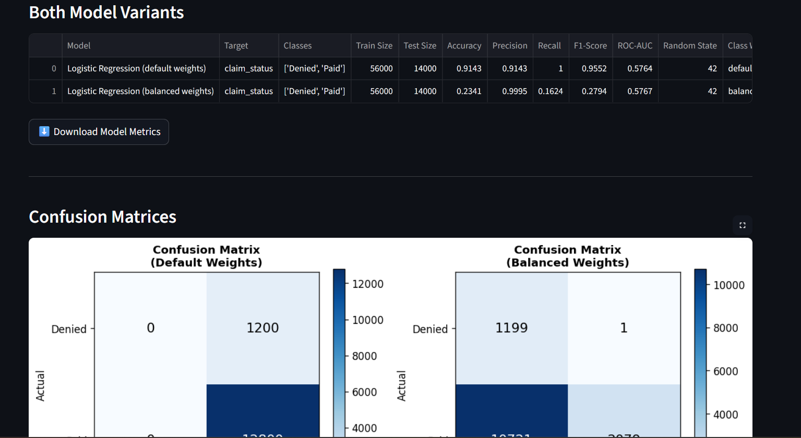
8. Model Evaluation Results
Primary Model (Default Weights):
Accuracy: 0.9143 | Precision: 0.9143 | Recall: 1.0000 | F1-Score: 0.9552 | ROC-AUC: 0.5764 (primary metric)
Sensitivity Model (Balanced Weights):
Accuracy: 0.2341 | Recall for Denied class: 0.9992 | F1-Score: 0.2794 | ROC-AUC: 0.5767
Interpretation: The 91.4% accuracy of the primary model is achieved by predicting nearly all claims as Paid (the majority class at 91.4%). ROC-AUC of 0.5764 is the meaningful discriminative metric — it is modestly above random (0.50) and honestly reflects that 7 pre-outcome features in synthetic data provide limited predictive signal. The balanced-weights model recalls 99.9% of denied claims but at the cost of an 83.8% false positive rate on Paid claims.
9. AI-Driven Insights
Auto-generated observations from actual data:
- Denial rate is 8.57% — nearly 1 in 12 claims is denied, creating operational improvement opportunities.
- $40.1M revenue gap between billed ($112.9M) and paid ($72.8M) amounts.
- Duplicate Claim is the #1 denial reason — real-time duplicate detection before submission is a quick-win.
- Strengthening prior authorisation workflows can reduce the second-largest denial category.
- Medicaid has the highest denial rate (9.24%) vs the overall average of 8.57%.

10. Dashboard
An 11-page interactive Streamlit dashboard (app.py) presents all findings. Pages: Executive Overview, Load Database, Claims & Insurance, Exploratory Data Analysis, Predictive Analytics, Model Results, AI-Driven Insights, Data Dictionary, Data Quality, Export, and About / Project Owner. Launch: streamlit run app.py (http://localhost:8501).
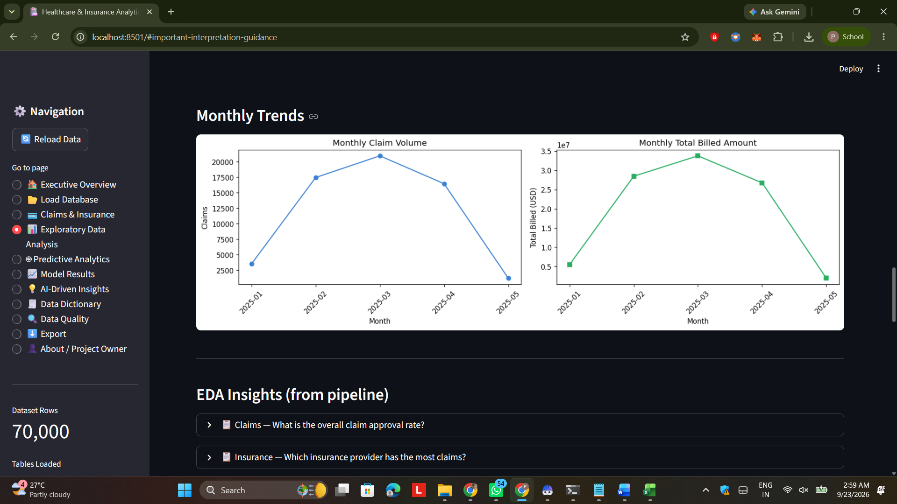
11. Limitations
Synthetic dataset — patterns do not reflect any real healthcare network. Only claims_and_billing.csv was available — no patient, encounter or clinical context. ROC-AUC of 0.576 reflects limited predictive signal with 7 pre-outcome features. No temporal validation — random split, not future-data hold-out. Class imbalance (91:9 ratio) requires careful metric interpretation.
12. Ethical Considerations
This is a synthetic dataset — no real patient data was used. This project does not diagnose patients or provide medical treatment recommendations. All findings are observational — not causal conclusions. The ML model is for educational demonstration only. In a real setting, a denial prediction model would require demographic fairness audits.
13. Conclusion
This project successfully delivered an end-to-end healthcare and insurance analytics application: 70,000 synthetic claims analysed, 10 EDA charts generated, 2 ML model variants trained with leakage prevention, an 11-page interactive Streamlit dashboard built and tested, 13 AI-generated insights derived from actual dataset values, and all outputs exported as downloadable CSVs and PNGs. The project demonstrates end-to-end data analytics proficiency using industry-standard Python tools and rigorous ML methodology.
References

1. Kaggle Dataset: CA Hospital Dataset Q1 2025 by rajkumarpadmanabhan — https://www.kaggle.com/datasets/rajkumarpadmanabhan/ca-hospital-dataset-q1-2025

2. scikit-learn: Machine Learning in Python — Pedregosa et al. (2011), JMLR 12 — https://scikit-learn.org

3. Streamlit — https://streamlit.io

4. IBM SkillsBuild Data Analytics with AI Program — https://skillsbuild.org

Author: Pappu Ramesh Baraf | Email: pappubaraf1@gmail.com |
LinkedIn: https://in.linkedin.com/in/pappubarafaiml | GitHub: https://github.com/PappuBaraf | College: FAMT, Ratnagiri , 415639 | B.E. CSE AI/ML (2023-2027)

