Playtest Feedback Platform — Alpha Release & Task Backlog
CS146S Aut26 · Paprika Chen & Amilia Liu · November 5, 2026
Code: github.com/PaprikaChen/Playtest_Platform · Demo video (2.5 min): youtu.be/Ofmbmhkycr4 · Backlog board: github.com/users/amilialiu25/projects/1
1. Early working demo
A developer uploads a web game, writes a few questions, and shares one link. The tester plays in the browser while their screen and voice are recorded on one timeline, typing notes whenever they want. When they finish, each question shows recall cards: what they said, when they said it, a 10-second replay, and an editable AI draft of how they might phrase it (“one way to put it”). Nothing is answered for them. The developer then watches the session, clicks any comment to jump to that exact moment, and always sees which answers include AI wording.
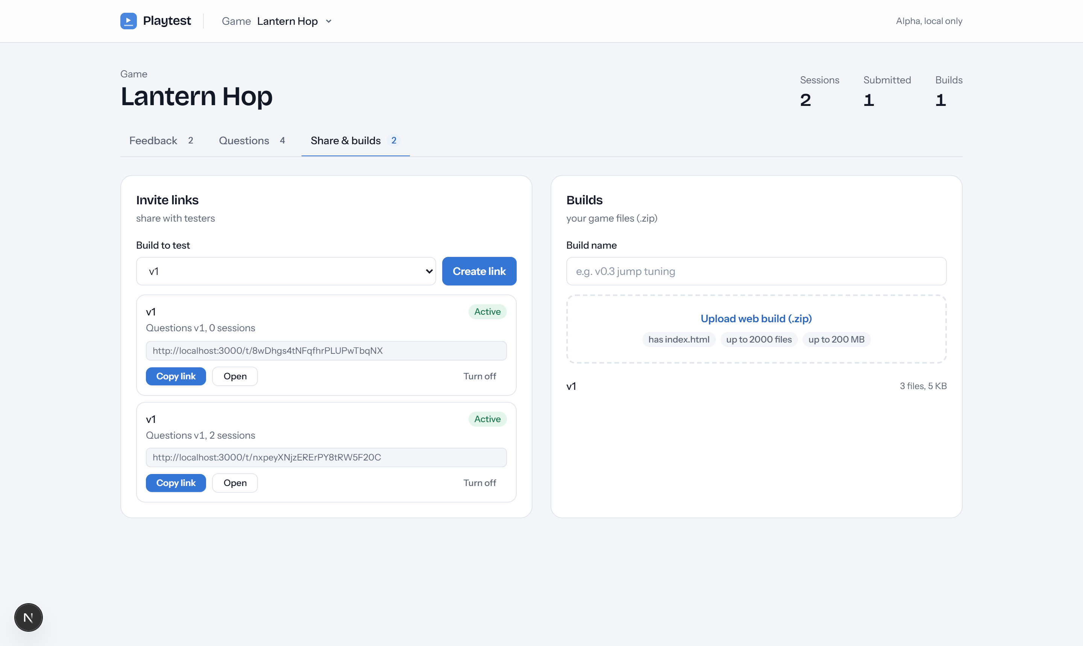
Figure 1. Creator setup: upload a build, save questions, share one invite link.
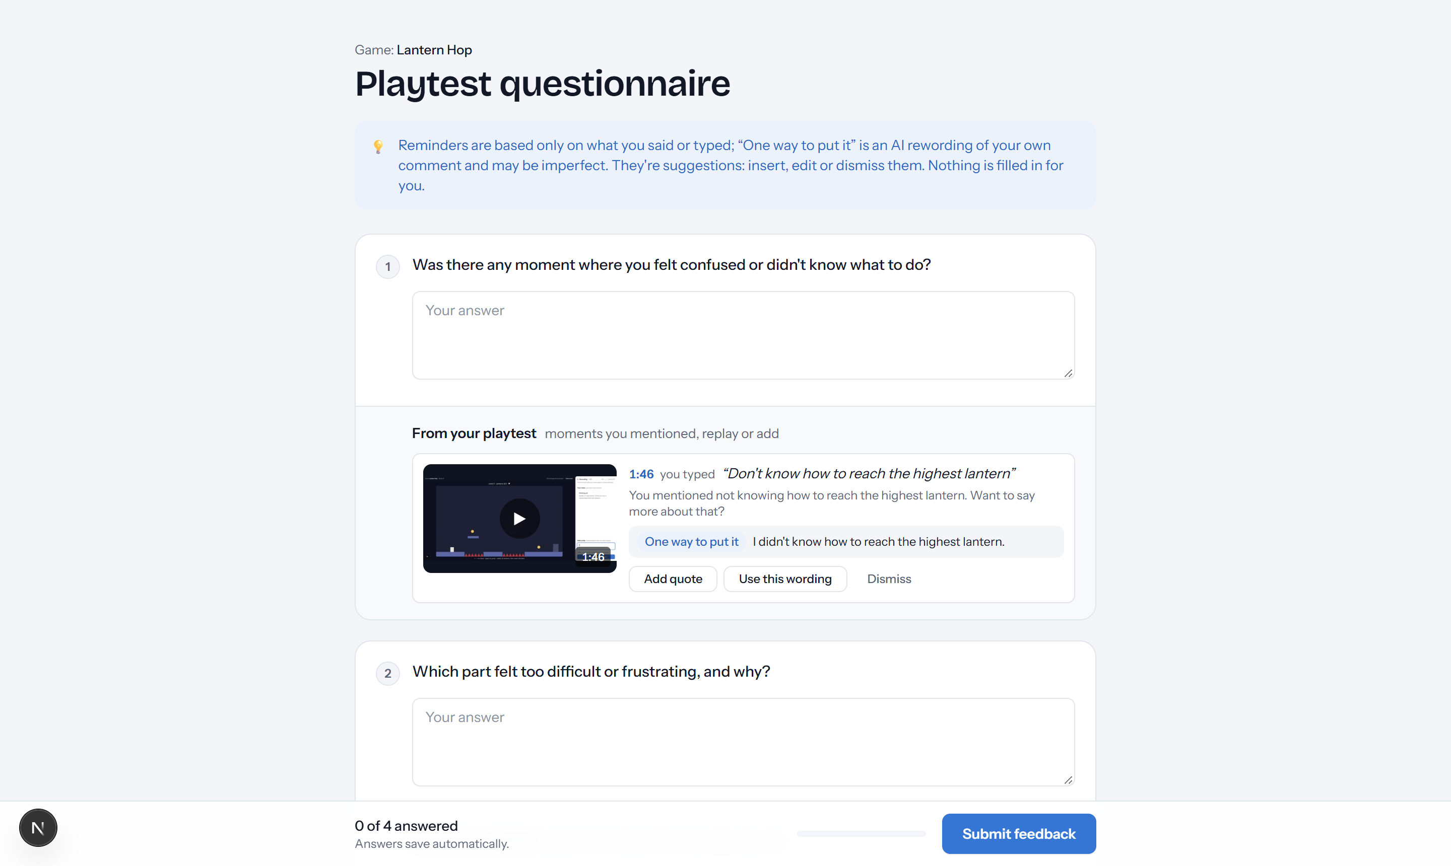
Figure 2. Tester questionnaire: a recall card with the quote, a replay, a neutral hint and an editable AI draft.
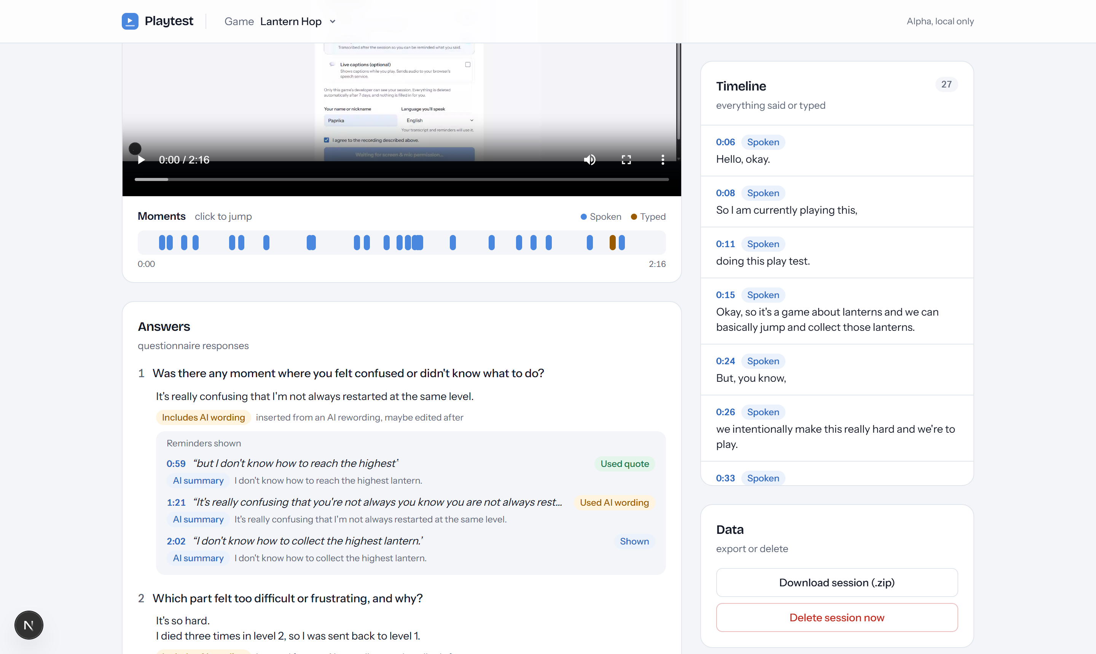
Figure 3. Developer review: a clickable comment timeline; answers are labeled when they include AI wording.
What | Status | Notes
Upload & share a game | Works | ZIP is validated (unsafe paths, >2000 files, >200 MB); the game runs in a sandboxed iframe
Screen + voice recording | Works | 5-second chunks with retries; the tester picks the language they'll speak
Typed notes | Works | Pinned to the moment typing started
Speech-to-text | Works | Local Whisper, word-level timestamps, free; cloud providers wired up but not yet tested
Recall cards with replay | Works | Replay can jump to any second (fixed after our first real playtest)
AI matching + drafts | Works | Claude Haiku matches comments to questions and drafts “one way to put it” — labeled, editable, tracked when used
Review, export, delete | Works | Everything auto-deletes after 7 days
Login, cloud storage, deployment | Not yet | The alpha runs locally, for one developer

2. Task backlog
We track tasks in GitHub Issues with status, priority and area labels, mirrored on a GitHub Projects board. We work in shifts: Amilia built the alpha (shift 1) and Paprika continued from it (shift 2). 17 tasks are closed — the 14 alpha tasks, plus a replay-seek fix, AI drafts on recall cards, and the spoken-language picker, all found or built during real use. The main open tasks:
# | Task | Priority | Assignee
16 | Pick the recall AI model with a labeled test set | High | Paprika
17 | Cloud transcription with a real key | High | Paprika
18 | Developer login | High | Paprika
19 | Move storage to Supabase | High | Paprika
20 | Serve games from a separate domain | High | Paprika
23–25 | Reconnect after network loss · engine compatibility · measure replay accuracy | Medium | In progress
21, 26 | Deployment · pilot study with 5–8 testers | Medium | Next shift
27–29 | Cross-session overview · comment hotkey · event SDK | Low | Stretch

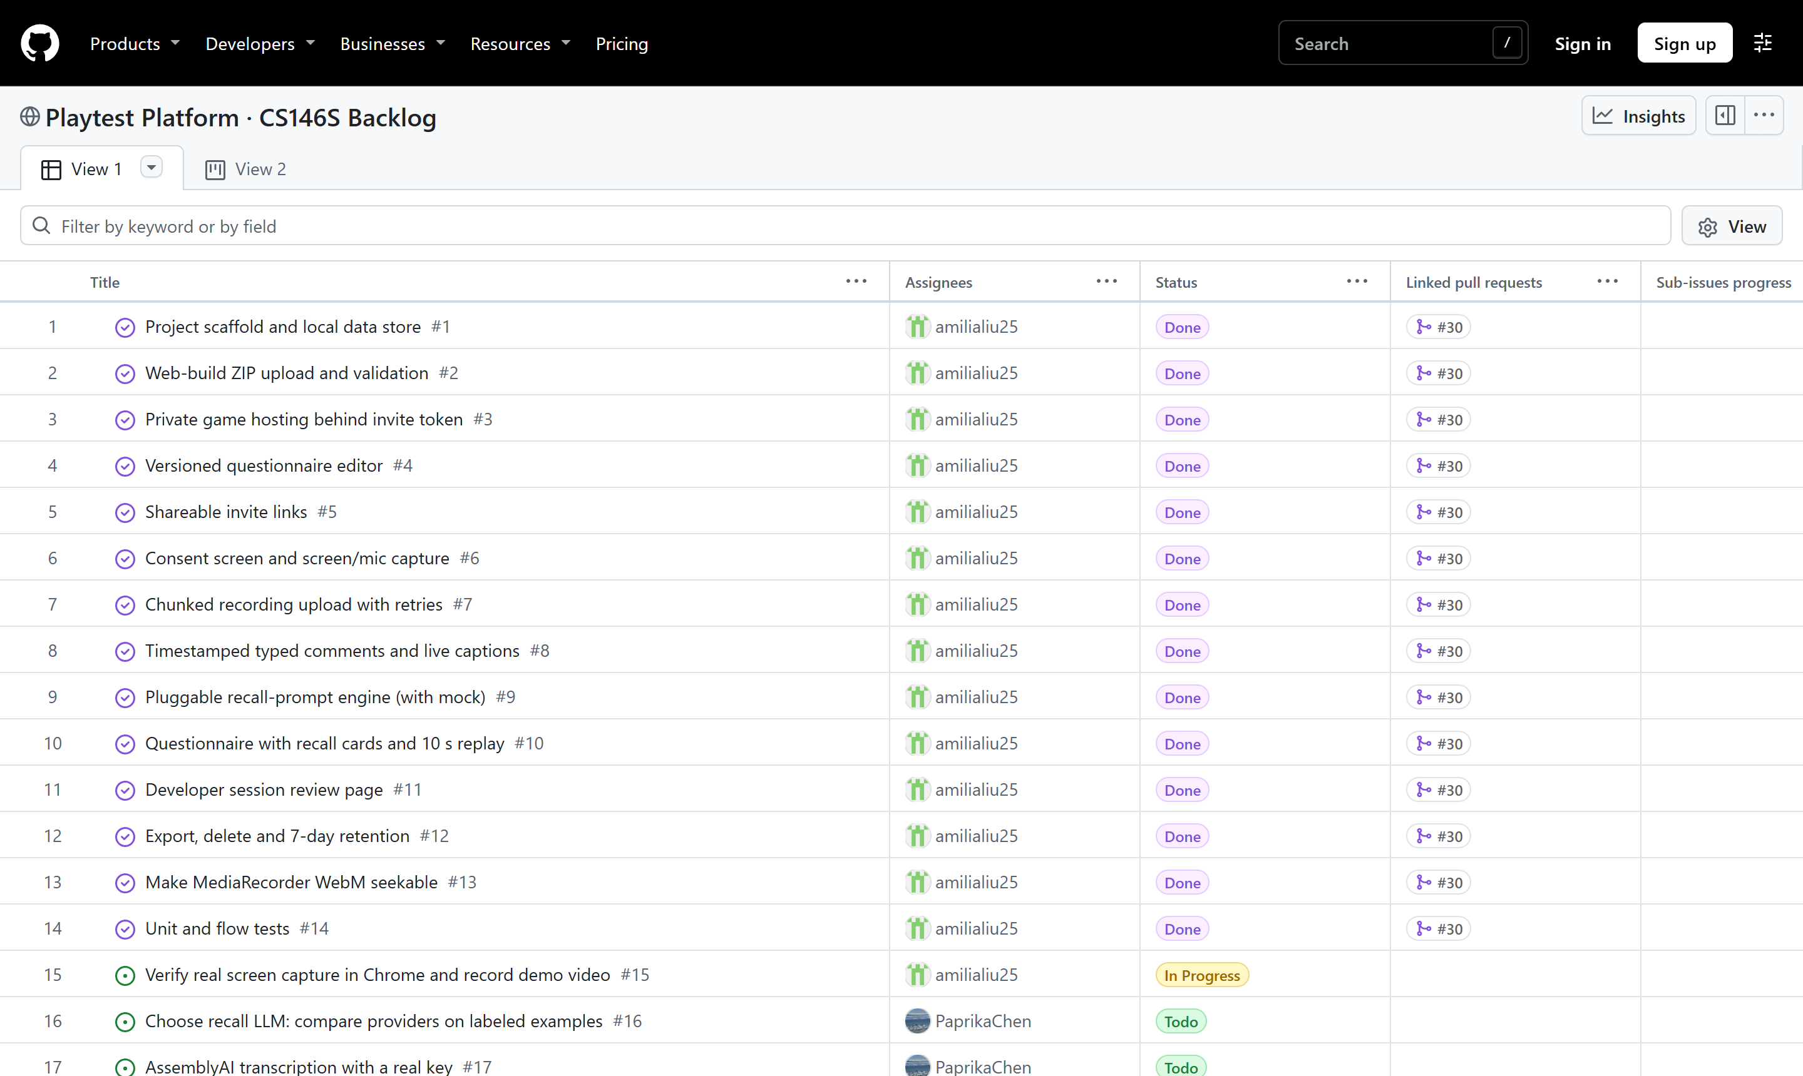
Figure 4. The backlog on our public GitHub Projects board: status, assignees and linked pull requests.
3. Using AI tools: what we learned
Tools: Claude Code as the coding agent (planning, building, testing, and driving the real app in a browser); Claude Haiku inside the product; ChatGPT and Claude for writing.
- It made us fast. Given our spec, the agent built a working alpha in one afternoon. Our time went into design decisions and checking behavior, not typing code.
- Check in a real browser. Having the agent re-test the running app caught bugs that unit tests and type checks missed.
- AI code can look right and be wrong. Two silent bugs — a corrupted video header, and a security check a library quietly bypassed — were only caught by inspecting real output. Both now have regression tests.
- Real users beat green tests. Our first human playtest broke video replay in a way seven passing test runs never hit, and showed that the browser’s language is not the language a tester speaks. Both are fixed: replays now seek anywhere, and testers pick their language.
- Keep the product’s AI on a short leash. The model may only point at comment IDs — quotes always come from the database. AI drafts are first-person, labeled, editable, and may not exaggerate; answers show when AI wording was used.
- The numbers. 19 logged AI tasks (8 features, 6 bug fixes) with 7 human corrections. Most defects were caught by browser checks (11) and unit tests (6).
- One warning. Our API key silently leaked into the test suite through .env.local and changed what the tests tested. Test configs now pin their own environment.

