Deployment

AKfycbwAYGFpskmmwDjfBL3eJ71-A7rbOLpAz7gbEE_EKXwEj5fbGKUmAMCJeKrhGpWWWhvP

URL: id: https://script.google.com/macros/s/AKfycbwAYGFpskmmwDjfBL3eJ71-A7rbOLpAz7gbEE_EKXwEj5fbGKUmAMCJeKrhGpWWWhvP/exec

Master project: Impression Kaleidoscope

Impression management is a conscious or [subconscious](https://en.wikipedia.org/wiki/Subconscious) process in which people attempt to influence the perceptions of other people about a person, object or event by regulating and controlling information in social interaction.

However, People want to do impression management on others but find it hard or no good solution. So our idea is to provide them with a tool that can help them know their impressions from others by using different filters(eg. relationship category, most interaction place…)

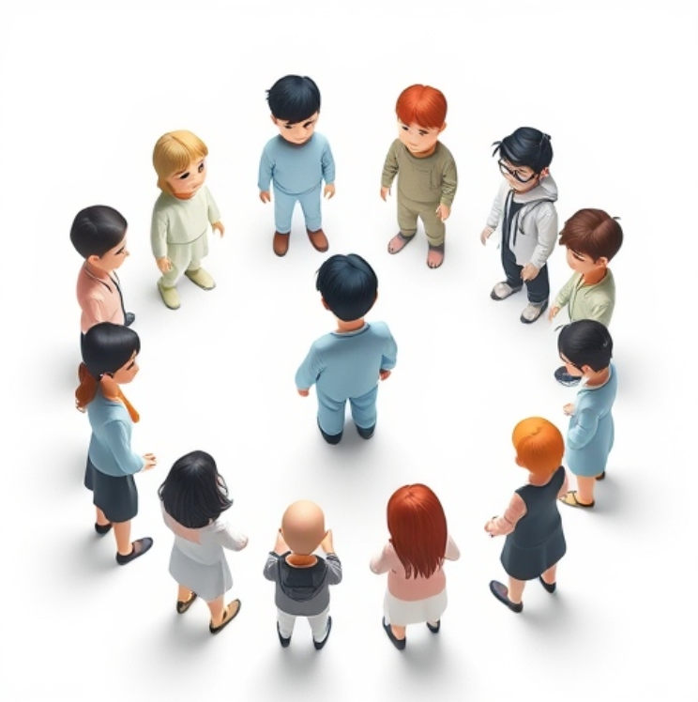

The whole process includes three parts now:

1. [not mandatory]User-study 1 -> by asking users what information can help them do better impression management, we can design the tool. Questions can be like:

* How do you do impression management to others?
  + Do they try to find others’ perceptions? If so, how?
  + How do they find about other’s perceptions?
* Whose perceptions matter most? (family, friend, lab-mate…)
* Do you interact with people differently? (places, time, frequency.. )

1. Design a tool that can collect others perception of MBTI and can be displayed by different categories, can be shown for each person’s perception, it was designed to have three pages till now.
   1. 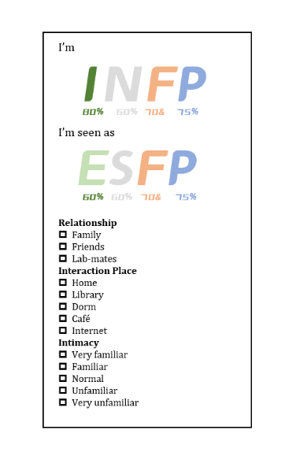Perception page: how I perceive myself and others perceive me in total. Looks like this:
   2. Invitation page: it includes the link or qrcode to the questionnaire that u can share with others to ask for their perceptions. The questionnaire 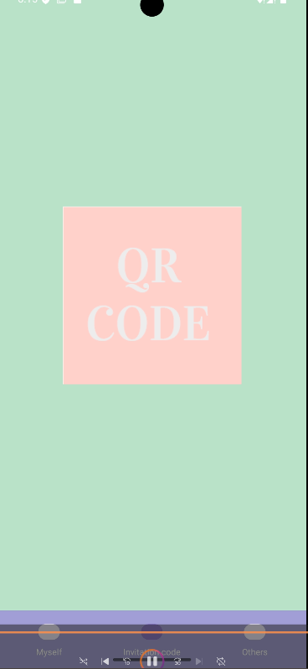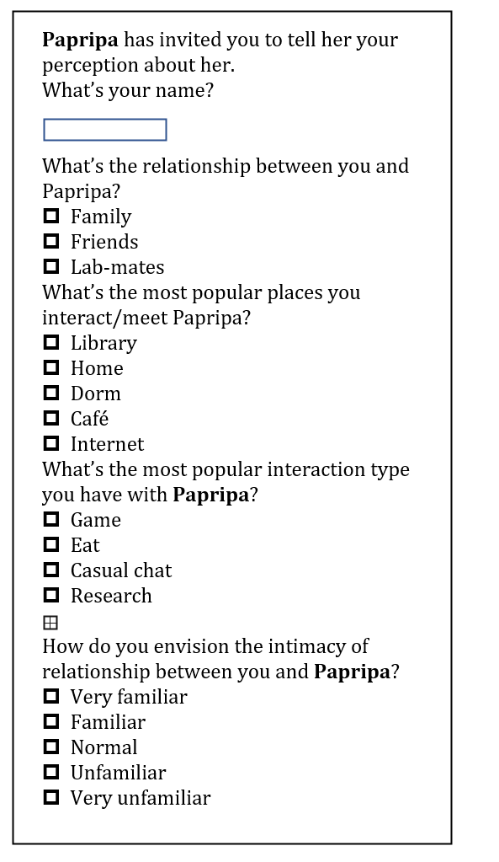should look like the right figure.
   3. Categorization page: you can filter the conditions to see how people with some conditions view you. Example page looks like this:

PS: after recruiting users to use it for 2 or more weeks to collect data. We can ask them to do a user study.

1. User-study 2 -> ask for their using experience and gain insights from the impression management process and user reflections. Can focus on :

* User experience and usability of the tool
* Does it help users to gain insights?
* Does it make people reflect on past interactions and make them to change?

Why do this?

人是由一切社会关系组成，多种维度、视角的思考让人的定义在经济、文化、社交上有着不同的定义和衍生，这是一种宏大叙事。但经济下行，逆全球化的潮流滚滚而来。对于个人而言，从微观视角而看，一个人，如果想要得到他想要的东西的，重点是如何接受在所处时代、社会的地位并控制和周遭的互动·。与天斗，与地斗，与人斗。时代的一粒灰，落在个人头上，就是一座山。没有人是一座孤岛，而人总是趋利避害的。在和人交往的过程中不可避免需要调整自己的行为方式以达到自己的目的。

Impressions everyday 个体的表现涉及两种不同的符号活动：给予gives的表现和他流露give off出的表现；而观察者通常通过流露的信息去验证给予信息的真实性并形成更多的判断和印象

1. 人与人之间的交往建立在某种情境的定义之上，
2. 控制他人的行为，尤其是对待他的方式，从而维持有利的关系