1. Define a class student as described below:

Data members/instance variables:

Name, age, m1, m2, m3( marks in 3 subjects ), maximum, average

Member methods:

i) A parameterized constructor to initialize the data members

ii) To accept the details of a student

iii) To compute the average and the maximum out of three marks

iv) To display the name, age, marks in three subjects, maximum and average. Write a main method to create an object of a class and call the above member methods.

2. Define a class called mobike with the following description:

Instance variables/data members:

int bno – to store the bike’s number

int phno – to store the phone number of the customer

String name – to store the name of the customer

int days – to store the number of days the bike is taken on rent

int charge – to calculate and store the rental charge

Member methods:

void input( ) – to input and store the detail of the customer.

void compute( ) – to compute the renall charge The rent for a mobike is charged on the following basis. First five days Rs 500 per day; Next five days Rs 400 per day Rest of the days Rs 200 per day

void display ( ) – to display the details in the following format: Bike No. PhoneNo. No. of days Charge

3. Define a class called Library with the following descriptions.

Instance variables/Data members:

Int acc_num stores the accession number of the book.

String title stores the title of the book.

String author stores the name of the author

Member methods:

1. void input() to input and store the accession number, title and author.
2. void compute() to accept the number of days late, calculate and display the fine charged at the rate of Rs.2/- per day.
3. void display() to display the details in the following format. Accession Number Title Author Write a main method to create an object of the class and call the above member methods

4. Define a class named FruitJuice with the following description :

Data members

int product_code : stores the product code number

String flavour : stores the flavour of the juice (Eg. Orange, apple etc.)

String pack_type : stores the type of packaging ( Eg. Tetra pack, PET bottle etc.)

int pack_size : stores the package size (Eg. 200ml, 400ml,etc.)

int product_price : stores the price of the product

Member functions

1. FruitJuice() : Default constructor to initialize integer data members to 0 and String data members to “”.
2. void input() : to input and store the product code, flavour, pack type, pack size, and product price.
3. void discount() : to reduce the product price by 10.
4. void display() : to display the product code, flavour, pack type, pack size and product price.

5. Define a class named movieMagic with the following description:

Instance variables/Data members

int year - to store the year of release of a movie

String title - to store the title of the movie float rating - to store the popularity of a movie ( minimum rating = 0.0 and maximum rating = 5.0)

Member methods

1. movieMagic() Default constructor to initialize numeric data members to 0 and String data members to “”.
2. void accept() To input and store year, title and rating.
3. void display() To display the title of a movie and a message based on the rating as per the table below: Rating Message to be displayed 0.0 to 2.0 Flop 2.1 to 3.4 Semi-hit 3.5 to 4.5 Hit 4.5 to 5.0 Super hit Write a main method to create an object of the class and call the above member methods

6. Define a class ParkingLot with the following description:

Instance variables/data members

int vno - To store the vehicle number

int hours - To store the number of hours the vehicle is parked in the parking lot. double bill - To store the bill amount

Member methods:

void input( ) - To input and store the vno and hours

void calculate( ) - To compute the parking charge at the rate of Rs. 3/- for the first hour or part thereof and Rs 1.50/- for each additional hour or part thereof. Write a main method to create an object of the class and call the above methods.

7.

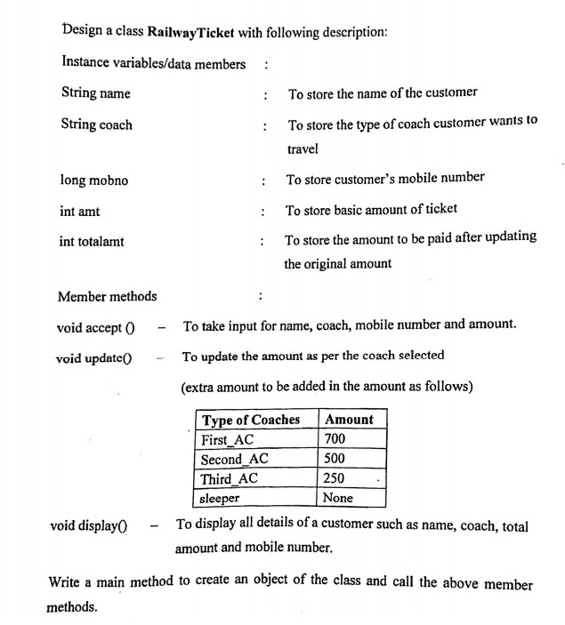

8.

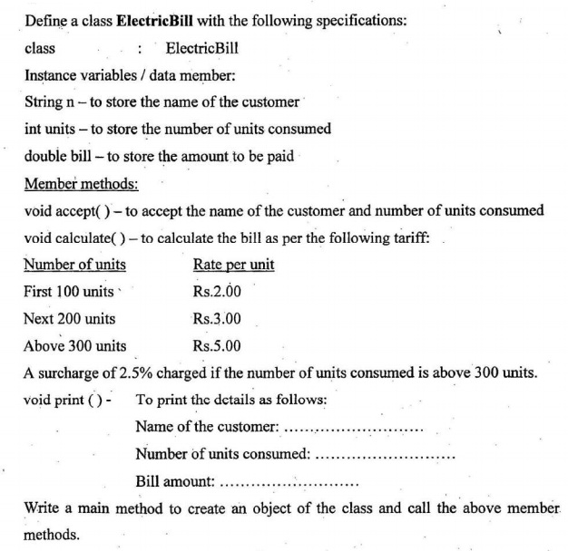

9.

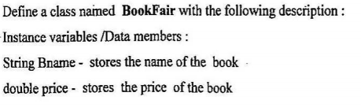

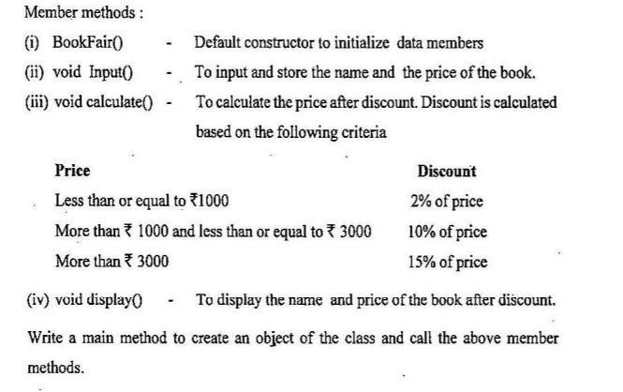

10.

