1.Design a class to overload a function compare ( ) as follows:

(a) void compare (int, int) – to compare two integer values and print the greater of the two integers.

(b) void compare (char, char) – to compare the numeric value of two character and print the character with higher numeric value.

(c) void compare (String, String) – to compare the length of the two strings and print the longer of the two.

2. Design a class to overload a function polygon( ) as follows:

i) void polygon(int n, char ch) with one integer argument and one character type argument that draws a filled square of side n using the character stored in ch.

ii) void polygon(int x, int y) with two integer arguments that draws a filled

rectangle of length x and breadth y, using the symbol @.

iii) void polygon() with no argument that draws a filled triangle below.

Example :

i) Input value of n=2. Ch=’O’

Output:

OO

OO

ii) Input value of x=2, y=5

Output:

@@@@@

@@@@@

iii) Output:

\*\*

\*\*\*

3. Design a class to overload a function area() as follows:

i) double area(double a, double b, double c) with three double arguments, returns the area of a scalene triangle using the formula:

area= 

where s= (a+b+c)/2

ii) double area(int a, int b, int height) with three integer arguments, returns the area of a trapezium using the formula area = 1/2height(a+b)

iii) double area (double diagonal1, double diagonal2) with two double arguments, returns the area of a rhombus using the formula:

area=1/2(diagonal1 x diagonal2).

4. Design a class to overload a function Joystring( ) as follows:

a) void Joystring(String s, char ch1, char ch2) with one string argument and two character arguments that replaces the character argument ch1 with the character argument ch2 in the given string s and prints the new string.

Example:-

Input value of s = “TECHNALAGY”

ch1=’A’

ch2=’O’

Output:

“TECHNOLOGY”

ii) void Joystring(String s) with one string argument that prints the position of the first space and last space of the given string s.

Example:-

Input value of s = “Cloud computing means Internet based computing”

Output: First index : 5

Second index:36

iii) void Joystring(String s1, String s2) with two String arguments that combines the 2 strings with a space between them and prints the resultant string.

Example:

Input value ofs1= “COMMON WEALTH”

Input value ofs2= “GAMES”

Output: COMMON WEALTH GAMES

(use library functions)

5. Design a class to overload a function series( ) as follows :

i) double series(double n) with one double argument and returns the sum of the series, sum= 1/1 + 1/2 +1/3 + …. 1/n

ii) double series(double a, double n) with 2 double arguments and returns the sum of the series, sum = 1/a2 + 4/a5 + 7/a8 + 10/a11+…… to n terms

6.

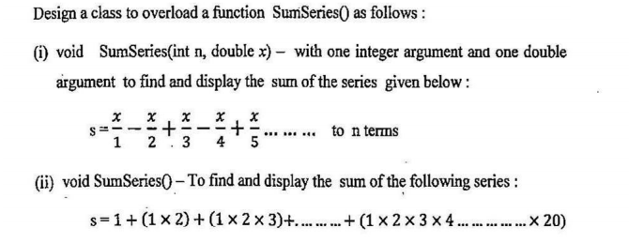

7.

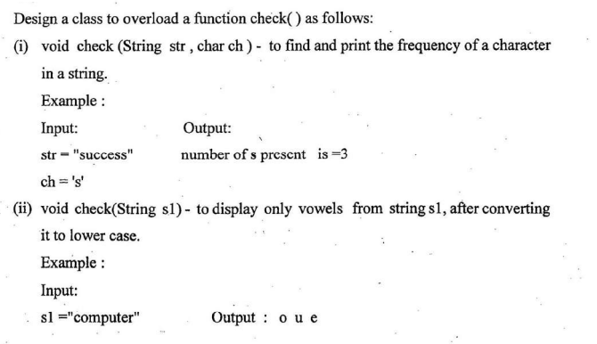

8.