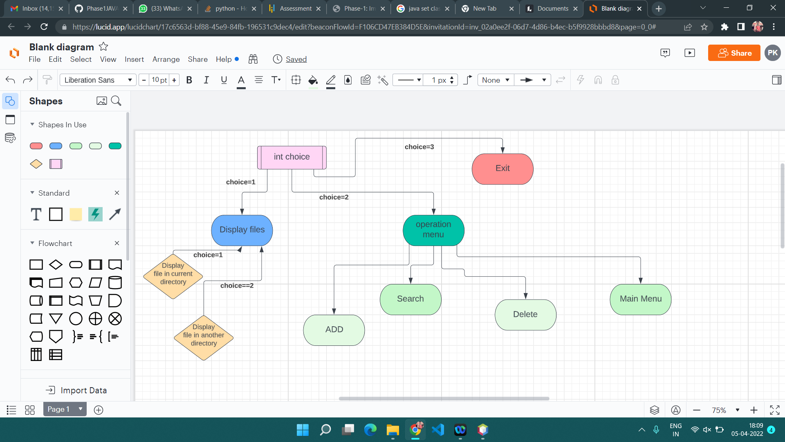

GitHub repository link:

<https://github.com/PapunKumarDas/LockersRoom_phase1Project.git>

run:

\*\*\*\*\*\*\*\*\*\*\*\*\*\*\*\*\*\*\* LockedMe.com \*\*\*\*\*\*\*\*\*\*\*\*\*\*

\*\*\*\*\*\*\*\*\*\*\*\*\*\*\*\*\*\*\*\*\*\*\*\*\*\*\*\*\*\*\*\*\*\*\*\*\*\*\*\*\*\*\*\*\*\*\*\*\*\*\*\*\*\*\*\*\*\*\*\*\*\*\*\*\*\*\*\*\*\*\*\*\*\*\*\*\*\*\*\*\*\*\*\*\*\*\*\*\*\*\*\*\*\*\*\*\*\*\*\*\*\*\*\*\*\*\*\*\*\*

developer details:

S PAPUN KUMAR DAS

Email Id : papunkumardas0@gmail.com

\*\*\*\*\*\*\*\*\*\*\*\*\*\*\*\*\*\*\*\*\*\*\*\*\*\*\*\*\*\*\*\*\*\*\*\*\*\*\*\*\*\*\*\*\*\*\*\*\*\*\*\*\*\*\*\*\*\*\*\*\*\*\*\*\*\*\*\*\*\*\*\*\*\*\*\*\*\*\*\*\*\*\*\*\*\*\*\*\*\*\*\*\*\*\*\*\*\*\*\*\*\*\*\*\*\*\*\*\*\*

\*\*\*\*\*\*\*\*\*\*\*\*\*\* Welcome to the File Management System \*\*\*\*\*\*\*\*\*\*\*\*\*\*\*\*

Thank you for using Lockedme....

Operation are available:

1 : Display names of all existing files in The Directory

2 : Display The Menu

3 : Exit

\*\*\*\*\*\*\*\*\*\*\*\*\*\*\*\*\*\*\*\*\*\*\*\*\*\*\*\*\*\*\*

Please Enter a Number of above which task you want to perfrom:

1

press 1 if you want to search a file in current directory :

press 2 if you want to choose a another directory:

1

files present in this directory are :-

a.txt

abc.txt

abcd.txt

build

build.xml

hari.java

manifest.mf

nbproject

pa.txt

papun.txt

sonu.txt

src

test

\*\*\*\*\*\*\*\*\*\*\*\*\*\* Welcome to the File Management System \*\*\*\*\*\*\*\*\*\*\*\*\*\*\*\*

Thank you for using Lockedme....

Operation are available:

1 : Display names of all existing files in The Directory

2 : Display The Menu

3 : Exit

\*\*\*\*\*\*\*\*\*\*\*\*\*\*\*\*\*\*\*\*\*\*\*\*\*\*\*\*\*\*\*

Please Enter a Number of above which task you want to perfrom: 2

\*\*\*\*\*\*\*\*\*\*\*\*\*\*\*\*\*LockedMe.com \*\*\*\*\*\*\*\*\*\*\*\*\*\*\*\*\*\*\*\*\*\*\*\*\*\*\*\*\*\*

\*\*\*\*\*\*\*\*\*\*\*\*\*\*\*\*\*\*\*FILE OPTION MENU\*\*\*\*\*\*\*\*\*\*\*\*\*\*\*\*\*\*\*\*\*\*\*

\*\*\*\*\*\*\*\*\*\*\*\*\*\*\*\*\*\*\*\*\*\*\*\*\*\*\*\*\*\*\*\*\*\*\*\*\*\*\*\*\*\*\*\*\*\*\*\*\*\*\*\*\*\*\*\*\*\*\*\*\*\*\*\*\*\*\*\*\*\*\*\*\*\*\*\*

choose one of them:

1. Add a New Files in the current directory

2. Search a File from current directory

3. Delete a file from current directory

4. Back to main Menu

\*\*\*\*\*\*\*\*\*\*\*\*\*\*\*\*\*\*\*\*\*\*\*\*\*\*\*\*\*\*\*\*\*\*\*\*\*\*\*\*\*\*\*\*\*\*\*\*\*

1

Creating file:

Enter your File Name with (\*extention\*):

b.txt

File created Successfully

\*\*\*\*\*\*\*\*\*\*\*\*\*\* Welcome to the File Management System \*\*\*\*\*\*\*\*\*\*\*\*\*\*\*\*

Thank you for using Lockedme....

Operation is available:

1 : Display names of all existing files in The Directory

2 : Display The Menu

3 : Exit

\*\*\*\*\*\*\*\*\*\*\*\*\*\*\*\*\*\*\*\*\*\*\*\*\*\*\*\*\*\*\*

Please Enter a Number of above which task you want to perfrom:

2

\*\*\*\*\*\*\*\*\*\*\*\*\*\*\*\*\*LockedMe.com \*\*\*\*\*\*\*\*\*\*\*\*\*\*\*\*\*\*\*\*\*\*\*\*\*\*\*\*\*\*

\*\*\*\*\*\*\*\*\*\*\*\*\*\*\*\*\*\*\*FILE OPTION MENU\*\*\*\*\*\*\*\*\*\*\*\*\*\*\*\*\*\*\*\*\*\*\*

\*\*\*\*\*\*\*\*\*\*\*\*\*\*\*\*\*\*\*\*\*\*\*\*\*\*\*\*\*\*\*\*\*\*\*\*\*\*\*\*\*\*\*\*\*\*\*\*\*\*\*\*\*\*\*\*\*\*\*\*\*\*\*\*\*\*\*\*\*\*\*\*\*\*\*\*

choose one of them:

1. Add a New Files in the current directory

2. Search a File from current directory

3. Delete a file from current directory

4. Back to main Menu

\*\*\*\*\*\*\*\*\*\*\*\*\*\*\*\*\*\*\*\*\*\*\*\*\*\*\*\*\*\*\*\*\*\*\*\*\*\*\*\*\*\*\*\*\*\*\*\*\*

2

File Details:

Enter the file name with (\*extension\*): b.txt

\*\*\*\*\*\*\*\*\*\*\*\*\*\*\*\*\*\*\*\*\*\*\*\*\*\*\*\*\*\*\*\*

information about b.txt is:

Path: D:\Simplilearn\java\phase1project\b.txt

Name: b.txt

\*\*\*\*\*\*\*\*\*\*\*\*\*\* Welcome to the File Management System \*\*\*\*\*\*\*\*\*\*\*\*\*\*\*\*

Thank you for using Lockedme....

Operation are available:

1 : Display names of all existing files in The Directory

2 : Display The Menu

3 : Exit

\*\*\*\*\*\*\*\*\*\*\*\*\*\*\*\*\*\*\*\*\*\*\*\*\*\*\*\*\*\*\*

Please Enter a Number of above which task you want to perfrom: 2

\*\*\*\*\*\*\*\*\*\*\*\*\*\*\*\*\*LockedMe.com \*\*\*\*\*\*\*\*\*\*\*\*\*\*\*\*\*\*\*\*\*\*\*\*\*\*\*\*\*\*

\*\*\*\*\*\*\*\*\*\*\*\*\*\*\*\*\*\*\*FILE OPTION MENU\*\*\*\*\*\*\*\*\*\*\*\*\*\*\*\*\*\*\*\*\*\*\*

\*\*\*\*\*\*\*\*\*\*\*\*\*\*\*\*\*\*\*\*\*\*\*\*\*\*\*\*\*\*\*\*\*\*\*\*\*\*\*\*\*\*\*\*\*\*\*\*\*\*\*\*\*\*\*\*\*\*\*\*\*\*\*\*\*\*\*\*\*\*\*\*\*\*\*\*

choose one of them:

1. Add a New Files in the current directory

2. Search a File from current directory

3. Delete a file from current directory

4. Back to main Menu

\*\*\*\*\*\*\*\*\*\*\*\*\*\*\*\*\*\*\*\*\*\*\*\*\*\*\*\*\*\*\*\*\*\*\*\*\*\*\*\*\*\*\*\*\*\*\*\*\*

3

Delete a File:

Enter the file Name (\*extension\*) which you Want to Delete : -

b.txt

b.txt file deleted

\*\*\*\*\*\*\*\*\*\*\*\*\*\* Welcome to the File Management System \*\*\*\*\*\*\*\*\*\*\*\*\*\*\*\*

Thank you for using Lockedme....

Operation are available:

1 : Display names of all existing files in The Directory

2 : Display The Menu

3 : Exit

\*\*\*\*\*\*\*\*\*\*\*\*\*\*\*\*\*\*\*\*\*\*\*\*\*\*\*\*\*\*\*

Please Enter a Number of above which task you want to perfrom: 3

Exiting from the Program....

Thank you for using Lockedme....

Have a good Day