Who we are  City Center Catering is a premier catering company that has been serving the local community for over a decade. Our passion for great food and exceptional service has made us the go-to choice for all types of events, from intimate dinners to large corporate events. |  |  | Your premier catering solution
Contact us  123 45th Street  Chicago, IL 54321  Phone 302.555.0132  Email citycentercatering@example.com  Web www.greatsiteaddress.com |  |  | 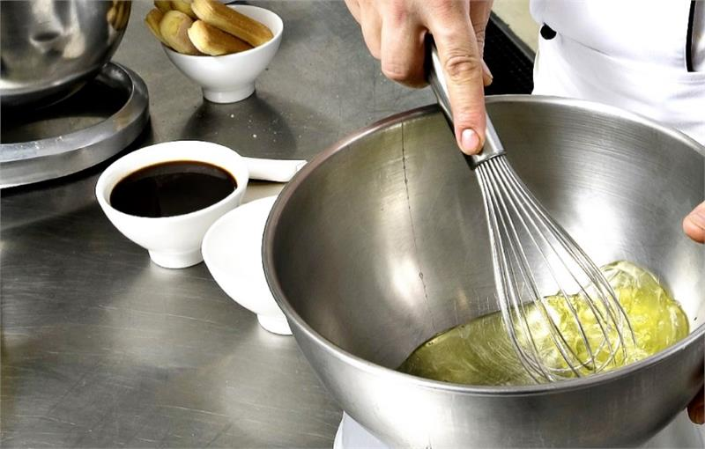
REPLACE WITH  LOGO |  |  | City Center Catering  - Elevating your event with exceptional catering and service.

Table of contents  Tabe of contents 1  Getting started 2  What to include 2  Focus on what you do best 2  Don’t forget the mission 3  Make it your own 4  Customize in almost no time 4  Make it picture perfect 4  Our products and services 5 |  |  | Our products & services  Appetizers and hors d'oeuvres
 |  |  |  |  | Wondering why the page number on this page is 5? This is the inside back cover.  This booklet is setup to make it easy to print a two-sided, eight-page booklet. The tips on this page will help you get that done.
 |  |  | Buffet-style meals
 |  |  |  |  | The bottom of inside pages is setup for you to manually add page numbers, so it’s easy to adjust numbering for your printing preferences. The table of contents at left is also setup for manual editing, so you can easily update page numbers.
 |  |  | Plated dinners
 |  |  |  |  | To print this booklet two-sided, click File and then click Print. Under the option that defaults to Print One Sided, select a two-sided print setting. This booklet is setup to flip on the short side of the page.
 |  |  | 5

Let us do the cooking  City Center Catering offers a wide range of products and services to meet your catering needs. Some of our most popular options include:  Appetizers and hors d’oeuvres, buffet style meals, plated dinners, desserts and baked goods, beverage service, and professional event coordination  “City Center Catering made planning our wedding reception a breeze.”  - Brian and Sara K.  Pricing  At City Center Catering, we believe that great catering shouldn't break the bank. We offer competitive pricing on all of our products and services, and we are happy to work with you to create a customized package that fits your budget.  Make it picture perfect  We can accommodate events of any size, from intimate dinners to large corporate events. Our team will work with you to customize a menu that fits your tastes and budget, and we are happy to accommodate any dietary restrictions or special requests. |  |  | Products & services CONT.  Desserts and baked goods
 |  |  |  |  | To replace any placeholder text, such as this, just click it and type.  Some pages in this template don’t use placeholders, so that you can easily customize the formatting and layout as needed.
 |  |  | Buffet-style meals
 |  |  |  |  | To replace any placeholder text, such as this, just click it and type.  Some pages in this template don’t use placeholders, so that you can easily customize the formatting and layout as needed.
 |  |  | Plated dinners
 |  |  |  |  | To replace any placeholder text, such as this, just click it and type.  Some pages in this template don’t use placeholders, so that you can easily customize the formatting and layout as needed.
4 |  |  | 1

City Center Catering  Experience and expertise  Our team of experienced chefs, servers, and event coordinators work together seamlessly to ensure that your event is a success. We take pride in using only the freshest ingredients and creating customized menus that suit your specific tastes and dietary needs.  “They were professional, accommodating, and the food was fantastic. We will definitely use them again for future events.” – John S  What we do best  City Center Catering offers a wide range of products and services to meet your catering needs. Some of our most popular options include:  - Appetizers and hors d'oeuvres  - Buffet-style meals  - Plated dinners  - Desserts and baked goods  - Beverage service  - Professional event coordination |  |  | Our Mission
 |  |  | At City Center Catering, our mission is to provide exceptional catering services that exceed our clients' expectations. We believe that every event should be an unforgettable experience, and we strive to create that experience through delicious food, exceptional service, and attention to detail. We are committed to sourcing the highest-quality ingredients, using innovative techniques and presentation, and delivering unparalleled customer service.
Our goal is to make your event a success, and we look
forward to serving you.
 |  |  |  | 
 |  |  | Above: Fresh ingredients | Roasted red pepper bisque
2 |  |  | 3

