 |  | 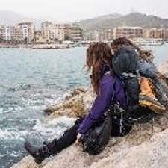

MARGIE’S
TRAVEL

Let Margie Plan Your Next Vacation

MARGIE’S TRAVEL
Street Address
City, St Zip Code
Phone Number
Website
Email

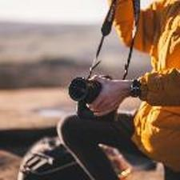 |  | 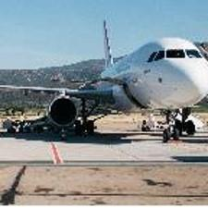
MARGIE’S TRAVEL OFFERS YOU  THE FOLLOWING: |  |  |  | 
01 | Booking for any type  of travel
02 | Quick, thorough, knowledgeable responses to calls and questions
03 | Resourceful and  well-traveled agents
04 | International  services

You are able to make this brochure yours by making a few minor design tweaks!  On the Home tab, check out the Styles gallery for styles already built into the template. Clicking on any style will update the format of your text easily. |  |  | 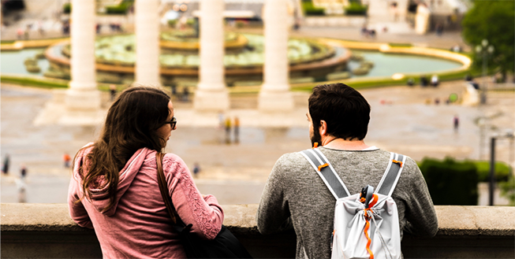
“We don’t merely book your travel; we can help you realize your travel dreams if you give us an idea of what kind of experience you seek.”  - Henriette Andersen |  |  |  |  | OUR SERVICES INCLUDE
 |  |  |  |  | Passport  Expediting | Excursion  Planning

 |  | To replace any of the pictures in this pamphlet, just click on the image you wish to change and delete it, then insert your own. |  |  | Hotel, Air,  Transportation  Arrangements | Trip  Insurance
 |  |  |  |  | If you replace a photo with your own and it’s not a flawless fit for the space, you can crop it to fit in almost no time. To do this, select Picture > Crop from the ribbon.

