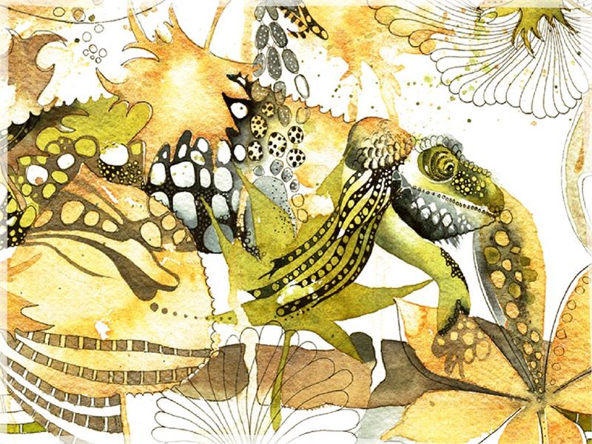 | 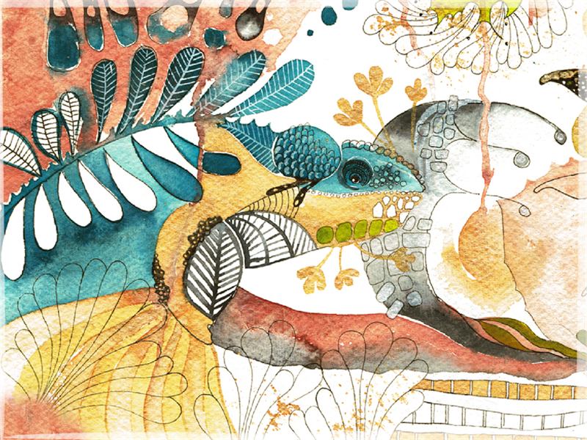

Click and start typing to customize your message, or delete for a blank card | Click and start typing to customize your message, or delete for a blank card

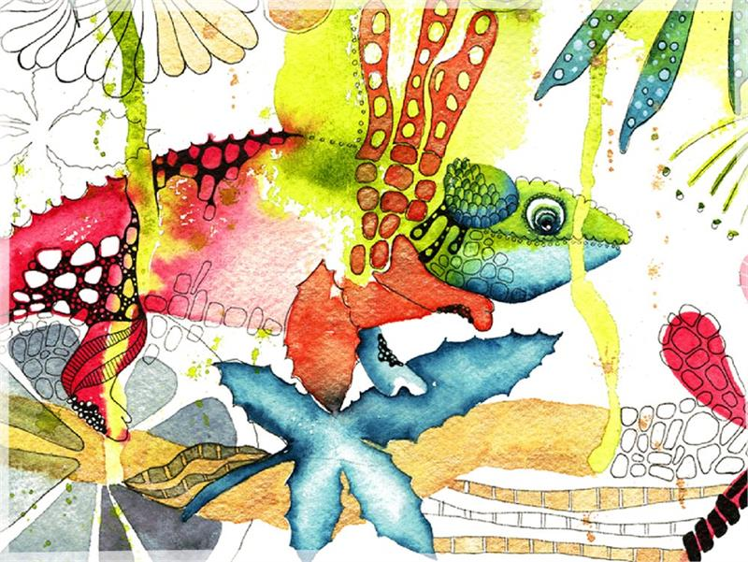 | 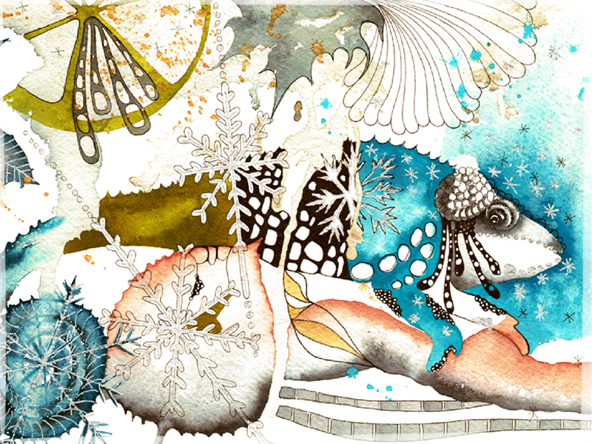

Click and start typing to customize your message, or delete for a blank card | Click and start typing to customize your message, or delete for a blank card

