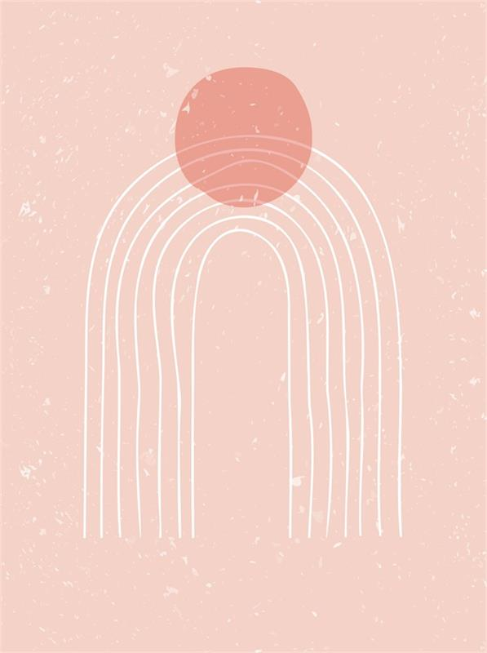


thank you

thank you

Thank you so much. Your kindness
means everything to me.
Thank you so much. Your kindness
means everything to me.

