 |   Merry Christmas
 |   Merry Christmas

We hope you have a
wonderful holiday!
We hope you have a
wonderful holiday!

 |   Merry Christmas
 |   Merry Christmas

We hope you have a
wonderful holiday!
We hope you have a
wonderful holiday!

 | 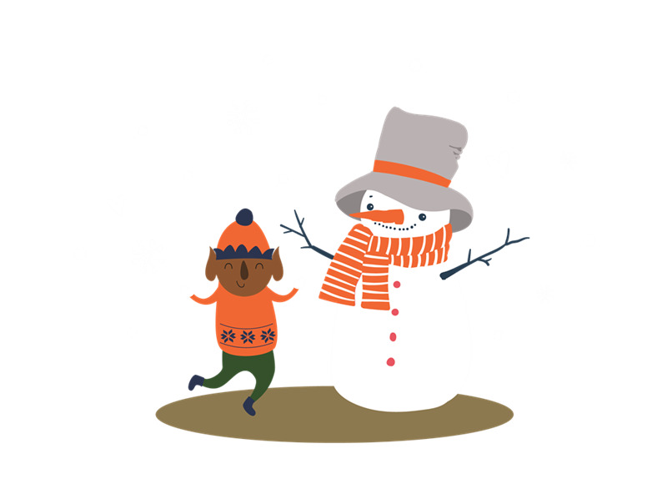  Merry Christmas
 |   Merry Christmas

We hope you have a
wonderful holiday!
We hope you have a
wonderful holiday!

