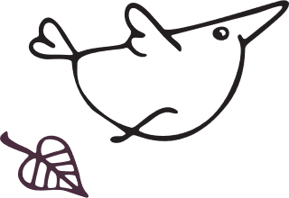






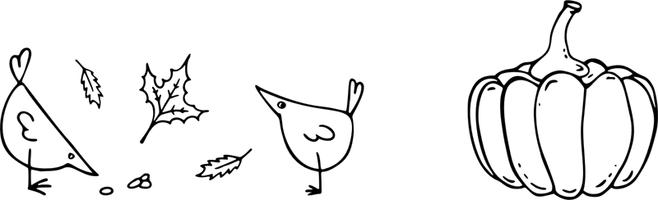

Thanksgiving

Party Menu

Appetizer
Select the text to update it with your own. Use this space to add a description of your food or your appetizer options. The appetizer is usually the smallest portion and served before the meal starts. (Example: Cheese, fruit plate, or any type of finger food.)

First Course
Select the text to update it with your own. Use this space to add a description of your food or your first course options. The first course is lighter than your main course. (Example: Salad.)

Main Course
Select the text to update it with your own. Use this space to add a description of your food or your main course. The main course is usually the largest portion. (Hint: If you’re serving a meat option, don’t forget to include a vegetarian/vegan option too.)

Sides
Select the text to update it with your own. Use this space to add a description of your food or your side options. The side is usually a cooked vegetable. (Example: Green beans, corn, potatoes, and more.)

Desserts
Select the text to update it with your own. Use this space to add a description of your food or your dessert options. The dessert can be served hot or cold. (Example: ice cream, fruit, dessert wine, and more.)

Thanksgiving

Party Menu
 |  | 
APPETIZER  Select the text to update it with your own. Use this space to add a description of your food or your appetizer options. The appetizer is usually the smallest portion and served before the meal starts. (Example: Cheese, fruit plate, or any type of finger food.) |  | FIRST COURSE  Select the text to update it with your own. Use this space to add a description of your food or your first course options. The first course is lighter than your main course. (Example: Salad.)
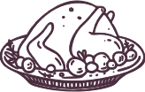 |  | 
MAIN COURSE  Select the text to update it with your own. Use this space to add a description of your food or your main course. The main course is usually the largest portion. (Hint: If you’re serving a meat option, don’t forget to include a vegetarian/vegan option too.) |  | SIDES  Select the text to update it with your own. Use this space to add a description of your food or your side options. The side is usually a cooked vegetable. (Example: Green beans, corn, potatoes, and more.)
 |  | 

DESSERTS
Select the text to update it with your own. Use this space to add a description of your food or your dessert options. The dessert can be served hot or cold. (Example: ice cream, fruit, dessert wine, and more.)

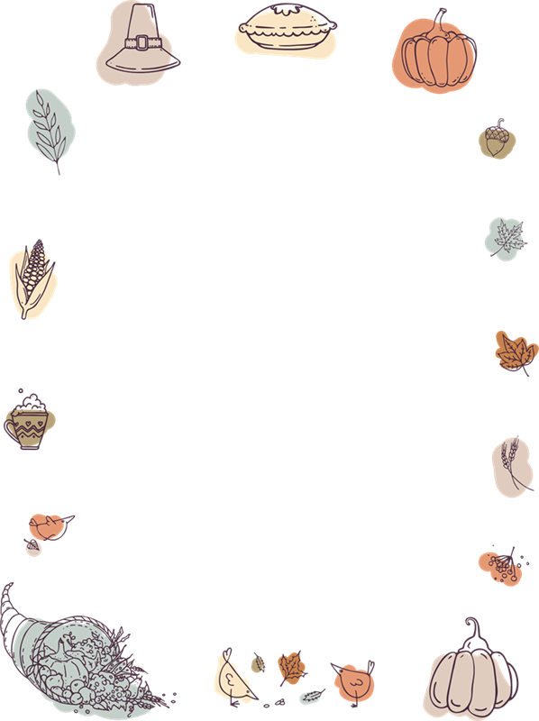
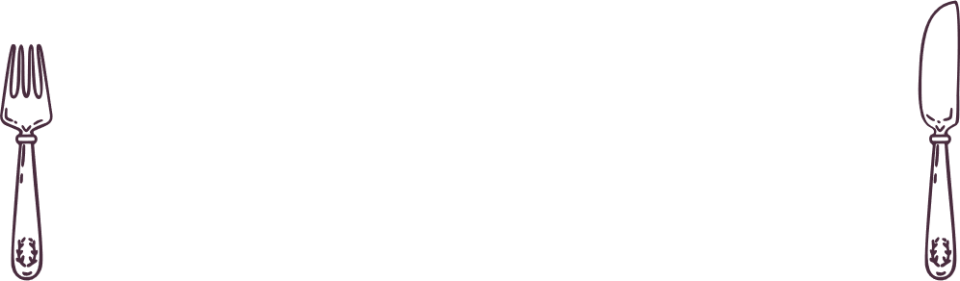

Thanksgiving

Party Menu

Appetizer
Select the text to update it with your own. Use this space to add a description of your food or your appetizer options. The appetizer is usually the smallest portion and served before the meal starts. (Example: Cheese, fruit plate, or any type of finger food.)

First Course
Select the text to update it with your own. Use this space to add a description of your food or your first course options. The first course is lighter than your main course. (Example: Salad.)

Main Course
Select the text to update it with your own. Use this space to add a description of your food or your main course. The main course is usually the largest portion. (Hint: If you’re serving a meat option, don’t forget to include a vegetarian/vegan option too.)

Sides
Select the text to update it with your own. Use this space to add a description of your food or your side options. The side is usually a cooked vegetable. (Example: Green beans, corn, potatoes, and more.)

Desserts
Select the text to update it with your own. Use this space to add a description of your food or your dessert options. The dessert can be served hot or cold. (Example: ice cream, fruit, dessert wine, and more.)

