BISTRO MENU
DRINKS  SODA – 3  Cola, Lemon-Lime, Orange, Grape, Strawberry  LEMONADE – 3  Strawberry, Mint, Blueberry, Mango, Peach  TEA – 2  Chamomile, Black, Earl Grey, Matcha, Jasmine, Chai, Fruit blend |  |  | SALADS  cobb - 14  Mixed greens, avocado, grilled chicken, tomato, hard-boiled egg, chives, blue cheese  CAESAR – 13  Romaine, grilled chicken, croutons, pine nuts, Parmesan cheese  Greek - 12  Iceberg, grape tomatoes, cucumbers, feta cheese, olives, croutons
EST. 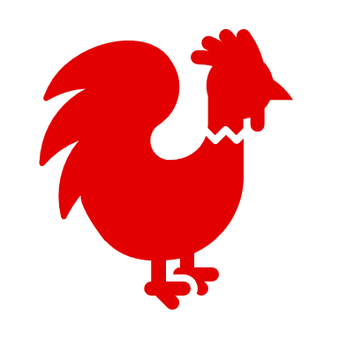 1981 |  |  | ENTREES  burger - 16  7oz custom ground beef patty, triple cream brie, alfalfa sprouts, caramelized onions  pasta - 15  Hand-made pasta, black truffle, olive oil, shaved Parmesan  gnocchi – 14  Potato dumplings, roasted mushrooms, spinach  grilled steak sandwich - 17  Caramelized onions, roasted tomatoes, horseradish

APPETIZERS

potato cakes – 7
Fried potato, apple jelly, sour cream

spinach dip - 5
Spinach, cream cheese, spices, tortilla chips

oysters - 13
Freshly shucked oysters

cheese fries - 4
Hand-cut fries, cheese, bacon, chives, jalapeno, sour cream

onion rings - 7
Thick cut yellow onion, beer battered, panko coated

DESSERTS

caramel cheesecake - 13
Caramelized banana, cream

apple cobbler - 12
Cinnamon crumble, vanilla ice cream, heirloom apples

brownie sundae - 9
Dark chocolate, nuts, vanilla ice cream

flan - 8
Vanilla custard with sweet caramel sauce

EST. | BISTRO MENU |  | 1981
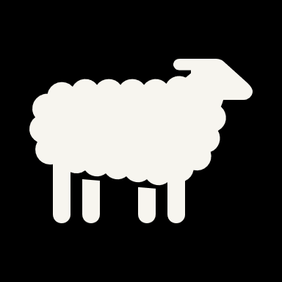 | Drinks  SODA – 3  Cola, Lemon-Lime, Orange, Grape, Strawberry  LEMONADE – 3  Strawberry, Mint, Blueberry, Mango, Peach  TEA – 2  Chamomile, Black, Earl Grey, Matcha, Jasmine, Chai, Fruit blend  COFFEE- 2  Dark roast, Blonde, Medium, French | Salads  ARUGULA – 11  Lemon, olive oil, garlic, Parmesan cheese  CAESAR – 13  Romaine, grilled chicken, croutons, pine nuts, Parmesan cheese  Greek - 12  Iceberg, grape tomatoes, cucumbers, feta cheese, olives, croutons  cobb - 14  Mixed greens, avocado, grilled chicken, tomato, hard-boiled egg, chives, blue cheese

Entrees
burger - 16
7oz custom ground beef patty, triple cream brie, alfalfa sprouts, caramelized onions

pasta - 15
Hand-made pasta, black truffle, olive oil, shaved Parmesan

gnocchi – 14
Potato dumplings, roasted mushrooms, spinach

grilled steak sandwich - 17
Caramelized onions, roasted tomatoes, horseradish

Appetizers
potato cakes – 7
Fried potato, apple jelly, sour cream

spinach dip - 5
Spinach, cream cheese, spices, tortilla chips

oysters - 13
Freshly shucked oysters

cheese fries - 4
Hand-cut fries, cheese, bacon, chives, jalapeno, sour cream

onion rings - 7
Thick cut yellow onion, beer battered, panko coated

Fried Pickles - 5
Battered + lightly fried dill pickles

Desserts
caramel cheesecake - 13
Caramelized banana, cream

apple cobbler - 12
Cinnamon crumble, vanilla ice cream, heirloom apples

brownie sundae - 9
Dark chocolate, nuts, vanilla ice cream

flan - 8
Vanilla custard with sweet caramel sauce

EST. | BISTRO MENU |  |  | 1981
  Appetizers  potato cakes – 7  Fried potato, apple jelly, sour cream  spinach dip - 5  Spinach, cream cheese, spices, tortilla chips  oysters - 13  Freshly shucked oysters  cheese fries - 4  Hand-cut fries, cheese, bacon, chives, jalapeno, sour cream  onion rings - 7  Thick cut yellow onion, beer battered, panko coated  Fried Pickles - 5  Battered + lightly fried dill pickles  poutine – 4  Gold potato fries, cheese curds, house-made veal gravy  house bread – 5  With balsamic and olive oil |  | Salads  ARUGULA – 11  Lemon, olive oil, garlic, Parmesan cheese  CAESAR – 13  Romaine, grilled chicken, croutons, pine nuts, Parmesan cheese  Greek - 12  Iceberg, grape tomatoes, cucumbers, feta cheese, olives, croutons | Drinks  SODA – 3  Cola, Lemon-Lime, Orange, Grape, Strawberry  LEMONADE – 3  Strawberry, Mint, Blueberry, Mango, Peach  JUICE – 2  Orange, Grapefruit, Apple, Grape  TEA – 2  Chamomile, Black, Earl Grey, Matcha, Jasmine, Chai, Fruit blend  COFFEE - 2  Dark roast, Blonde, Medium, French  CAPPUCCINO - 4  Dark, rich espresso with a layer of thick milk foam  Espresso - 3  Espresso roast with rich flavor and caramelly undertones  Flat white – 4  Espresso with the perfect amount of steamed whole milk

Entrees

burger - 16
7oz custom ground beef patty, triple cream brie, alfalfa sprouts, caramelized onions

pasta - 15
Hand-made pasta, black truffle, olive oil, shaved Parmesan

gnocchi – 14
Potato dumplings, roasted mushrooms, spinach

grilled steak sandwich - 17
Caramelized onions, roasted tomatoes, horseradish

Desserts

caramel cheesecake - 13
Caramelized banana, cream

apple cobbler - 12
Cinnamon crumble, vanilla ice cream, heirloom apples

brownie sundae - 9
Dark chocolate, nuts, vanilla ice cream

flan - 8
Vanilla custard with sweet caramel sauce
 |  |  | 