
 |  | The Review | August 20XX  Issue #12
 |  | The latest news, views, and announcements
INSIDE
__
New finds this week
Add description text here to get your subscribers interested in your topic.
__
Corporate newsletter
Add description text here to get your subscribers interested in your topic.
__
The observer
Add description text here to get your subscribers interested in your topic.

New finds this week
‒ By Peyton Davis
Newsletters are periodicals used to advertise or update your subscribers with information about your product or blog. They can be printed or emailed and are an excellent way to maintain regular contact with your subscribers and drive traffic to your site. Type the content of your newsletter here.
Newsletters are periodicals used to advertise or update your subscribers with information about your product or blog. They can be printed or emailed and are an excellent way to maintain regular contact with your subscribers and drive traffic to your site. Type the content of your newsletter here.
Newsletters are periodicals used to advertise or update your subscribers with information about your product or blog. They can be printed or emailed and are an excellent way to maintain regular contact with your subscribers and drive traffic to your site. Type the content of your newsletter here.

The Review
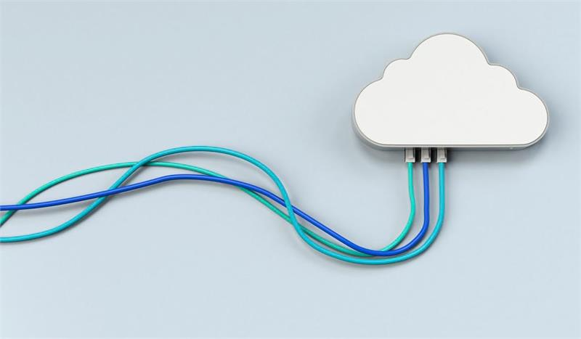  Corporate newsletter  ‒ By Shir Rosenstein  Newsletters are periodicals used to advertise or update your subscribers with information about your product or blog. They can be printed or emailed and are an excellent way to maintain regular contact with your subscribers and drive traffic to your site. Type the content of your newsletter here.  Newsletters are periodicals used to advertise or update your subscribers with information about your product or blog.  Newsletters are periodicals used to advertise or update your subscribers with information about your product or blog. They can be printed or emailed and are an excellent way to maintain regular contact with your subscribers and drive traffic to your site. Type the content of your newsletter here. |  |  | Work with the industry’s best  ‒By Taylor Phillips  Newsletters are periodicals used to advertise or update your subscribers with information about your product or blog. They can be printed or emailed and are an excellent way to maintain regular contact with your subscribers and drive traffic to your site. Type the content of your newsletter here.  Newsletters are periodicals used to advertise or update your subscribers with information about your product or blog. Type the content of your newsletter here.  Newsletters are periodicals used to advertise or update your subscribers with information about your product or blog. They can be printed or emailed and are an excellent way to maintain regular contact with your subscribers and drive traffic to your site. Type the content of your newsletter here.
 | The observer  ‒By Chanchal Sharma  Newsletters are periodicals used to advertise or update your subscribers with information about your product or blog. They can be printed or emailed and are an excellent way to maintain regular contact with your subscribers and drive traffic to your site. Type the content of your newsletter here.  Newsletters are periodicals used to advertise or update your subscribers with information about your product or blog. They are an excellent way to maintain regular contact with your subscribers.

