Tuesday September 20 20XX | NEWS TODAY  Latest news and bulletin updates |  |  |  |  |  |  |  | Issue  #10
April Hansson  New program launches  The latest updates  Video provides a powerful way to help you prove your point. When you click Online Video, you can paste in the embed code for the video you want to add. You can also type a keyword to search online for the video that best fits your document.  To make your document look professionally produced, Word provides header, footer, cover page, and text box designs that complement each other. For example, you can add a matching cover page, header, and sidebar.  Click Insert and then choose the elements you want from the different galleries.  Themes and styles also help keep your document coordinated. When you click Design and choose a new Theme, the pictures, charts, and SmartArt graphics change to match your new theme. When you apply styles, your headings change to match the new theme.  Save time in Word with new buttons that show up where you need them. To change the way a picture fits in your document, click it and a button for layout options appears next to it.  When you work on a table, click where you want to add a row or a column, and then click the plus sign. |  |  |  | 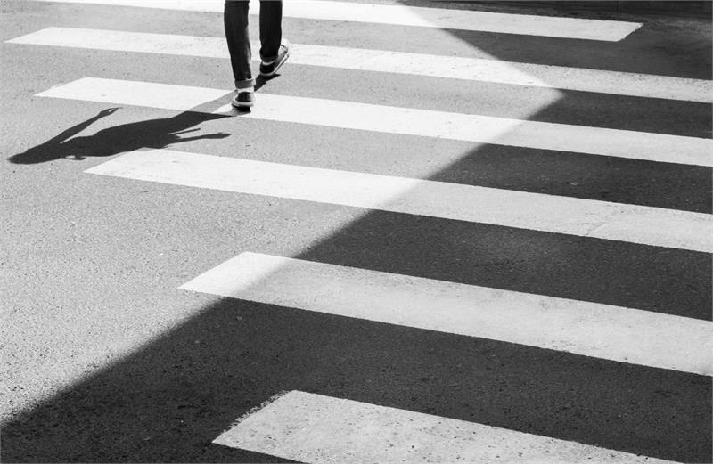
 |  |  |  | Picture Caption: To make your document look professionally produced, Word provides header, footer, cover page, and text box designs that complement each other.
Kayla Lewis

Community rallies for charity
Daily news updates and opinions
 |  |  |  | Video provides a powerful way to help you prove your point. When you click Online Video, you can paste in the embed code for the video you want to add. You can also type a keyword to search online for the video that best fits your document.  To make your document look professionally produced, Word provides header, footer, cover page, and text box designs that complement each other. For example, you can add a matching cover page, header, and sidebar.  Save time in Word with new buttons that show up where you need them. To change the way a picture fits in your document, click it and a button for layout options appears next to it. When you work on a table, click where you want to add a row or a column, and then click the plus sign. |  |  |  | Themes and styles also help keep your document coordinated. When you click Design and choose a new Theme, the pictures, charts, and SmartArt graphics change to match your new theme. When you apply styles, your headings change to match the new theme.  Save time in Word with new buttons that show up where you need them. To change the way a picture fits in your document, click it and a button for layout options appears next to it. When you work on a table, click where you want to add a row or a column, and then click the plus sign.  Reading is easier, too, in the new Reading view. You can collapse parts of the document and focus on the text you want. If you need to stop reading before you reach the end, Word remembers where you left off - even on another device.
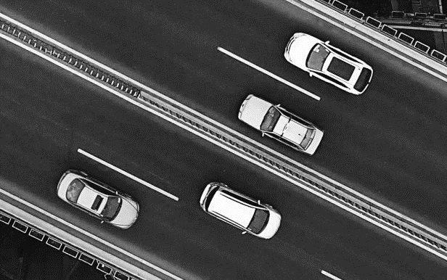
Picture Caption: To make your document look professionally produced, Word provides header, footer, cover page, and text box designs that complement each other.
School budget  The latest updates |  |  | Police prevent crime  The latest updates |  |  |  | Athlete sets record  The latest updates
Eric Solomon |  |  | Kymbat Galymzhan |  |  |  | Reda Sayegh
To make your document look professionally produced, Word provides header, footer, cover page, and text box designs that complement each other.  Page XX |  |  | Reading is easier, too, in the new Reading view. You can collapse parts of the document and focus on the text you want.  Page XX |  |  |  | To make your document look professionally produced, Word provides header, footer, cover page, and text box designs that complement each other.  Page XX
 |  |  |  |  | Page 1

Tuesday Sep 20, 20XX | NEWS TODAY |  |  |  |  |  | Issue #10
Mattia Trentini

The latest breaking news of the day
The latest updates to get you through the day
Save time in Word with new buttons that show up where you need them. To change the way a picture fits in your document, click it and a button for layout options appears next to it. When you work on a table, click where you want to add a row or a column, and then click the plus sign.  Reading is easier, too, in the new Reading view. You can collapse parts of the document and focus on the text you want. If you need to stop reading before you reach the end, Word remembers where you left off - even on another device.  Themes and styles also help keep your document coordinated. When you click Design and choose a new Theme, the pictures, charts, and SmartArt graphics change to match your new theme. When you apply styles, your headings change to match the new theme. |  |  | Video provides a powerful way to help you prove your point. When you click Online Video, you can paste in the embed code for the video you want to add. You can also type a keyword to search online for the video that best fits your document.  To make your document look professionally produced, Word provides header, footer, cover page, and text box designs that complement each other. For example, you can add a matching cover page, header, and sidebar.  Save time in Word with new buttons that show up where you need them. To change the way a picture fits in your document, click it and a button for layout options appears next to it. When you work on a table, click where you want to add a row or a column, and then click the plus sign. |  |  | Themes and styles also help keep your document coordinated. When you click Design and choose a new Theme, the pictures, charts, and SmartArt graphics change to match your new theme. When you apply styles, your headings change to match the new theme.  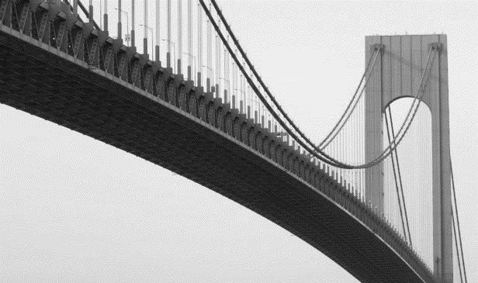
 |  |  |  |  |  | Picture caption: Picture Caption: To make your document look professionally produced, Word provides header, footer, cover page, and text box designs that complement each other.
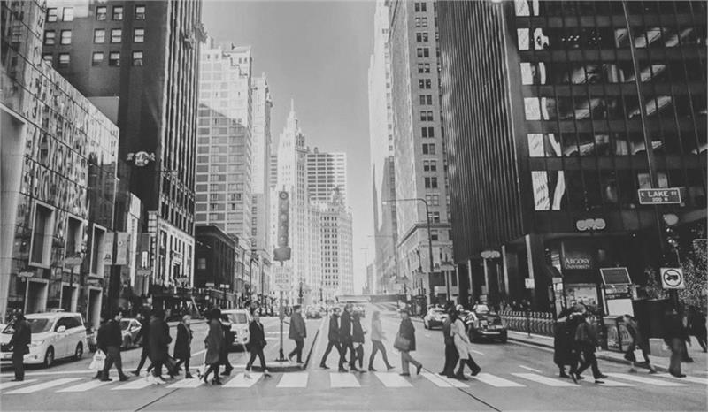 |  |  |  |  |  | Mirjam Nilsson  The scoop of the day  The latest updates  Themes and styles also help keep your document coordinated. When you click Design and choose a new Theme, the pictures, charts, and SmartArt graphics change to match your new theme. When you apply styles, your headings change to match the new theme.  Save time in Word with new buttons that show up where you need them. To change the way a picture fits in your document, click it and a button for layout options appears next to it. When you work on a table, click where you want to add a row or a column, and then click the plus sign. Reading is easier, too, in the new Reading view. You can collapse parts of the document and focus on the text you want.  When you work on a table, click where you want to add a row or a column, and then click the plus sign.  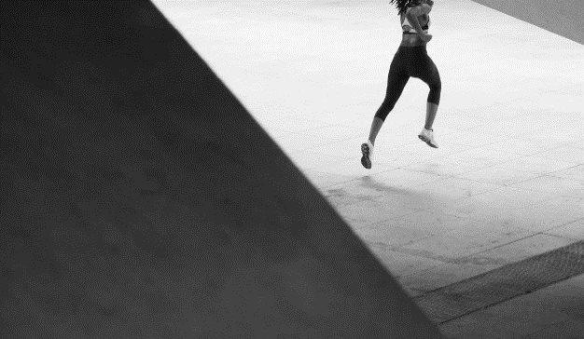
Picture Caption: To make your document look professionally produced, Word provides header, footer, cover page, and text box designs that complement each other.
Tonnie Thomsen

The latest breaking news
The latest updates to get you through the day
Save time in Word with new buttons that show up where you need them. To change the way a picture fits in your document, click it and a button for layout options appears next to it.  When you work on a table, click where you want to add a row or a column, and then click the plus sign.  Video provides a powerful way to help you prove your point. When you click |  | Online Video, you can paste in the embed code for the video you want to add. You can also type a keyword to search online for the video that best fits your document.  Themes and styles also help keep your document coordinated. When you click Design and choose a new Theme, the pictures, charts, and SmartArt graphics change to match your new theme.
 |  |  |  |  |  | Picture Caption: To make your document look professionally produced, Word provides header, footer, cover page, and text box designs that complement each other.
 |  |  |  | Page 2

Tuesday Sep 20, 20XX | NEWS TODAY |  |  |  |  |  | Issue #10
Mohan Narang  The scoop of the day  The latest updates  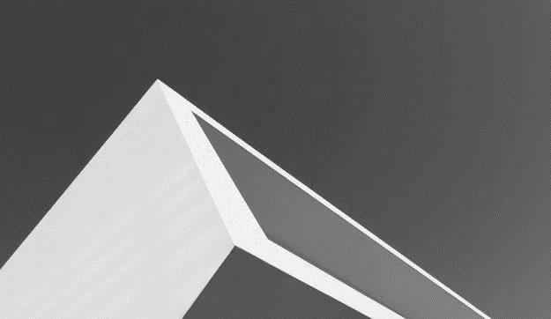 |  | To change the way a picture fits in your document, click it and a button for layout options appears next to it.  Themes and styles also help keep your document coordinated. When you click Design and choose a new Theme, the pictures, charts, and SmartArt graphics change to match your new theme. When you apply styles, your headings change to match the new theme.  Save time in Word with new buttons that show up where you need them. To change the way a picture fits in your document, click it and a button for layout options appears next to it.  When you work on a table, click where you want to add a row or a column, and then click the plus sign. Reading is easier, too, in the new Reading view. You can collapse parts of the document and focus on the text you want.  To change the way a picture fits in your document, click it and a button for layout options appears next to it. |  |  |  | Srecko Posavec  The scoop of the day  The latest updates  Themes and styles also help keep your document coordinated. When you click Design and choose a new Theme, the pictures, charts, and SmartArt graphics change to match your new theme. When you apply styles, your headings change to match the new theme.  To change the way a picture fits in your document, click it and a button for layout options appears next to it.  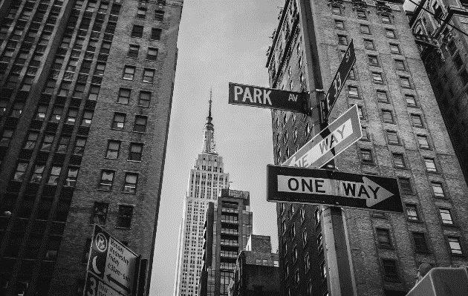
Picture Caption: To make your document look professionally produced, Word provides header, footer, cover page, and text box designs that complement each other.
To make your document look professionally produced, Word provides header, footer, cover page, and text box designs that complement each other. For example, you can add a matching cover page, header, and sidebar.
Click Insert and then choose the elements you want from the different galleries. Save time in Word with new buttons that show up where you need them.
 |  |  |  |  |  | Picture Caption: To make your document look professionally produced, Word provides header, footer, cover page, and text box designs that complement each other.
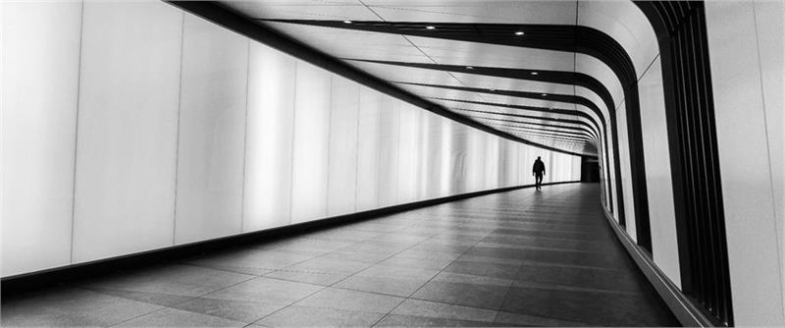
Picture Caption: To make your document look professionally produced, Word provides header, footer, cover page, and text box designs that complement each other.
Vanja Jovanovic

The latest breaking news of the day
The latest updates to get you through the day
To make your document look professionally produced, Word provides header, footer, cover page, and text box designs that complement each other. For example, you can add a matching cover page, header, and sidebar. Click Insert and then choose the elements you want from the different galleries.  Save time in Word with new buttons that show up where you need them.To change the way a picture fits in your document, click it and a button for layout options appears next to it. Themes and styles also help keep your document coordinated. When you click Design and choose a new Theme, the pictures, |  |  |  | charts, and SmartArt graphics change to match your new theme. When you apply styles, your headings change to match the new theme.  Save time in Word with new buttons that show up where you need them. To change the way a picture fits in your document, click it and a button for layout options appears next to it. When you work on a table, click where you want to add a row or a column, and then click the plus sign. Reading is easier, too, in the new Reading view. You can collapse parts of the document and focus on the text you want.
 |  |  | Page 3

Tuesday Sep 20, 20XX |  | NEWS TODAY |  |  |  |  |  | Issue #10
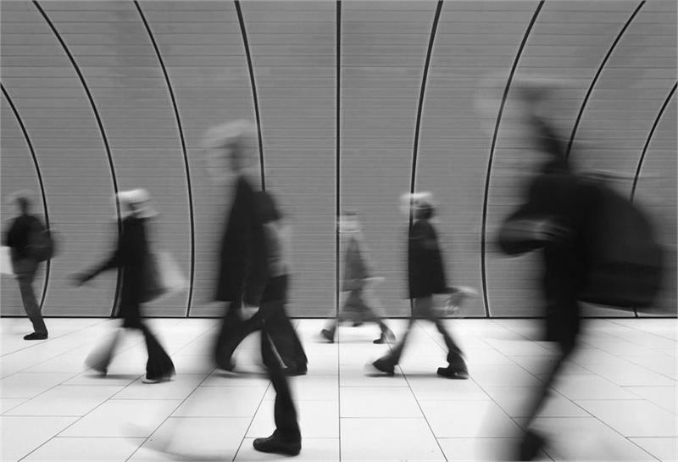
Picture Caption: To make your document look professionally produced, Word provides header, footer, cover page, and text box designs that complement each other.
The latest breaking news of the day
The latest updates to get you through the day
  Takuma Hayashi | Video provides a powerful way to help you prove your point. When you click Online Video, you can paste in the embed code for the video you want to add. You can also type a keyword to search online for the video that best fits your document. |  |  |  | Save time in Word with new buttons that show up where you need them. To change the way a picture fits in your document, click it and a button for layout options appears next to it. When you work on a table, click where you want to add a row or a column, and then click the plus sign. Reading is easier, too, in the new Reading view. You can collapse parts of the document and focus on the text you want.
To make your document look professionally produced, Word provides header, footer, cover page, and text box designs that complement each other. For example, you can add a matching cover page, header, and sidebar. Click Insert and then choose the elements you want from the different galleries.  Themes and styles also help keep your document coordinated. When you click Design and choose a new Theme, the pictures, charts, and SmartArt graphics change to match your new theme. When you apply styles, your headings change to match the new theme. Save time in Word with new buttons that show up where you need them.  To change the way a picture fits in your document, click it and a button for layout options appears next to it. When you work on a table, click where you want to add a row or a column, and then click the plus sign. Reading is easier, too, in the new Reading view. You can collapse parts of the document and focus on the text you want.  To make your document look professionally produced, Word provides header, footer, cover page, and text box designs that complement each other. For example, you can add a matching cover page, header, and sidebar. |  |  |  |  | “Video provides a powerful way to help you prove your point.”  - Takuma Hayashi
Video provides a powerful way to help you prove your point. When you click Online Video, you can paste in the embed code for the video you want to add. You can also type a keyword to search online for the video that best fits your document. To make your document look professionally produced, Word provides header, footer, cover page, and text box designs that complement each other. For example, you can add a matching cover page, header, and sidebar.
Click Insert and then choose the elements you want from the different galleries. Themes and styles also help keep your document coordinated. When you click Design and choose a new Theme, the pictures, charts, and SmartArt graphics change to match your new theme.
 |  |  |  | Page 4

