
LAWN AND LANDSCAPE  Take your weekends back. Summer is here!  Let us do the dirty work so you can enjoy it |  |  |  | August | 20XX | Issue #10
In this issue
News from the garden
Add description text here to get your subscribers interested in your topic.
Tony’s landscapes and more
Add description text here to get your subscribers interested in your topic.
Design, construct, and maintain
Add description text here to get your subscribers interested in your topic
News from the garden  By Robin Zupanc |  | Newsletters are periodicals used to advertise or update your subscribers with information about your product or blog. They can be printed or emailed and are an excellent way to maintain regular contact with your subscribers and drive traffic to your site. Type the content of your newsletter here.  Newsletters are periodicals used to advertise or update your subscribers with information about your product or blog. They can be printed or emailed and are an excellent way to maintain regular contact with your subscribers and drive traffic to your site. Type the content of your newsletter here.  Newsletters are periodicals used to advertise or update your subscribers with information about your product or blog. They can be printed or emailed and are an excellent way to maintain regular contact with your subscribers and drive traffic to your site. Type the content of your newsletter here.


 |  | LAWN AND LANDSCAPE
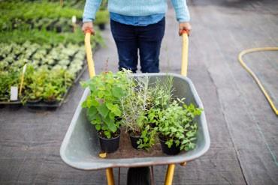  Ideas for growing your summer garden  By Peyton Davis  Newsletters are periodicals used to advertise or update your subscribers with information about your product or blog. They can be printed or emailed and are an excellent way to maintain regular contact with your subscribers and drive traffic to your site. Type the content of your newsletter here.  Newsletters are periodicals used to advertise or update your subscribers with information about your product or blog. Type the content of your newsletter here.  Newsletters are periodicals used to advertise or update your subscribers with information about your product or blog. They can be printed or emailed and are an excellent way to maintain regular contact with your subscribers and drive traffic to your site. Type the content of your newsletter here.  Newsletters are periodicals used to advertise or update your subscribers with information about your product or blog. They can be printed or emailed and are an excellent way to maintain regular contact with your subscribers and drive traffic to your site. Type the content of your newsletter here.  Newsletters are periodicals used to advertise or update your subscribers. |  | Tony’s landscapes and more  By Gerd Simonsen
Newsletters are periodicals used to advertise or update your subscribers with information about your product or blog. They can be printed or emailed and are an excellent way to maintain regular contact with your subscribers and drive traffic to your site. Type the content of your newsletter here.
Newsletters are periodicals used to advertise or update your subscribers with information about your product or blog. Type the content of your newsletter here.
Newsletters are periodicals used to advertise or update your subscribers with information about your product or blog. They can be printed or emailed and are an excellent way to maintain regular contact with your subscribers and drive traffic to your site. Type the content of your newsletter here.
Newsletters are periodicals used to advertise or update your subscribers with information about your product or blog.

