  - INTERIOR
DESIGN
EXPO

Twine + Burlap
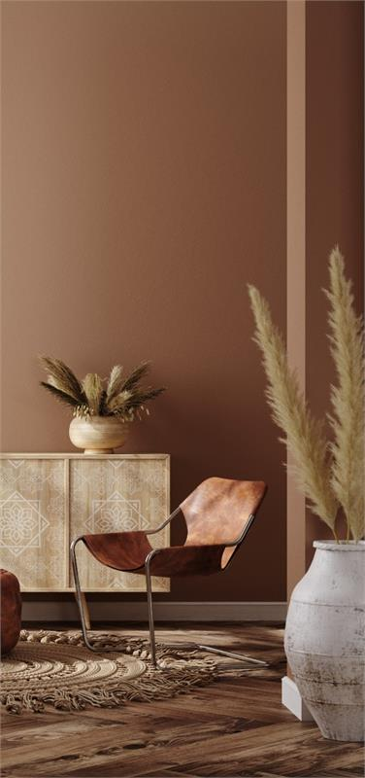 | Discover the art of interior design at the Twine & Burlap Interior Design Expo.  Join us for a captivating showcase of home decor trends, expert tips, and exclusive deals. Get inspired and transform your living spaces. Save the date and get ready to elevate your home.
 | - DAY ONE  Color Exploration |  | - DAY TWO  Texture & Materials
 | - DAY THREE  Lighting Aesthetics |  | - DAY FOUR  Furniture & Space
 | (901) 555-0189 |  | tandb@example.com

