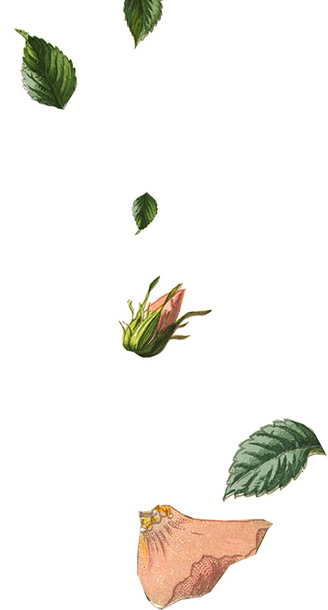


Please join
  - Flora Persson
For their Bridal Shower!

Please join
  - Flora Persson
For their Bridal Shower!







DATE: [Date]
TIME: [Time]
LOCATION: [Location]

Registered at: [Store Name]

RSVP by [Click to select date] to

[Name] at [phone]
DATE: [Date]
TIME: [Time]
LOCATION: [Location]

Registered at: [Store Name]

RSVP by [Click to select date] to

[Name] at [phone]

