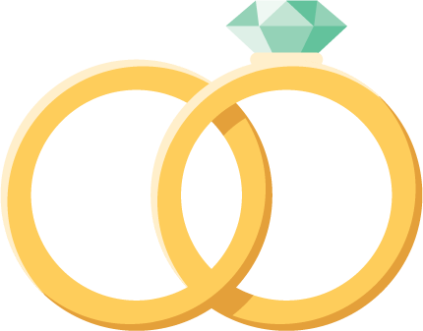 |   To the happy couple!
 |   To the happy couple!

To get started right away, just tap any placeholder text (such as this) and start typing to replace it with your own or delete for a blank card.
To get started right away, just tap any placeholder text (such as this) and start typing to replace it with your own or delete for a blank card.

