

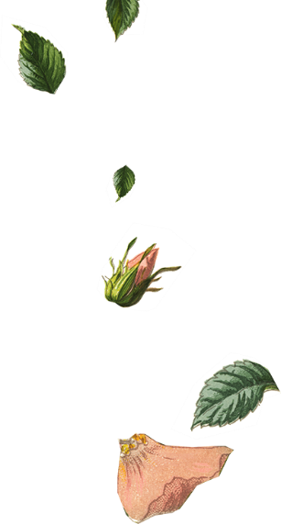




  - You are invited to join

Flora Persson

Kalle Astrom

&

on our wedding day
  - You are invited to join

Flora Persson

Kalle Astrom

&

on our wedding day

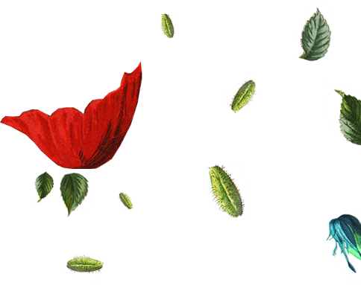
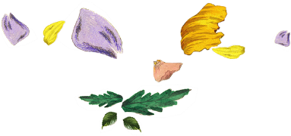


Mr. & Mrs. Flora Persson
Request the honor of Your Presence
At the marriage of their daughter

Flora Persson
To

Kalle Astrom
Son of
Mr. & Mrs. Kalle Astrom

Saturday the Twenty-First of June

Two thousand and [Year]

Eleven O’clock in the morning

At Location City, State.

Reception to Follow
Mr. & Mrs. Flora Persson
Request the honor of Your Presence
At the marriage of their daughter

Flora Persson
To

Kalle Astrom
Son of
Mr. & Mrs. Kalle Astrom

Saturday the Twenty-First of June

Two thousand and [Year]

Eleven O’clock in the morning

At Location City, State.

Reception to Follow

