

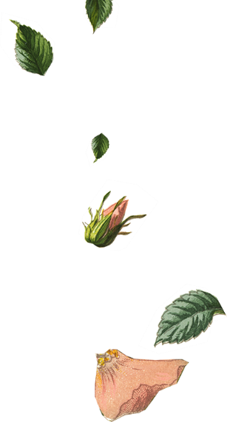



  - You are invited to join

Robin Zupanc

Peyton Davis

&

on our wedding day
  - You are invited to join

Robin Zupanc

Peyton Davis

&

on our wedding day





Mr. & Mrs. Robin Zupanc
Request the honor of Your Presence
At the marriage of

Robin Zupanc
To

Peyton Davis
Child of
Mr. & Mrs. Peyton Davis

Saturday the Twenty-First of June

Two thousand and [Year]

Eleven O’clock in the morning

At Location City, State.

Reception to Follow
Mr. & Mrs. Robin Zupanc
Request the honor of Your Presence
At the marriage of

Robin Zupanc
To

Peyton Davis
Child of
Mr. & Mrs. Peyton Davis

Saturday the Twenty-First of June

Two thousand and [Year]

Eleven O’clock in the morning

At Location City, State.

Reception to Follow

