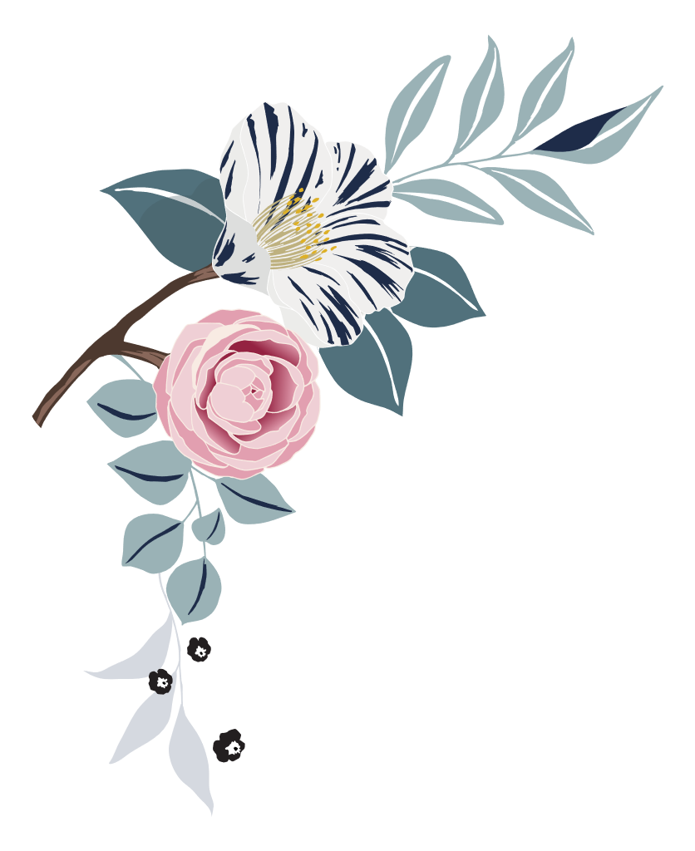

Wedding

photo checklist

Pre-ceremony

bride
☐ | Bride hairstyling | ☐ | Zip or buttoning of wedding gown
☐ | Bride makeup application | ☐ | Bride putting on veil
☐ | Wedding dress (hanging, draped) | ☐ | Bride looking in mirror
☐ | Something old/new/borrowed/blue | ☐ | Bride with bouquet
☐ | Wedding shoes, jewelry, veil displayed | ☐ | Click or tap here to enter text.

Wedding party
☐ | Bridesmaids’ hair and makeup | ☐ | Flower girls or junior bridesmaids with bride
☐ | Bride and bridesmaids pre-wedding outfits | ☐ | Bridesmaids with bouquets
☐ | Bride with Maid of Honor | ☐ | Flower girls with flower baskets
☐ | Candid photos of bridesmaids dressing | ☐ | Candid photos of wedding party leaving for ceremony

Bride’s family
☐ | Bride with mother | ☐ | Bride pinning mother’s corsage
☐ | Mother of bride adjusting veil | ☐ | Bride pinning father’s boutonniere
☐ | Bride with father | ☐ | Candid photos of bride’s family leaving for ceremony

Groom
☐ | Groom tying tie | ☐ | Groom with father
☐ | Groom putting on boutonniere | ☐ | Groom with groomsmen
☐ | Groom looking in mirror | ☐ | Groom with ring bearer
☐ | Groom with best man | ☐ | Groomsmen putting on boutonnieres
☐ | Groom with mother | ☐ | Candid photos of groom and groomsmen leaving for ceremony

at the ceremony

☐ | Church/venue exterior | ☐ | Groom’s first sight of bride
☐ | Church/venue interior (empty) | ☐ | Bride and escort entering
☐ | Officiant with groom | ☐ | Bride and escort from rear of venue
☐ | Guests arriving | ☐ | Bride “given away”
☐ | Bride arriving | ☐ | Musical performances and special readings
☐ | Groom arriving | ☐ | Unity ceremonies or memorials

☐ | Musicians and soloists | ☐ | Communion, eucharist, or other religious ceremonies
☐ | Seating of grandparents | ☐ | Exchange of vows
☐ | Seating of parents | ☐ | Exchange of rings
☐ | Groom and officiant entering | ☐ | Candid photos of children in wedding party
☐ | Entrance of children | ☐ | The kiss
☐ | Entrance of wedding party | ☐ | Introduction and applause
☐ | Guests standing for bride | ☐ | Recessional
☐ | Bride and escort framed in doorway | ☐ | Wedding couple with attendants after ceremony

Formal photos

☐ | Wedding musician’s close-up | ☐ | Groom alone
☐ | Invitation close-up | ☐ | Wedding couple together
☐ | Altar or chuppah | ☐ | Wedding couple with officiant
☐ | Bride alone | ☐ | Rings close-up

Family photos
☐ | Bride with bride’s family | ☐ | Wedding couple with bride’s parents
☐ | Bride with groom’s family | ☐ | Bride with bride’s grandparents
☐ | Groom with bride’s family | ☐ | Wedding couple with bride’s grandparents

☐ | Groom with groom’s family | ☐ | Groom with groom’s parents
☐ | Wedding couple with bride’s family | ☐ | Groom with mother
☐ | Wedding couple with groom’s family | ☐ | Groom with father
☐ | Wedding couple with both families | ☐ | Groom with groom’s grandparents
☐ | Bride with bride’s parents | ☐ | Wedding couple with groom’s parents
☐ | Bride with mother | ☐ | Wedding couple with groom’s grandparents
☐ | Bride with father | ☐ | Couple with siblings

Attendants
☐ | Bride with maid of honor | ☐ | Groom with groomsmen
☐ | Groom with best man | ☐ | Wedding couple with groomsmen
☐ | Bride with wedding attendants | ☐ | Bride with child attendants
☐ | Groom with wedding attendants | ☐ | Groom with child attendants
☐ | Wedding couple with wedding attendants | ☐ | Wedding couple with child attendants
☐ | Bride with groomsmen | ☐ | Lorem ipsum dolor sit amet

Reception photos

☐ | Exterior of reception venue (empty) | ☐ | Groom’s dance with mother
☐ | Interior of reception venue (empty) | ☐ | Parents dancing

☐ | Arrival at reception venue | ☐ | Grandparents dancing
☐ | Wedding cake | ☐ | Guests dancing
☐ | Bar setup | ☐ | Wedding couple greeting guests
☐ | Groom’s cake | ☐ | Cake cutting
☐ | Buffet and servers | ☐ | Cake feeding
☐ | Band or DJ | ☐ | Speeches/toasts
☐ | Gift table | ☐ | Bride tossing bouquet
☐ | Centerpieces | ☐ | Groom removing garter
☐ | Floral arrangements | ☐ | Groom throwing garter
☐ | Favors | ☐ | Bouquet and garter catchers dancing
☐ | Entrance of wedding party | ☐ | Bride and groom’s last dance
☐ | Entrance of wedding couple | ☐ | Decorated “just married” car
☐ | Bride and groom’s first dance | ☐ | Wedding couple exiting venue
☐ | Bride’s dance with father | ☐ | Guests at exit (throwing birdseed, blowing bubbles, etc.)
☐ | Centerpieces | ☐ | Wedding couple in car waving goodbye

