 | Menu
To update images, single click with the left mouse until they are selected. Do a right mouse click and choose Change Picture from the shortcut menu.
Appetizer |  | 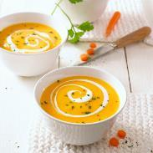

Describe your Appetizer.
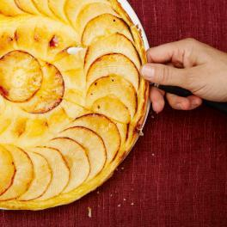 |  | Main Course
 |  | Describe your Main Course, and don’t hold back
Dessert |  | 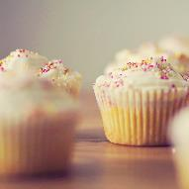

Describe your Dessert and
don’t hold back

