**Coffee Shop Sales Dashboard Analysis**

**Executive Summary**

---------------

This report details the development and analysis of an interactive sales analytics dashboard for a coffee shop chain. The implementation transforms complex sales data into actionable insights through innovative visualization techniques and comprehensive data analysis.

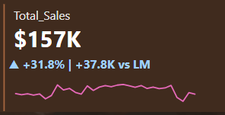

**Technical Implementation**

**----------------------**

**Dashboard Architecture**

**---------------------**

The dashboard incorporates real-time tracking of essential performance metrics, providing immediate visibility into business operations. The core KPIs demonstrate remarkable growth:

- Total Sales reached $166K (31.8% month-over-month increase)

- Order volume hit 35,352 (32.3% growth)

- Quantity sold reached 50,942 units (32.3% improvement)

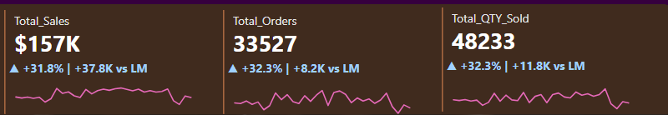

**Interactive Features Development**

**------------------------------**

**Calendar Visualization**

**--------------------**

The dashboard features a sophisticated calendar heat map implementation that provides intuitive sales volume visualization. The heat map employs dynamic color coding where darker shades represent higher sales volumes, allowing quick identification of peak sales days.

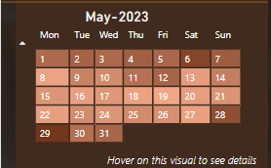

***Key Features:***

- Dynamic month selection via dropdown

- Color-intensity mapping to sales volume

- Interactive tooltips displaying daily metrics

- Seamless integration with filtering system

## Custom Tooltip Implementation

## Calendar Chart Tooltip

The dashboard implements two specialized interactive tooltips that enhance data exploration:

When hovering over the calendar visualization, users see a comprehensive tooltip displaying:

* Date: May 26, 2023
* Total Sales: $5,301
* Total Orders: 1,089
* Total Quantity Sold: 1,661
* Growth Metrics: +27.4% | +28.7K vs LM

The tooltip includes a circular visual representation divided into three segments:

* Sales (blue)
* Orders (navy)
* QTY (orange)

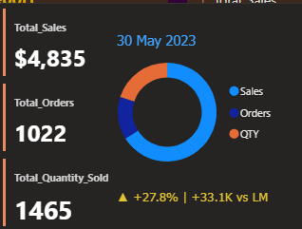

## Heat Map Tooltip

The hourly sales heat map tooltip provides detailed time-based metrics:

* Day and Hour: Friday, Hour No: 11
* Total Sales: $1,290
* Total Orders: 290
* Total Quantity Sold: 395
* Performance Indicator: +21.1% | +1.6K vs LM

This tooltip also features the same tri-segmented circular visualization showing the distribution between Sales, Orders, and QTY metrics.

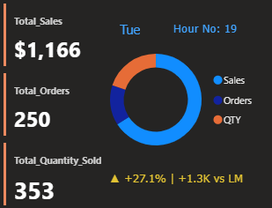

**Sales Distribution Analysis**

**-------------------------**

The weekend vs. weekday analysis reveals crucial patterns in customer behavior:

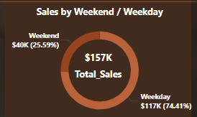

- Weekend Revenue: $157K (45.18% of total)

- Weekday Revenue: 54.82% of total

- Pattern indicates strong weekend customer base

**Location Performance Tracking**

**---------------------------**

The multi-location analysis system tracks performance across all store locations:

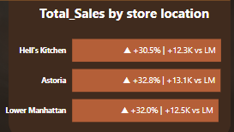

Performance Highlights:

- Mall Kitchen: Leading growth at +30.5% MoM

- Atlantic: Strong performance with +32.2% growth

- Lower Manhattan: Consistent growth at +32.0%

**Product Category&Type Analysis**

**------------------------**

The product category tracking system reveals valuable insights into consumer preferences:

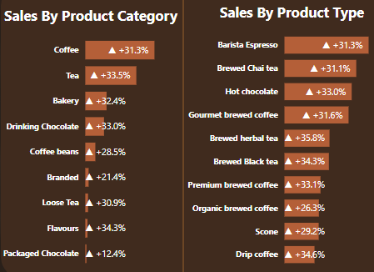

Top Performers:

1. Coffee: Dominant with +33.6% growth

2. Brewed Chai Tea: Strong showing at +33.1%

3. Hot Chocolate: Impressive +33.0% increase

**Temporal Analysis Implementation**

**------------------------------**

The system tracks sales patterns throughout operating hours:

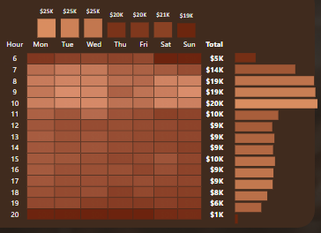

***Key Findings:***

- Primary Peak: 8AM-11AM

- Secondary Peak: 2PM-4PM

- Distinct weekend patterns identified

**Future Enhancements**

**-------------------------**

1. Advanced Analytics Integration

- Predictive sales modeling

- Customer segmentation

- Inventory optimization

2. Enhanced Visualization Features

- Custom reporting templates

- Advanced filtering options

- Mobile-optimized interfaces

**Implementation Impact**

**--------------------**

The dashboard implementation has demonstrated significant value:

- Enabled data-driven decision making

- Improved operational efficiency

- Enhanced performance monitoring capabilities

- Facilitated strategic planning

**Conclusion**

**----------**

This dashboard implementation represents a sophisticated solution for business intelligence in the retail coffee sector. The consistent growth across all metrics validates both the technical implementation and business strategies while highlighting opportunities for continued optimization.

