**Name: Parth Das  
Sap: 60004220185 Roll No: C-111  
Subject: DEVOPS**

## Topic: Case Study on Devops with Agile integration Introduction

DevOps is a set of practices that combines software development (Dev) and IT operations (Ops) to enhance collaboration, streamline workflows, and improve the efficiency of software delivery. By fostering a culture of continuous integration and deployment, DevOps aims to minimize development cycles and enhance software quality. This case study explores DevOps, its lifecycle, and its synergy with Agile methodologies.

**1. Understanding DevOps**

DevOps is a methodology that bridges the gap between development and operations teams by promoting automation, monitoring, and collaboration. The primary goals of DevOps include faster deployment, improved collaboration, automation, and ensuring scalability and reliability of applications.

**Key Practices of DevOps**

1. **Continuous Integration (CI)**: Developers integrate code into a shared repository multiple times a day, allowing automated testing to detect bugs early in the development cycle. This practice ensures that code changes do not introduce new issues and maintain software stability.
2. **Continuous Deployment (CD)**: Once the code is tested and verified, it is automatically deployed into production. CD ensures that new features and updates reach users quickly, reducing time-to-market and enhancing user experience.
3. **Microservices Architecture**: In traditional monolithic architectures, applications are developed as a single entity, making updates and scalability challenging. DevOps promotes a microservices approach where applications are divided into small, independent services that communicate with each other via APIs. This enhances maintainability and allows teams to work on different services independently.
4. **Infrastructure as Code (IaC)**: Instead of manually configuring servers and infrastructure, IaC enables the use of code to manage and provision infrastructure resources. Tools like Terraform and Ansible help maintain consistency across environments, reduce human errors, and simplify scalability.
5. **Monitoring and Logging**: Monitoring tools like Prometheus, ELK Stack, and Grafana collect real-time application performance data, helping teams identify issues before they impact users. Logging mechanisms provide insights into application behavior and assist in debugging errors efficiently.

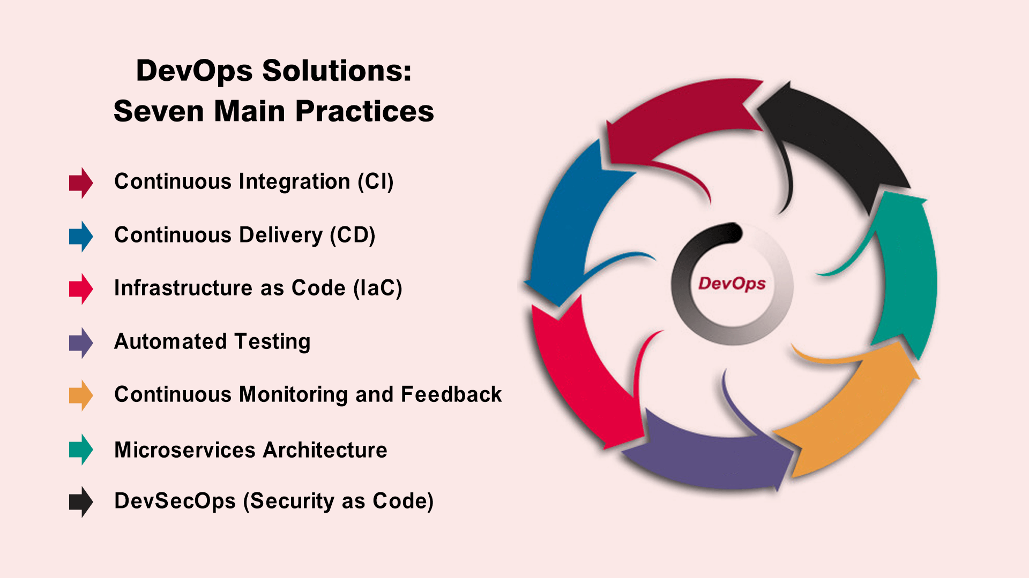

**2. DevOps Life Cycle**

The DevOps lifecycle consists of multiple stages, ensuring seamless software development and deployment through iterative and automated processes.

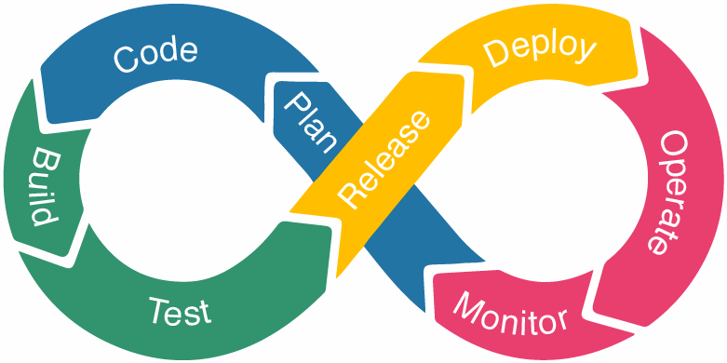

1. **Plan**: This phase involves gathering requirements, defining objectives, and creating a roadmap. Teams use Agile methodologies and project management tools like JIRA and Confluence to outline user stories and milestones.
2. **Code**: Developers write, review, and merge code into a shared repository using version control systems like Git. Collaboration and code quality are ensured through practices like code reviews and pair programming.
3. **Build**: Source code is compiled, dependencies are resolved, and executable artifacts are generated. Automated build tools such as Maven, Gradle, or Jenkins streamline this process and ensure consistency across builds.
4. **Test**: Automated testing frameworks like Selenium, JUnit, and PyTest validate the functionality, security, and performance of applications. Testing in DevOps is continuous, ensuring quick detection and resolution of defects.
5. **Release**: Once the code passes all tests, it moves to the release phase, where it is packaged and deployed into a staging environment for final verification. Release management tools facilitate this process, reducing manual interventions and risks.
6. **Deploy**: Deployment automation ensures that applications are rolled out to production environments with minimal downtime. Tools like Kubernetes, Docker, and AWS Lambda handle deployments across cloud and on-premise infrastructure.
7. **Operate**: Post-deployment, applications are monitored for performance, availability, and security. Automated scaling, incident response mechanisms, and infrastructure health checks help maintain stability.
8. **Monitor**: Continuous monitoring and feedback loops allow teams to detect issues proactively and optimize performance. Real-time alerts and logging tools provide insights to improve system reliability.

**3. DevOps with Agile Methodology**

Agile and DevOps work together to enhance software development speed, quality, and responsiveness. While Agile focuses on iterative development with frequent feedback loops, DevOps ensures that software changes are quickly and reliably deployed.

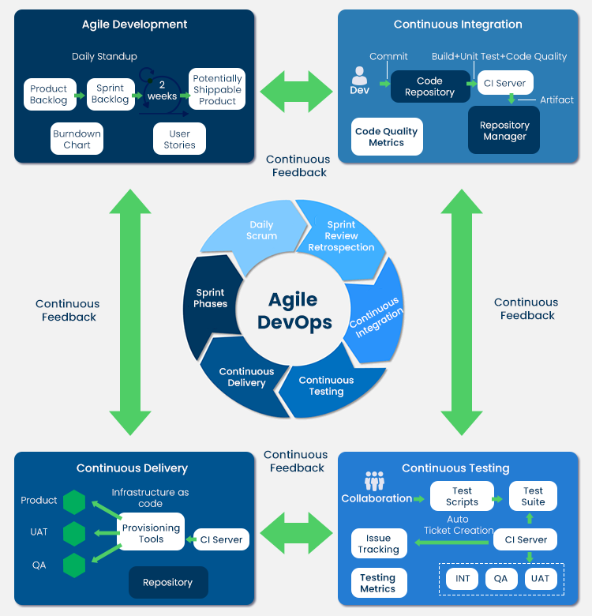

**How DevOps Enhances Agile**

* **Automated Testing**: Agile teams require rapid iterations, and DevOps enables automated testing, reducing the time required for manual testing.
* **Faster Releases**: Agile methodologies emphasize delivering small, incremental updates. DevOps CI/CD pipelines support this by automating code integration, testing, and deployment.
* **Better Collaboration**: Agile fosters teamwork among developers, and DevOps extends this collaboration to operations and security teams, ensuring holistic software development and deployment.
* **Scalability & Flexibility**: Agile teams need the ability to scale projects dynamically. DevOps tools, such as Kubernetes for container orchestration and Terraform for infrastructure management, provide the necessary flexibility to accommodate changing requirements.

**Key Tools Integrating DevOps & Agile**

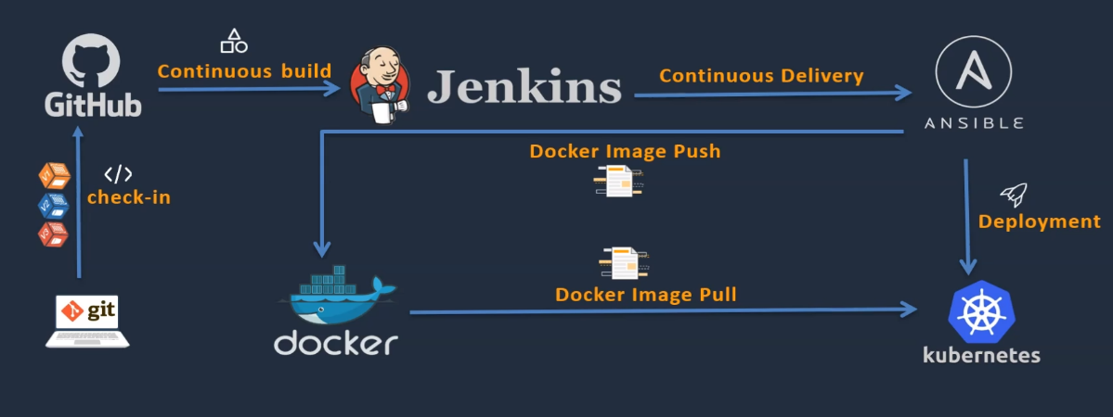

* **Jenkins & GitHub Actions**: Automate CI/CD pipelines, reducing deployment time and human intervention.
* **Docker & Kubernetes**: Enable containerization and orchestration, ensuring applications run consistently across different environments.
* **Ansible & Terraform**: Provide infrastructure automation, allowing Agile teams to spin up, configure, and manage cloud resources efficiently.
* **JIRA & Confluence**: Support Agile project management, enabling teams to track progress, document requirements, and improve collaboration.

**Conclusion**

DevOps has transformed software development by fostering collaboration, automation, and continuous delivery. Its lifecycle ensures a streamlined approach to building, testing, deploying, and maintaining applications efficiently. By integrating DevOps with Agile methodologies, organizations can achieve faster development cycles, improved software quality, and increased adaptability to market demands.

Businesses that adopt DevOps gain a competitive advantage by reducing deployment risks, minimizing downtime, and enhancing user satisfaction. As technology evolves, the adoption of DevOps will continue to grow, making it an essential practice for modern software development teams.