**Name: Parth Das**

**Sap: 60004220185  
Roll No: C-111**

**Subject: DEVOPS**

**Topic: Version Control- Git & Github**

# Version Control, Git, and GitHub

## ****Version Control****

### What is Version Control?

Version Control is a system that tracks changes in files over time, allowing multiple developers to work on a project without conflicts.

### ****Why Use Version Control?****

* **Track Changes**: See what was modified, when, and by whom.
* **Collaboration**: Multiple developers can work on the same project simultaneously.
* **Backup & Recovery**: Restore previous versions if needed.
* **Branching & Merging**: Experiment with new features without affecting the main project.

### ****Types of Version Control Systems (VCS)****

#### **Local Version Control**

* Stores changes **locally** on a developer’s machine.
* Simple but **not good for collaboration**.
* Example: Manual file copying, RCS (Revision Control System).

#### **Centralized Version Control (CVCS)**

* Uses a **central server** to store all changes.
* Developers pull from and push changes to this server.
* **Issues**: If the server goes down, you lose access to the project.
* Example: SVN (Apache Subversion), Perforce, CVS.

#### **Distributed Version Control (DVCS) - Git**

* **Each developer has a complete copy** of the repository.
* No reliance on a single server.
* Faster and more resilient.
* Example: **Git, Mercurial**.

## ****Git****

### What is Git?

Git is a **distributed version control system (DVCS)** used to track changes in source code during software development.

### ****Why Use Git?****

* **Fast & Efficient**: Handles large projects efficiently.
* **Distributed**: Every developer has a full copy of the repo.
* **Branching & Merging**: Work on features independently.
* **Open-source**: Free to use!

## ****Installing Git****

### ****Windows****

1. Download **Git for Windows** from [git-scm.com](https://git-scm.com/download/win).
2. Install it with default settings.
3. Verify installation:
4. git --version

### ****Linux (Debian/Ubuntu)****

sudo apt update

sudo apt install git

git --version

### ****Linux (Fedora)****

sudo dnf install git

git --version

### ****macOS****

brew install git # Using Homebrew

git --version

## ****GitHub****

### ****What is GitHub?****

GitHub is a **cloud-based platform** that allows developers to manage, store, and collaborate on code repositories using Git. It is widely used for **version control, collaboration, and DevOps workflows**.

**1. What is GitHub?**

GitHub is a **hosting service for Git repositories** that provides additional features like:  
✅ **Collaboration** – Multiple developers can work on the same project.  
✅ **Issue Tracking** – Manage bugs, tasks, and feature requests.  
✅ **Pull Requests** – Review and discuss changes before merging.  
✅ **Actions & Automation** – Automate workflows like CI/CD.  
✅ **Security Features** – Code scanning, dependency management, and access controls.

**2. Key Features of GitHub**

**🔹 GitHub Repositories**

* A **repository (repo)** is where all your project’s files and version history are stored.
* You can have **public** (open-source) or **private** repositories.

**🔹 Branching & Merging**

* Create **branches** to work on new features without affecting the main code.
* Use **pull requests (PRs)** to merge changes and get code reviews.

**🔹 GitHub Issues & Discussions**

* **Issues** are used for bug tracking and feature requests.
* **Discussions** allow teams to communicate within GitHub.

**🔹 GitHub Actions (CI/CD)**

* Automate testing, deployment, and integration using YAML-based workflows.

**🔹 GitHub Pages**

* Host **static websites** directly from a GitHub repository.

**3. Installing & Setting Up GitHub**

**✅ Creating a GitHub Account**

1. Go to [GitHub.com](https://github.com/).
2. Click **Sign Up** and enter your details.
3. Verify your email and complete your profile setup.

**✅ Installing GitHub Desktop (GUI)**

* Download from [GitHub Desktop](https://desktop.github.com/).
* Install and **sign in** using your GitHub credentials.
* Clone repositories, create branches, and push changes using a GUI.

**Fetching from my repo to local repo**

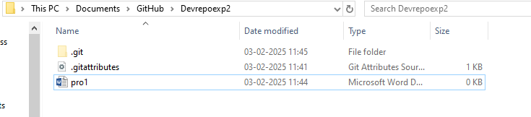

Fetching a .pdf file from my github repo to my local repo

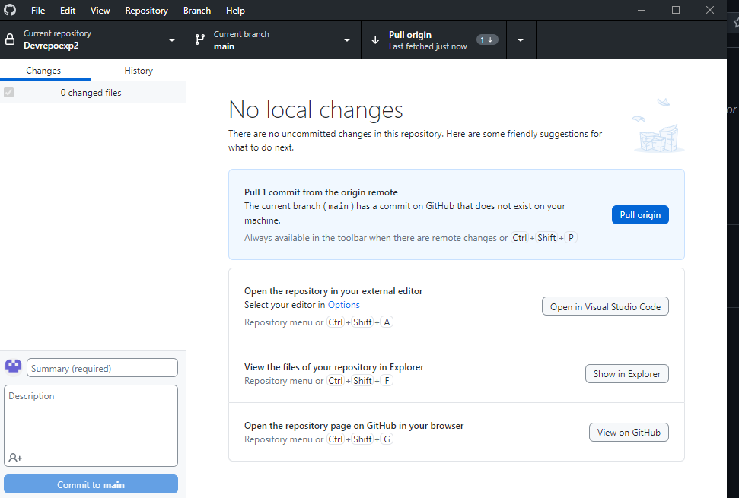

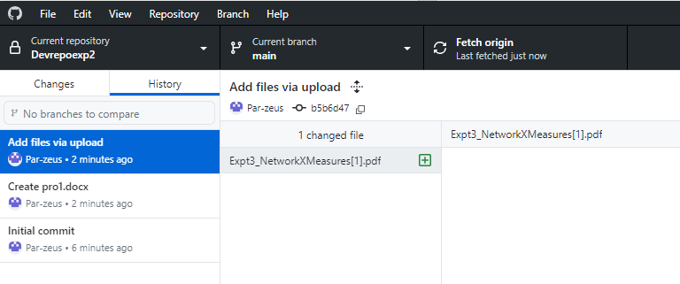

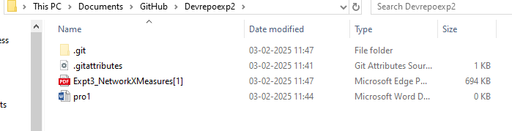

**Pushing the changes made in my local repo to my global github repo**

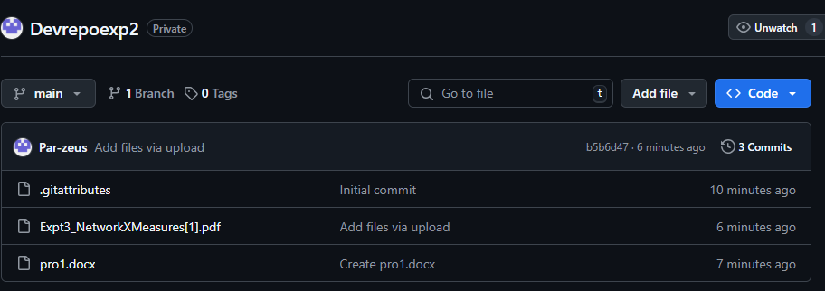

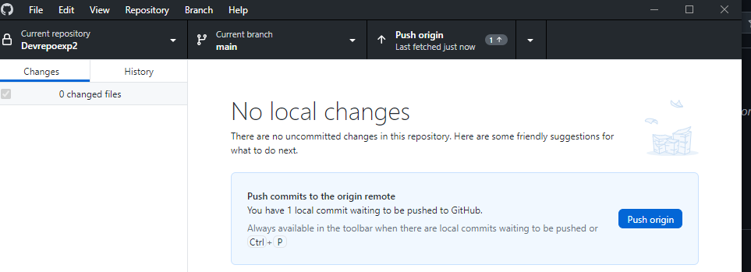

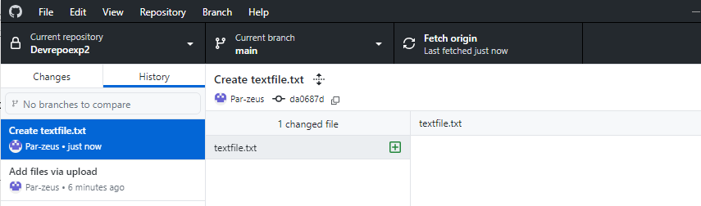

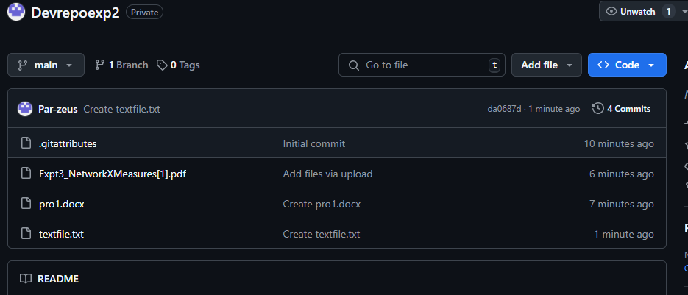

**Conclusion:-**

Git and GitHub are essential tools for modern software development. They enable efficient version control, collaboration, and code management. By mastering Git commands, setting up repositories, and following best practices, developers can streamline their workflow and ensure code integrity. Whether working solo or in a team, integrating Git and GitHub into the development process significantly enhances productivity and project organization.