**Department of Computer Engineering**

**Name of the Student: Parth Das Roll Number: C-111**

**SAP ID: 60004220185 Class: Comps Division: C-2 Batch: 2**

**Subject: Information Security**

**DATE OF PERFORMANCE: 15/02/2025 DATE OF SUBMISION: 16/02/2025**

**EXPERIMENT NO: 3**

**AIM:** Design and Implement Simple Columnar Transposition Cipher with Single Round & Multiple Round

**Theory:**

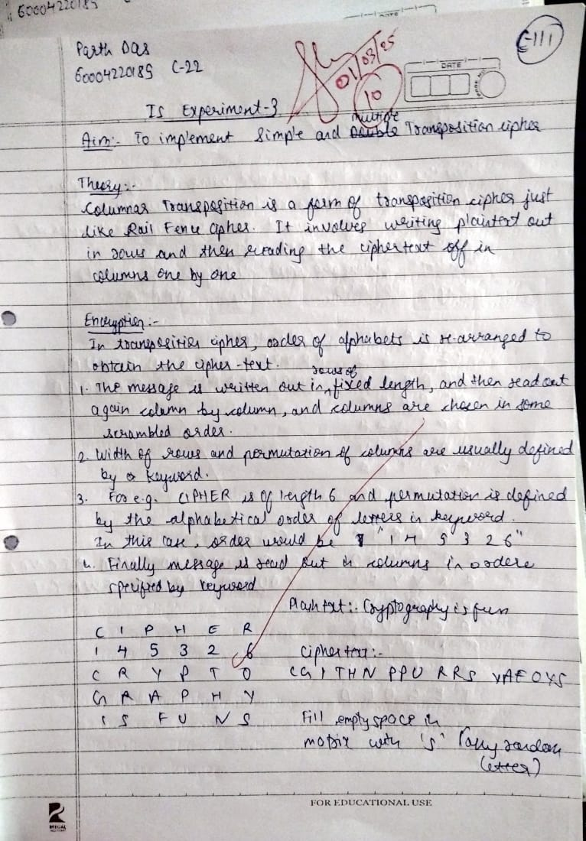

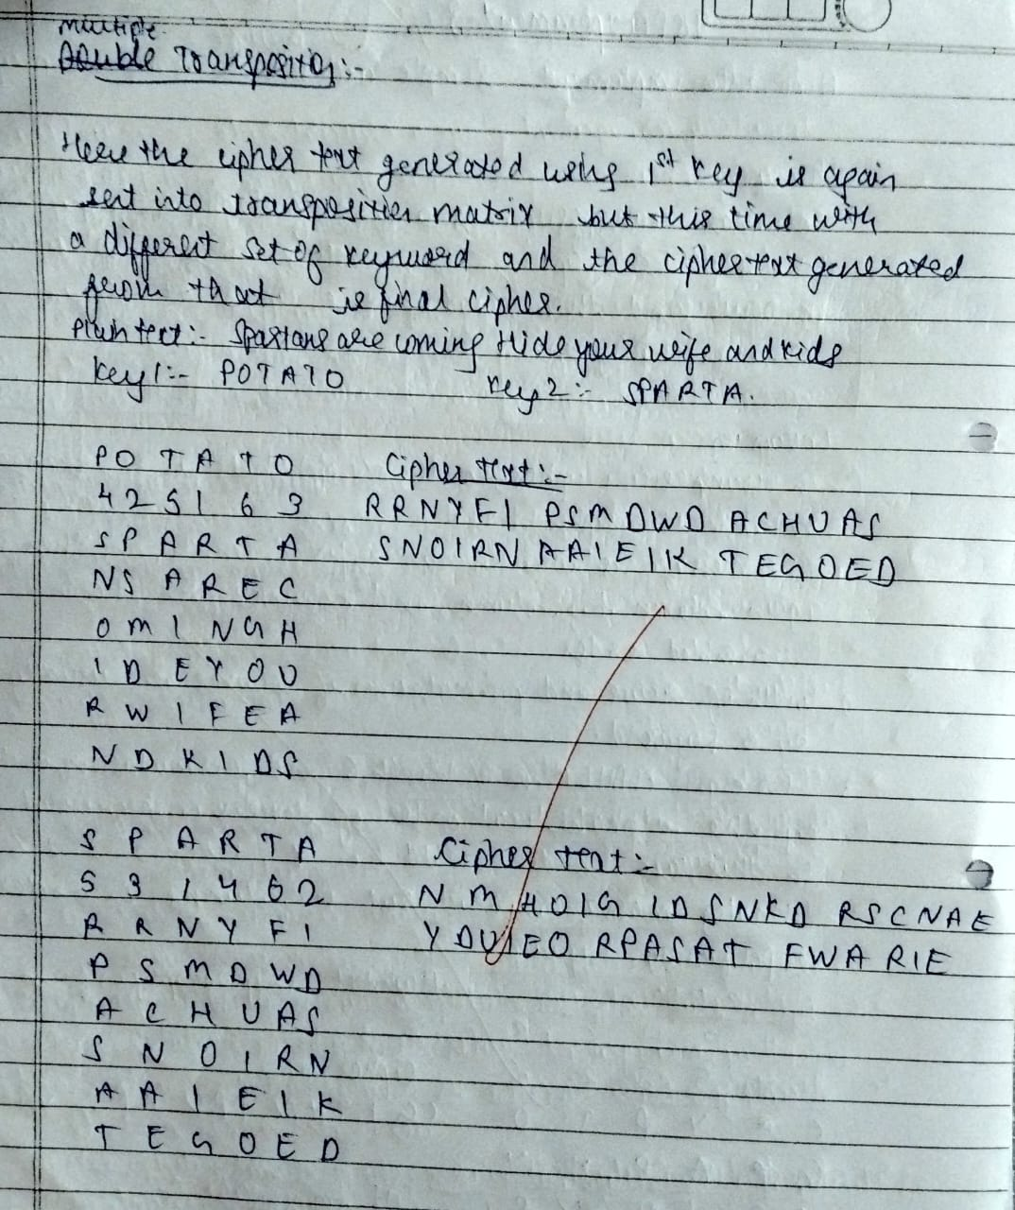

**SOURCE CODE WITH OUTPUTS:**

import math

MAX_KEY_LEN = 20

MAX_TEXT_LEN = 200

MAX_ROUNDS = 10

def generate_column_order(key, len_key):

sorted_key = sorted(key)

col_order = [-1] * len_key

index = 0

for i in range(len_key):

for j in range(len_key):

if key[j] == sorted_key[i] and col_order[j] == -1:

col_order[j] = index

index += 1

break

return col_order

def encrypt(key, plain_text):

len_key = len(key)

len_text = len(plain_text)

num_rows = math.ceil(len_text / len_key)

matrix = [['X'] * len_key for _ in range(num_rows)]

col_order = [-1] * len_key

index = 0

for i in range(num_rows):

for j in range(len_key):

if index < len_text:

matrix[i][j] = plain_text[index]

index += 1

col_order = generate_column_order(key, len_key)

cipher_text = []

index = 0

for i in range(len_key):

col = col_order.index(i)

for r in range(num_rows):

cipher_text.append(matrix[r][col])

return ''.join(cipher_text)

def decrypt(key, cipher_text):

len_key = len(key)

len_cipher = len(cipher_text)

num_rows = math.ceil(len_cipher / len_key)

matrix = [['X'] * len_key for _ in range(num_rows)]

col_order = generate_column_order(key, len_key)

index = 0

for i in range(len_key):

col = col_order.index(i)

for r in range(num_rows):

matrix[r][col] = cipher_text[index]

index += 1

decrypted_text = []

for i in range(num_rows):

for j in range(len_key):

if matrix[i][j] != 'X':

decrypted_text.append(matrix[i][j])

return ''.join(decrypted_text)

def main():

num_rounds = int(input("Enter number of encryption rounds: "))

keys = []

for i in range(num_rounds):

key = input(f"Enter keyword {i + 1} (Unique letters only): ")

keys.append(key.strip())

plain_text = input("Enter plain text (Letters only): ").strip()

cipher_text = plain_text

print("\nEncryption Process")

for i in range(num_rounds):

cipher_text = encrypt(keys[i], cipher_text)

print(f"Round {i + 1} Cipher Text using Key {i + 1}: {cipher_text}")

decrypted_text = cipher_text

print("\nDecryption Process")

for i in range(num_rounds - 1, -1, -1):

decrypted_text = decrypt(keys[i], decrypted_text)

print(f"Round {num_rounds - i} Decrypted Text using Key {i + 1}: {decrypted_text}")

print("\nFinal Results")

print(f"Original Plain Text: {plain_text}")

print(f"Final Cipher Text: {cipher_text}")

print(f"Final Decrypted Text: {decrypted_text}")

if __name__ == "__main__":

main()

**Output:-**

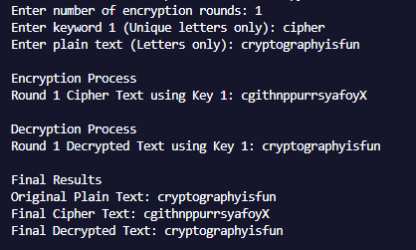

**CONCLUSION:**

The single-round columnar transposition cipher provides a simple yet effective method of encryption by rearranging plaintext columns based on a predefined key. While it offers basic security, it is vulnerable to frequency analysis and anagramming techniques.

In contrast, the multiple-round columnar transposition cipher enhances security by applying transposition iteratively, making pattern detection and cryptanalysis significantly harder. The increased complexity strengthens resistance against brute-force attacks but also demands careful key management to ensure decryption accuracy.