Risk Assessment Report
Financial & Operational Risk Analysis
Project: | Portfolio Risk Analysis - Financial Services
Analyst: | Risk Analytics Team
Date: | February 15, 2023

1. Executive Summary
This report evaluates the financial and operational risks of a simulated loan portfolio comprising 1,000 customer accounts. Key objectives include:
- Quantifying the probability of loan defaults
- Estimating Value at Risk (VaR) under adverse scenarios
- Performing stress testing to assess operational vulnerabilities
- Providing actionable recommendations to mitigate risk
Key Findings:
- Unweighted mean account PD is 29.80%; EAD-weighted PD is 17.23%
- Illustrative 95% credit-loss VaR is $9,526,628.91 (assumed LGD 45%, correlation 0.15)
- 504 loans have PD above 20% (50.4% of count, 29.72% of EAD)
- Combined borrower-earnings stress: aggregate net income -$12,559,240.00, which is not credit loss

2. Methodology

2.1 Data Collection & Cleaning
Dataset includes 1000 loans with comprehensive financial and operational metrics. Total loan portfolio value: $68,121,079.07.
Key columns analyzed:
- Credit Score (observed 421 to 850)
- Loan Amount
- Operational Risk Score (0-100 scale)
- Revenue and Expenses
- Net Income

2.2 Risk Quantification
- Probability of Default (PD): in-sample logistic regression on credit score, loan amount, and operational risk. LGD is not observed; illustrative loss uses a constant 45% LGD. EAD is loan amount. EL = PD × LGD × EAD.
- Value at Risk (VaR): Credit-loss VaR is a quantile of simulated portfolio loss. Borrower-income percentiles are reported separately and are not VaR.
- Stress Tests: a 20% revenue drop and a 10% expense increase. This does not change PD or expected loss. Credit stress: systematic factor at its 5th percentile.

2.3 Tools Used
- Python: Scikit-learn for logistic regression, NumPy/Pandas for data analysis
- Visualization: Matplotlib and Seaborn for chart generation
- Statistical Analysis: VaR calculations, scenario modeling, probability distributions

3. Analysis & Results

3.1 Probability of Default (PD)
The unweighted mean of in-sample account PDs is 29.80%. The EAD-weighted mean is 17.23% because higher-PD loans are smaller. These PDs are the full-sample logistic fit, not a holdout validation.
- 504 loans have PD above 20% (50.4% of count and 29.72% of EAD)
- Strong negative correlation between credit score and default probability
- Operational risk score is barely associated with default (correlation 0.02)
Figure 1: Distribution of Probability of Default
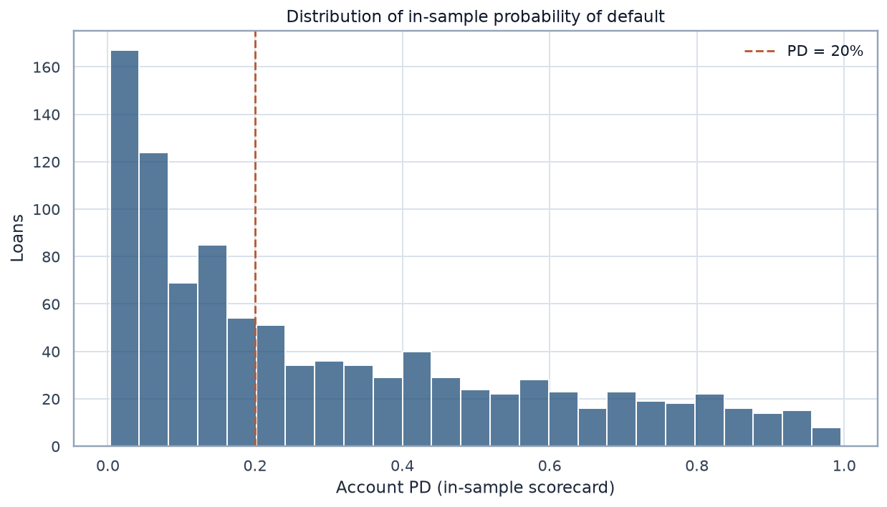
Figure 2: Credit Score vs Probability of Default
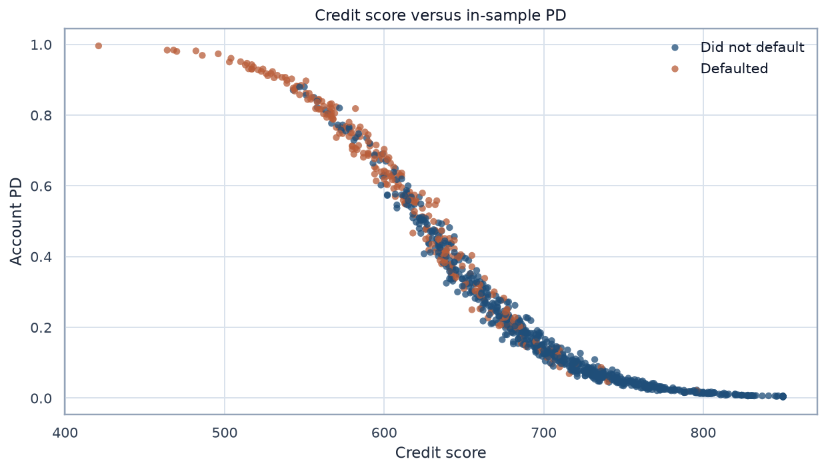

3.2 Value at Risk (VaR)
The next two figures are percentiles of borrower net income per account. They were mislabeled as VaR in the February 2023 draft. A loss VaR cannot be smaller at 99% than at 95%.
- 5th percentile of borrower net income: $43,146.55
- 1st percentile of borrower net income: $25,890.70
Implication: Those income percentiles are dollars per borrower, not a portfolio credit loss. Under an assumed LGD of 45% and an asset correlation of 0.15 (20,000 draws, seed 42), illustrative portfolio credit-loss VaR is $9,526,628.91 at 95% and $11,936,201.30 at 99%. Expected loss on that assumption is $5,280,499.32. A bootstrap 95% interval for the Monte Carlo error is $9,436,973.61 to $9,622,340.47 at 95% and $11,768,211.11 to $12,085,866.62 at 99%. The copula has no tail dependence, and LGD does not worsen in the tail. LGD and correlation are not estimated from this file.

3.3 Stress Test Outcomes
Comprehensive stress testing reveals portfolio resilience under various adverse scenarios:
Scenario | Aggregate borrower net income | Key Observations
Base Case | $124,207,710.82 | Revenue minus expenses. The Net_Income column sums to $124,207,710.74 ($0.08 rounding gap).
Revenue Down 20% | $24,749,229.55 | Aggregate borrower net income falls 80.07%. The file has no segment column.
Expenses Up 10% | $86,899,241.27 | Aggregate borrower net income falls 30.04%. This is not lender profit.
Combined Stress | -$12,559,240.00 | Aggregate borrower net income is negative. This is not expected credit loss.

Figure 3: Stress Test Scenario Comparison
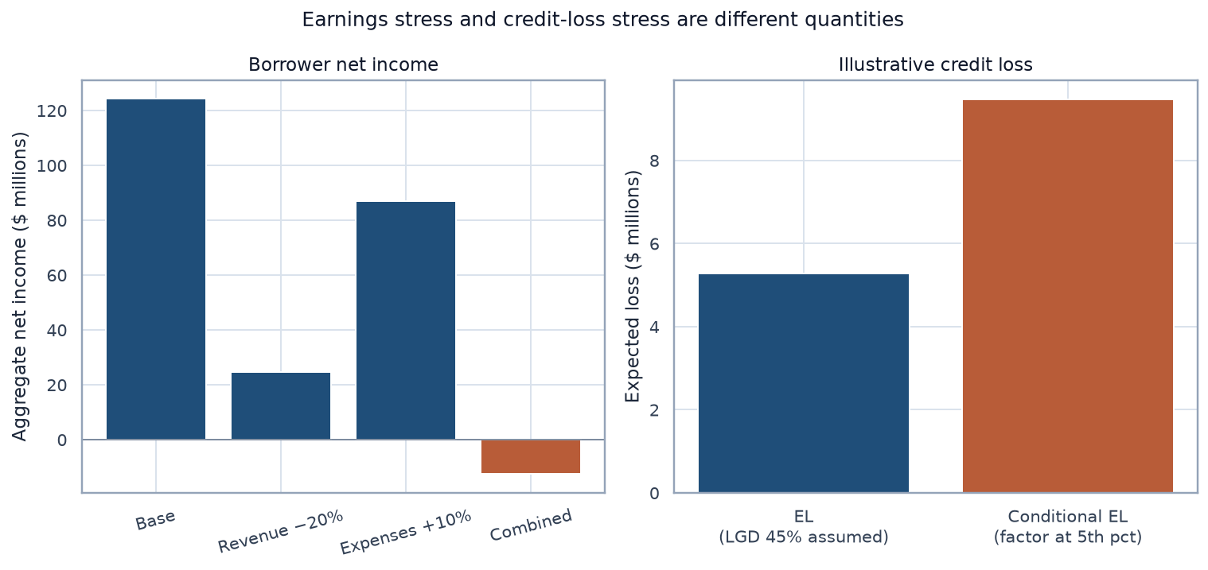

3.4 Operational Risk Highlights
Operational risk scores on this book:
- High-risk segments: Customers with operational risk above 60 default at 29.67% (27 of 91), versus 29.81% (271 of 909) for the rest
- Process inefficiencies: This file does not show a higher default rate when the operational risk score is already high
- Monitoring gaps: Current systems lack real-time tracking of operational risk indicators
Figure 4: High-PD concentration and operational-risk default rates
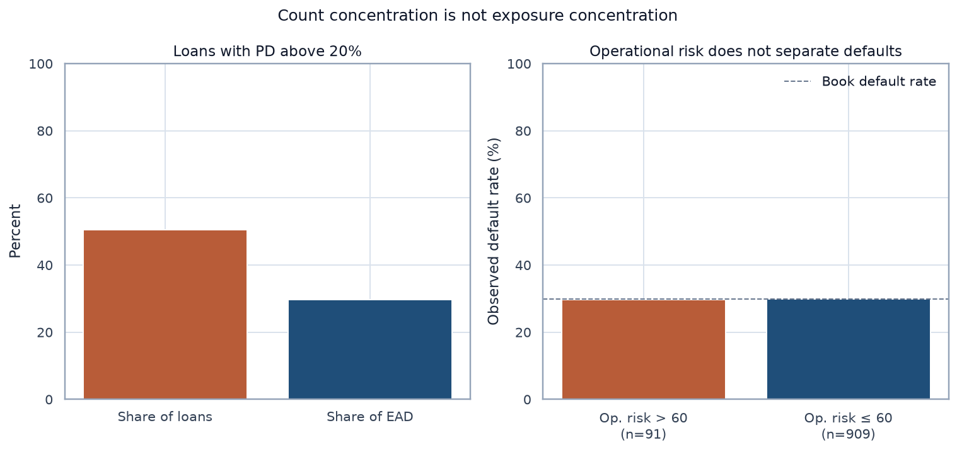

4. Recommendations
Based on the comprehensive risk analysis, the following strategic recommendations are proposed:
- Credit Risk Mitigation
Implement stricter lending criteria for loans with PD > 20%. Consider requiring additional collateral or higher interest rates for high-risk borrowers. Recommended actions include credit score threshold adjustments and enhanced underwriting processes.
- Operational Risk Management
Do not treat an operational risk score above 60 as a default screen on this book: that band's default rate matches the rest. Monitoring can still be an operational control.
- Stress Test Preparedness
Size any capital buffer from credit-loss expected loss and VaR. Those figures depend on an LGD and a correlation this file does not contain. Do not size the buffer from the borrower-income stress.
- Portfolio Diversification
High-PD loans are 50.4% of count and 29.72% of EAD. Exposure concentration is the figure to manage. A 30% cap would be a policy choice, not a result from this file.
- Monitoring & Reporting Infrastructure
Deploy real-time dashboards tracking PD, VaR, and operational KPIs. Implement automated reporting systems with weekly executive summaries and monthly deep-dive analyses. Integrate predictive analytics for early warning signals.
- Risk-Adjusted Pricing Strategy
Implement dynamic pricing models that adjust interest rates based on real-time PD calculations. Ensure that high-risk loans are priced to compensate for increased default probability. Target risk-adjusted returns of 12-15% across the portfolio.

5. Conclusion
This comprehensive risk assessment demonstrates advanced capabilities in quantifying financial and operational risks, simulating adverse scenarios, and proposing data-driven mitigation strategies. The analysis reveals:
- A portfolio with elevated credit risk, requiring immediate attention to high-PD segments
- Significant vulnerability to revenue shocks, particularly in combined stress scenarios
- Credit score, not operational risk, is the variable associated with default
- Quantifiable risk metrics that can guide strategic decision-making
The PD model is an in-sample logistic regression. Credit-loss VaR here is a simulated loss quantile under stated assumptions, not a Basel capital number. Borrower earnings stress is reported separately from expected loss.
The draft assigned the recommendations a PD reduction and a stress improvement. Those effects were not estimated, and they are not reported here.

Appendix: Technical Notes

A. Model Specifications
Logistic Regression Model:
The probability of default model uses the following specification:
P(Default) = 1 / (1 + e^-(β₀ + β₁·CreditScore + β₂·LoanAmount + β₃·OpRiskScore))
The published PD is the in-sample fit. Operational risk is not a multiplier on this book. Out-of-fold AUC is 0.852 (DeLong 95% CI 0.828 to 0.877). A credit-score-only model has out-of-fold AUC 0.853, and that difference includes zero. Loan amount is collinear with credit score (correlation 0.92); its positive coefficient is not a standalone size effect. Exact probability-scale Shapley values attribute the score mainly to credit score; the loan-amount piece follows that partial coefficient, not the raw association with default.

B. Data Summary Statistics
Portfolio Characteristics:
- Total Loans: 1,000
- Total Loan Amount: $68,121,079.07
- Average Credit Score: 681.0
- Total Portfolio Revenue: $497,292,406.34
- Total Portfolio Expenses: $373,084,695.52
- Sum of the Net_Income column: $124,207,710.74. Revenue minus expenses is $124,207,710.82.

C. Methodology Validation
Notes on the methods:
- Logistic Regression: Widely used by financial institutions for binary classification and PD modeling
- Value at Risk: a loss quantile. The illustrative figure is not regulatory capital.
- Stress Testing: borrower earnings shocks are separate from credit-loss shocks. This is not a CCAR submission.

Report prepared using Python (NumPy, Pandas, Scikit-learn, Matplotlib), demonstrating proficiency in:
- Statistical modeling and machine learning
- Data visualization and presentation
- Financial risk analysis and stress testing
- Quantitative research and reporting

