Part A Analysis

Huang Qian 774496

Take Yamanaka

Our program consists the following main step:

1. Read input from System.in
2. Create broad and fill in the data (pieces types)
3. Iterate the whole board and find V H pieces.
4. For each V/H piece, calculate its legal moves and add them together to get numLegalHMoves/numLegalVMoves

Time complexity.

Let n be the board size.

For step 1. We need a double for loop to read data. Thus, it is O(n^2).

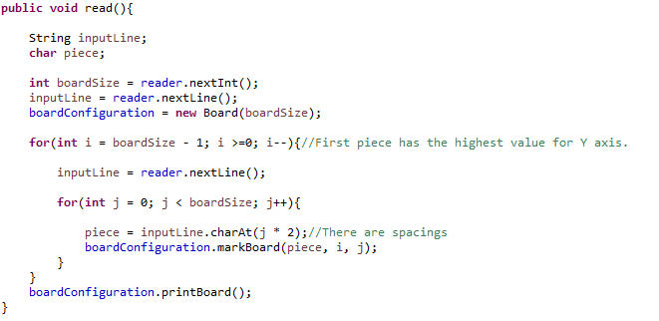

For step 2. We fill in the data right after we read it (in the same loop). So, it is also O(n^2).

For step 3. Iterate the whole board also needs O(n^2)

For step 4. Let the number of V+H piece be n. Since there are maximum 3 possible moves for each piece, it will take up to 3n time. So, it is O(n).

Add step 1 to 4 together we get O(n^2).