
Title
Report 6
Project
RadixLink
Author
Nathanael Mercaldo

SOFTWARE REQUIREMENTS SPECIFICATION
- a – Functional Requirements
RadixLink functionality must include:
  - The ability for the user to create configuration files which define the behavior of the job.
  - User must be able to interface and manage compute cluster (a compute cluster is a network of computers where each node performs a specific task) through the use of a web interface.
  - Direct management of active connections between compute nodes in the network.
- b – Non-Functional Requirements
RadixLink non functional requirements are:
  - Application must be run on windows platform.
  - Application host machine must be connected to a LAN.

APPLICATION DEVELOPMENT SECTION

PROJECT CONCEPT PROPOSAL
- Purpose:
The RadixLink project is a framework which enables the quick and efficient execution of distributed code and algorithms across multiple machines on a local area network.

  - Context:

Modern distributed computing frameworks offer many powerful features, however, they are generally very complex and may be difficult to learn and apply to smaller scale problems.

  - Goals:

The goal of this project is to create a distributed computing framework which is lightweight, has low overhead and is designed to be applied to small scale and prototyping contexts.

  - Audience:

Project target audience include software engineers and algorithm developers working in the field of distributed computing. Usability outcomes include: Easy framework setup and maintenance, simple method of code creation and execution and finally simple mechanism to allow the receiving and storing of results from distributed code execution.

  - Functionality:

Project should provide 1) an interface to manage multiple distributed nodes within the network. 2) an interface to monitor the current status of nodes on the distributed network. 3) Allow execution of code and algorithms on multiple computers across a network.

  - Milieu:

Existing distributed computing networks include Apache Spark and MPI.
- Apache Spark is a large and complex distributed computing framework which allows the direct execution of processes over the network. Disadvantage of Apache Spark include: Complex architecture. Advantages include: Large set of features, and that it is built on a mature codebase.
- MPI is not in fact a complete framework, instead it is a low level library for sending task information over a network in a highly synchronized manner. Advantages: MPI provides useful tools for distributed computing. Disadvantages: MPI is not feature complete and must be used in conjunction with an existing framework.

  - Novelty:

RadixLink is unique in that it provides an extremely simple and easy to use avenue for testing and running algorithms on multiple machines across a network. Further, unlike existing frameworks which run entire applications on a cluster, RadixLink runs code snippets entered by the developer directly with no need for the developer to even compile their own code.

- Resources:

Languages: C++, JavaScript, HTML, CSS
Demo Algorithms: https://lodev.org/cgtutor/filtering.html
APIs: Windows API

- Optional:
None as of yet.
- Challenges:

- Proper synchronization of nodes within the compute cluster.
- Dynamic generation of jobs
- Proper division and transfer of job data to and from computer cluster nodes.

- Measures:
- Future Extensions:
  - Cross platform support
  - Multi-language support
- Preliminary Software Requirements Specifications
  - Number: 1
    - Statement: Application binary which takes two code files and a configuration file as input, and outputs a final job configuration file.
    - Evaluation Method: Successful execution of job generated using generator.
    - Dependencies: None
    - Priority: low
    - Requirement revision history: None
  - Number 2
    - Statement: User interface written in HTML, CSS, JavaScript which may generate and send basic requests to cluster nodes. This communication will be done through the use of AJAX and JSON.
    - Evaluation Method: Successful management of networked computers though the interface.
    - Dependencies: Job framework
    - Priority: medium
    - Requirement revision history: None
  - Number 3
    - Statement: The Job framework, (A native binary application) which implements full RadixLink compute functionality. Application must manage all incoming and outgoing connections for given node, properly decode and encode job data and allow external querying of node status via the web interface.
    - Evaluation Method: Successful transfer of jobs between computers in compute cluster. And the successful execution of said jobs on the target machines.
    - Dependencies: none
    - Priority: high
    - Requirement revision history: None

INSPIRATION
- Motivation:

In modern times, the idea of massively parallel computing is revolutionizing the tech industry. Companies like Google, FaceBook and Youtube rely heavily on distributed tech on a day by day basis. I believe that the concepts which drive distributed computing technology are extremely interesting. For this reason I have decided to “Try my hand” at creating a lightweight framework which enables such computation in a clear and flexible manner.

- Career:

As mentioned above, distributed computing is gaining huge popularity in the industry. Thus I believe employers would find it very attractive to see somebody with both a skill and interest in the area. This shows both a love of difficult technical challenges and cutting edge technology.

- Other if applicable:

None

VISION AND SCOPE
The vision of RadixLink is to provide researches and developers with a powerful tool which enables the running of algorithms on multiple computers at the same time. Users will be able to setup the network of computers with ease, generate test algorithms quickly, and deploy large scale execution of the algorithm at a moment’s notice.
The scope of RadixLink is not to replace existing distributed computing systems, but instead implement a simple subset of the functionality provided by these frameworks, in a simple manner. For example, current distributed solutions allow the direct execution of processes across the network, however RadixLink is limited to only running small code samples.

SYSTEM DESIGN AND ARCHITECTURE

General Description
RadixLink client application is made up of four main modules. The “networking module”, “job module” and “node module”.
    - Networking Module
The networking module is responsible for managing all data flow to and from a given node. The module is also responsible for managing connections between the parent node and any relevant external nodes in the cluster.
    - Job Module
The job module handles the initialization, execution and completion of jobs running on a given compute cluster node.
    - Node Module
The node module manages the current state of the node, and provides node status information to other nodes in the compute cluster. NOTE: Any requests made by the radix link web interface will be forwarded to the node module.

Detailed Description
The following is a detailed description of the software architecture used to implement the above mentioned modules.
- Networking Module Classes
  - NetworkManager
Stores and manages active connections to node. Allows the creation of connections and allows reading and writing to currently open connections.
  - Buffer
Wrapper around char vector which provides extra helper functions for the network manager.
- Job Module Classes
  - JobManager
Stores and tracks execution of currently available jobs.
  - Job
Stores the state of a given job.
  - JobInfo
Stores meta data relating to a given job.
- Node Module Classes
  - NodeManager
Stores, tracks and allows access to the status of a given node.
- Common Classes
  - Dispatcher
Glues all modules together by dispatching requests from one module to another. (Hard coded Observer pattern)
  - Decoder
Transforms a given buffer of bytes into a series of Resources.
  - Encoder
Transforms a series of Resources into a buffer of bytes.
  - Resource
Represents the most fundamental unit of information processed by each module.

Architecture Diagram

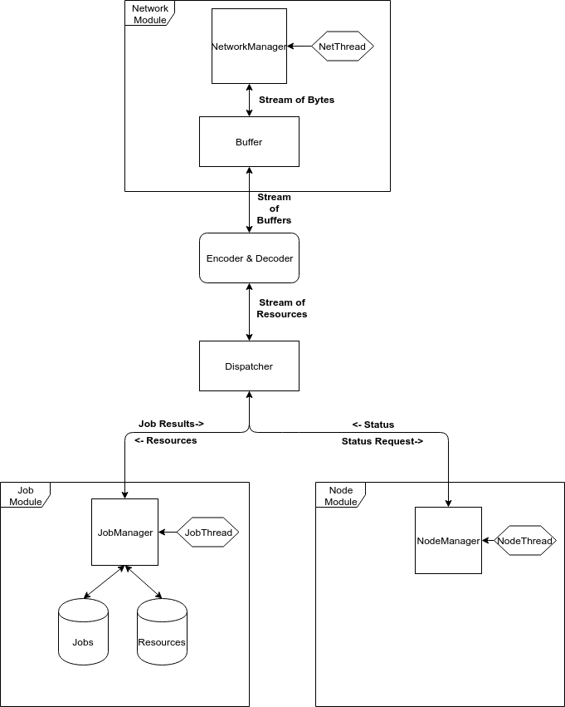
EXECUTIVE SECTION

- FROM: Nathanael Mercaldo
- SUBJECT: RadixLink
- DATE: 2/8/2019

ACCOMPLISHMENTS:

This week the project proposal was created. A basic technical prototype was also completed. This prototype involved cross compiling from linux to windows and basic TCP/IP socket based communication.

CHALLENGES:

The main challenge this week was properly setting up the linux cross compiler MinGW.

TIME SPENT:

Around 2 hours.

GOALS:

Goals for next week include: Sketching out general SAP architecture and completing any necessary analysis and documentation.

- FROM: Nathanael Mercaldo
- SUBJECT: RadixLink
- DATE: 2/14/2019

ACCOMPLISHMENTS:

This week the second report written was written. Report includes general requirements, scope and vision.

Implementation of general communications protocol between nodes in the cluster.

CHALLENGES:

One challenge was designing a flexible protocol for communication between nodes in the cluster.

TIME SPENT:

Around 10 hours.

GOALS:

Goals for next week include: Completion of node communications protocol and implementation of basic job management.

- FROM: Nathanael Mercaldo
- SUBJECT: RadixLink
- DATE: 2/21/2019

ACCOMPLISHMENTS:

This week general communications protocol was successfully compiled.. There exists one final bug however in the protocol which must be fixed.

CHALLENGES:

Challenge this week was the final ironing out of bugs in the communication protocol.

TIME SPENT:

Around 4 hours.

GOALS:

Goals for next week include: Debugging of communications protocol and implementation of basic job management.

- FROM: Nathanael Mercaldo
- SUBJECT: RadixLink
- DATE: 3/1/2019

ACCOMPLISHMENTS:

This week the communication protocol was completed as well as the general system architecture.

CHALLENGES:

Challenge this week was to create the final general system architecture.

TIME SPENT:

Around 6 hours.

GOALS:

Goals for next week include: The completion of general system architecture.

