**Report of Assignment 2**

Written by Sven Gerhards; Reviewed and discussed with Isaac Clancy and Austin Chen.

About

A manual for our First National Bank Project. Here every feature and design decision will be listed and discussed. Furthermore there is an Instruction specifically for End-Users.

We contentiously worked on our project using GitHub (<https://github.com/Paraakie/InternetpaperA2>)

**Features**

User-Accounts

To use our website one has to create a user-account. A user account has three variables ID, which is generated by the program as well as a Name and a Password. Hence the user will be promoted to enter a Name and Password, when registering an account. After registering the user, will be logged-in automatically and has the ability to log-out and of course to log-in.

Bank-Accounts

Once the user is logged into their account they have the ability to create unlimited accounts. Whenever creating an account the user will be promoted to enter a name for their accounts. No restrictions apply to the name as many users would be expected to use generic names like ‘Savings’. Furthermore they can see all their accounts and the account details. An account can be deleted, if there is no money left on the account, to avoid money being lost.

Transactions

Having a bank account allows the user to deposit, withdrawal from their accounts. As well as transferring their money between any accounts created with our bank.

Deposit

Withdrawal

Transfer

**Design Choices**

Data-Modelling

During the initial drafting phase this was the first draft we came up with for the database.

“UserID” would be the foreign key of User’s “ID” and “AccountID” would be Accounts’ “ID”.

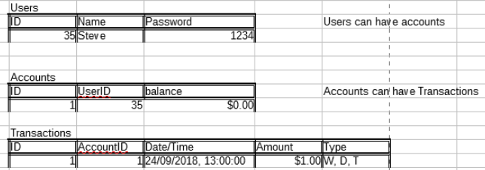

However during development, we agreed that a name for an account was necessary for the user to identify their account easier and a name variable was added to Accounts.  
Due to complications and bugs with deleting accounts, we came to the conclusion to make “AccountID” couldn’t be a Foreign key. Additionally the connection between accounts and transactions is generally weak as it was only used to display the transactions. As well as the values in question can’t be changed, this change shouldn’t cause an issue.

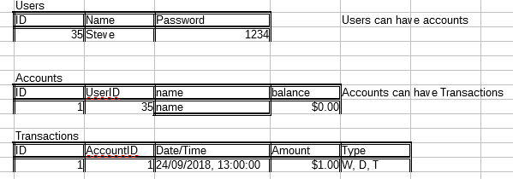

Talk about features

-> talk about Weak connection of accounts and transactions *tick*

-> what you can do

A report detailing your application’s

o Specifications

o Design choices

o Database schema and relations

o Instructions for end-user (with screenshots for clarity if needed)

**Instructions for end users**

The user can navigate from the Homepage by clicking the “Sign-up” button to create an account. Additionally like many successful online services, we ask the user to re-enter their password.