**Report of Assignment 2**

Written by Sven Gerhards. Reviewed and discussed with Isaac Clancy and Austin Chen.

About

The purpose of this report is to introduce our JIS Tech Project. Every feature and design decision will be listed and discussed in details. We continuously worked on our project using GitHub (https://github.com/Paraakie/InternetpaperA3).

**Features**

User-Accounts

In order to use our website, one has to create a user-account. A user account has five variables. First off ID, which are generated by the program as well as a Nickname, Username, Password and Email Address . Username like the ID must be unique and can only contain letters. The Password has to be between 7 and 15 characters long as well as include one capital letter. After registering, the user will be logged-in automatically.

*The User TheToolman was implemented as requested.



*Screenshot of log-in page*

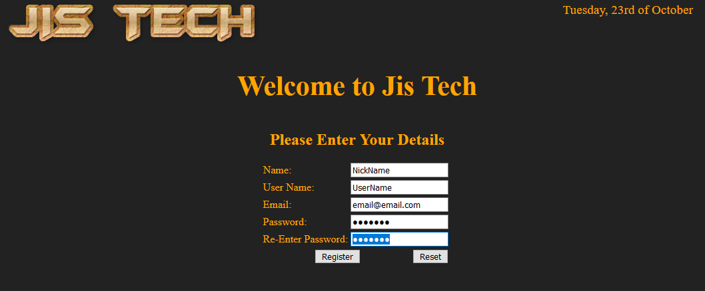

*Screenshot of log-out page*

Home-Page

Whenever a user logged in they are redirected to the main menu. Here one is greeted by a welcome message and an user instruction. Furthermore the user can navigate to the Search-Page and the Browse-Page, as well as log-out.



*Screenshot of home-page*

Search-Page

The Search page functionality was implemented using AJAX, once the table gets input the character(s) are compared to the existing Product names and matches will be displayed. No input shows all Products.

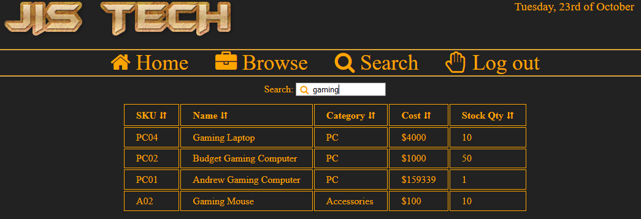

*screenshot of search page*

Browse-Page

The browse page uses buttons to filter all available products. One can also click the product properties to sort them. The products are displayed in a professional looking table.

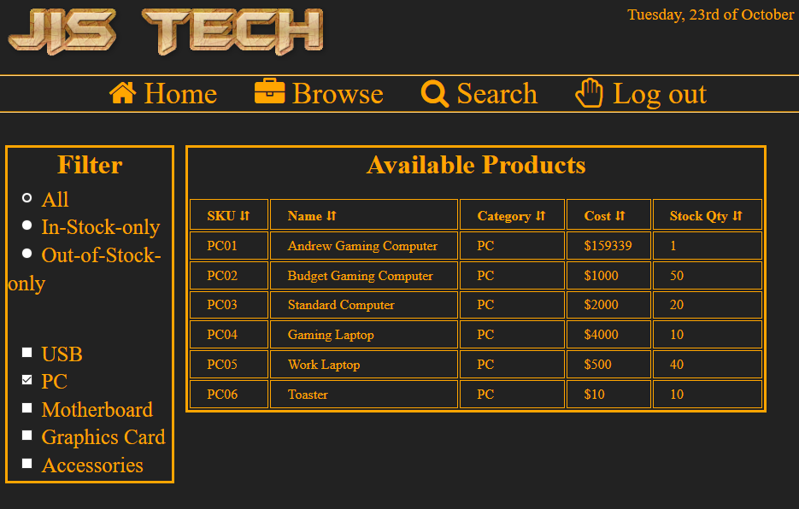

*screenshot of browse page; showing all PCs, sorted by SKU*

Top Menu

The Top-Menu was contained in a ‘div’, using a CSS #id made it easy to design the Top Menu. Additionally it looks more professional with icons next to the options.



Products & Categories

We agreed to create a tech company, JIS Tech, hence all products are computer hardware related. The properties of a products are ‘Name’, ‘SKU’, ‘Cost’, ‘Quantity’ and ‘Category’.

E.g. Gaming Laptop, PC01, $4000, 20, PC

Twenty Products and five Categories have been implemented.

**Design Choices**

Data-Modelling

Data-Modelling is straight forward. The database contains users, products and categories.

…

Footer

In all the screenshots one is able to see the footer that is because it always sticks to the bottom. We designed the website this way to avoid overlap the long product table as well as personal preference.