

ExpenSense
Intelligent Finance & Expense Tracking with Receipt Recognition
"Track Smarter. Live Better."

System Documentation

Developed by:
James Ryan Amba – Lead Developer
Graco Aloba – Co-Developer & QA
Ellijan Esquivel – Co-Developer & QA
Jed Ortega – Co-Developer & QA

[Course Name] | [Section]
Submitted to: [Instructor Name]
[School Name]
[Date of Submission]

Table of Contents
- Project Title and Group Members
- System Overview and Objectives
- Major System Features
- System Requirements
- How to Use the System (Step-by-Step)
- Screenshots of Important Procedures and Features
- Known Limitations
- Member Contributions

1. Project Title and Group Members
Project Title: ExpenSense – Intelligent Finance & Expense Tracking with Receipt Recognition
Name | Role
James Ryan Amba | Lead Developer
Graco Aloba | Co-Developer & QA
Ellijan Esquivel | Co-Developer & QA
Jed Ortega | Co-Developer & QA

2. System Overview and Objectives

2.1 Background
Many students and young earners have a hard time answering one simple question: "Where does my money go?" Everyday expenses like food, transportation, school needs, and small daily purchases look small one at a time, but they add up quickly. Receipts are easily lost, and writing down every expense by hand is tedious, so most people stop tracking after a few days.

2.2 System Overview
ExpenSense is a mobile application for Android and iOS that helps users record, organize, and understand their expenses. Instead of typing every detail, the user can simply take a photo of a receipt. The app reads the receipt, pulls out the important details (merchant, date, items, and total), and lets the user review and correct them before saving. Saved expenses are then reflected in the user's transactions, wallets, budgets, and analytics.
The app was built using React Native with Expo and TypeScript. User accounts, data, and receipt images are stored using Supabase (authentication, PostgreSQL database, and private file storage). Receipt recognition (OCR) is handled by a Supabase Edge Function called process-receipt, and the results are checked and parsed inside the app.

2.3 Objectives
General Objective: To develop a mobile application that makes everyday expense tracking faster, simpler, and more understandable for students and everyday spenders.
Specific Objectives:
- To allow users to record expenses by scanning or uploading a receipt, reducing manual typing.
- To let users review and correct the recognized receipt details before saving, so the records stay accurate.
- To provide manual expense entry for purchases that have no receipt.
- To keep all money movement (expenses, income, cash-in, and transfers) in one searchable transaction history.
- To help users manage wallets, monthly category budgets, and savings goals.
- To present spending analytics and insights so users can see patterns, not just totals.

3. Major System Features
Feature | Description
Account & Onboarding | Three-page introduction, account creation with email verification, sign in, forgot password, and password reset.
Home Dashboard | Personal greeting, mascot tip, total spending for the selected period (week/month/year), budget progress, income, remaining budget, and pinned category tiles.
Receipt Scanner | Capture a receipt with the camera (with flashlight) or upload an image from the gallery. The image is optimized and sent for recognition.
Receipt Processing & Review | Shows the recognition steps, then a review screen with the detected merchant, date, items, totals, and a confidence label. The user can edit any field, choose the transaction type (expense, cash-in, or transfer), category, and wallet before confirming.
Manual Expense Entry | Enter amount, merchant, category, wallet, date and time, notes, and an optional photo.
Transactions | Unified history of expenses, income, cash-in, and transfers with search, filters, sorting, a spending calendar, details, editing, and deleting.
Wallets, Budgets & Goals | Multiple wallets, total balance (with option to hide it), adding income, transfers between wallets, monthly category budgets, and savings goals.
Analytics & Insights | Monthly income vs. expense, category breakdown (donut chart), spending trends, and insight cards such as top category, recurring merchants, unusual spending, and budget suggestions.
Categories | Default and custom categories with icons and colors; categories can be pinned to the dashboard or hidden.
Budget Assistant | A simple built-in assistant on the Home screen that answers a set of common spending questions using the selected month's data. It works offline.
Profile & Settings | Account information, change password, notification preferences, light/dark/system theme, privacy information, help/FAQ, and about page.
Offline Support | Manual expenses created, edited, or deleted while offline are saved on the device and synced once the connection returns.

4. System Requirements

4.1 User (Mobile Device) Requirements
Requirement | Specification
Device | Android or iOS smartphone
Operating System | Android 7.0 or later / iOS 16.4 or later
Camera | Rear camera (for scanning receipts)
Internet Connection | Required for sign in, receipt recognition, and syncing data
Permissions | Camera access (scanning) and photo library access (uploading receipts)
Account | A registered ExpenSense account with a valid email address

4.2 Development Requirements
Requirement | Specification
Computer | Windows, macOS, or Linux
Runtime | Node.js 22.13 or later and npm
Framework | Expo SDK 57, React Native 0.86, React 19.2
Language | TypeScript
Backend | Supabase project (Auth, PostgreSQL, Storage, Edge Functions)
Tools | Code editor (VS Code / Kiro), Git, Expo CLI, EAS (for builds and updates)

5. How to Use the System (Step-by-Step)

5.1 Creating an Account and Signing In
- Open the ExpenSense app. The splash screen appears, followed by the onboarding pages.
- Swipe through the onboarding pages and tap Get Started.
- On Create Account, enter your name, email, password, and confirm the password, then tap Create Account.
- Check your email and verify your account if asked.
- Go back to Sign In, enter your email and password, and tap Sign In.
- If you forget your password, tap Forgot Password, enter your email, and follow the reset link sent to you.

5.2 Viewing the Home Dashboard
- After signing in, the Home screen shows your total spending, budget progress, income, and remaining budget.
- Use the period selector to switch between week, month, and year.
- Tap the mascot's speech bubble to open the budget assistant and choose a suggested question.
- Tap a category tile to see the spending and transactions for that category.

5.3 Adding an Expense by Scanning a Receipt
- Tap the green Scan button in the middle of the bottom navigation bar.
- Choose Scan Receipt (camera) or Upload Receipt (gallery). Allow camera or photo access if asked.
- Place the whole receipt inside the frame and tap the capture button. Use the flashlight button if it is dark.
- Wait while the app processes the receipt. A checklist shows each step (preparing image, checking quality, reading receipt, checking structure, extracting details, checking totals).
- On the Receipt Review screen, check the merchant, date, items, and total. Edit anything that is wrong.
- Choose the transaction type, category, and wallet, and add notes if needed.
- Tap Confirm & Save. The expense is added to your transactions, and your wallet balance and budget are updated.
- If recognition fails, you can Retake Photo, Upload Another Image, or Fill In Details Myself.

5.4 Adding an Expense Manually
- Tap Scan, then choose Manual Entry.
- Enter the amount (or tap a quick amount chip) and the merchant name.
- Select the category, wallet, date, and time. Optionally attach a photo and write notes.
- Tap Save Expense. A message confirms that the expense was saved.

5.5 Managing Transactions
- Tap Transactions in the bottom navigation (or swipe from Home).
- Use the search bar to find a merchant, or tap the filter button to filter by type, date, or category.
- Open the calendar view to see spending per day.
- Tap a transaction to view its details. From there, tap Edit to change it or Delete to remove it.

5.6 Managing Wallets, Budgets, and Goals
- Tap Wallet in the bottom navigation to see your total balance, wallets, goals, and category budgets.
- Tap the eye icon to hide or show your balances.
- Open Manage Wallets to add a wallet, add income or cash-in, or transfer money between wallets.
- Set or change a monthly budget for each category to track how much is left.
- Open Goals to create a savings goal and add money to it over time.

5.7 Viewing Analytics and Insights
- Tap Analytics in the bottom navigation.
- View your income, expenses, and net total for the month, plus the category donut chart.
- Switch to Trends to see how your spending changes over time.
- Tap View Spending Insights to read cards about your top category, recurring merchants, unusual spending, and budget suggestions.

5.8 Categories, Profile, and Settings
- Open Categories to add a custom category, pin it to the dashboard, edit it, or hide it.
- Open the quick menu and go to Profile to see your account and settings.
- In settings you can edit your name, change your password, set notifications, choose light/dark theme, and read Help and Privacy information.
- Tap Log Out to sign out of your account.

6. Screenshots of Important Procedures and Features
Note: The screenshots below show the ExpenSense interface design. Some labels may differ slightly from the latest build (for example, the fifth tab is now labeled Wallet instead of Budget).

6.1 Getting Started
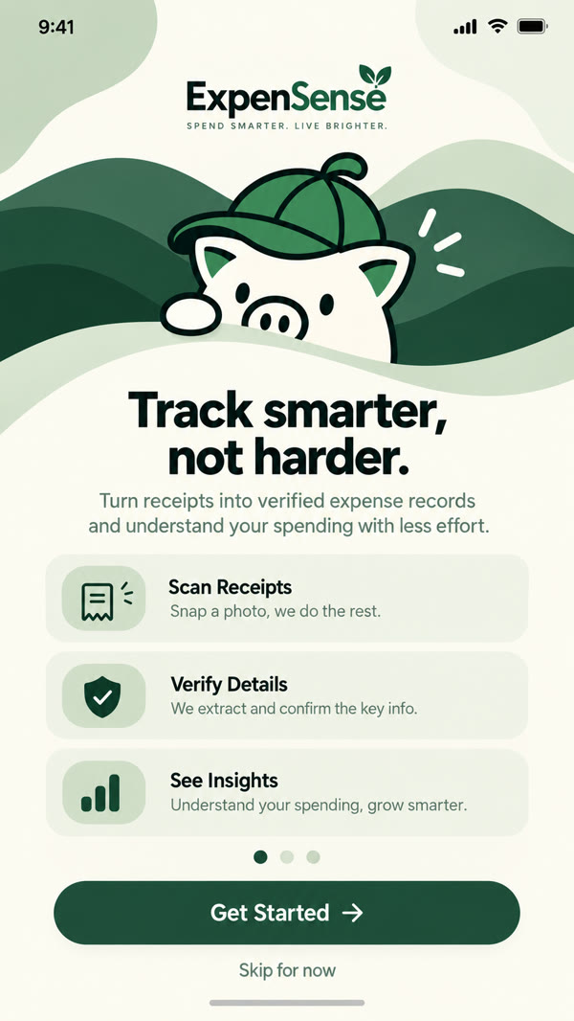  Figure 1. Onboarding Screen | 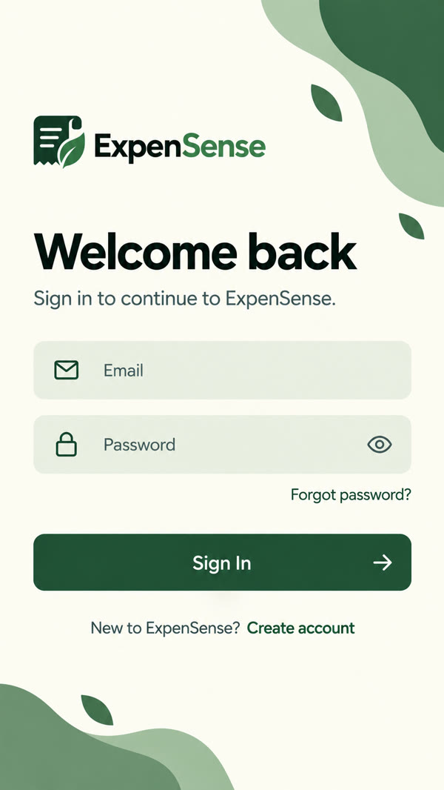  Figure 2. Sign In Screen
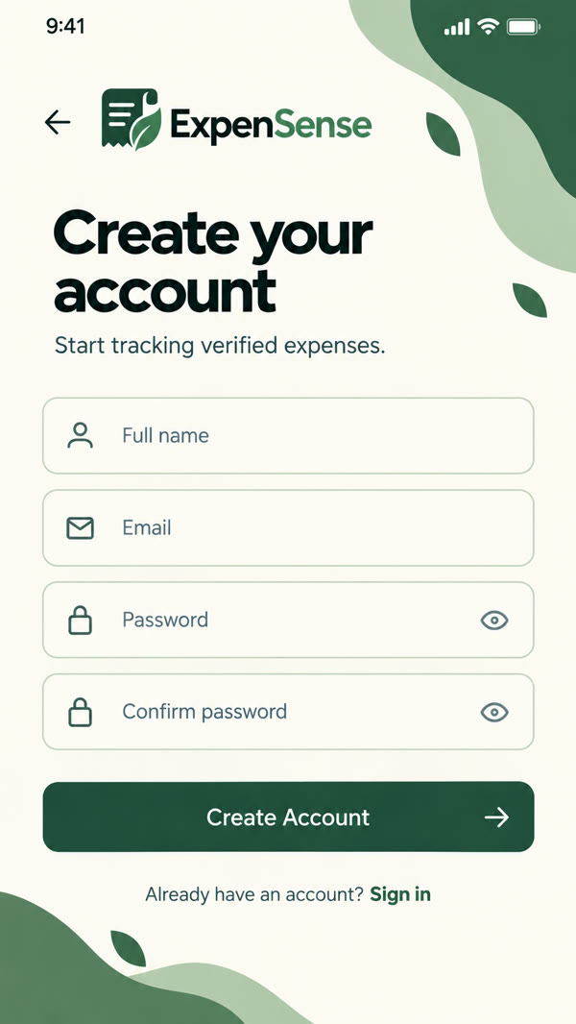  Figure 3. Create Account Screen | 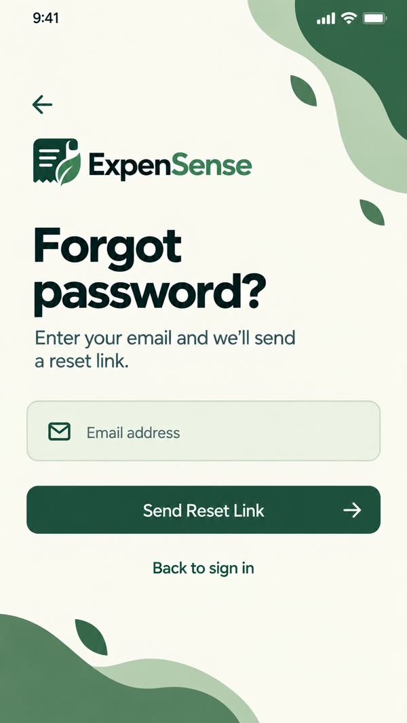  Figure 4. Forgot Password Screen

6.2 Home Dashboard
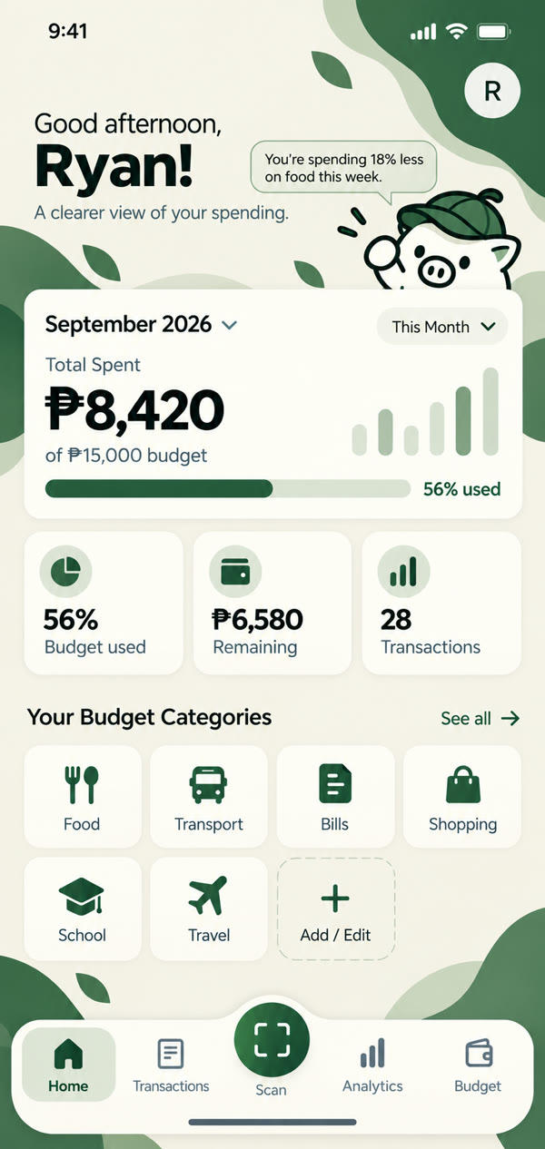  Figure 5. Home Dashboard | 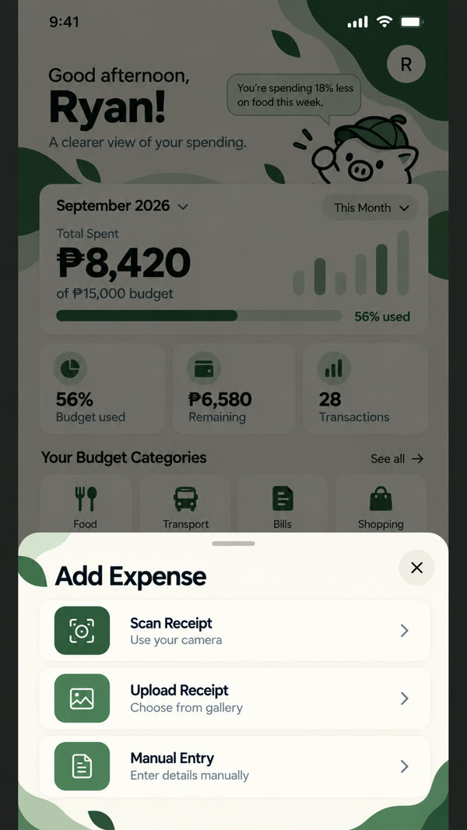  Figure 6. Add Expense Options (Scan, Upload, Manual)

6.3 Receipt Scanning Procedure
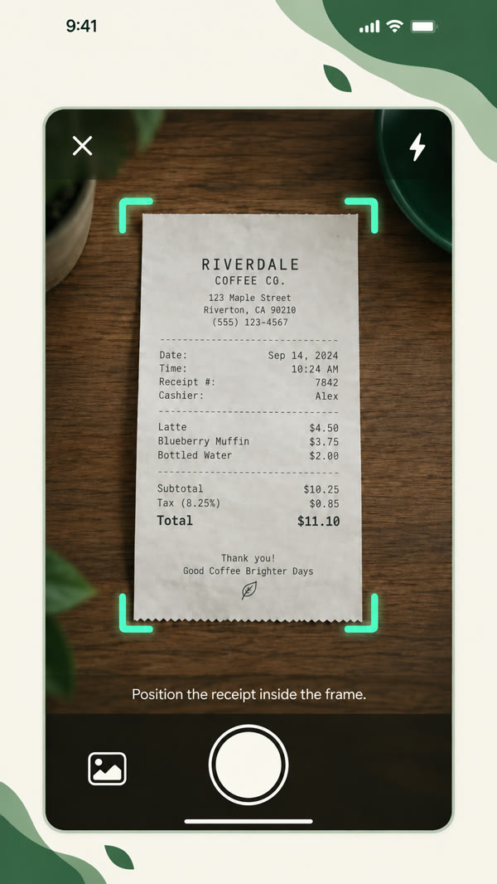  Figure 7. Step 1 – Capture the Receipt | 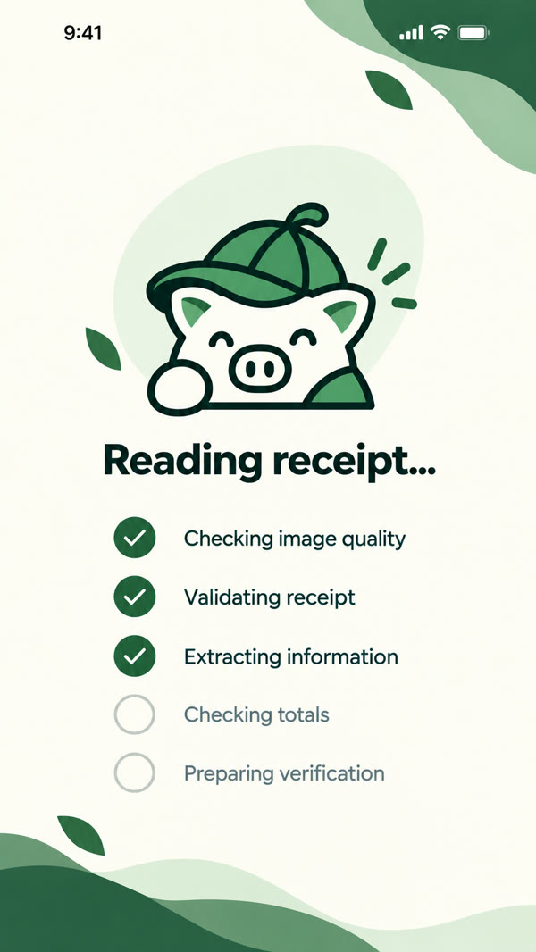  Figure 8. Step 2 – Processing the Receipt
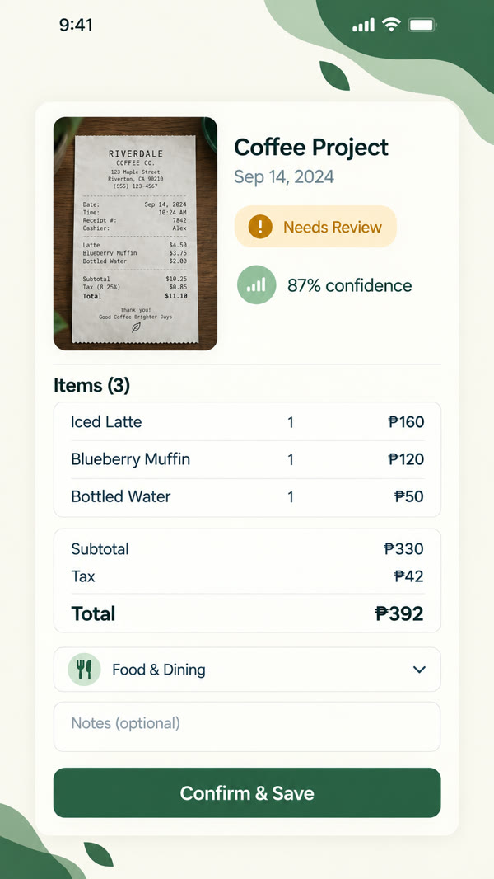  Figure 9. Step 3 – Review and Confirm | 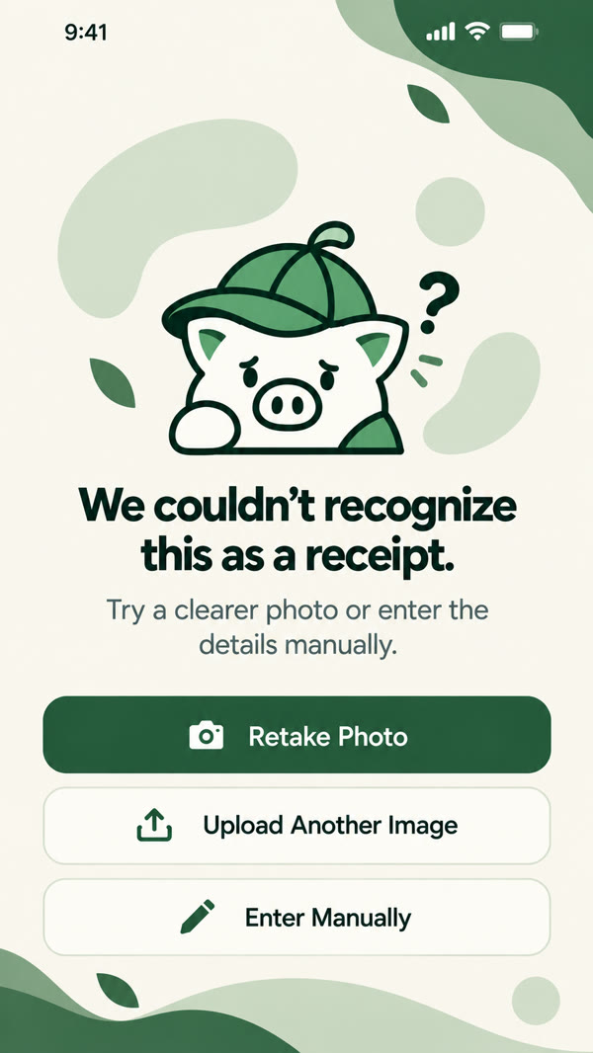  Figure 10. Recognition Failed (Recovery Options)

6.4 Manual Entry and Transactions
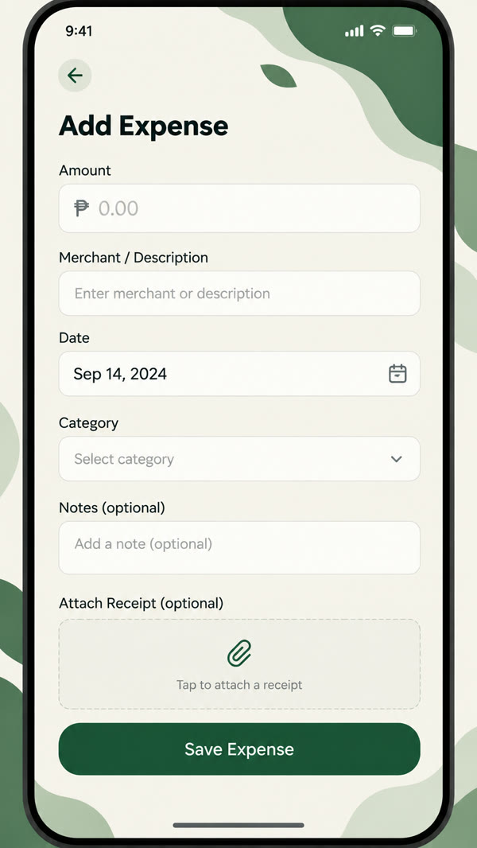  Figure 11. Manual Expense Entry | 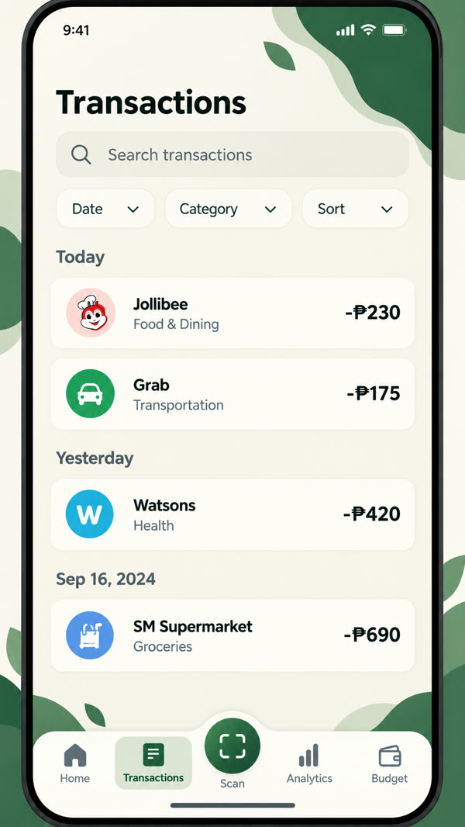  Figure 12. Transactions List
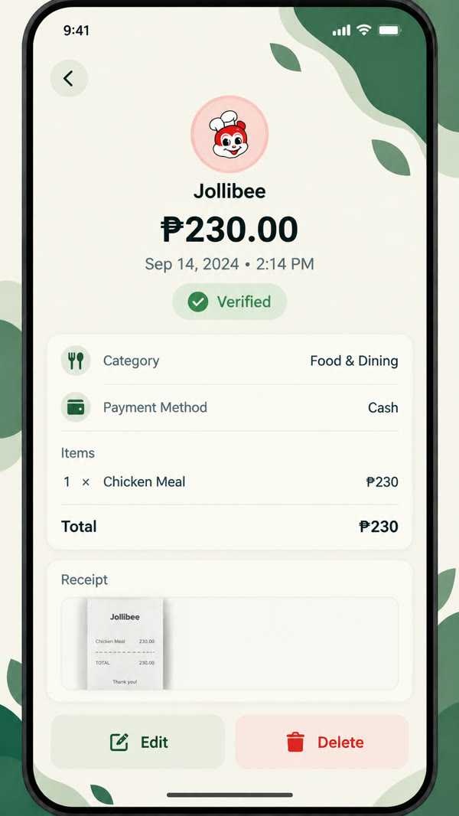  Figure 13. Transaction Details | 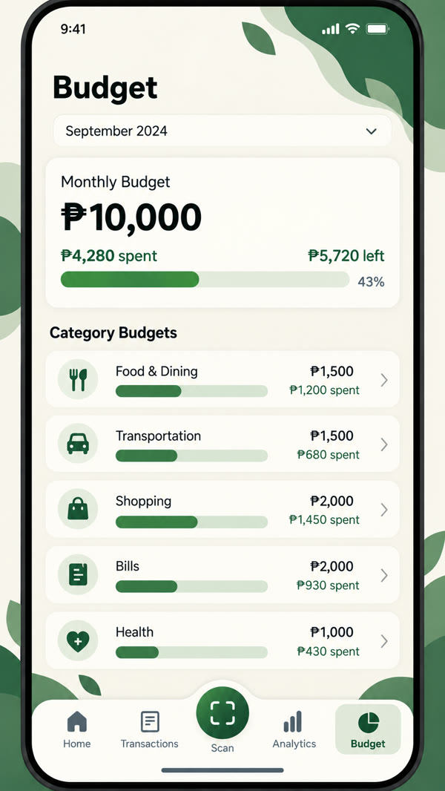  Figure 14. Wallet & Budget Overview

6.5 Analytics, Categories, and Settings
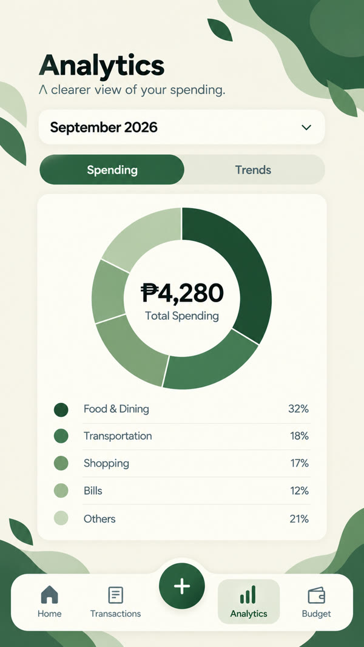  Figure 15. Analytics Overview | 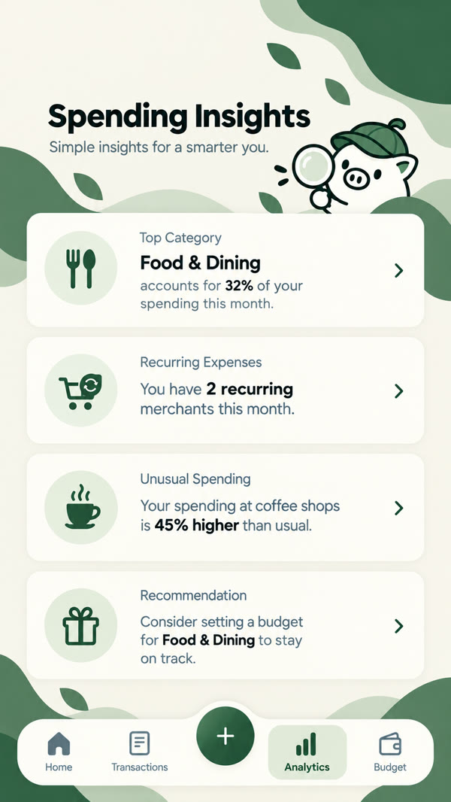  Figure 16. Spending Insights
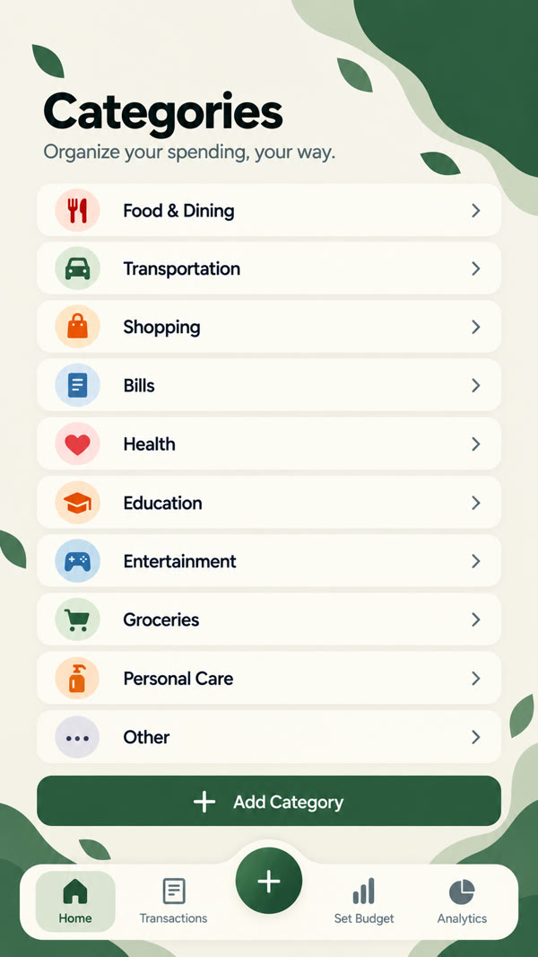  Figure 17. Categories | 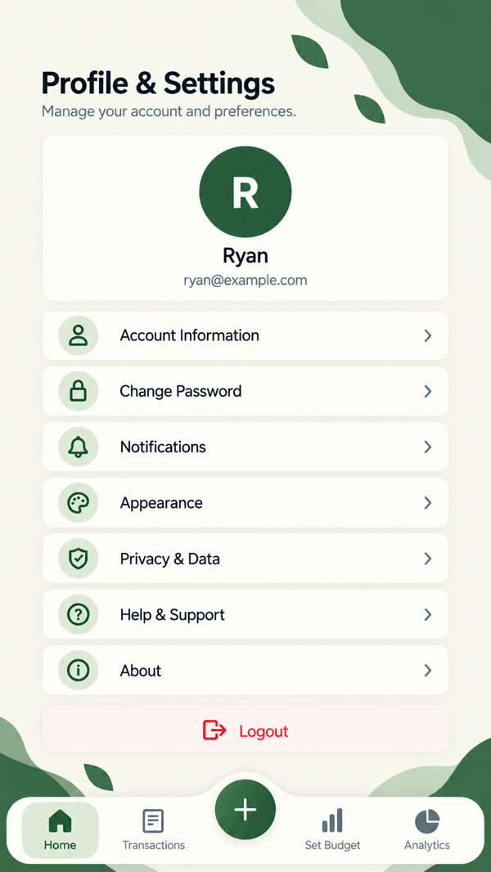  Figure 18. Profile & Settings

7. Known Limitations
- Internet is required for receipt scanning. Receipt recognition runs on the server, so it does not work offline. Manual entry can be used instead.
- Recognition depends on image quality. Blurry, dark, crumpled, faded, or cut-off receipts may be read incorrectly or rejected. Low-resolution images are also rejected.
- Recognized details must be reviewed. The OCR is not 100% accurate, so the user should always check the details before tapping Confirm & Save.
- Screenshots are not accepted as receipts. The app rejects images that look like screenshots instead of photos of real receipts.
- Photos are not saved offline. If a manual expense with an attached photo is saved while offline, the expense is saved but the photo is not.
- Recognition speed depends on the network. On a slow connection, processing a receipt may take longer.
- The budget assistant is limited. It only answers a fixed set of spending and budget questions and is not a general-purpose chatbot.
- An account and email verification are required. Users must sign up with a valid email before using the app.

8. Member Contributions
Member | Role | Contributions
James Ryan Amba | Lead Developer | Planned the overall system and app structure; developed the main screens and navigation; set up the Supabase database, authentication, and storage; integrated the receipt recognition (OCR) flow; handled builds and deployment; led the team and reviewed all features.
Graco Aloba | Co-Developer & QA | Helped develop app screens and features; tested the receipt scanning and manual entry flows; reported and helped fix bugs; assisted in preparing the documentation and presentation.
Ellijan Esquivel | Co-Developer & QA | Helped develop app screens and features; tested transactions, wallets, budgets, and analytics; checked the app on different devices; assisted in preparing the documentation and presentation.
Jed Ortega | Co-Developer & QA | Helped develop app screens and features; tested account sign-up, sign-in, password reset, and settings; wrote test cases and checked user flows; assisted in preparing the documentation and presentation.

ExpenSense – Track Smarter. Live Better.

