Layer 2:

Move to Left: **U’L’U’LUFUF’**

Move to Right: **URUR’U’F’U’F**

Layer 3(Top):

Backwards Fish: **RUR’URU2R’**

Forward Fish: **RU2R’U’RU’R’**

Dot: **BULU’L’B’**

Backwards L: **FURU’R’F’**

Line: **FRUR’U’F’**

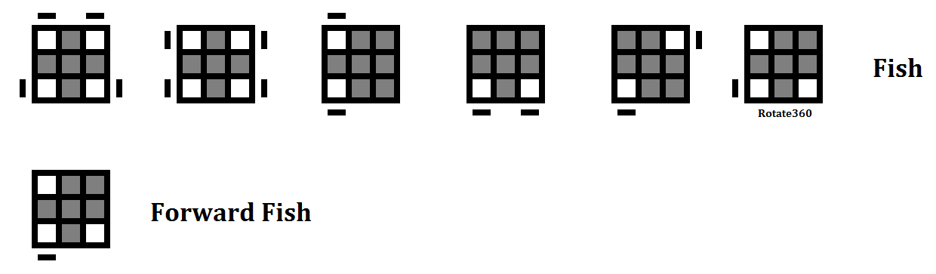

Layer 3(Sides):

Two Match: **F2UR’LF2RL’UF2**

Move Forwards: **R’FR’B2RF’R’B2R2**

Move Backwards: **R2B2RFR’B2RF’R**

