Java

Code: https://github.com/Paradise02/Interviews/tree/master/Beijin-Tuiwen/Java

1. Count file in JDK

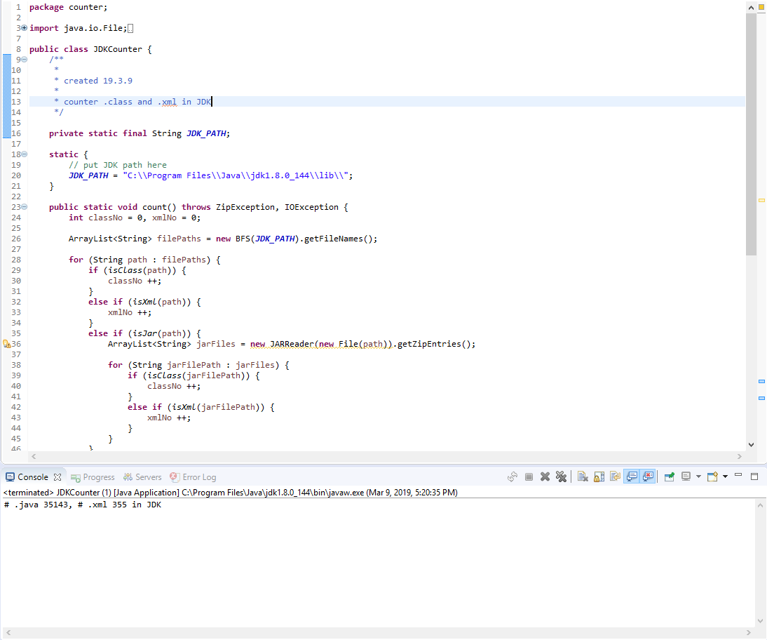

BFS

& ZipFile

& Regex

2. Groovy

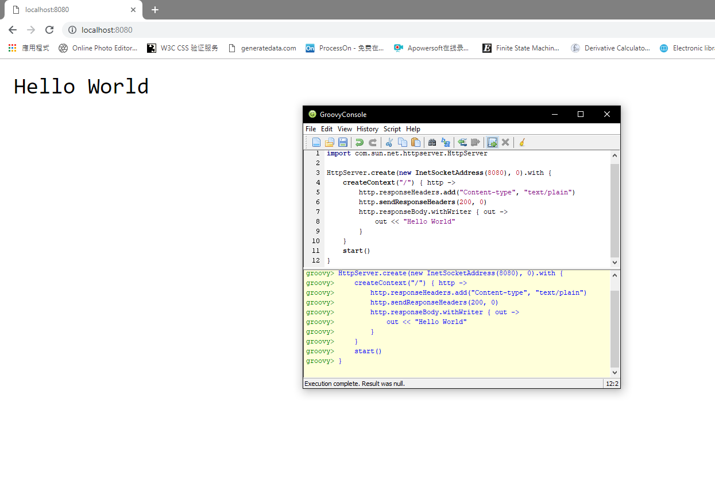

1. Spring Boot

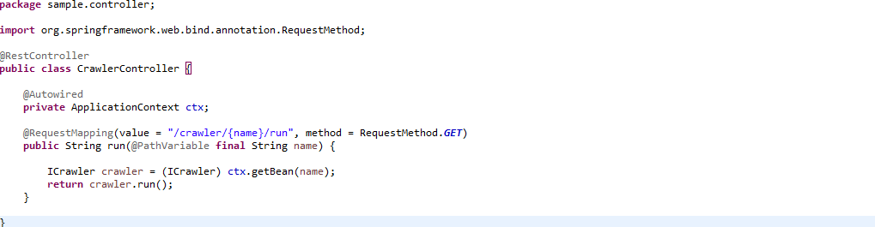

Bean factory

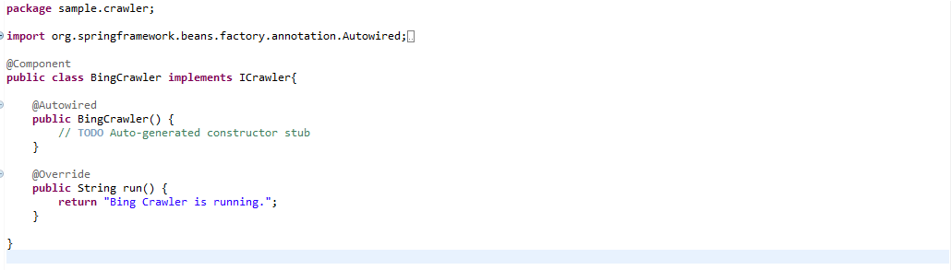

Annotation register & Polymorphism

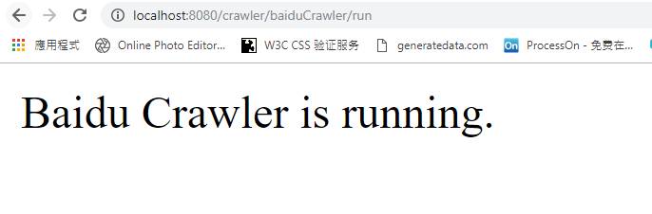

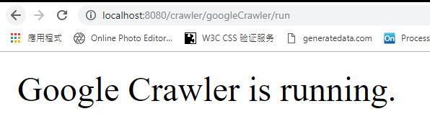

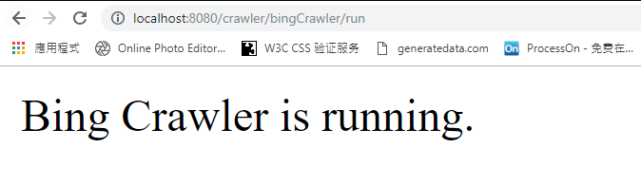

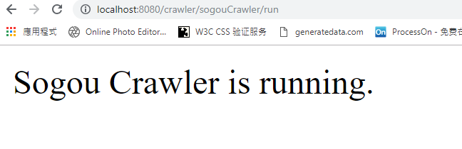

Python

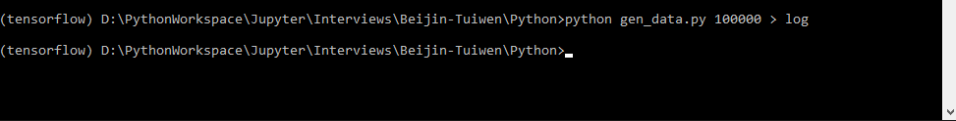

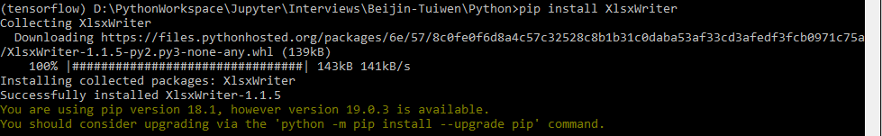

Install XlsxWriter