Admin Panel Front
Adventure Station
Technical and End-User Documentation

Document version: 1.0
Date: June 12, 2026
Paradise Solutions / JS Tour & Travel



Table of Contents

Part I — End-User Documentation
- System access and navigation
- Creating and configuring Tours
- Creating and configuring Providers
- Creating and configuring Operators
- User management and permissions
Part II — Technical Documentation
- Stack, architecture, and project structure
- Authentication, API, and Redux
- Routes and development guide
- Configuration, troubleshooting, and file reference

Part I — End-User Documentation

1. Introduction
Admin Panel Front is the web administration panel for Adventure Station. This application manages tours, providers, operators, catalog data, users, and commercial settings. The sidebar menu only shows the modules your account has access to.

2. System Access
- Open the panel URL in your browser (default in development: http://localhost:3000).
- Enter your email and password on the login screen.
- Click the login button. If credentials are valid, you will be redirected to the Tours section.
- If you forgot your password, use the 'Forgot password' link to request a reset by email.

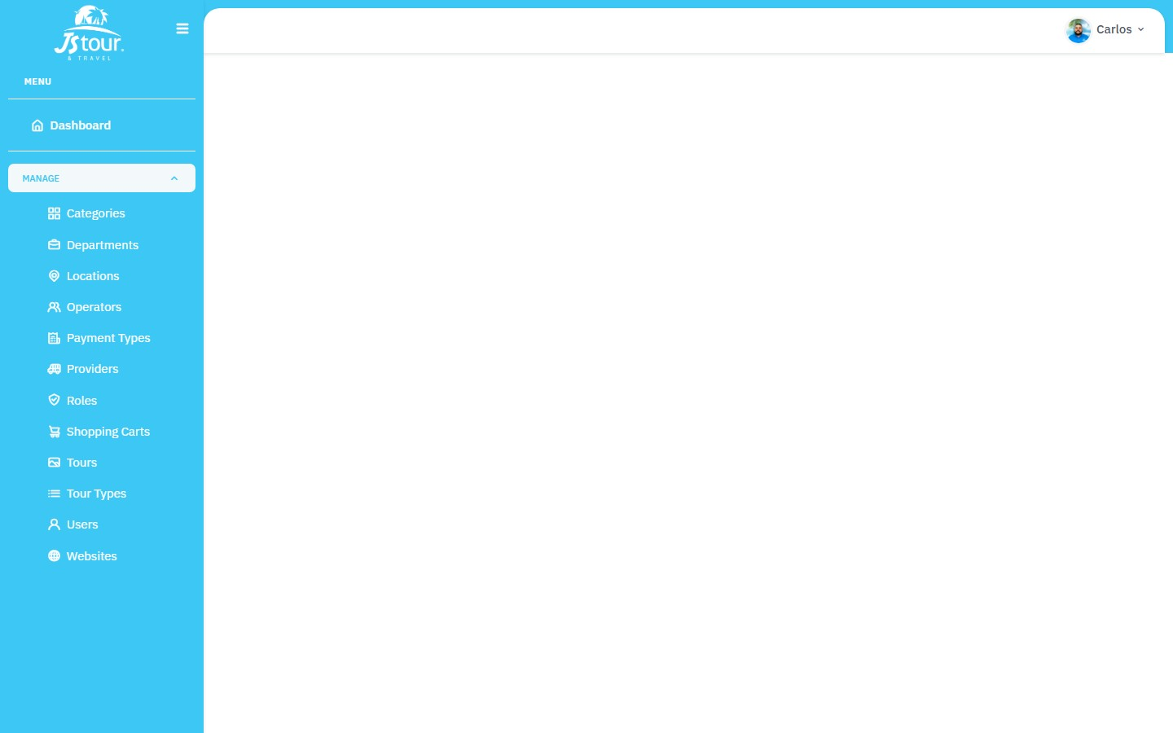
Figure 1 — Admin panel login screen (live screenshot)

3. General Navigation
After logging in, you will find the following navigation structure:
- Sidebar: access to modules based on permissions (Tours, Providers, Operators, Users, etc.).
- Header: logo, user profile, and logout option.
- Content area: table listings with filters, global search, and 'Add New' button.
- Edit screens: forms organized in tabs (Tours) or accordions (Providers/Operators).

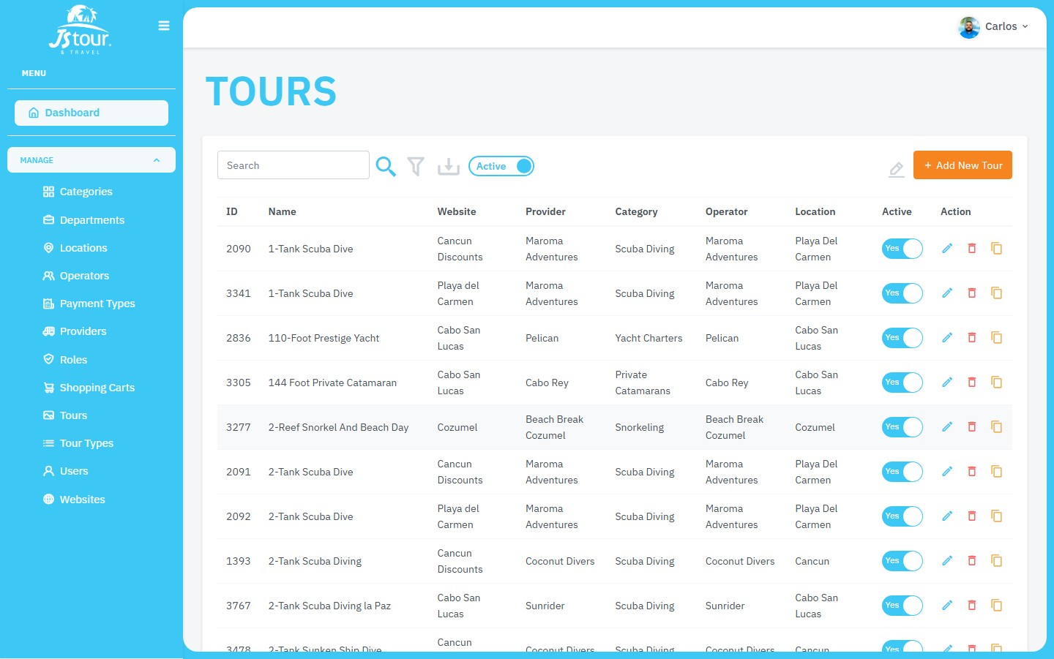
Figure 2 — Main view after login: tours list with sidebar and action bar

4. Process: Creating a Tour
Tours are the main module of the system. Creation happens in two phases: initial registration with general data, then detailed configuration on the edit screen.

4.1 Tours List
- In the sidebar, select 'Tours'. The list opens at /tours.
- Use the global filter to search tours by name, code, or other fields.
- The Active/All toggle lets you view active tours or all records.
- The orange 'Add New Tour' button (top right) starts creation.


Figure 3 — Tours list with 'Add New Tour' button and filter controls

4.2 Create Tour — General Information
- Click 'Add New Tour'. You will be directed to /tours/new.
- Fill in the required fields marked with an asterisk (*):
- • Tour Type: tour type (e.g. Adventure, Fishing, Transportation).
- • Website: website where the tour will be published.
- • Shopping Cart: shopping cart associated with the selected website.
- • Provider: provider offering the service.
- • Operator: operator running the tour.
- • Location: geographic location of the tour.
- • Main Category and Sub-Category (if applicable): catalog categorization.
- • Tour Name: commercial name of the tour.
- • 2-Digit Code: unique two-character code.
- Click 'Continue' to save. The system shows a success message and redirects to tour editing.

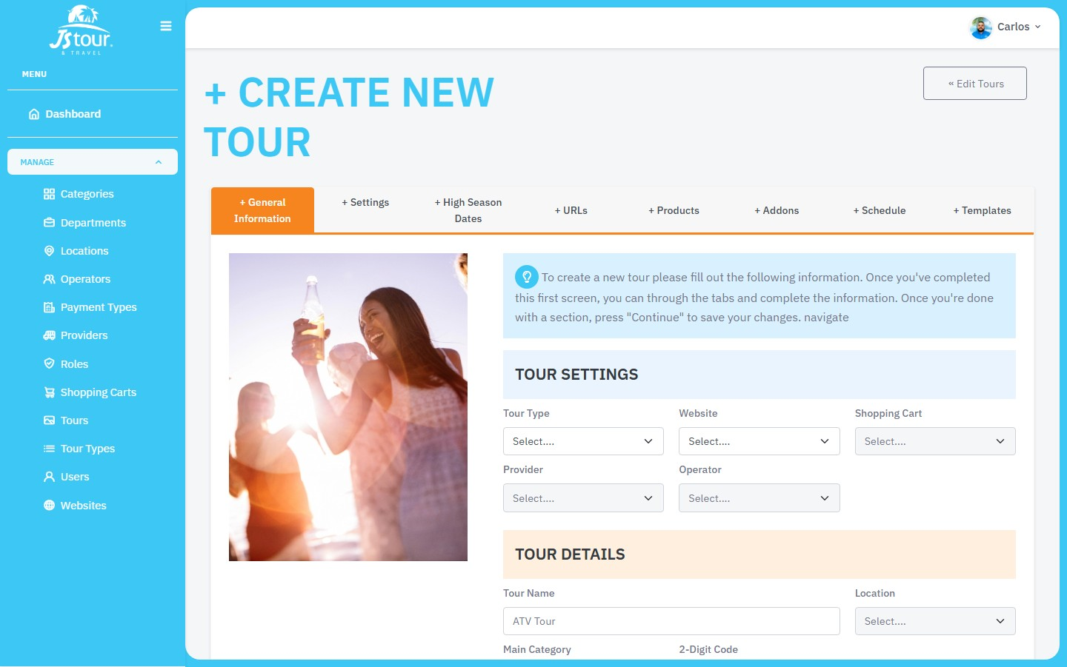
Figure 4 — Tour creation form (General Information tab, live screenshot)

4.3 Configure Tour — Edit Tabs
Once the tour is created, go to /tours/{id} to complete configuration. Available tabs:
- General Information — basic tour data.
- Settings — operational configuration, duration, capacity, instructions.
- Payments — payment methods and conditions.
- High Season Dates — high season dates and special pricing.
- URLs — web pages associated with the tour.
- Products — products and pricing.
- Addons — tour add-ons and extras.
- Schedule — schedules and availability.
- Templates — automated confirmation.
- Related — related tours.

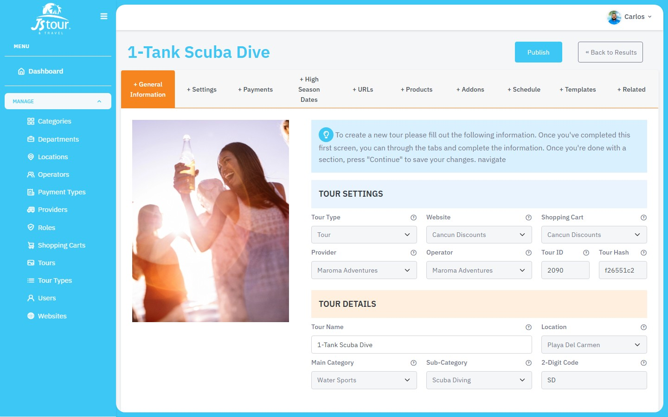
Figure 5 — Tour edit: General Information tab

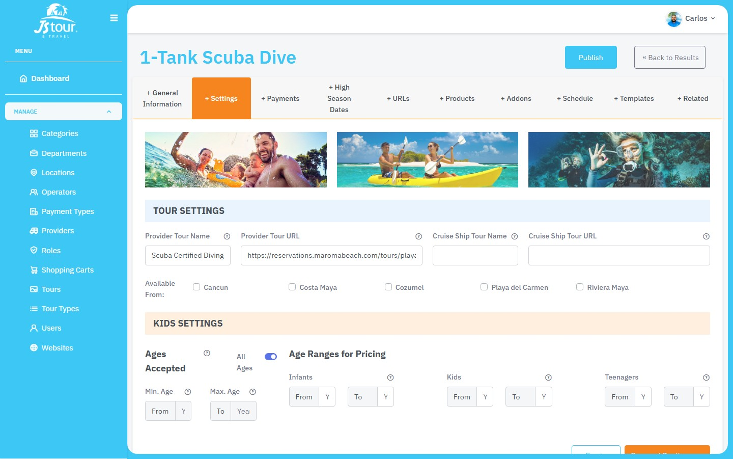
Figure 6 — Tour edit: Settings tab

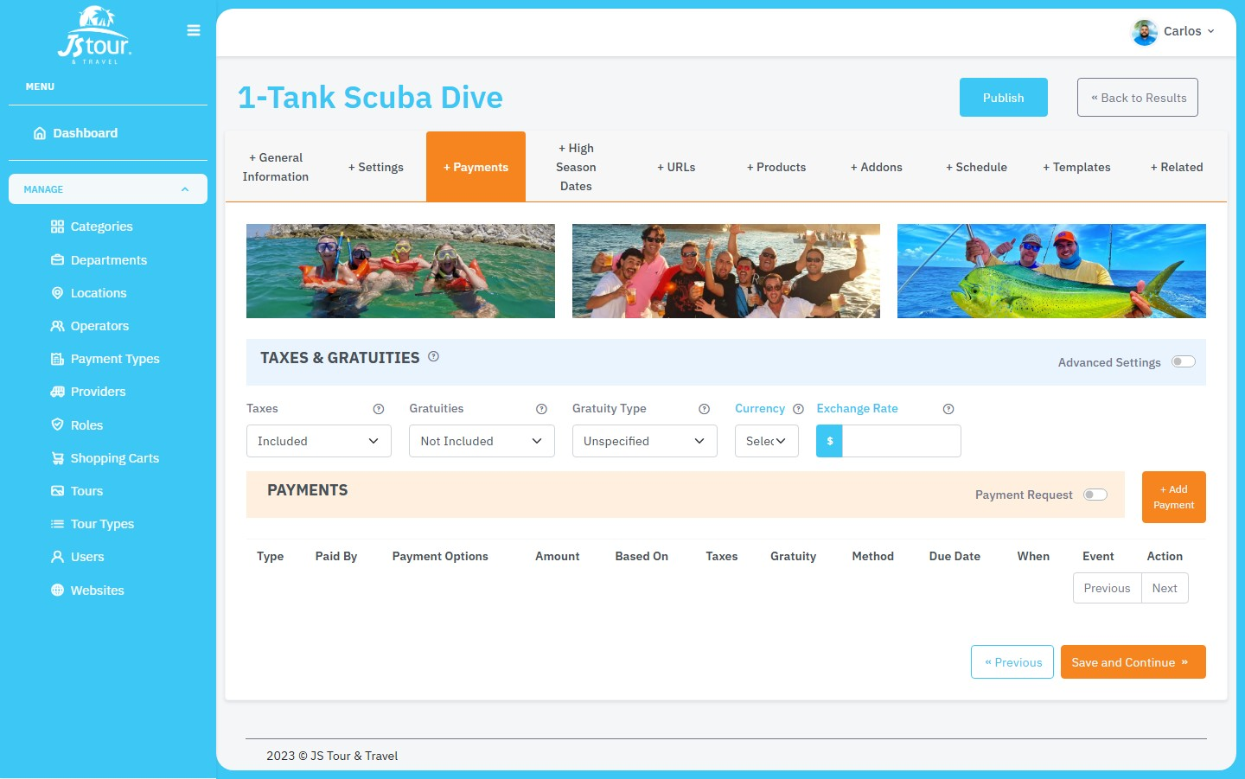
Figure 7 — Tour edit: Payments tab

4.4 Payments, Seasons, and Products
- On the Payments tab, configure accepted payment methods and their conditions.
- On High Season Dates, define high season periods with differentiated pricing.
- On Products, create pricing products (private tours, charters, transfers, etc.).
- On Addons, add optional tour add-ons.
- On Schedule, configure departure times, available days, and calendar exceptions.

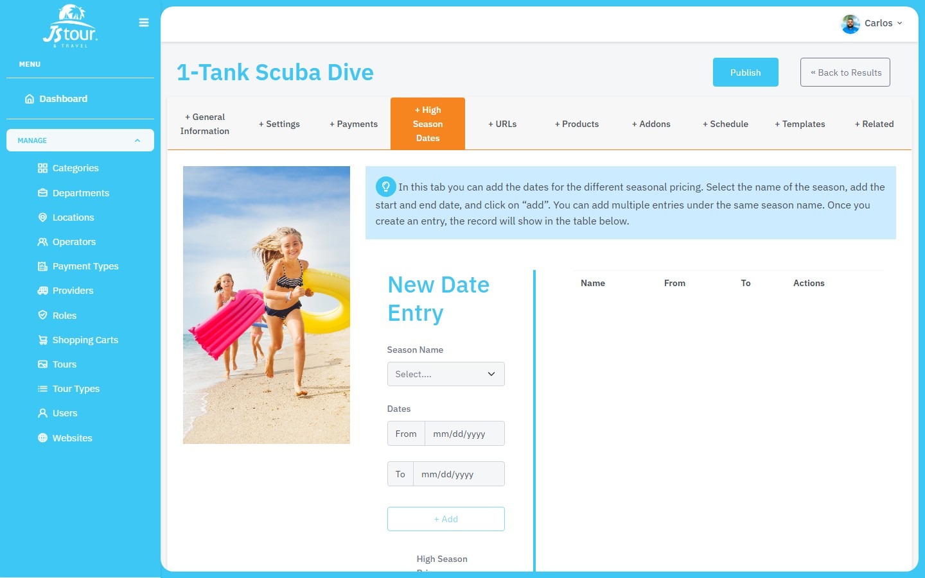
Figure 8 — Tour edit: High Season Dates tab

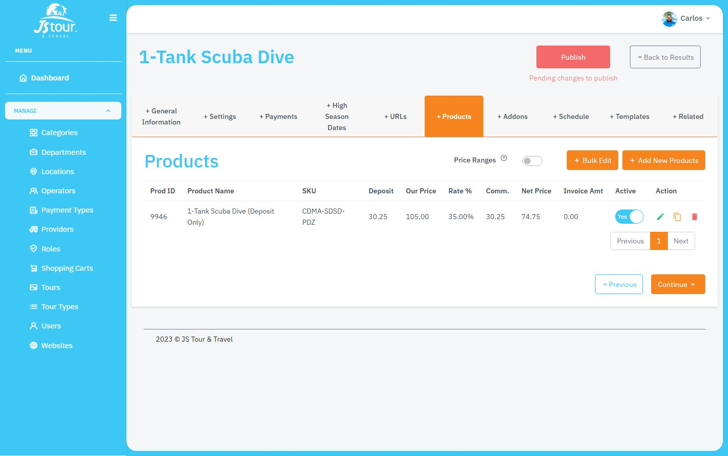
Figure 9 — Tour edit: Products (pricing) tab

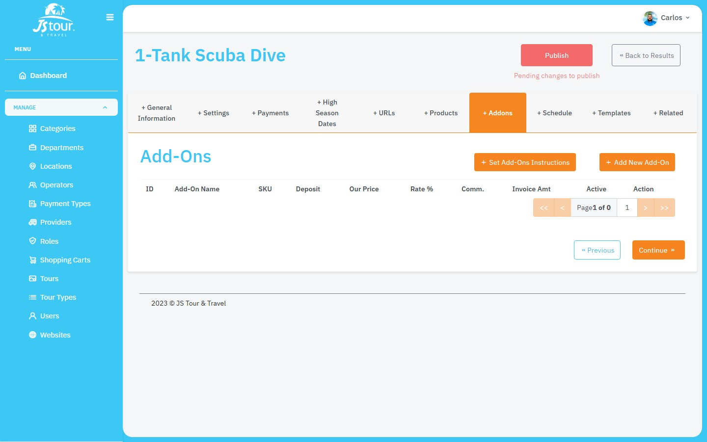
Figure 10 — Tour edit: Addons tab

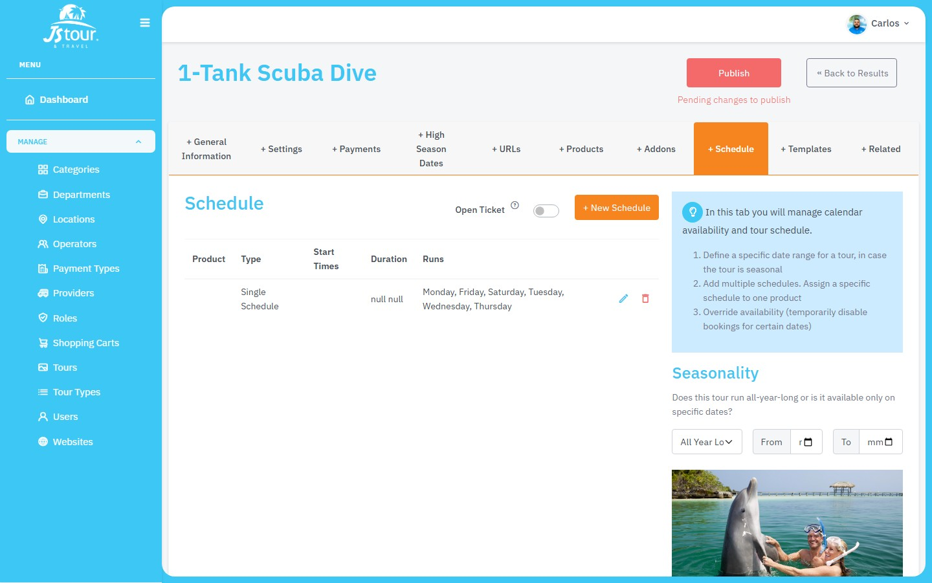
Figure 11 — Tour edit: Schedule tab

4.5 Publish Changes
- After changes to URLs, prices, or schema, the 'Publish' button may turn red indicating pending changes.
- Click 'Publish' to push updates to the tour's web pages.
- Wait for confirmation. Tours with many URLs may take longer to process.
- Use 'Back to Results' to return to the tours list.

5. Process: Creating a Provider
Providers are companies or entities offering tourism services. They can also be configured as operators using a toggle in the form.

5.1 List and Access
- In the sidebar, select 'Providers' (/providers).
- Use filters and global search to find existing providers.
- Click 'Add New Provider' to create a new record.

5.2 Create Provider — General Information
- Fill in the required fields:
- • Name (*): commercial name of the provider.
- • 2-Digit Code (*): two-character identifier code.
- • Country code (*): country code.
- • Service Area (*): select at least one service area.
- Fill optional fields as needed: legal name, address, phones, emails, WhatsApp, website, description.
- Enable the 'Operator' toggle if this provider also acts as a tour operator.
- Click 'Save Changes'. The system redirects to /providers/{id} to complete configuration.

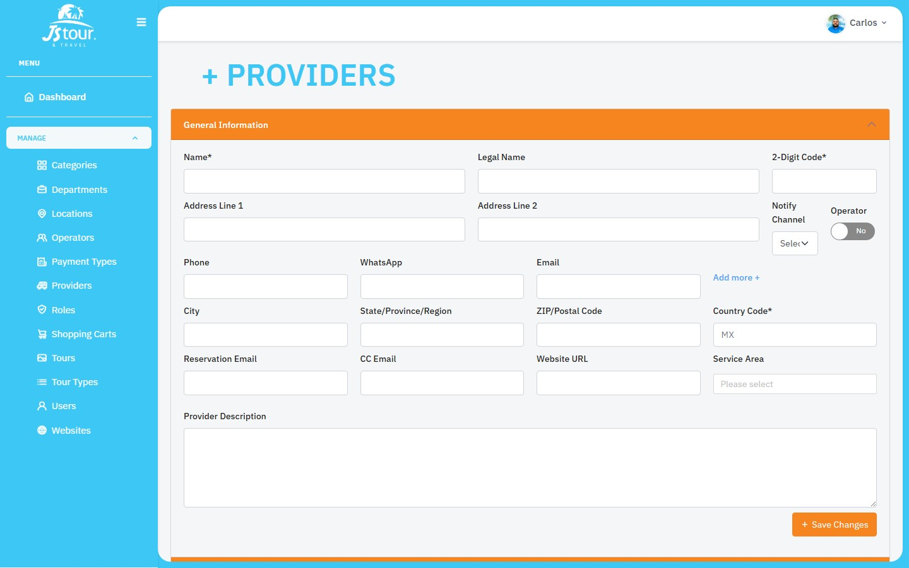
Figure 13 — Provider creation form (General Information, live screenshot)

5.3 Configure Provider — Edit Sections
- Edit General Information — update basic provider data.
- Contacts — add and edit provider contacts.
- Payment Methods — configure ACH, Zelle, PayPal, and other payment methods.
- Assets — manage boats, vehicles, and resources (only if is_operator = Yes).
- Operational Info — cancellation, change, no-show, holiday policies, documents.
- Social Media — provider social media profiles.

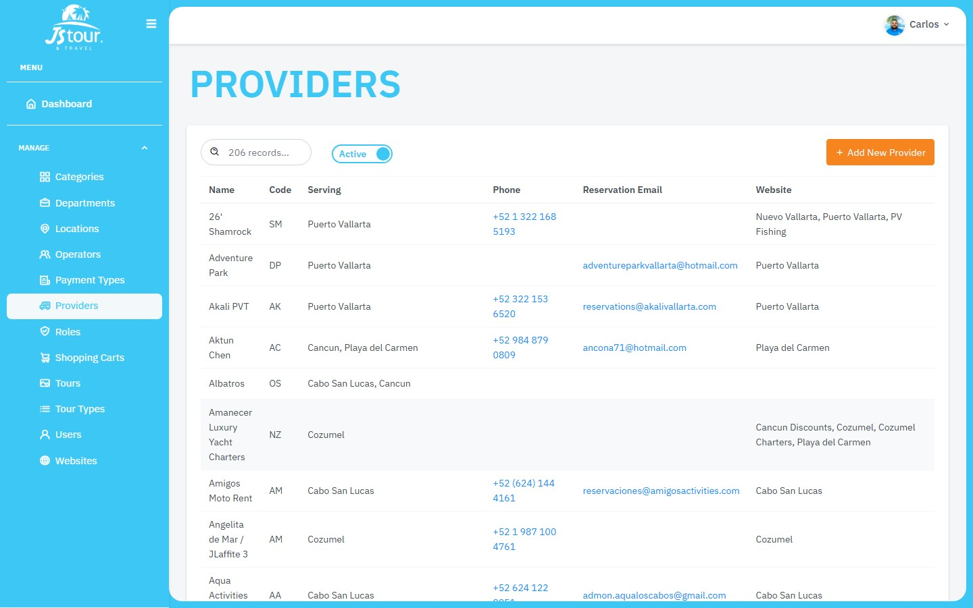
Figure 14 — Providers list with 'Add New Provider' button

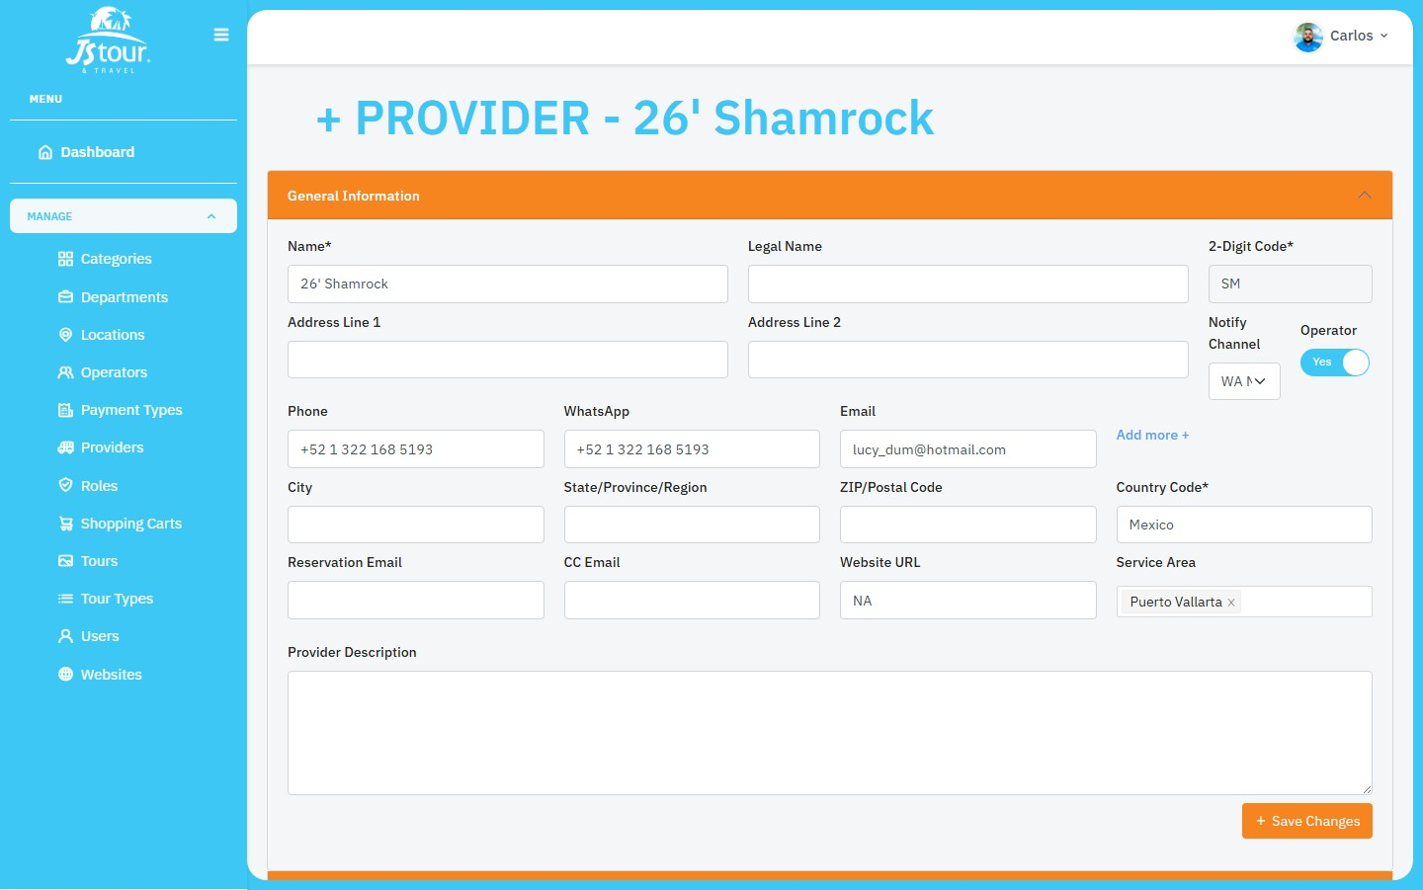
Figure 15 — Provider edit screen with accordion sections

6. Process: Creating an Operator
Operators run tours in the field. They share structure with providers but include specific sections such as automated confirmation, vouchers, and restrictions.

6.1 List and Access
- In the sidebar, select 'Operators' (/operators).
- Review the operators list with filters and search.
- Click 'Add New Operator' to start creation.

6.2 Create Operator — General Information
- Fill in required fields: Name, 2-Digit Code, Country code, and Service Area(s).
- Add contact information: phones, emails, WhatsApp, website, and description.
- Enable the 'Provider' toggle if this operator also acts as a provider.
- Click 'Save Changes'. You will be redirected to /operators/{id}.

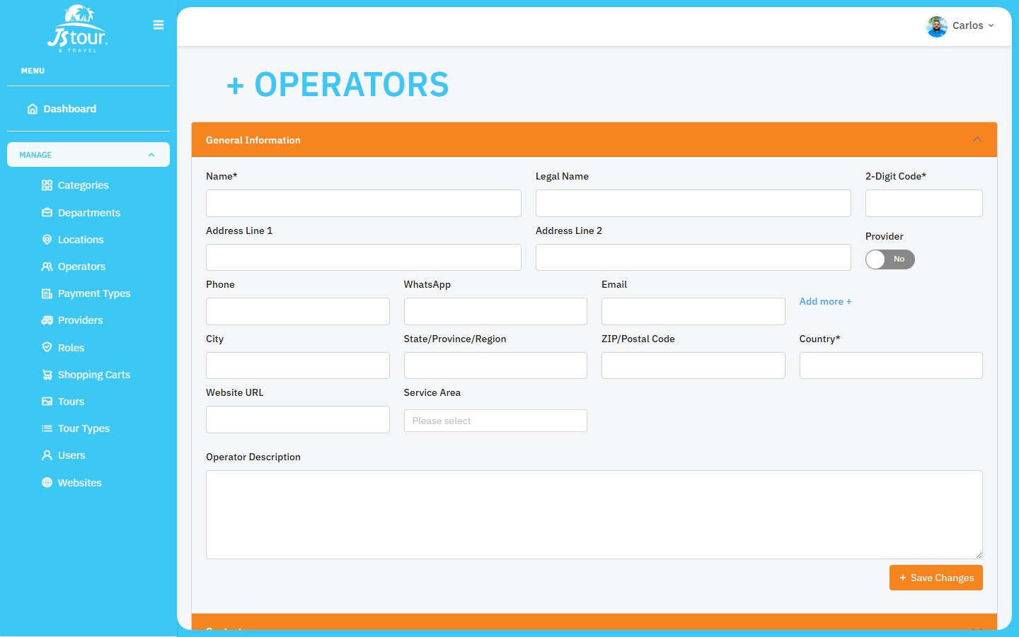
Figure 16 — Operator creation form (General Information, live screenshot)

6.3 Configure Operator — Edit Sections
- Edit General Information — basic operator data.
- Contacts — operational and administrative contacts.
- Payment Methods — visible only if the operator is also a provider (is_provider = Yes).
- Automated Confirmation — vouchers, extra fees, notification channels.
- Assets — boats, maps, locations, restrictions, and additional fees.
- Social Media — social media presence.

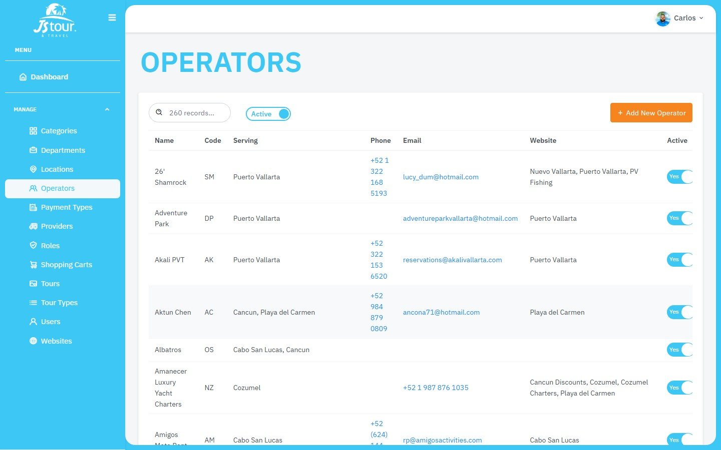
Figure 17 — Operators list with 'Add New Operator' button

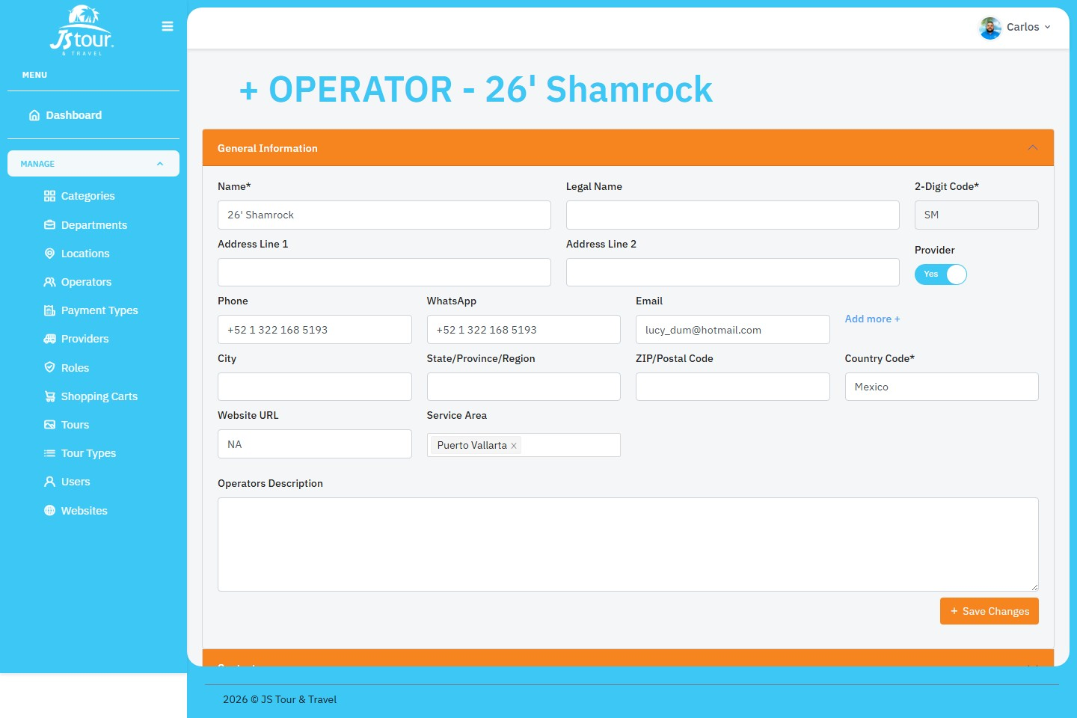
Figure 18 — Operator edit screen with accordion sections

7. User Management
- Go to 'Users' in the sidebar (/users).
- To create a user, click 'Add New User'. A modal with the form will open.
- Fill in: first name, last name, email, password, job title, department, and role.
- Click 'Submit'. The modal closes and the list refreshes.
- To edit, use the pencil icon in the Action column. To delete, use the trash icon (confirmation required).

8. Permissions and Modules
Each user has assigned modules that determine which sections they can see:
ID | Module | Main route
1 | Users | /users
2 | Departments | /departments
3 | Roles | /roles
4 | Websites | /websites
5 | Tour Types | /tour-types
6 | Categories | /categories
7 | Locations | /locations
8 | Operators | /operators
12 | Shopping Carts | /shopping-carts
13 | Payment Types | /payment-types
14 | Providers | /providers
15 | Tours | /tours
If you do not see a module in the menu, contact an administrator to assign the corresponding permission to your role.

Part II — Technical Documentation

1. Technology Stack
Area | Technology | Version / Notes
UI Framework | React | 17.x
Build Tool | Create React App (react-scripts) | 5.0.0
Routing | react-router-dom | v5
Global state | Redux + redux-thunk | —
HTTP Client | Axios | —
Forms | Formik + Yup | Schema validation
Tables | react-table, react-bootstrap-table-next | —
Alerts | SweetAlert2 | Confirmations and messages
Dates | moment | —
Styling | SCSS + Bootstrap 5 + Reactstrap | Theme #3DC7F4
Additional UI | Ant Design, Material-UI v4 | Spot usage

2. Application Architecture
Startup and routing flow:
- src/index.js — Mounts Redux Provider, BrowserRouter, and global styles (theme.scss).
- src/App.js — Renders AppRoutes.
- AppRoutes — Splits public (/login, /forgot-password, /reset-password) and private routes.
- PrivateRoutes — Checks token in localStorage; redirects to /login if missing.
- Layout — Authenticated shell with Header + Sidebar + ContentRoutes.
- ContentRoutes — Registers routes for each business module.

3. Project Structure
Main folder organization:
- src/Pages/ — Screens by domain (Tours, Providers, Operators, Users, Auth, etc.).
- src/Components/Layout/ — Header, Sidebar, Layout.
- src/Components/Common/ — TableContainer, reusable modals.
- src/Components/Assets/ — SCSS, images, fonts.
- src/Utils/API/ — Axios functions per resource.
- src/Utils/Redux/ — Store, Actions, Reducers, Types.
- src/Utils/Routes/ — Public and private route definitions.
- src/Utils/CommonFunctions/ — Shared utilities.

4. Authentication and Security
Authentication flow implementation:
- Login: POST /login with email and password (src/Pages/Auth/Login/index.js).
- Response stored in localStorage under key 'token' (JWT + user + modules).
- createStorageSync updates Authorization: Bearer <token> header on all Axios requests.
- PrivateRoutes parses the token; missing or corrupt token redirects to /login.
- Post-login: automatic redirect to /tours.
- Logout: Header.js removes token from localStorage.
- Forgot/Reset password: POST /forgot-password and POST /reset-password.
Key authentication files:
- src/Utils/API/index.js — API_URL and header configuration.
- src/Utils/Routes/PrivateRoutes.js, PublicRoutes.js
- src/Utils/Redux/Actions/LoginActions/index.js
- src/Pages/Auth/Login/index.js, ForgotPassword/index.js, ResetPassword/index.js

5. API and Backend Communication
Production base URL: https://api.paradisesolutions.com/api (configurable in src/Utils/API/index.js).

5.1 Main endpoints
Resource | Method | Endpoint | Purpose
Auth | POST | /login | Sign in
Tours | GET | /tours/filter-status/{0|1} | Filtered list
Tours | POST | /tours | Create tour
Tours | GET | /tours/{id} | Get tour
Providers | GET | /providers/filter-status/{0|1} | List
Providers | POST | /providers | Create provider
Operators | GET | /operators/filter-status/{0|1} | List
Operators | POST | /operators | Create operator
Users | POST | /users | Create user
Users | PUT | /users/{id} | Edit user

5.2 Redux pattern
Standard flow for list screens:
- Types in Utils/Redux/Types/ — GET_<DOMAIN>_INIT | SUCCESS | ERROR.
- Action thunk — dispatch INIT, call Axios, dispatch SUCCESS with resp.data.
- Reducer — stores { data, loading, error } under the domain key.
- Page — useEffect(() => dispatch(domainData())), useSelector(state => state.domain...).
- Note: edit screens often call the API directly without Redux.
Combined reducers in the store:
login, departments, websites, users, modules, roles, tourTypes, carts, paymentTypes, categories, providers, locations, operators, serviceArea, tours.

6. System Routes

6.1 Tours
Route | Component | Description
/tours | Pages/Tours/index.js | List
/tours/new | Pages/Tours/newTour.js | Create tour
/tours/:id | Pages/Tours/editTour.js | Edit (10 tabs)

6.2 Providers
Route | Component | Description
/providers | Pages/Providers/index.js | List
/providers/new | Pages/Providers/newProvider.js | Create
/providers/:id | Pages/Providers/editProvider.js | Edit (accordions)

6.3 Operators
Route | Component | Description
/operators | Pages/Operators/index.js | List
/operators/new | Pages/Operators/newOperator.js | Create
/operators/:id | Pages/Operators/editOperator.js | Edit (accordions)

7. Development Guide

7.1 Quick start
- Requirements: Node.js 16.x/18.x LTS, npm 8+.
- git clone <repo> && cd admin-panel-front
- npm install
- npm start → http://localhost:3000
- npm run build → build/ folder

7.2 Add an endpoint
- Create or extend functions in src/Utils/API/<Resource>/index.js.
- Import API_URL and options from src/Utils/API/index.js.
- If the list should use Redux: add action + reducer + type.

7.3 Add a route
- Create a page in src/Pages/<Module>/.
- Create or extend Utils/Routes/<Module>Routes/index.js.
- Register in ContentRoutes.js.
- Add entry in Sidebar.js with the correct module_id.

7.4 UI patterns
- Lists: TableContainer + columns in *Cols.js + SweetAlert2 for confirmations.
- Tour editing: Reactstrap Nav + TabContent tabs.
- Provider/Operator editing: Collapse accordions with independent sections.
- Modals: src/Components/Common/Modals/ (64+ modals, mostly in Tours and Pricing).
- Forms: Formik + Yup for validation.

8. Configuration and Environment
Local backend (optional):
src/Utils/API/index.js contains commented code to point to localhost. Uncomment and adapt for your team's environment.
UI preferences (sessionStorage):
getCookie/setCookie in Utils/API/index.js use sessionStorage for filters and preferences (e.g. active/inactive tours toggle).

9. Troubleshooting
Symptom | Likely cause | Solution
Redirects to /login | Missing or corrupt token | Clear localStorage and sign in again
Module not visible | No module_id in token.modules | Assign permission to the user's role
401 API error | Expired token | Log out and sign in again
npm start fails | Insufficient memory | NODE_OPTIONS=--max-old-space-size=4096
Data not updating | Stale Bearer token | Verify createStorageSync after login

10. Key File Reference
File | Responsibility
src/index.js | Application entry point
src/Utils/Routes/AppRoutes.js | Public vs private routes
src/Utils/Routes/ContentRoutes.js | Authenticated routes
src/Components/Layout/Sidebar.js | Menu and module permissions
src/Utils/API/index.js | Central API configuration
src/Utils/Redux/Store/index.js | Redux store
src/Pages/Tours/editTour.js | Tour editing (most complex module)
src/Pages/Providers/editProvider.js | Provider editing
src/Pages/Operators/editOperator.js | Operator editing

11. Useful Commands
- npm start — Development with hot reload
- npm run build — Production build
- npm test — Tests with Jest + Testing Library
- python scripts/capture_screenshots.py — Capture live panel screenshots
- python scripts/generate_documentation_en.py — Regenerate this English Word document

