|  |
| --- |
| Multi-Platform Desktop RSS Reader |
|  |

|  |  |  |  |
| --- | --- | --- | --- |
|  |  |  |  |
|  | INTRODUCTIONModern-day applications are focused on mobile devices but many people also are dependent on Desktops in their day-to-day life, RSS readers for mobile devices are common but Desktop applications are rare. Here I have created a solution for this problem by introducing a minimal and material-themed RSS reader that works on all desktop platforms.The creation of this application used QT native functions and instead of using a database to store data a local JSON format is used to further simplify and minimize the size of the application. The application is completely functional while a few future implementations are possible with further development. Further clarification will be done below. | |  |
|  | Scope and Functionality The requirements of the software are as follows:   * The user can add any RSS feed he needs * Needs a straightforward process * The interface needs to be simple and minimal * User should be able to remove and add new feeds as he wishes * RSS feed topics need to be updated instantly * The app needs to run on minimum system resources * User should be able to instantly access their daily feeds * User can exit at any time and data needs to be saved and should stay persistent during the next opening of the application * User can view all information within the same application   All the above has been implemented in the application except for the viewing of info within the same application due to time constraints and depreciated functionalities in the latest version of QT. | |  |

##### Bugs and Issues

The initial plan of the application was to display the selected RSS Topic within the application itself but QtWebEngine elements needed for this function have been depreciated and have been replaced by Chromium based widgets which need additional programming function which were not completed due to time constraints. Instead, I have opted to opening news feed topics through the default installed web browser of your desktop.

Bugs:

* Some feed topics may not display on Windows platform. Clicking on the topic or link a few times resolves this issue. Bug seems to be due to a windows communication error through SSL authentication.
* Some RSS feeds will not display at all on Windows platform at all. To overcome this the user needs to install OpenSSL Separately. Packaging the OpenSSL package with the windows installer is a possible fix for this.

##### Supported Platforms

The app has been compiled and run on the Following platforms:

* Ubuntu 20.04.1 LTS
* Windows 10 Pro Build 19042.685

MacOS compatibility is possible but not tested.

|  |  |  |  |
| --- | --- | --- | --- |
|  |  |  |  |

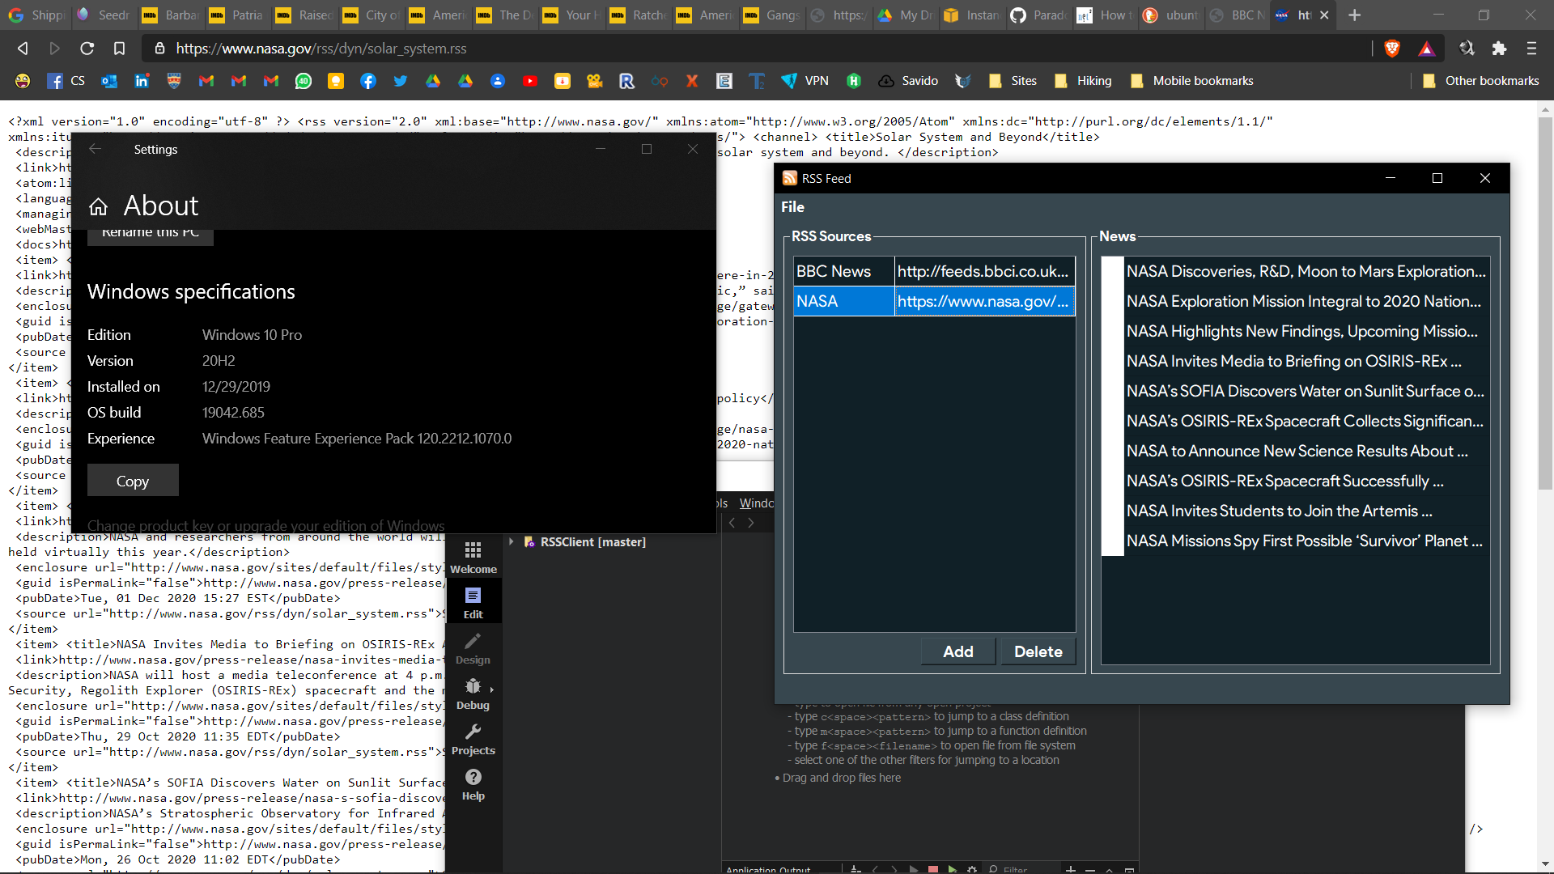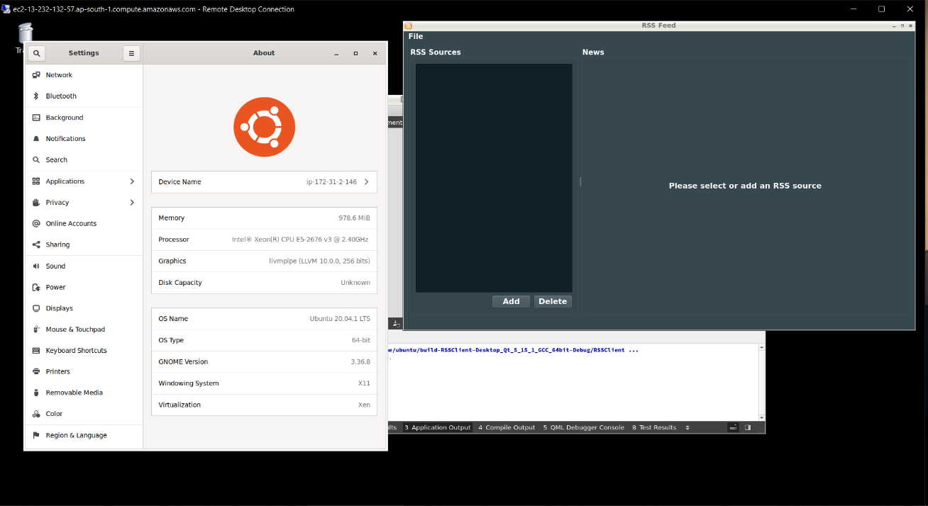

*Successfully compiled on a Windows Platform. Image shows the application with along with the Windows OS information and a RSS feed example in the background. The same RSS feed has been added to the application and is successfully displayed*

*Successfully compiled on Ubuntu OS. Image shows the application along with the Ubuntu OS details. (Ubuntu OS running on a AWS EC2 instance RDP connected to windows Desktop)*

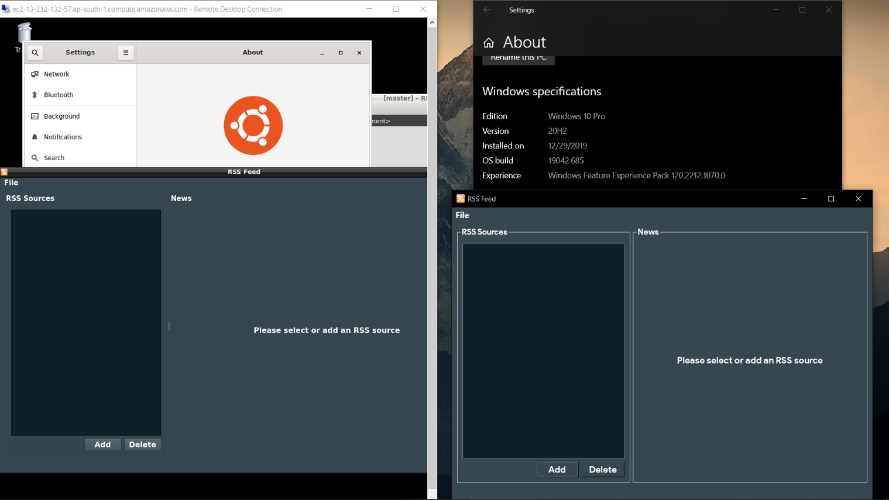

##### Interfaces

The interfaces have been designed by taking into consideration UI/UX principles and using a minimal and straightforward interface. Colors are of a material theme which is preferred by most users in modern times. The entire application Consists of two resizable interfaces;

* Main windows which contains the feed and links with topics
* Add Feed window which is used to add new feeds to the application

The rest is taken care of by the backend of the application leaving the user with little to no need of doing complex actions.

*Side by Side view of application running on Windows OS and Ubuntu OS*

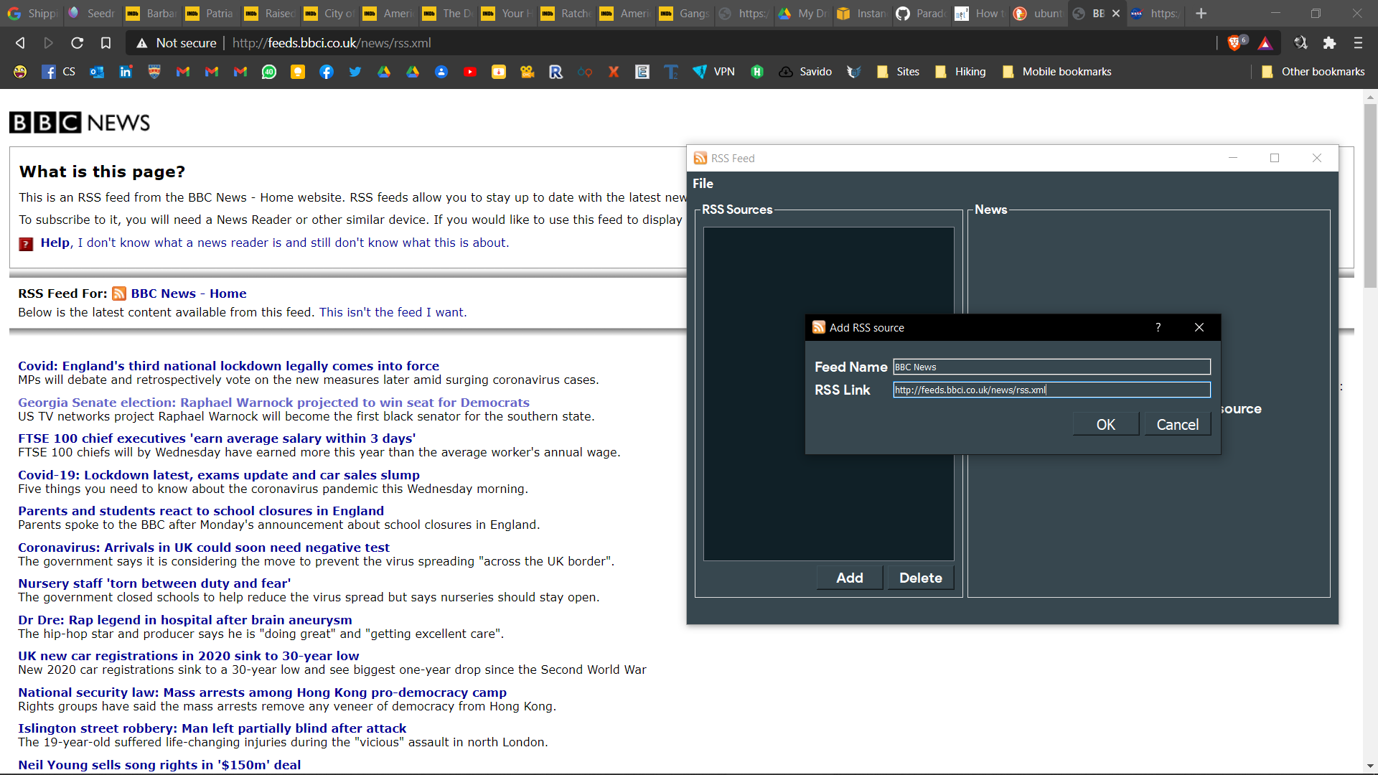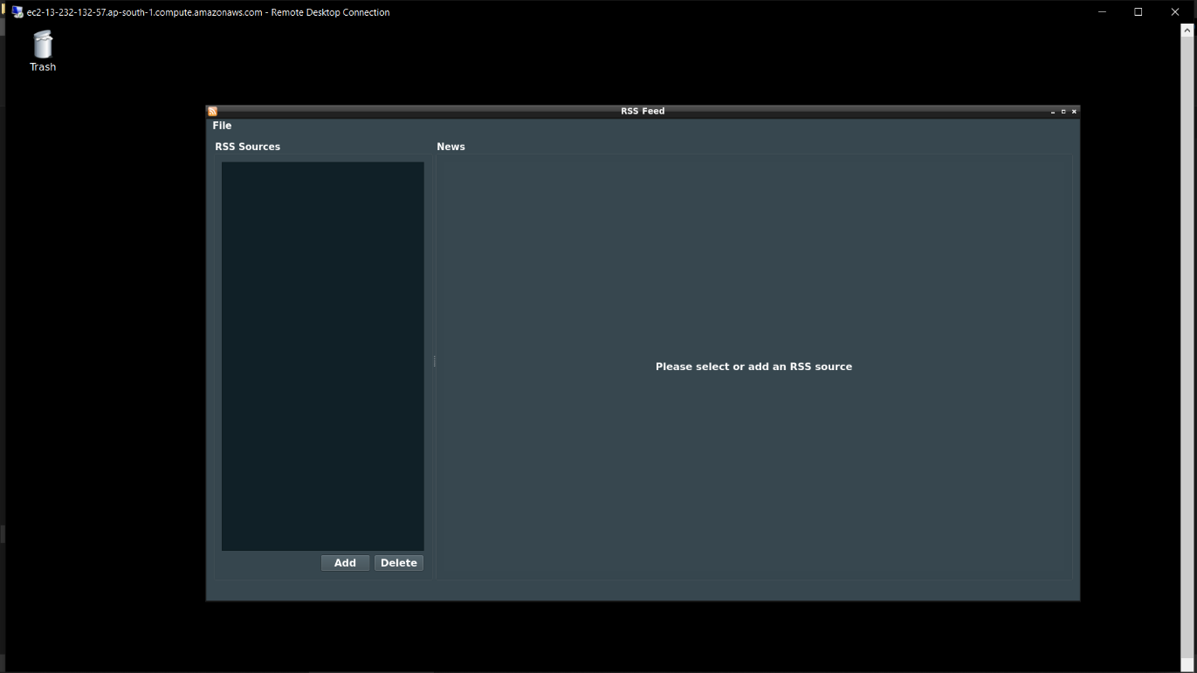

*The add feed dialog and a example of a feed that is to be added.*

*The Main windows where all information topics and feeds are displayed.*

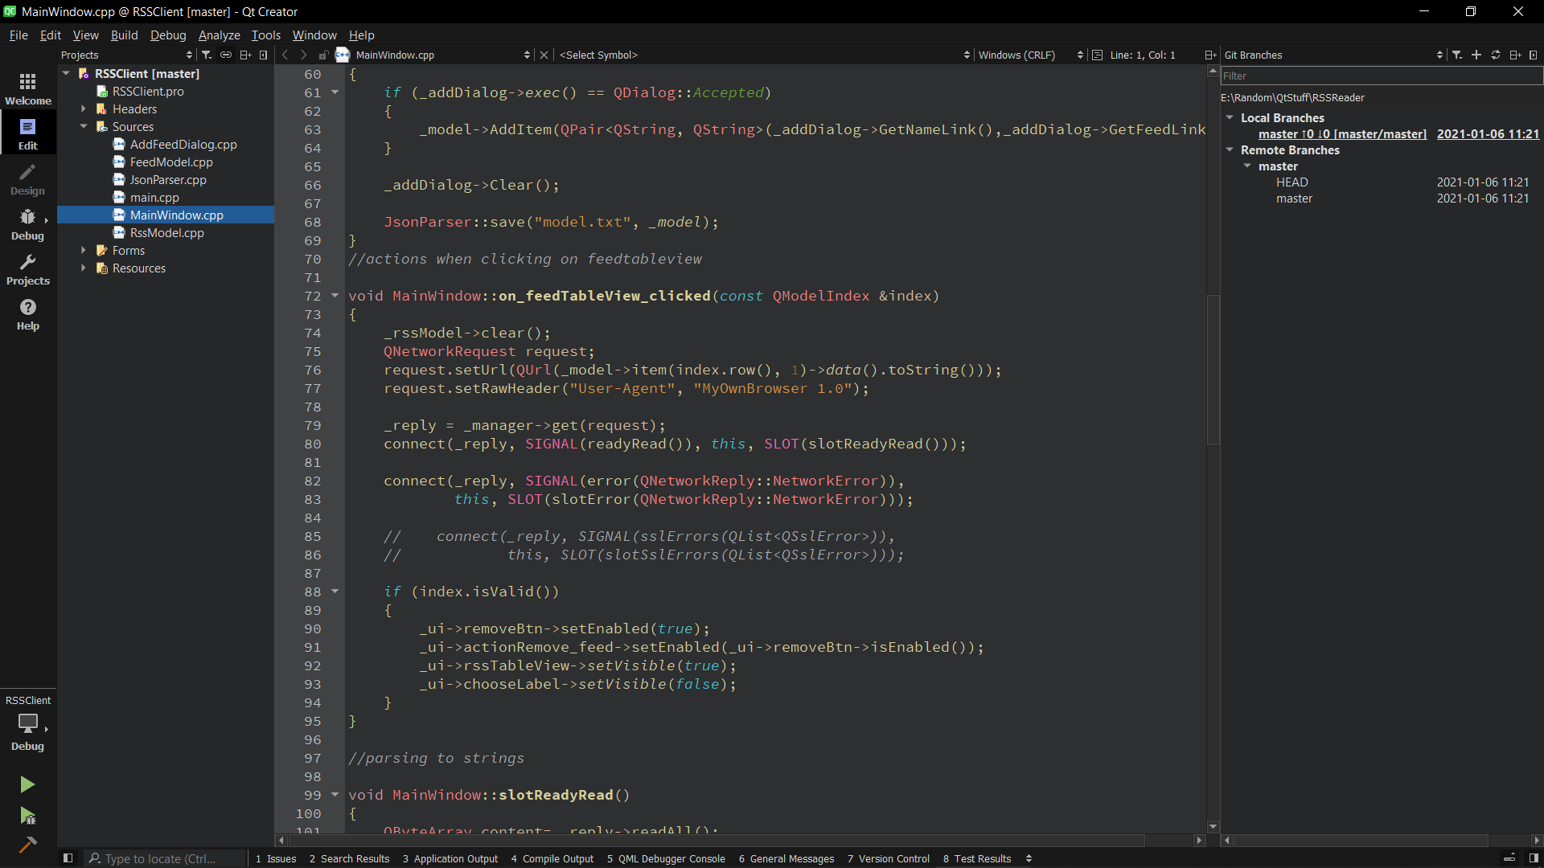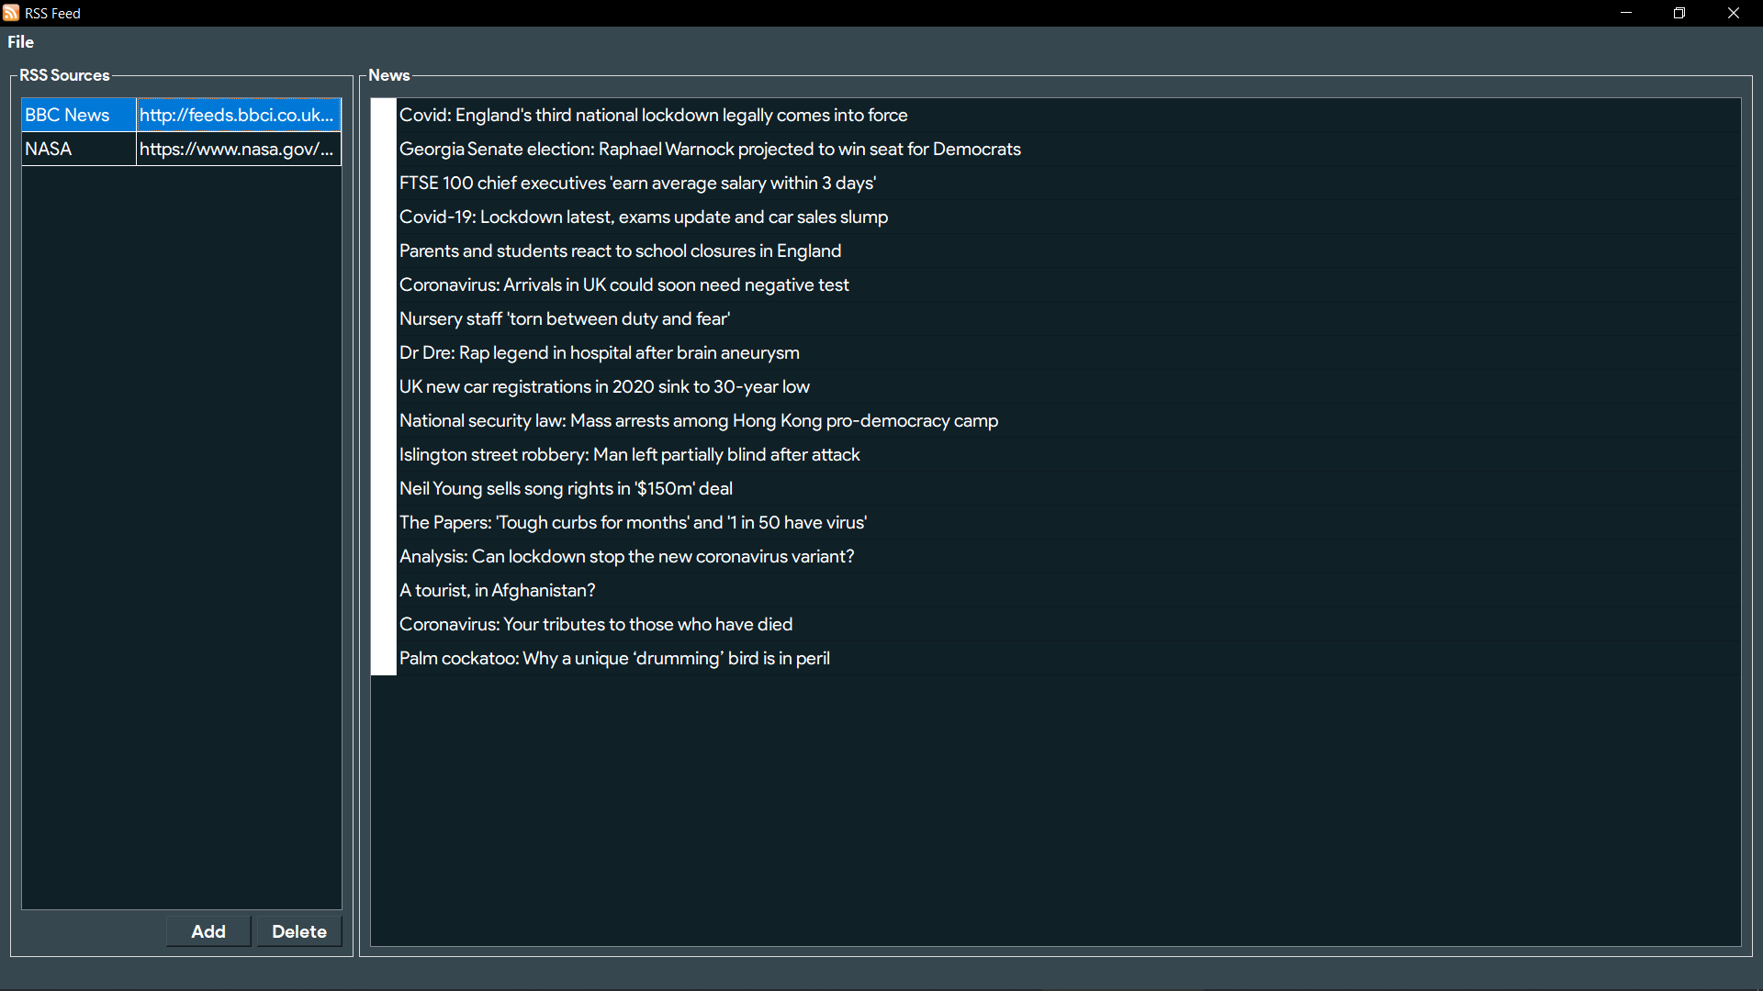

Network Redirections

##### Future Implementations

Further convenience would be added if the user does not need to be redirected to a separate browser to view the feeds. Instead being able to read the entire feed topic within the application itself would further enhance the users experience.

Suggesting the user with new topics and RSS feeds to add can be implemented according to the tastes of the user.

*The application when it is in full use with added links and RSS Feed topics that the user can click and go forward with.*

##### Installing the application

## Windows OS

Install the OpenSSL package for proper functionality through this link [Link](https://slproweb.com/products/Win32OpenSSL.html)

The 3MB installer will be sufficient.

On windows platform use the ***Desktop QT 5.15.1 MinGW 32-Bit***kit to compile the application when in debugging mode.

Run the application and enjoy!

## Linux (Ubuntu)

No extra packages need to be installed. Just compile and run!

##### RSS Link examples for running

BBC Top Stories: <http://feeds.bbci.co.uk/news/rss.xml>

BBC World News: <http://feeds.bbci.co.uk/news/world/rss.xml>

BBC News UK: <http://feeds.bbci.co.uk/news/uk/rss.xml>

NASA Breaking News: <https://www.nasa.gov/rss/dyn/breaking_news.rss>

Life Hacker: <https://lifehacker.com/rss>

Reddit News: <https://www.reddit.com/r/news/.rss>