# CPRG-352 - Web Application Programming

## Lab 7

## Topic: JDBC

This lab is intended to be completed over two weeks.

## Description

We are going to be building a 3-tier MVC Web Application from scratch with a MySQL database. The application will be used to manage users. The web application must have the ability to view all users, add a user, update a user, and delete a user. A user must have the following attributes:

* email (primary identifier/key of a user)
* active (boolean to determine if the user account is active)
* first name
* last name
* password
* role (one of system admin, regular user, or company admin)

For updating (editing) a user account, all attributes are editable except for email.

# User Interface

The user interface design is completely up to you. Recommendations: checkbox for active, drop-down list for role, and textboxes for everything else. You do not need to show all of the user attributes for “view all users” functionality; you may show just the first name and last name, if you wish. There is no need for authentication (login) or authorization (permissions).

Below is an example UI created by a student from a previous year. *(Please note: the “active” field is not shown here.)*

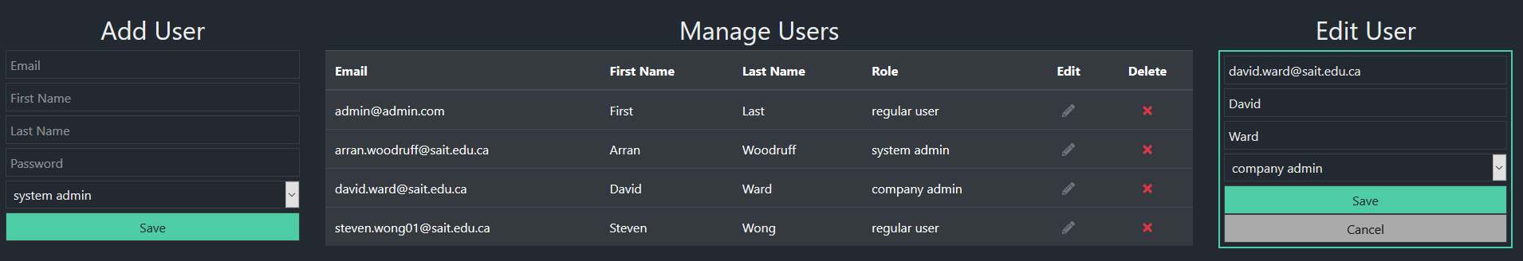

# Part A: Database

The following SQL script goes in a file called database/userdb.sql within the NetBeans project. Feel free to customize the script as much as you want.

DROP SCHEMA IF EXISTS `userdb`;

CREATE SCHEMA IF NOT EXISTS `userdb` DEFAULT CHARACTER SET latin1;

USE `userdb`;

-- -----------------------------------------------------

-- Table `userdb`.`role`

-- -----------------------------------------------------

CREATE TABLE IF NOT EXISTS `userdb`.`role` (

`role_id` INT(11) NOT NULL,

`role_name` VARCHAR(25) NOT NULL,

PRIMARY KEY (`role_id`));

-- -----------------------------------------------------

-- Table `userdb`.`user`

-- -----------------------------------------------------

CREATE TABLE IF NOT EXISTS `userdb`.`user` (

`email` VARCHAR(40) NOT NULL,

`active` TINYINT(1) NOT NULL DEFAULT '1',

`first_name` VARCHAR(20) NOT NULL,

`last_name` VARCHAR(20) NOT NULL,

`password` VARCHAR(20) NOT NULL,

`role` INT(11) NOT NULL,

PRIMARY KEY (`email`),

CONSTRAINT `fk_user_role`

FOREIGN KEY (`role`)

REFERENCES `userdb`.`role` (`role_id`));

INSERT INTO `role` VALUES (1, 'system admin');

INSERT INTO `role` VALUES (2, 'regular user');

INSERT INTO `role` VALUES (3, 'company admin');

INSERT INTO `user` (`email`,`active`,`first_name`,`last_name`,`password`,`role`)

VALUES ('cprg352+admin@gmail.com', true, 'Admin','Admin', 'password', 1);

INSERT INTO `user` (`email`,`active`,`first_name`,`last_name`,`password`,`role`)

VALUES ('cprg352+admin2@gmail.com', true, 'Admin2','Admin2', 'password', 3);

INSERT INTO `user` (`email`,`active`,`first_name`,`last_name`,`password`,`role`)

VALUES ('cprg352+anne@gmail.com', true, 'Anne','Annerson', 'password', 2);

INSERT INTO `user` (`email`,`active`,`first_name`,`last_name`,`password`,`role`)

VALUES ('cprg352+barb@gmail.com', true, 'Barb','Barber', 'password', 2);

# Part B: Models

Implement models.User and models.Role based on the database design.

# Part C: Data Access Layer (object relational mapping)

In the package dataaccess, implement the following classes:

* ConnectionPool.java
* DBUtil.java
* UserDB.java
* RoleDB.java (only getAll() is needed, but feel free to implement all CRUD methods)

Add a resource to the context.xml file for the connection pool.

# Part D: Business Layer

In the package services, implement the following classes:

* UserService
* RoleService (again, only getAll() is needed)

# Part E: Controller

In the package “servlets”, implement UserServlet.

# Part F: View

In the folder /WEB-INF, implement users.jsp.

# Part G: Code review

Review your coding style and ensure all code has the same style.

# Part H: QA

Test the application fully.