Java 7

Exercise 1:
Using java.nio… package:
- Create a class “DiskExplorer”. This class lists all files found (recursively) in a selected folder and prints them to the console. The number of folders and files are also printed.
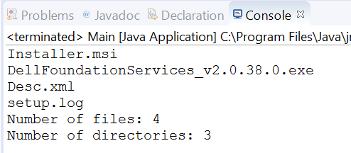
To select folder, you can use:
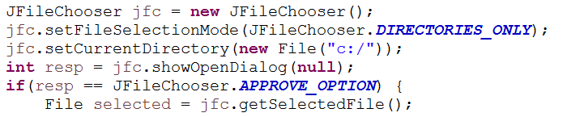
- Adapt your program to log all path’s to a log file with the date when the file was last modified.
Exercise 2:
Using java.nio… package:
Create a “SpyLogger” class, that watches all creation, modification… of folders and files in a given folder. These events must be logged in “c:/Logs/logTest.log”. If the file does not exist, it has to be created.
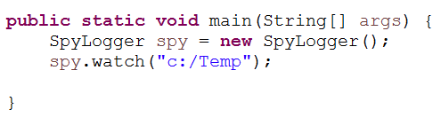
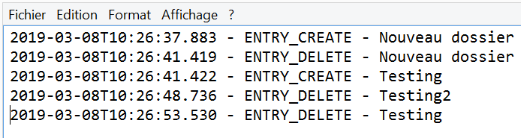

Exercise 3:
Create a new class “FileFinder”. In this class, put a method to get how many CPU’s (core) you have and a method that lists all “image files” you have on the disk (“png” and “jpg” for example). Do it with a “RecursiveAction”.

Exercise 4:
Using the given sql and code (Library), implement methods using new features (essentially in LibraryDAO):
- The methods getBooks(BookType type) and getAuthors() must return a CachedRowSet
- The methods getBooks() and getBooks(Author author) must return a Set<Book> using a JoinRowSet
- Experiment inserting, updating with the different RowSet implementations
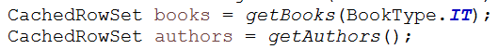
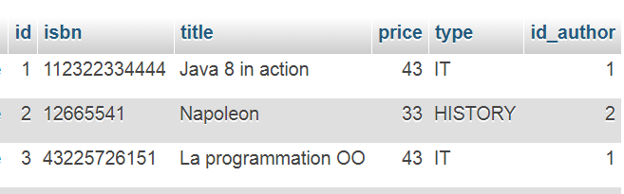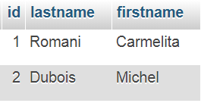

Exercise 5:
TransferQueue: Producer – Consumer (CubbyHole)
Create a Producer and Consumer class. Both implement Runnable. In the run() method, write a for loop (5x, for example). The producer puts in the TransferQueue and Consumer takes from TransferQueue. Monitor the execution using System.out.println() command.
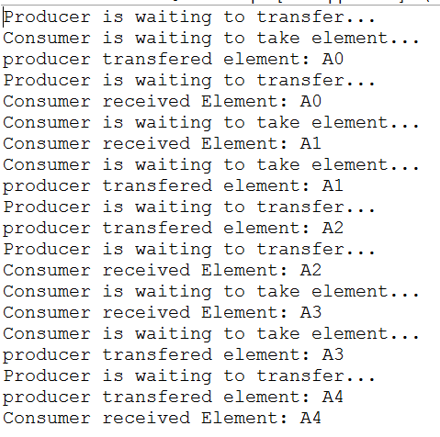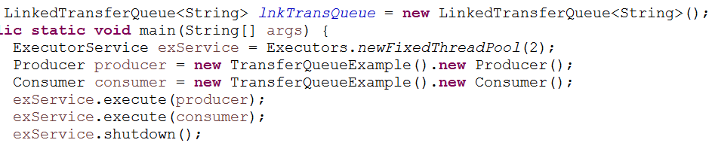

Exercise 6:
Fork – Join
Create a program that creates a big number of random words stored in a List. With and without parallelism, count the number of chars contained in the list and compare time taken.

Exercise 7:
Fork – Join
Create a program to count the number of words in text files contained in a folder. Add monitoring (System.out.print)…

