NAME:- Krishna Harish Paryani
Rollno.14

- Display the current working directory
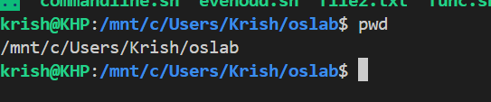
- List all files and directories
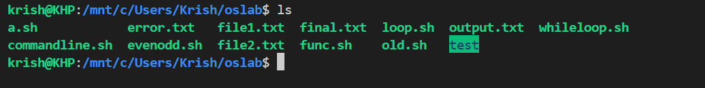
- List all files including hidden files
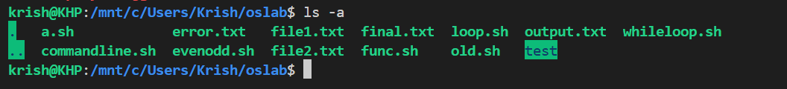
- Create a directory named test
- Remove a directory named old
- Create a file named file1.txt
- Display the contents of file1.txt
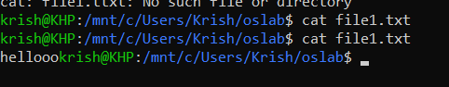
- Write the text Hello Linux into file1.txt
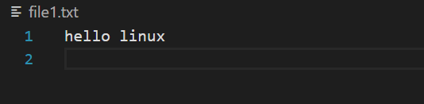
- Append the text Welcome to file1.txt
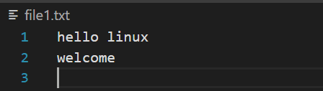
- Copy file1.txt to file2.txt
- Display the first 5 lines of file1.txt
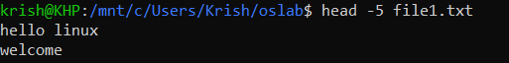
- Display the last 5 lines of file1.txt
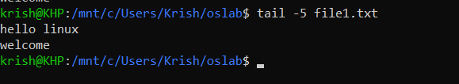
- Count the number of lines in file1.txt
- Count the number of words in file1.txt
- Display file1.txt with line numbers
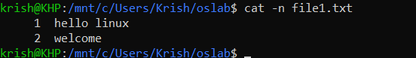
- Search for the word "Linux" in file1.txt
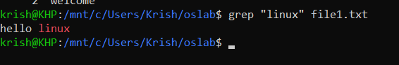
- Perform a case-insensitive search for "linux"
- Display lines starting with the letter A
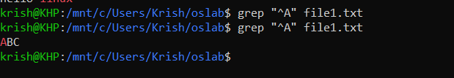
- Display lines ending with the word "Linux"
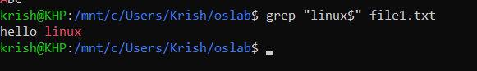
- Display lines containing numbers
- Count the number of lines containing the word "Hello"
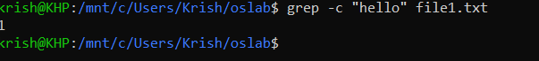
- Display line numbers for lines containing "Welcome"
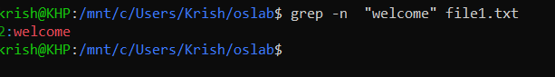
- Display all lines not containing the word "error"
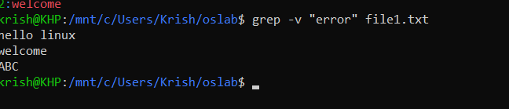
- Search for the word "root" in all .txt files

- Search recursively for the word "admin" in a directory
- Display file permissions of file1.txt
- Change permission to read and write for owner only

- Display file size in human-readable format
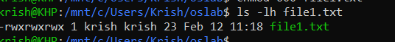
- Display inode number of file1.txt
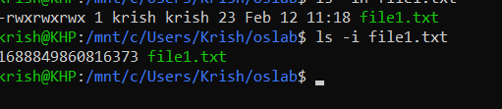
- Find all .txt files in the current directory
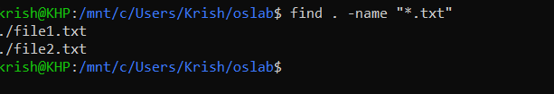
- Redirect output of ls to output.txt
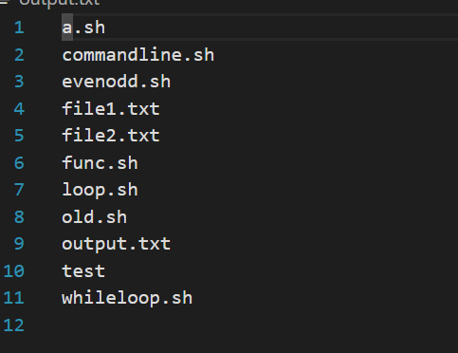
- Redirect error messages of a wrong command to error.txt
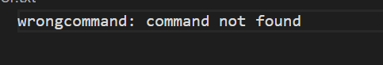
- Combine file1.txt and file2.txt into final.txt
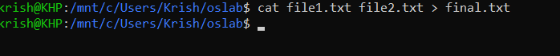
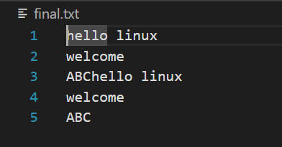
- Sort the contents of file1.txt
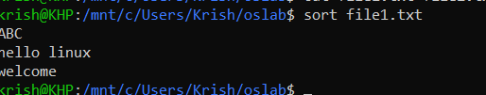
- Display unique lines from file1.txt
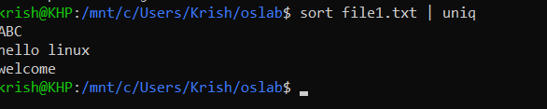
- Search for lines containing either "CSE" or "IT"

- Search for lines starting with a digit
- Extract only email IDs from a file
- Count total occurrences of the word "success"
- Display only the matched word using grep
