Assignment No. 6
Aim: Create and study a state diagram for a real-world application to capture system behaviour and state transitions.
Objective:
- The main objective of this assignment is to understand what is a state diagram.
- To identify the different states and transitions in the system.
- To understand how the system changes from one state to another based on events.
- To represent our project idea using a state diagram.
Problem Statement:
In many educational institutions, managing academic projects is very difficult and time consuming. There is no proper system to track what students are doing, what tasks have been assigned, and how much progress is made.
We are building an Academic Project Management Platform that helps students, guides, and admins to manage project groups, tasks, progress updates, and notices all in one place.
Admin, Guide, and Student are the three main users of this system. The system moves through different states depending on what each user does, like logging in, assigning tasks, submitting progress, and giving feedback.
Theory:
A state diagram basically shows how a system moves from one state to another based on events or actions. It does not focus on internal logic but mainly on what the system is doing at a given point of time. It provides a clear picture of all possible states and how they are connected through transitions.
States, transitions, events, and actions are the key components of a state diagram.
A state represents a condition or situation in which the system exists at a particular moment. In our Academic Project Management Platform, the key states are:
- Account – The system shows the login or register screen.
- Admin – The admin is logged in and can manage users, subjects, and groups.
- Guide – The guide is logged in and can mentor groups and assign tasks.
- Student – The student is logged in and can view tasks and submit progress.
- Subject / CP – A course or subject is being set up in the system.
- Group – A project group has been created and members are assigned.
- Task Created – The guide has defined a task and set a deadline.
- Task in Progress – The student has started working on the task.
- Progress Submitted – The student has submitted a progress update.
- Under Review – The guide is reviewing the progress submitted.
- Notice Sent – A notice has been sent to the group or students.
A transition is an arrow that connects two states and shows the movement from one state to another. In our project, transitions happen based on user actions like log in, assigns tasks, submit update, guide reviews, approved, and project complete.
Events trigger these transitions. For example, when a student submits an update, the system moves from Task in Progress state to Progress Submitted state.
Actions are what the system does while in a state. In UML state diagrams, we write them as do / action inside the state box. For example, in the Task in Progress state, the system does do / work on task.
There are also special elements like the initial pseudo state (filled black circle) that shows where the system starts, and the final state (bullseye symbol) that shows where the system ends.
A feedback loop is used in our diagram to show that after the guide reviews the progress, if changes are needed, the system goes back to Task in Progress state. This is shown as a dashed arrow from Under Review back to Task in Progress.
Overall, state diagrams help in understanding the behaviour of a system in a simple and visual way. They are mainly used to understand dynamic behaviour and lifecycle of objects or actors in the system.
Input:
The system takes inputs from users based on their roles:
- Login credentials (username and password) for all users.
- Admin inputs: new subject details, user registrations, group creation.
- Guide inputs: task name, deadline, milestone description, feedback message, notice content.
- Student inputs: progress update text, task completion status.
Output:
After processing the inputs, the system gives outputs like:
- Successful login and role-based dashboard for Admin, Guide, and Student.
- Subject and group created and visible to all members.
- Task assigned to the group with deadline shown to students.
- Progress update logged with timestamp and alert sent to guide.
- Feedback sent back to student or approval given to mark task complete.
- Notice broadcast to all group members on project completion.

State Diagram:
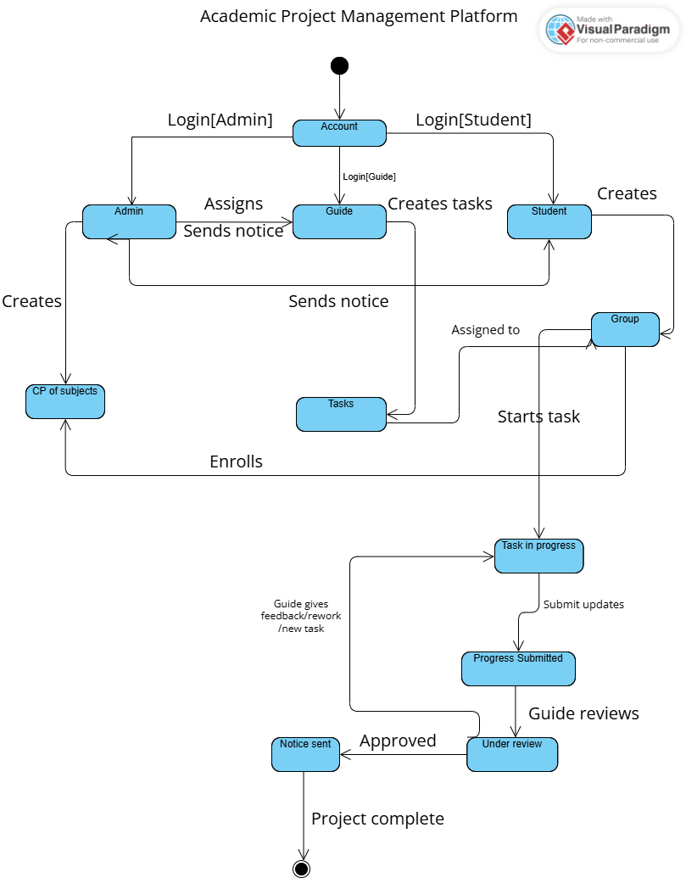

Explanation Using Our Project:
To understand how a state diagram works, we apply it to our Academic Project Management Platform step by step.
The system starts from the initial pseudo state and enters the Account state, which shows the login or register screen to the user.
When an admin logs in, the system moves to the Admin state. Here the admin can create subjects, register users, and create project groups. When the admin assigns a guide to a group, the system moves to the Guide state.
In the Guide state, the guide can mentor groups and define milestones. When the guide defines a task, the system moves to the Task Created state. The guide sets the deadline and the student gets notified.
When a student logs in, the system enters the Student state. When the student starts working on the assigned task, the system moves to Task in Progress state.
When the student submits a progress update, the system moves to Progress Submitted state. The update is logged with a timestamp and the guide gets an alert.
The guide then reviews the update and the system enters Under Review state. If the guide gives feedback and changes are needed and if he/she is satisfied with the current assigned tasks and wants to move on by assigning new tasks then, the system goes back to Task in Progress state using a feedback loop. If the guide approves, the system moves to Notice Sent state.
In the Notice Sent state, a notice is broadcast to all group members. Finally, the system reaches the final state (bullseye) when the project is marked complete.
This step-by-step flow clearly shows how a state diagram maps the entire lifecycle of a project in our system.
Conclusion:
From this assignment, we understood how to represent a system using a state diagram. It helped us to identify the different states our system goes through and the transitions that happen based on user actions. We also got a better idea about our project and how all the parts are connected from login to task completion to final review.
State diagrams are very useful in the early stages of software development because they show the dynamic behaviour of the system clearly and simply.
Remark:

