# 3D-Object-Image-Generation-For-Capsule-Networks

**Objective:**

The objective of the Project is to Create a Database of images of 3-D object’s and

create a website, so it can be used by capsule neural networks team and Data base

can be made available to public.

To achieve this the project is divided into Tasks where each Task contributes to final

goal.

1.Create images of 3-D objects using Maya.

2.Create a Database schema

3.Cloud integration.

4.website creation.

We are assigned the task to generate images using Maya. The workflow of the

project is now described in a weekly manner.

## My contribution in short

### Week 1

* Installed Maya and learnt its functionality using tutorials given by Prof Nik Brown and Youtube
* Built basic objects like cubes, cones, etc. and rotated them using python and MEL scripting
* Created camera and lights to get understanding of how shadows work and tried to manually capture images from camera view on single axis
* Analyzed the Cloud Providers along with Cost Statistics and Cloud Usage along with services to be required for implementing Capsule Network on Cloud.
* Deployed few Cloud Services on AWS Cloud as a part of dry run to get the usage and cost estimates.

### Week 2

* Started deploying the Cloud Services and tried to replicate the as-is functionalities on Cloud Platforms
* Initially, proceeded with AWS Cloud and deployed EC2 instance and S3 buckets.
* The Elastic Compute Engine was required to leverage the virtual environment and augment the computation power of running the algorithms.
* In the S3 buckets we stored the objects in form of the images. We created the categories and sub categories and then stored few images in the buckets.
* From the Maya Development part, worked on scripting part and tried to capture the images by fine tuning the parameters.
* Few challenges faced were rendering of images and taking snapshots of images with the required precision and noise elimination.
* Worked on database for finalizing parameters and schema for creation of database and tables associated with database.

[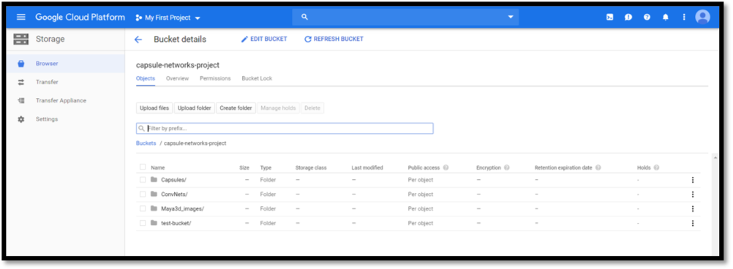](https://github.com/johailsherieff/johailsherieff.github.io/blob/master/images/Images/Bucket_Cloud.png)

### Week 3

* Analyzed the database part and set up the Cloud Infrastructure environment on the Google Cloud Platform.
* The primary reason for choosing the Google Cloud Platform over the other cloud platforms were the credits availability and the ease of using the services.
* Worked on creation of database schema, created Cloud Infrastructure Set up for SQL, set up My SQL instance on GCP, selected second generation of MY SQL database instance and configured the database as per the schema decided by the team.
* Created the 11 modelling objects in MAYA tool as per the latest environment, the environment had the features and aspects that will assist in amiably identifying the objects by the cnn model
* Also, in the previous environments there were missing shaders, mesh rendering, lambert effects for which an updated script was compiled by the Maya scripting team and with their assistance implemented the scripts to model 10 different objects using the updated script and environment.
* The object models were chosen from Sports, Nature and Electronics category with most of the objects from Sports category.
* The script generated 540 images for each object at an angle rotation of 45 degrees along with the shadows.

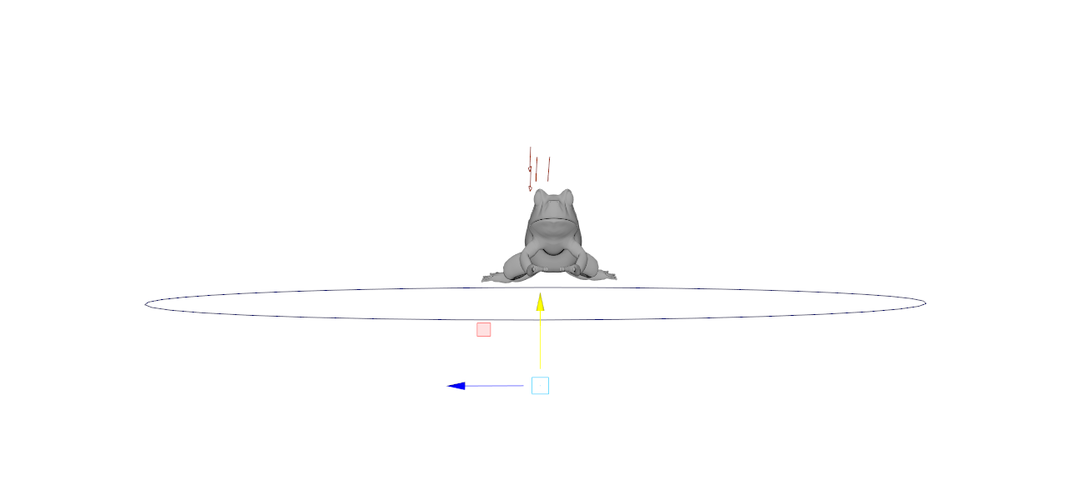

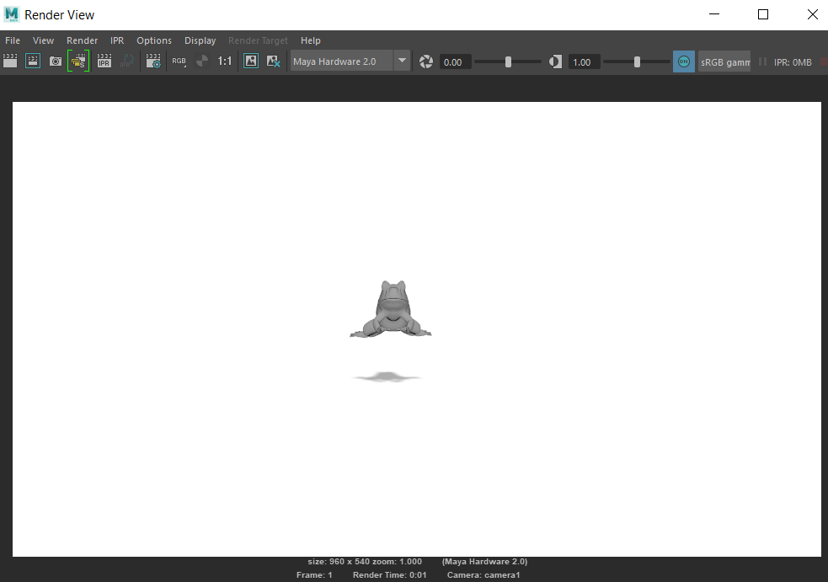

Cloud SQL Instance for Database(SQL Standard):

M/C type : db-n1-standard-4

RAM(GB) : 15

Max Storage Capacity: 50 GB

Max Connections: 4000

We will require Cloud type as : My SQL and Second Generation.

Cloud Storage as a Common database as of now are using our google drive to store and retrieve the data.

Compute Engine Instance for the Capsule Network project:

M/C type : n1-standard-8

Virtual CPU: 8

Memory: 50 GB

### Week 4

* Used GCP’s cloud storage as a repository to store the images and retrieve the same. Also, the buckets were created in the form of categories, sub-categories etc.
* After bucket creation the next steps were storing the images efficiently and assigning the permissions to bucket objects.
* Created the SQL infrastructure as per the new schema, the SQL instance supported My SQL Generation 2 and the database was created and tables were formed.
* Also, queries were fired for tables generation, storage of data, etc.

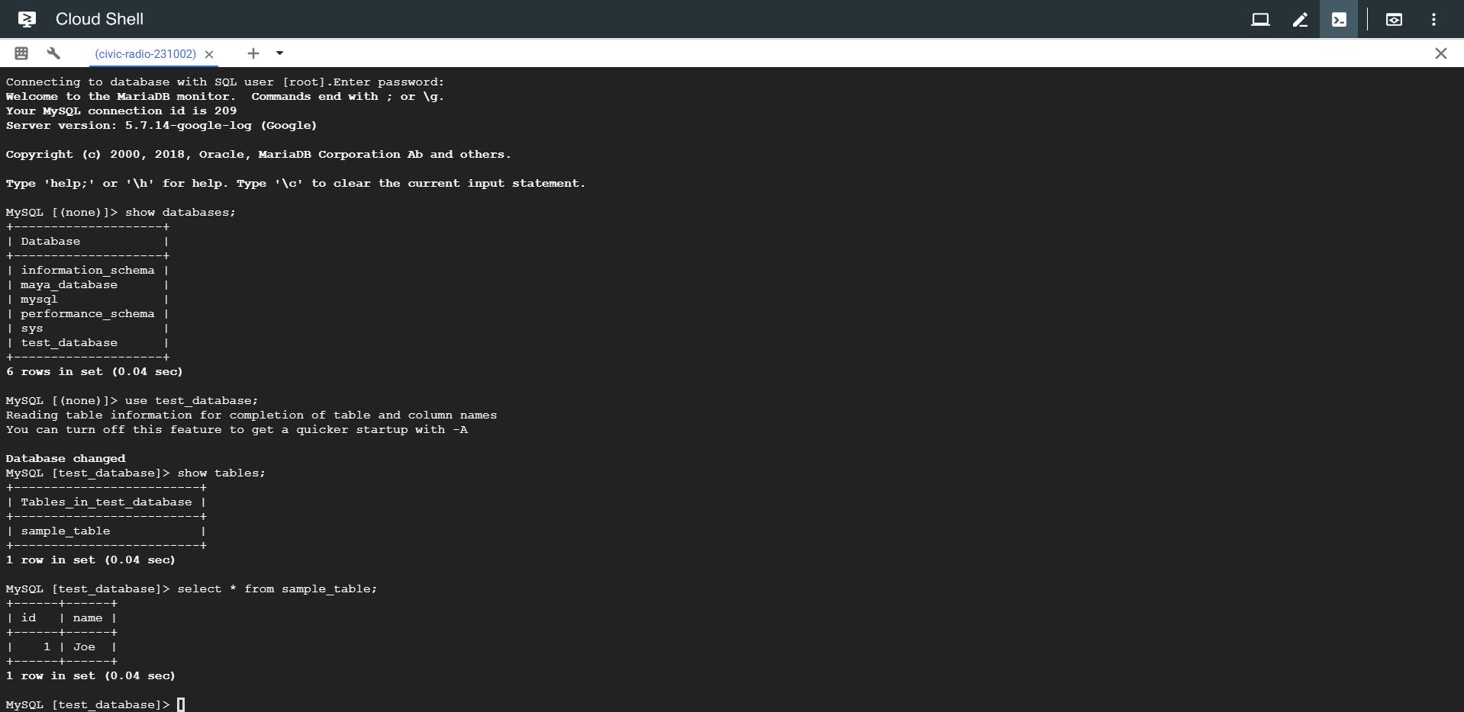

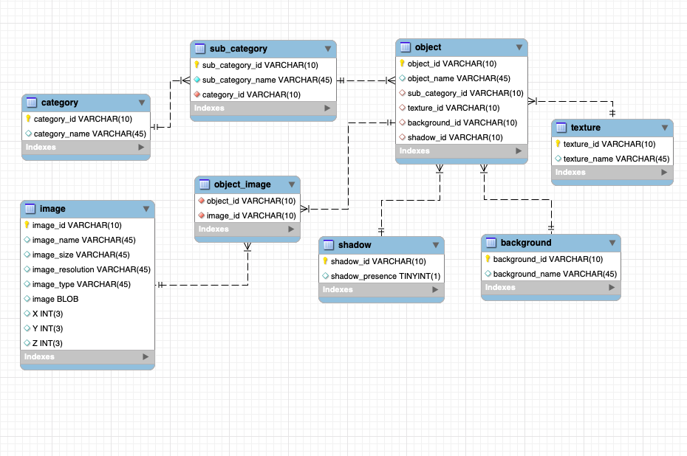

### Week 5

* Created Google Compute Engine instance that would suffice the requirement of running the CNN Algorithm and scripts.
* Choose the SQL instance with high configuration as in 16 vcpu’s and 30 GB memory and additionally tried to add GPU’s as well.
* Due to region and credit constraints the GPU’s were not being added to the instance configuration.
* Wrote the commands and scripts for integration of jupyter notebook and running it from cloud.
* Integrated the scripts and commands in shell editor and executed successfully jupyter notebook running from cloud and accessing that locally
* Installed and deployed Python, Keras, Tensor flow, Scikit, apache etc. in the instance
* Also, imported and integrated the database schema and created the database in the database instance.

[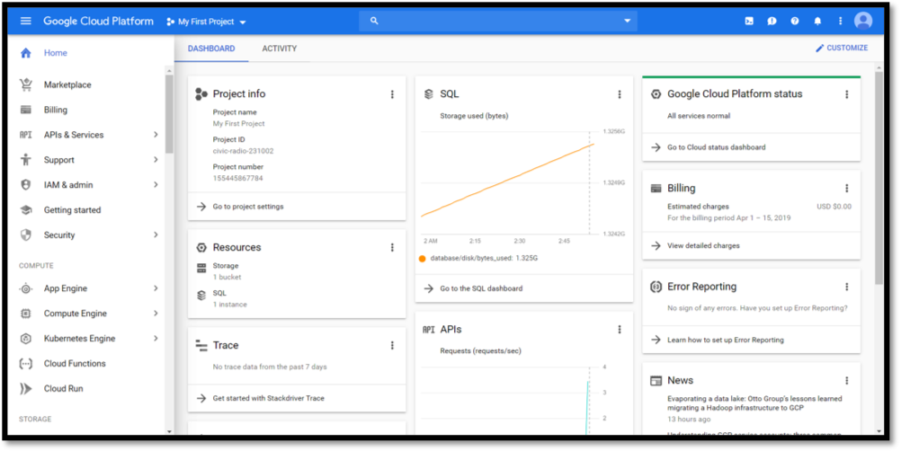](https://github.com/johailsherieff/johailsherieff.github.io/blob/master/images/Images/GCP.png)

[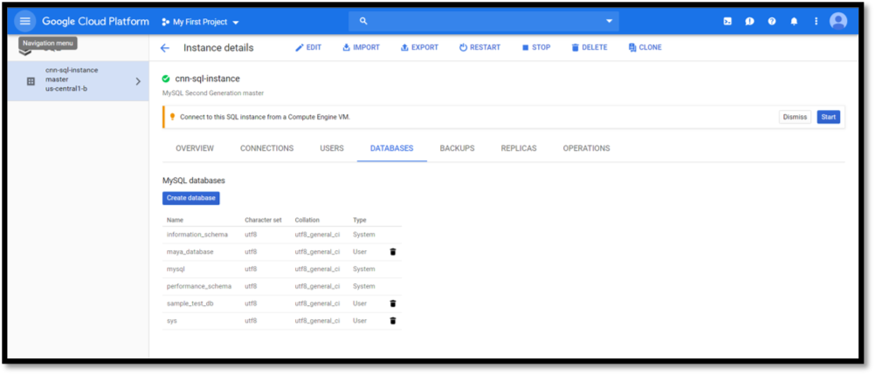](https://github.com/johailsherieff/johailsherieff.github.io/blob/master/images/Images/Database_Cloud_SQL.png)

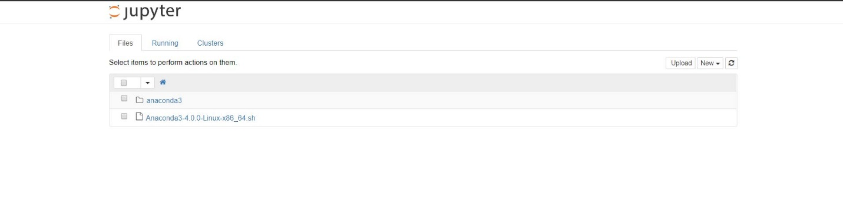

- Cumulatively, we collected almost 200 objects together and built different categories.

We would really appreaciate your feedback and support .

We are planning to continue our work in future as well.

**Citations**

* **Cloud SQL No SQL 2nd gen**

[**https://cloud.google.com/sql/pricing#2nd-gen-storage-networking-prices**](https://cloud.google.com/sql/pricing#2nd-gen-storage-networking-prices)

* **Cloud SQL features**

[**https://cloud.google.com/sql/docs/features**](https://cloud.google.com/sql/docs/features)

* **Cloud MY SQL Documentation**

[**https://cloud.google.com/sql/docs/mysql/**](https://cloud.google.com/sql/docs/mysql/)

* **Import / Export My SQL**

[**https://cloud.google.com/sql/docs/postgres/import-export/importing**](https://cloud.google.com/sql/docs/postgres/import-export/importing)

* **GCP Links for ML Stuff**
* [**https://cloud.google.com/blog/products/gcp/how-to-classify-images-with-tensorflow-using-google-cloud-machine-learning-and-cloud-dataflow**](https://cloud.google.com/blog/products/gcp/how-to-classify-images-with-tensorflow-using-google-cloud-machine-learning-and-cloud-dataflow)
* [**https://medium.com/giscle/setting-up-a-google-cloud-instance-for-deep-learning-d182256cb894**](https://medium.com/giscle/setting-up-a-google-cloud-instance-for-deep-learning-d182256cb894)
* [**https://medium.com/datadriveninvestor/complete-step-by-step-guide-of-keras-transfer-learning-with-gpu-on-google-cloud-platform-ed21e33e0b1d**](https://medium.com/datadriveninvestor/complete-step-by-step-guide-of-keras-transfer-learning-with-gpu-on-google-cloud-platform-ed21e33e0b1d)

**Conclusion**

This project assisted me exploring functionalities of Capsule Networks along with 3D image modelling. Along with that I learnt database creation, storing of data, rotating 3D image objects and retrieval on website. The main takeaway was putting the database and replicating other cloud features on the cloud and leverage cloud based services.

**MIT Licence**

Copyright 2019 Nikunj Doshi

Permission is hereby granted, free of charge, to any person obtaining a copy of this software and associated documentation files (the "Software"), to deal in the Software without restriction, including without limitation the rights to use, copy, modify, merge, publish, distribute, sublicense, and/or sell copies of the Software, and to permit persons to whom the Software is furnished to do so, subject to the following conditions:

The above copyright notice and this permission notice shall be included in all copies or substantial portions of the Software.

THE SOFTWARE IS PROVIDED "AS IS", WITHOUT WARRANTY OF ANY KIND, EXPRESS OR IMPLIED, INCLUDING BUT NOT LIMITED TO THE WARRANTIES OF MERCHANTABILITY, FITNESS FOR A PARTICULAR PURPOSE AND NONINFRINGEMENT. IN NO EVENT SHALL THE AUTHORS OR COPYRIGHT HOLDERS BE LIABLE FOR ANY CLAIM, DAMAGES OR OTHER LIABILITY, WHETHER IN AN ACTION OF CONTRACT, TORT OR OTHERWISE, ARISING FROM, OUT OF OR IN CONNECTION WITH THE SOFTWARE OR THE USE OR OTHER DEALINGS IN THE SOFTWARE.

   