Using GCP Cloud

What are we trying to do?

* Leverage Cloud Platform Services – Through GCP tools and services we want to leverage the cloud based services for this project
* Speed Up Computation Time- As the cloud platforms offers GPU’s and CPU’s ML can work seamlessly.
* Achieve Scalability- As the instances and consumption is dependent upon usage, auto up and down scalability can be set
* Google Cloud Allows Quick Collaboration
* Less Data has to be stored on Vulnerable Devices
* Control and Flexibility Available to Users

Existing Things Used:

* Local Dedicated Machines
* Other Cloud Based Platforms such as AWS, Azure, etc.

For Image Recognition

* AWS – Rekognition Image
* Microsoft Azure –
* Computer Vision API
* Custom Vision Service
* Face API

What we are proposing?

* GCP Cloud’s Services
* Google Cloud ML Engine:
* Supports TensorFlow (as well as scikit-learn and XGBoost in beta)
* Image Recognition Services:
* Vision API
* AutoML Vision
* Google Storage Services:
* Google Cloud Storage (Bucket Objects)
* Google Cloud Database:
* Google Cloud Database (My SQL)

Overcoming Challenges and Trying to Achieve

* Functioning Time
* SLA and High Availability
* Collaboration of Work
* Pay for what you use
* Data Protection

Cloud Requirement Analysis for the Dry Run

The Analysis of cloud and its servies was analysed based on the following features:-

**1 Cloud SQL Instance for Database**

SQL Standard

M/C type : db-n1-standard-4

RAM(GB) : 15

Max Storage Capacity: 10,230 GB

Max Connections: 4000

We will require Cloud type as : My SQL and Second Generation.

**1 Cloud Storage**

**1 Compute Engine Instance**

M/C type: n1-standard-8

Virtual CPU: 8

Memory: 30 GB

GCP Links used for the Referencing

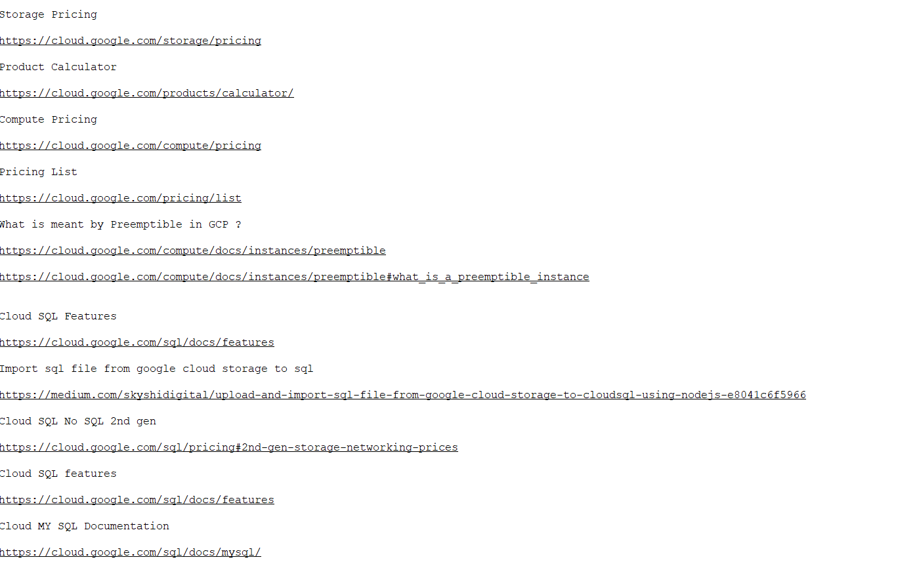

Using EC2 Instance on AWS

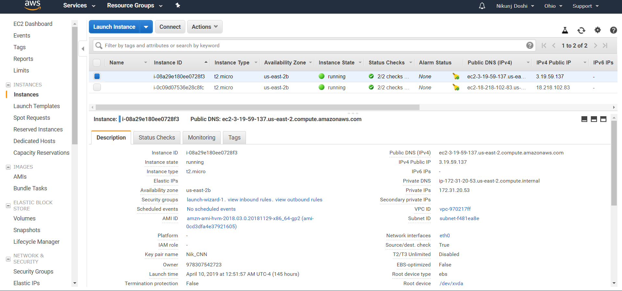

Using S3 Buckets on AWS

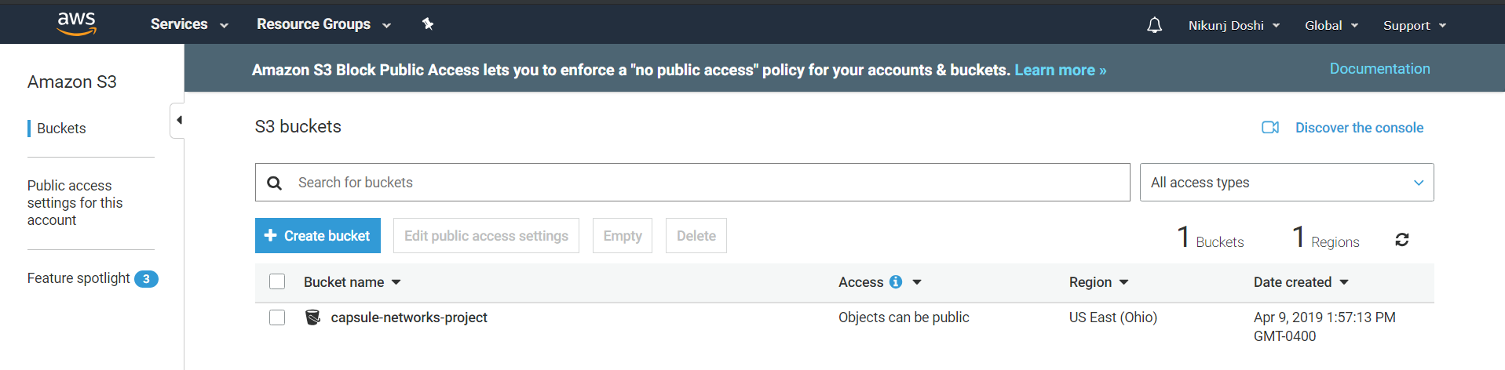

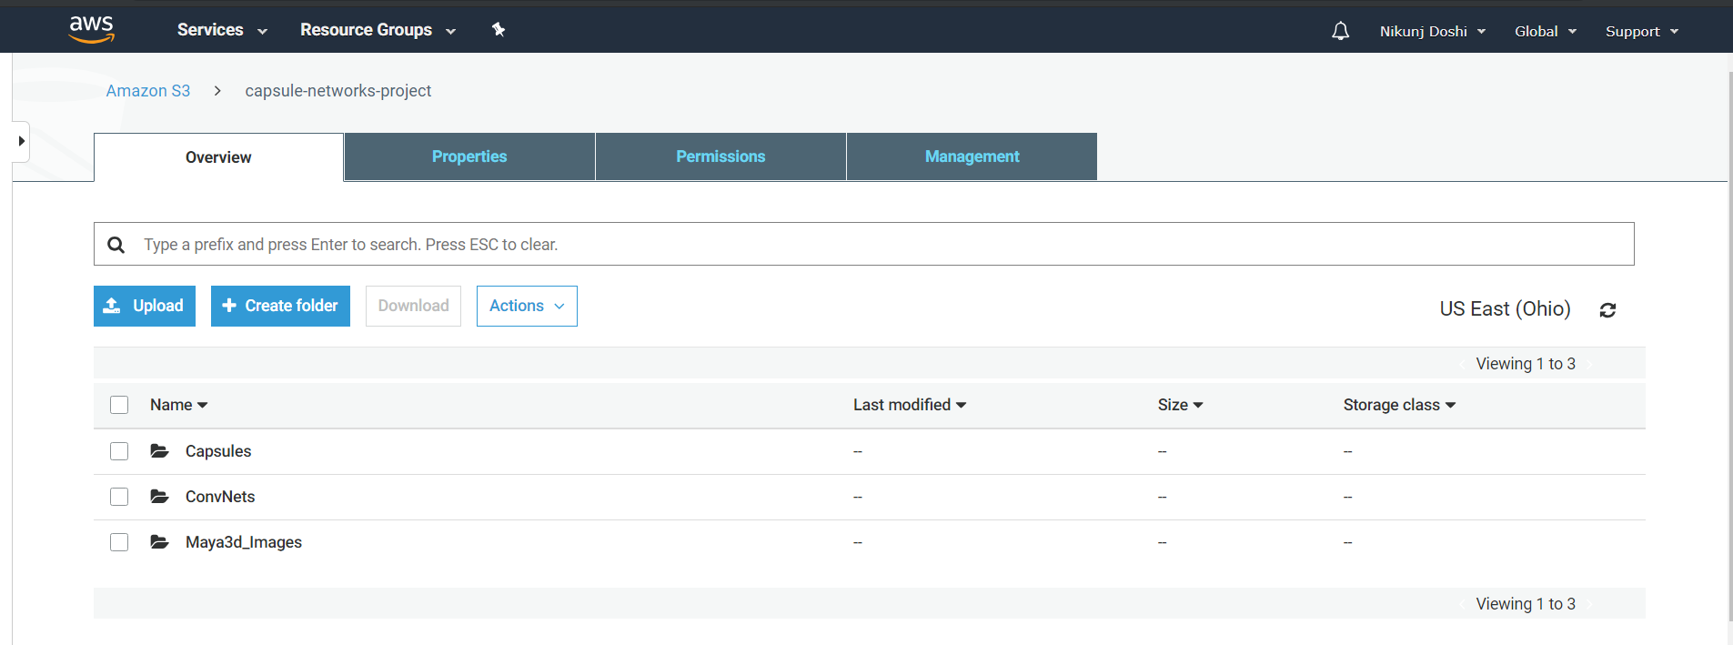

Installing My SQL on AWS

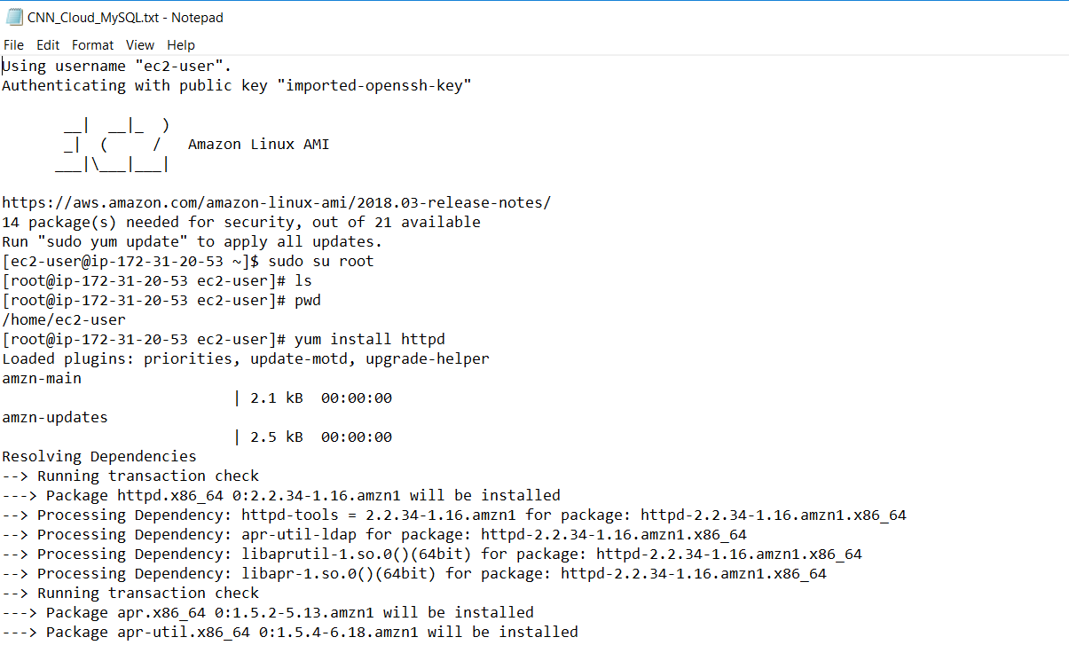

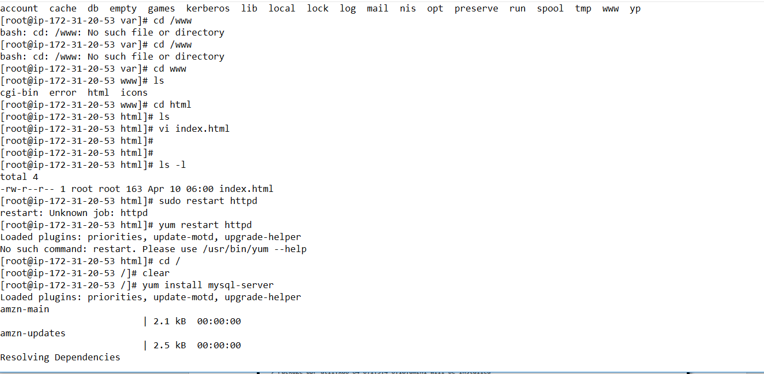

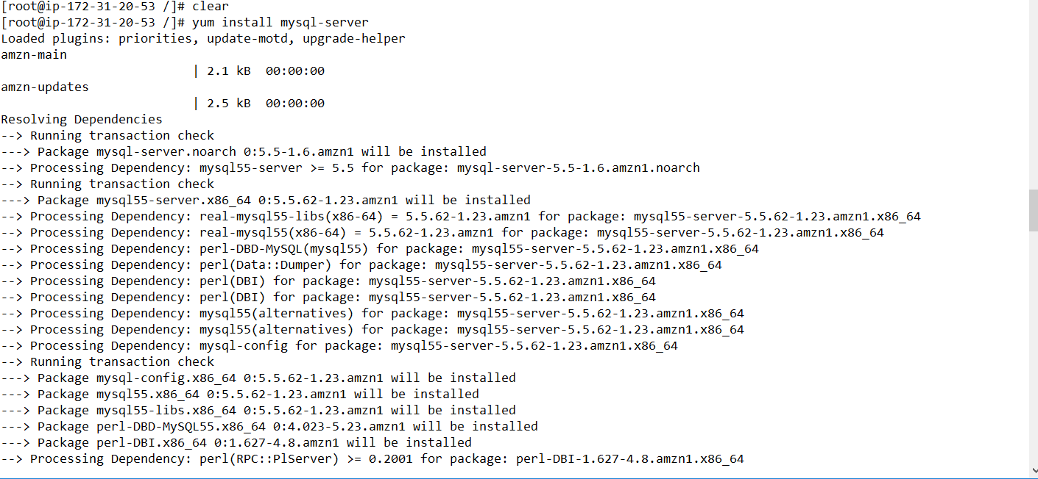

GCP Dashboard

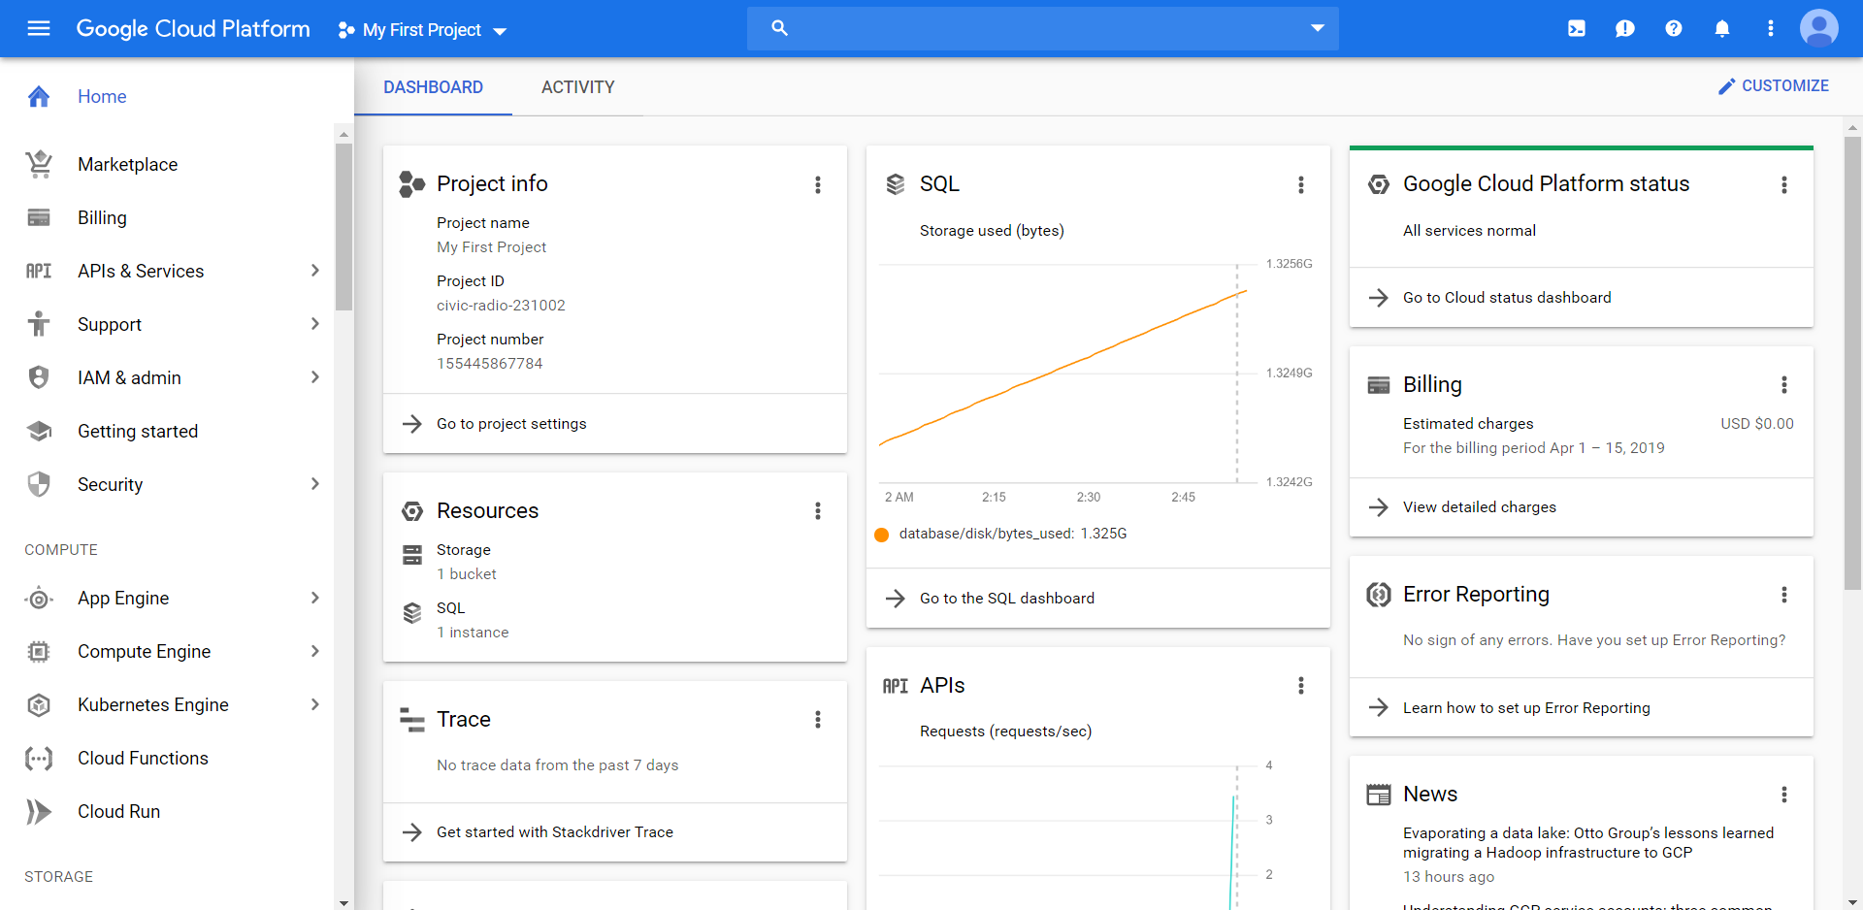

Google Cloud Storage

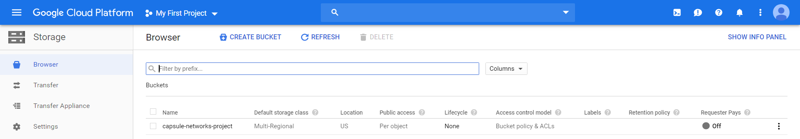

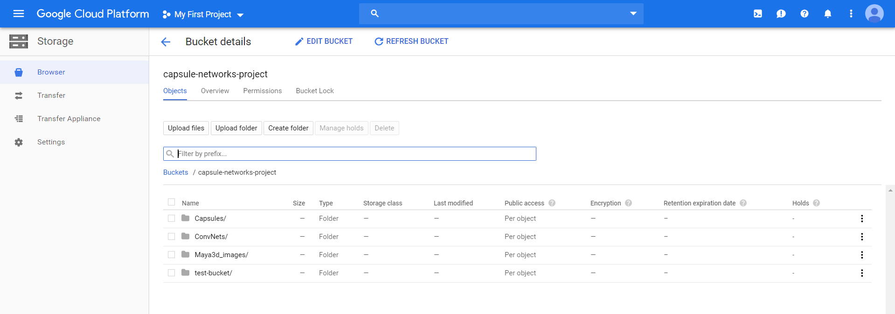

Google Cloud SQL

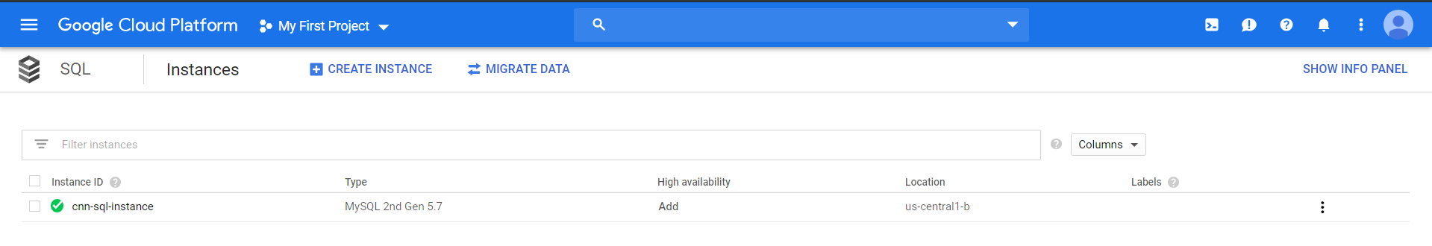

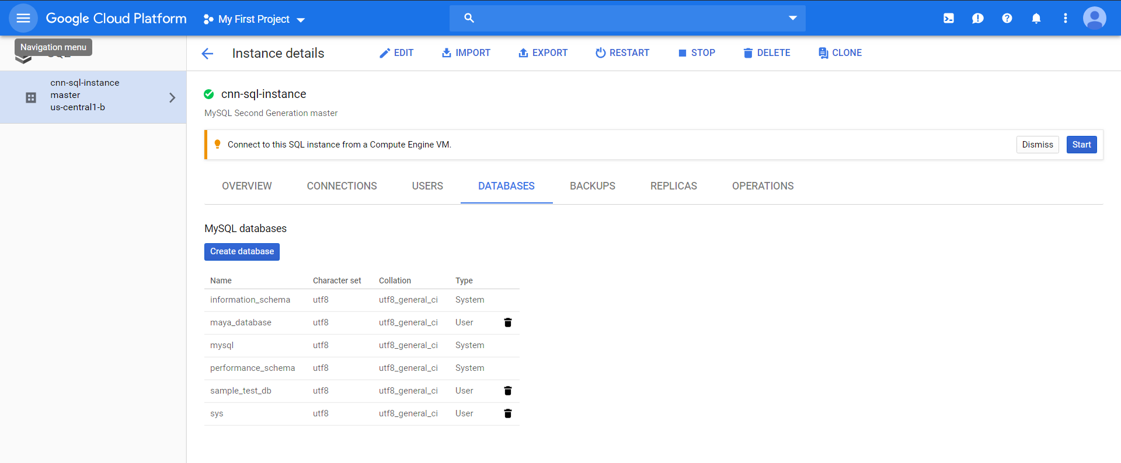

Installation of MY SQL on GCP

