EXPLORATORY DATA ANALYSIS COURSE PROJECT

Play Store Applications Performance Analysis

TEAM NO: 10

Guided By:

Dr. Karibasappa K G

Prof. Sunil G

TEAM DETAILS

| **NAME** | **USN** | **Roll No.** |
| --- | --- | --- |
| **Pranavi Kulkarni** | **01FE20BCS118** | **253** |
| **Mayuri Kalmat** | **01FE20BCS095** | **230** |
| **Parag Hegde** | **01FE20BCS096** | **231** |
| **Pranav Jadhav** | **01FE20BCS099** | **234** |

Content:

**o Abstract**

**o Introduction**

**o Problem statement**

**o Dataset description**

**o Data pre-processing**

**o Analysis with graphs and inferences or conclusions**

**References.**

**Abstract:**

Play Store Applications Performance Analysis is a project under the course Exploratory Data Analysis. A sample data set consisting of 10,840 records is taken from over millions of records present in the play store for the analysis of the various trends. We have filtered the data by applying suitable data preprocessing techniques. Later, we have demonstrated the visualizations by various graphs and plots. Various like users age, users’ interests, highly downloaded categories and applications have been observed and recorded. At the end, prediction has been demonstrated for predicting the rating and downloads of the applications. This analysis helps the application developers to develop the better applications and the users to choose the best applications.

**Introduction:**

Google Play Store is home to millions of mobile applications used worldwide. Every day, millions of users download various applications that belong to a wide range of genres from Education to Finance, from beauty to communication, from shopping to sales. Every possible category is covered by the apps.

As there are several applications hosted on the play store for a single genre, it becomes essential to figure out which application among all performs well. Based on the data available such as number of downloads, ratings, reviews and so on, we can analyze the users’ interests. This analysis helps the users to download the better applications and also the application developers to improvise and modify according to the user interests.

**Problem Statement:**

“Analyze the user interests and trends of Google Play Store applications.”

**Dataset description:**

| **Categorical** | Category,Type, Genres, ContentRating | 4 |
| --- | --- | --- |
| **Ordinal** | Rating, LastUpdated, TimeStamp, date, month, year, CurrentVersion, AndroidVersion | 8 |
| **Numerical** | NoOfReviews,Size,NoOfInstalls,Price,  UpdateFrequency | 5 |
| **Binary** | Advertisement, BetaVersion | 2 |

| **Attributes** | Description |
| --- | --- |
| **Category** | Denotes the category to which the app belongs. |
| **Type** | Denotes if the application is free to use or the paid one. |
| **Genres** | Denotes the genre to which the application belongs. |
| **Content Rating** | Denotes the group of users suitable to use the respective application. |

| **Attributes** | **Description** |
| --- | --- |
| **Rating** | Denotes the category to which the app belongs. |
| **LastUpdated** | Denotes the date on which the application was updated recently. |
| **Timestamp** | Denotes the time at which the data was recorded for analysis. |
| **Attributes** | **Description** |
| **Date, Month, Year** | The date on which the data was recorded for analysis. |
| **CurrentVersion** | Denotes the current version of application. |
| **Android Version** | Denotes the minimum version supported by the application. |

| **Attributes** | **Description** |
| --- | --- |
| **NoOfReviews** | Denotes the count of reviews by the users to the application. |
| **Size** | Denotes the download size of the application. |
| **NoOfInstalls** | Denotes the number of downloads of the application throughout the globe. |
| **UpdateFrequency** | Denotes the average time gap between two successive updates to the application. |

| **Attributes** | **Description** |
| --- | --- |
| **Advertisement** | Denotes if the application contains advertisements. |
| **Beta Version** | Denotes if the beta version is available for the application. |

**Data pre-processing:**

1. 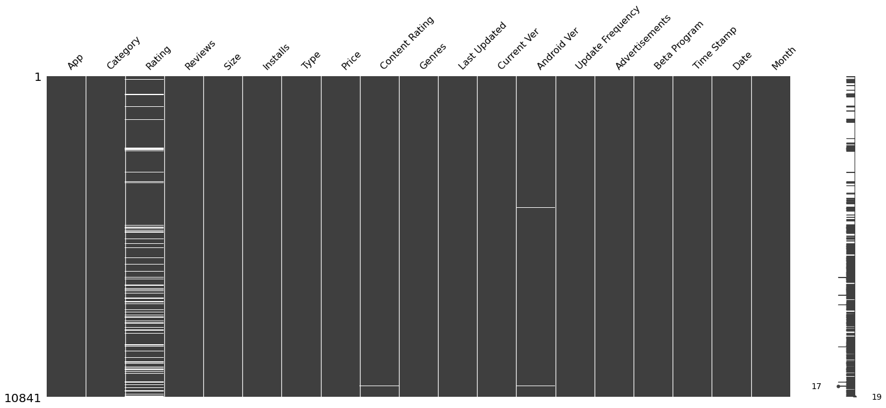Identifying and handling the null values

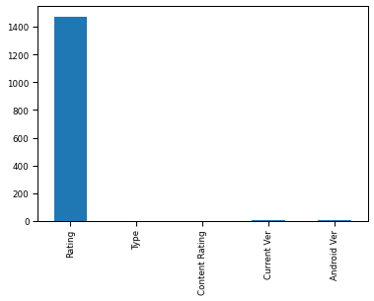

From the bar graph of Null Values, it is evident that attribute 'rating' has the highest number of null values. This also indicates that users are less active in giving the ratings to the applications they use.

**The Impact of Preprocessing**

Before preprocessing

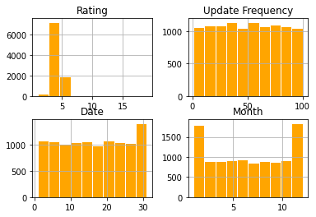

After Preprocessing

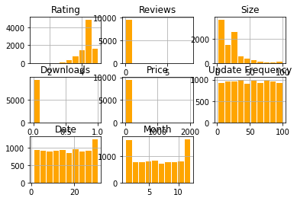

**Inference:** After the preprocessing, since the null values are removed, there is increase in the number of numeric attributes.

**Exploratory Data Analysis**

1.Availability based on categories

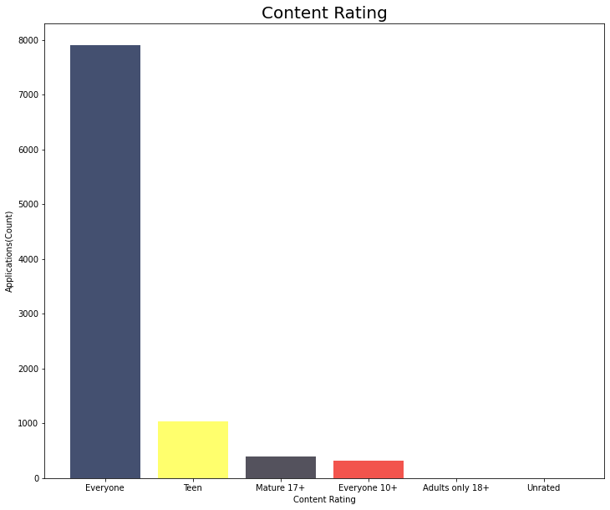

From the bar graph, it is evident that the applications which are available for everyone are the highest downloaded ones.

Followed by them, there are the apps suitable for teens, mature 17+ etc.,

This shows that most of the users download the applications that are made to be used and available for everyone.

2.The Highest Earning Applications

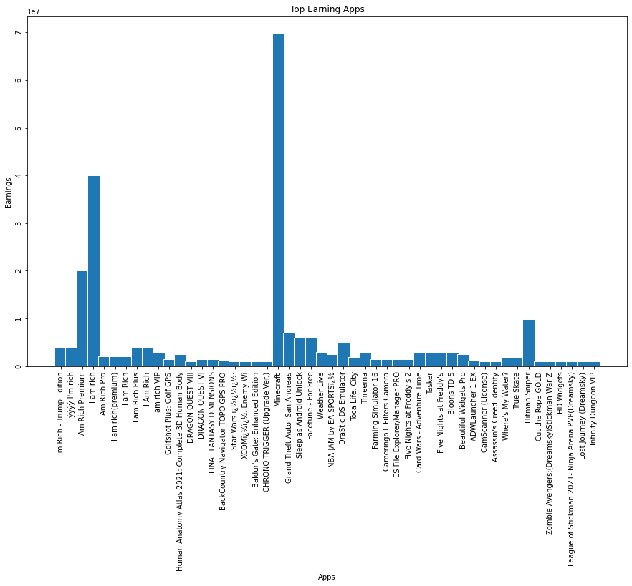

When a bar graph was plotted between the paid apps and their earnings, it was then inferred that:

the Minecraft is the highest earning app.

It is followed by 'I am Rich', 'I Am Rich Premium', 'Hitman Sniper', and 'Grand Theft Auto: San Andreas'.

3.The Distribution of Ratings

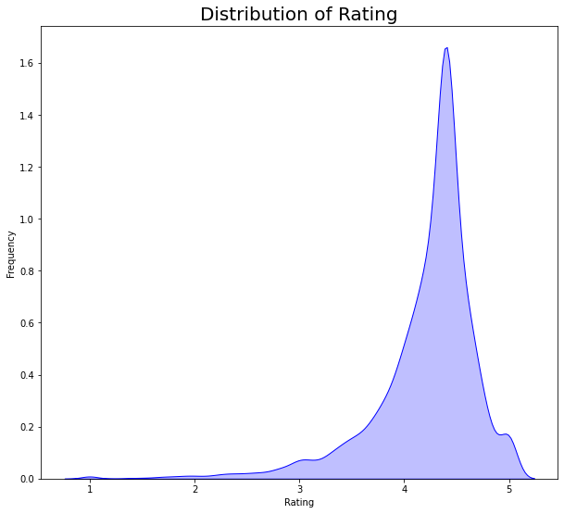

From the graph, it is inferred that majority of the applications are rated between 4.0 and 4.5. The applications with ratings below 3.5 are the too less in number.

4.Distribution Of paid and free applications in Play Store

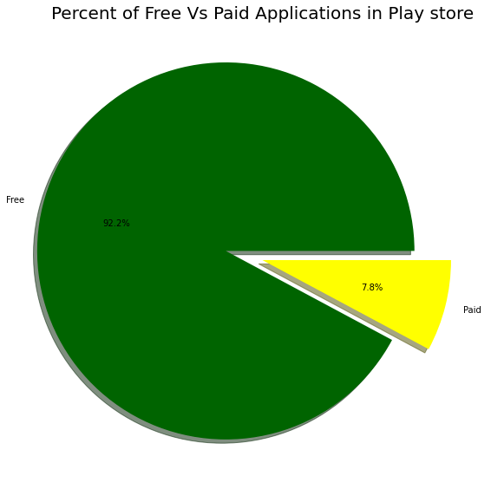

From the pie chart, it is clearly evident that the google play store is dominated by the free applications.

Of the total applications, 92.2% applications are free to download and use. Rest 7.8% applications are the paid applications.

5.Number of applications that are free and paid in each category

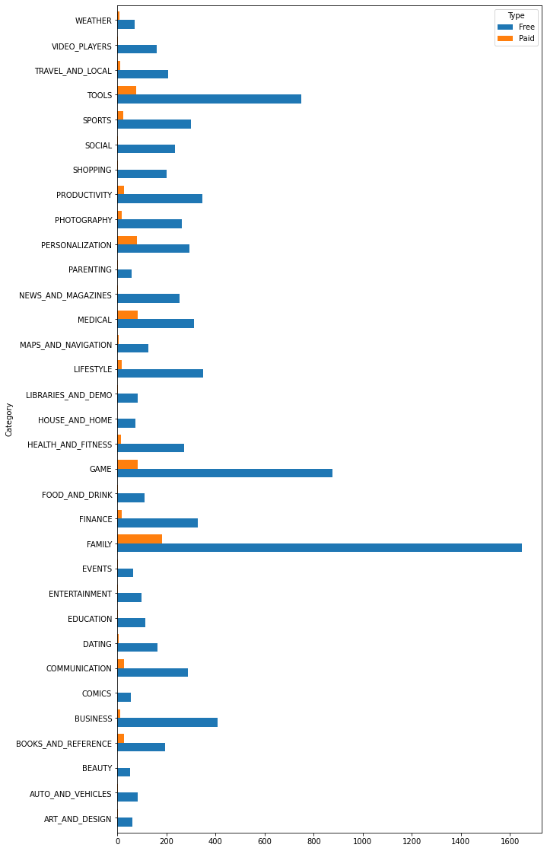

‘Family’ is the category with the highest number of paid applications. It is also the category with the highest number of free applications.

The categories ‘Game’ and ‘Tools’ have almost same number of free applications.

6. To know which category has the highest number of downloads in Play Store

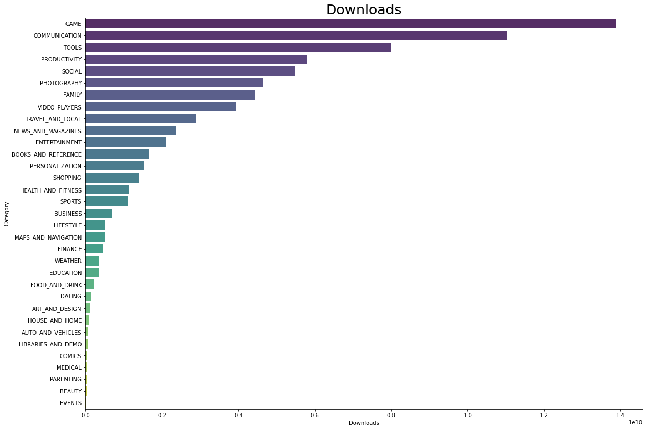

When it comes to the number of downloads, the category **'Game'** acquires the first position and can be called as **the highest downloaded category**.

It is then followed by Communication, Tools, Productivity, and Social.

**This shows that majority of users are interested in Gaming category**.

It's more likely that users might range between **teenagers to mid 20s**.

Very **minimum** downloads has been observed from the category **Events**.

7. To know relation between Category, count of application and their highest rating

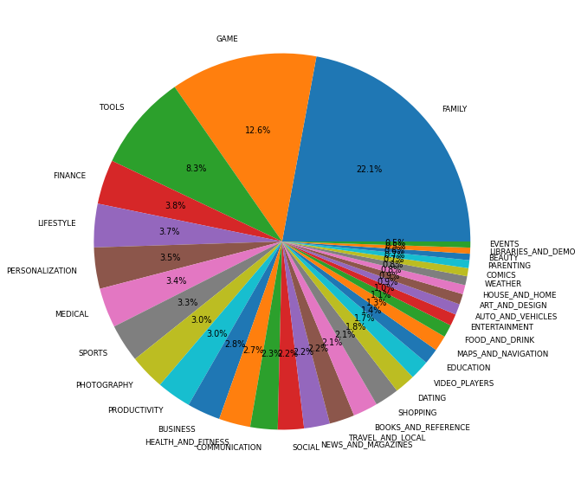

This chart displays all the categories, partitioned according to the proportions of their quantity.

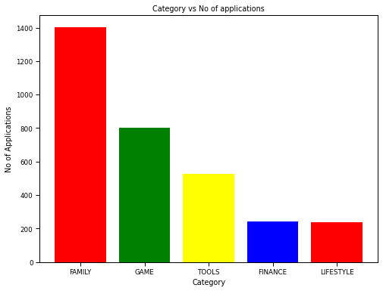

The bar graph of Category vs No of applications reveals that

the applications under the category 'Family' are downloaded the most. This category is followed by 'Game', 'Tools', 'Medical', and 'Finance'. Together, these five categories represent the top five most downloaded categories.

| App Names | Ratings |
| --- | --- |
| Fr. Mike Schmitz Audio Teachings | 5.000000 |
| Safe Santa Fe | 5.000000 |
| BM SPM Practice | 5.000000 |
| WPBS-DT | 5.000000 |
| COMSATS BOOK STORE FOR BS(CS) | 5.000000 |

FAMILY

GAME

| App Names | Ratings |
| --- | --- |
| Axe Champs! Wars | 5.000000 |
| Mad Dash Fo' Cash | 5.000000 |
| Santa's Monster Shootout DX | 5.000000 |
| 211:CK | 5.000000 |
| Ra Ga Ba | 5.000000 |

TOOLS

| App Names | Ratings |
| --- | --- |
| CZ Kompas | 5.000000 |
| CE Smart | 5.000000 |
| CR Tracker for Chests | 5.000000 |
| CL REPL | 5.000000 |
| BM speed test | 5.000000 |

FINANCE

| App Names | Ratings |
| --- | --- |
| EB Scanner | 5.000000 |
| BV Mobile Apps | 5.000000 |
| DL Image Manager | 5.000000 |
| Ek Vote | 5.000000 |
| CJ'S TIRE AND AUTO INC. | 5.000000 |

LIFESTYLE

| App Names | Ratings |
| --- | --- |
| DN Calculators | 5.000000 |
| BI APP | 5.000000 |
| FD Calculator (EMI, SIP, RD & Loan Eligilibility) | 5.000000 |
| CT Checkout | 5.000000 |
| CF | 5.000000 |

RATINGS OF TOP FIVE APPLICATIONS OF FIVE CATEGORIES WITH HIGHEST RATINGS.

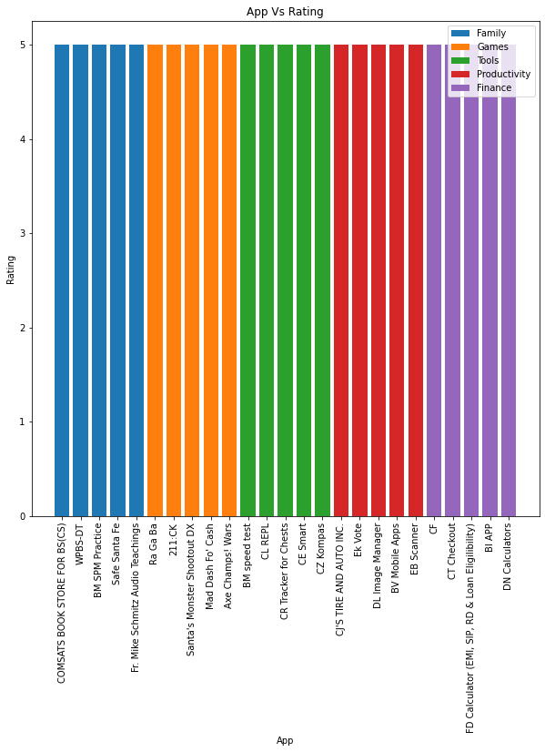

8. Category wise distribution of Rating

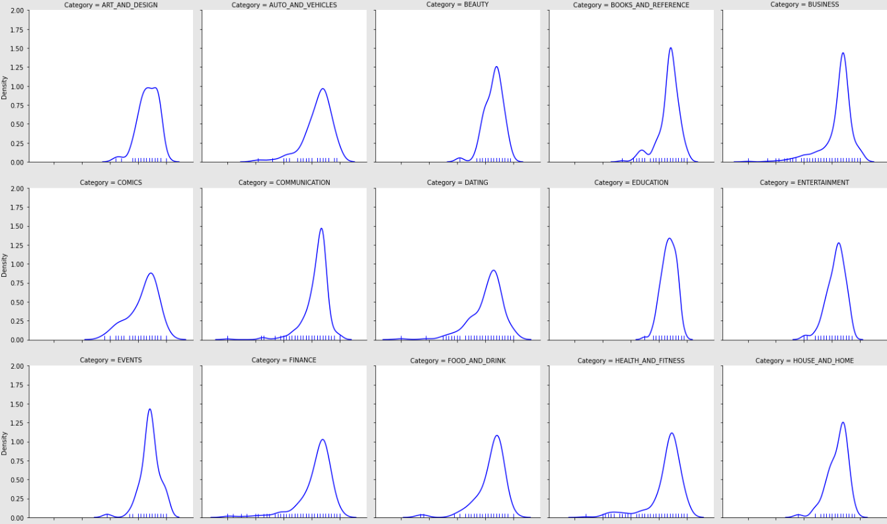

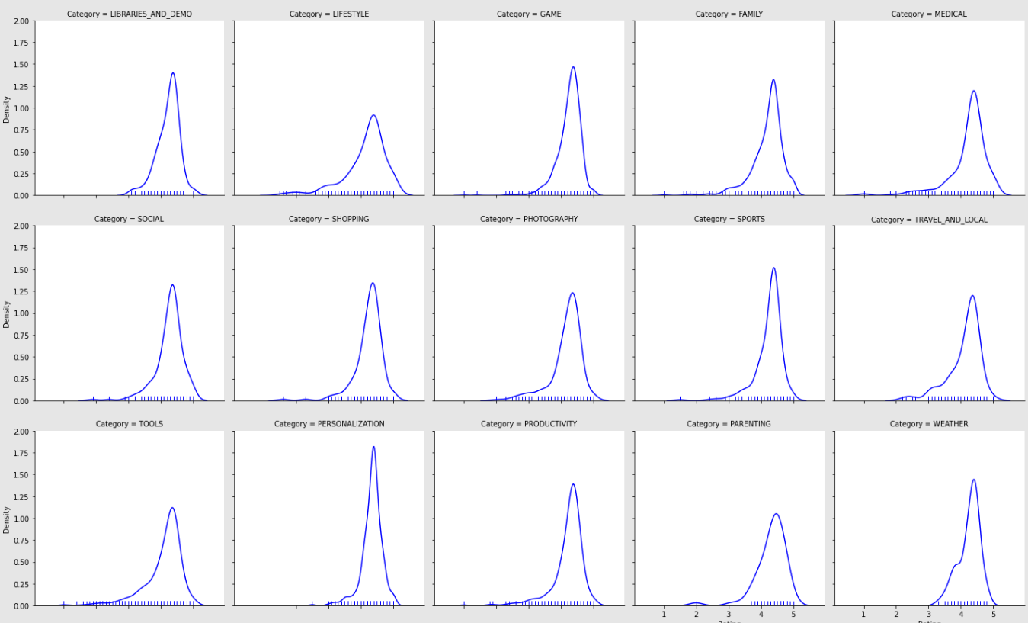

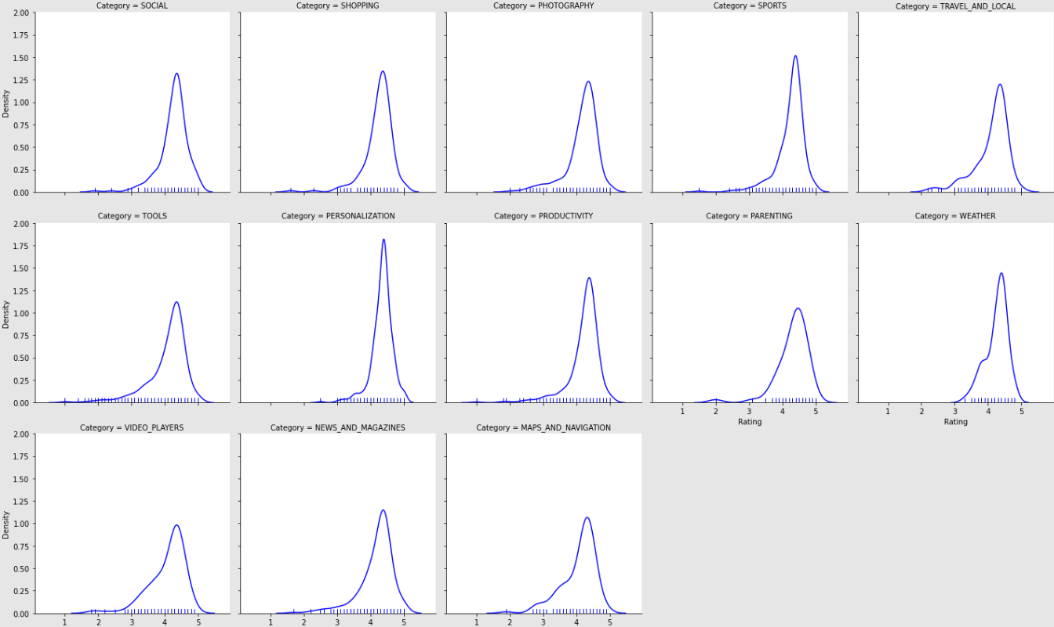

Everyday updated apps give optimization and better applications hence its ratings are high.

9. To know the rating of the application when update frequency is 1(everyday update).

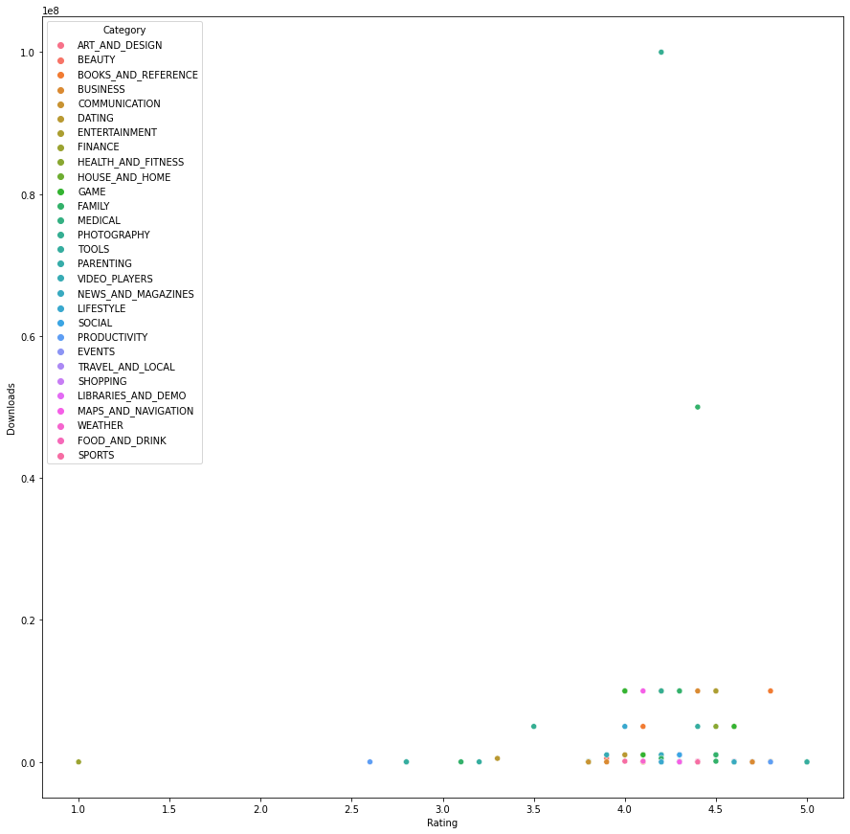

Everyday updated apps gives optimisation and better applications hence its ratings are high

Predictions

**Predictions:**

1. For the given number of reviews, size of the applications, and number of downloads predict the Rating of the application

* For given number of reviews=**100000**, size of the applications=20, number of downloads=1000000

The predicted rating is 4.13

2. To predict the number of downloads of an application for the given rating, reviews and size

* For the given rating=5, reviews=1000 and size=100000

The predicted number of downloads is 1.5031*10^9