Problem 1:Build Periodically - Pipeline - Compile Java

Complete this exercise using the jenkins in your environment.

**Instructions To Submit Code To Tekstac Code Editor :**

1. In windows explorer, go to **JENKIN's home**directory (that is ".jenkins" directory),

*NOTE : The path given in the image is an example.*



2. Open the directory *with the job name you mentioned in jenkins*. Right-click on '**builds**' and '**config.xml**' ONLY

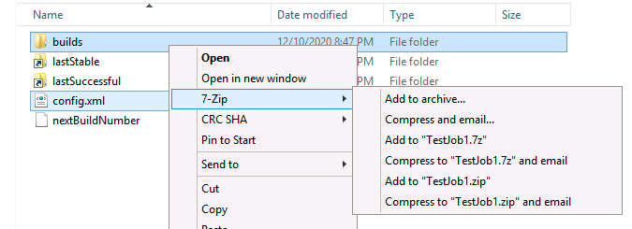

3. Create a zip

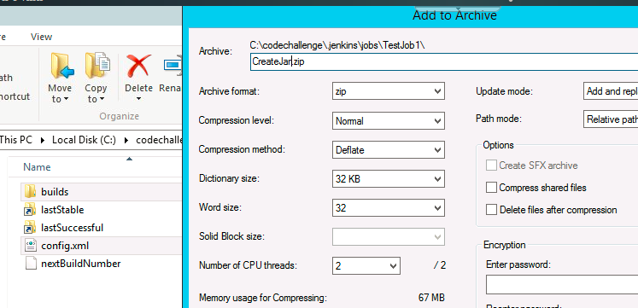

4. In Tekstac platform, on clicking code editor, you will see the below option. Click **cancel**

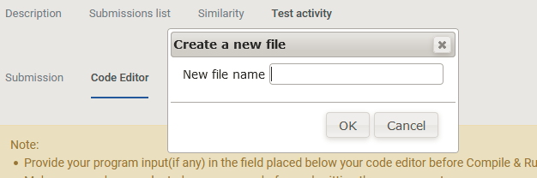

5. Drag and drop the zip file in Tekstac code editor.

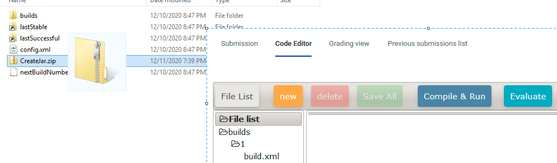

***Lets start the activity....***

**Objectives:**

To learn how to create a pipeline project and to compile and execute java program using bat file  
  
***Procedure to be followed:***

1. Start jenkins and open jenkins in the browser.

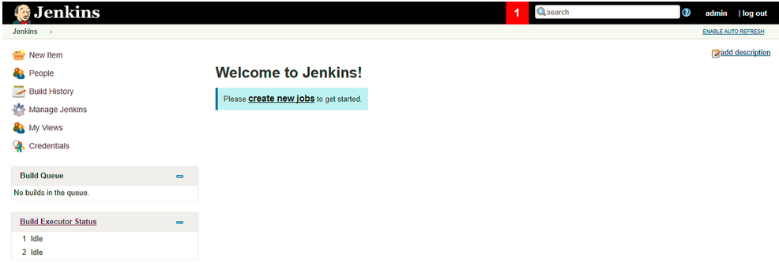

   2. Click **"New Item"**, Provide Job name, Select **"Pipeline"** and Click **OK** to create ne

3. On next page click on **"Pipeline".**Write a pipeline script.

  4.Write a pipeline script which contains one Stages with stage named '**Compile**'.

     Compile stage should execute the bat file.

            Create a Bat file(with name **"compile.bat"**) which contains two commands.

            a. javac Sample.java

            b. java Sample

  5. Click save.

  6. Click **Build Now** option in the dashboard.

Problem 2: Build Maven Project - Build Ant project - Using Pipeline Script

Complete this exercise using the jenkins in your environment.

**Instructions To Submit Code To Tekstac Code Editor :**

1. In windows explorer, go to **JENKIN's home**directory (that is ".jenkins" directory),

*NOTE : The path given in the image is an example.*



2. Open the directory *with the job name you mentioned in jenkins*. Right-click on '**builds**' and '**config.xml**' ONLY



3. Create a zip



4. In Tekstac platform, on clicking code editor, you will see the below option. Click **cancel**



5. Drag and drop the zip file in Tekstac code editor.



***Lets start the activity....***

**Objectives:**

To learn how to create a pipeline project and to compile and test maven project.    
  
***Procedure to be followed:***

1. Start jenkins and open jenkins in the browser.

   2. Click **"New Item"**, Provide Job name, Select **"Pipeline"** and Click **OK** to create new job.

3. On next page click on **"Pipeline".**Write a pipeline script.

**Use the below github repository ( Branch :"main")**

**https://github.com/kutty27/AntProject.git**

4. Before start the pipeline do the following steps,

     First you have to configure the ANT in jenkins.

* In Jenkins, navigate to "Manage Jenkins" -> "**Global Tool Configuration**."
* Locate the "**ANT**" section and add a ANT installation. Provide a name (e.g., "**ANT_HOME**") and set the ANT_HOME to the path where ANT is installed on your machine or installed automatically.

 5. Write a pipeline script which contains one Stage with stage named '**Compile**'  and contains one post build action.

      The script starts with **agent any**, indicating that the pipeline can run on any available agent.

      Next write the **tools**block, the script specifies that it should use the "**ANT_HOME"** installation for Ant-related tasks.

      In the 'Compile'  stage, the script uses the git step to clone a Ant project from the specified GitHub repository (**https://github.com/kutty27/AntProject.git**)

     In this 'Compile' stage runs a Ant Target (compile )

     If the "Compile" stage is success print the echo message "**Ant project compiled successfully**"

**<< Sample Script Template -  >>**

pipeline {  
    agent any

     tools {

        // Specify the Ant tool defined in Jenkins  
        ant 'ANT_HOME'  
    }

     stages {

         stage('Compile') {

                  // Checkout the source code from the specified GitHub repository and branch  
                **<<insert code to checkout the code from the given GIT Repo>>**  
  
                 // Compile the Ant project using the specified Ant tool  
                bat '"%ANT_HOME%\\bin\\ant" compile'

            }  
        }  
    }

    post {

        success {  
            // Additional post-build actions if needed  
            echo 'Ant project compiled successfully!'  
        }  
    }  
}

  5. Click save.

  6. Click **Build Now** option in the dashboard.