Architecture Overview
Agentic SDLC Orchestration System
Components · Orchestration Model · Control Flow · Key Decisions

Architecture Diagram
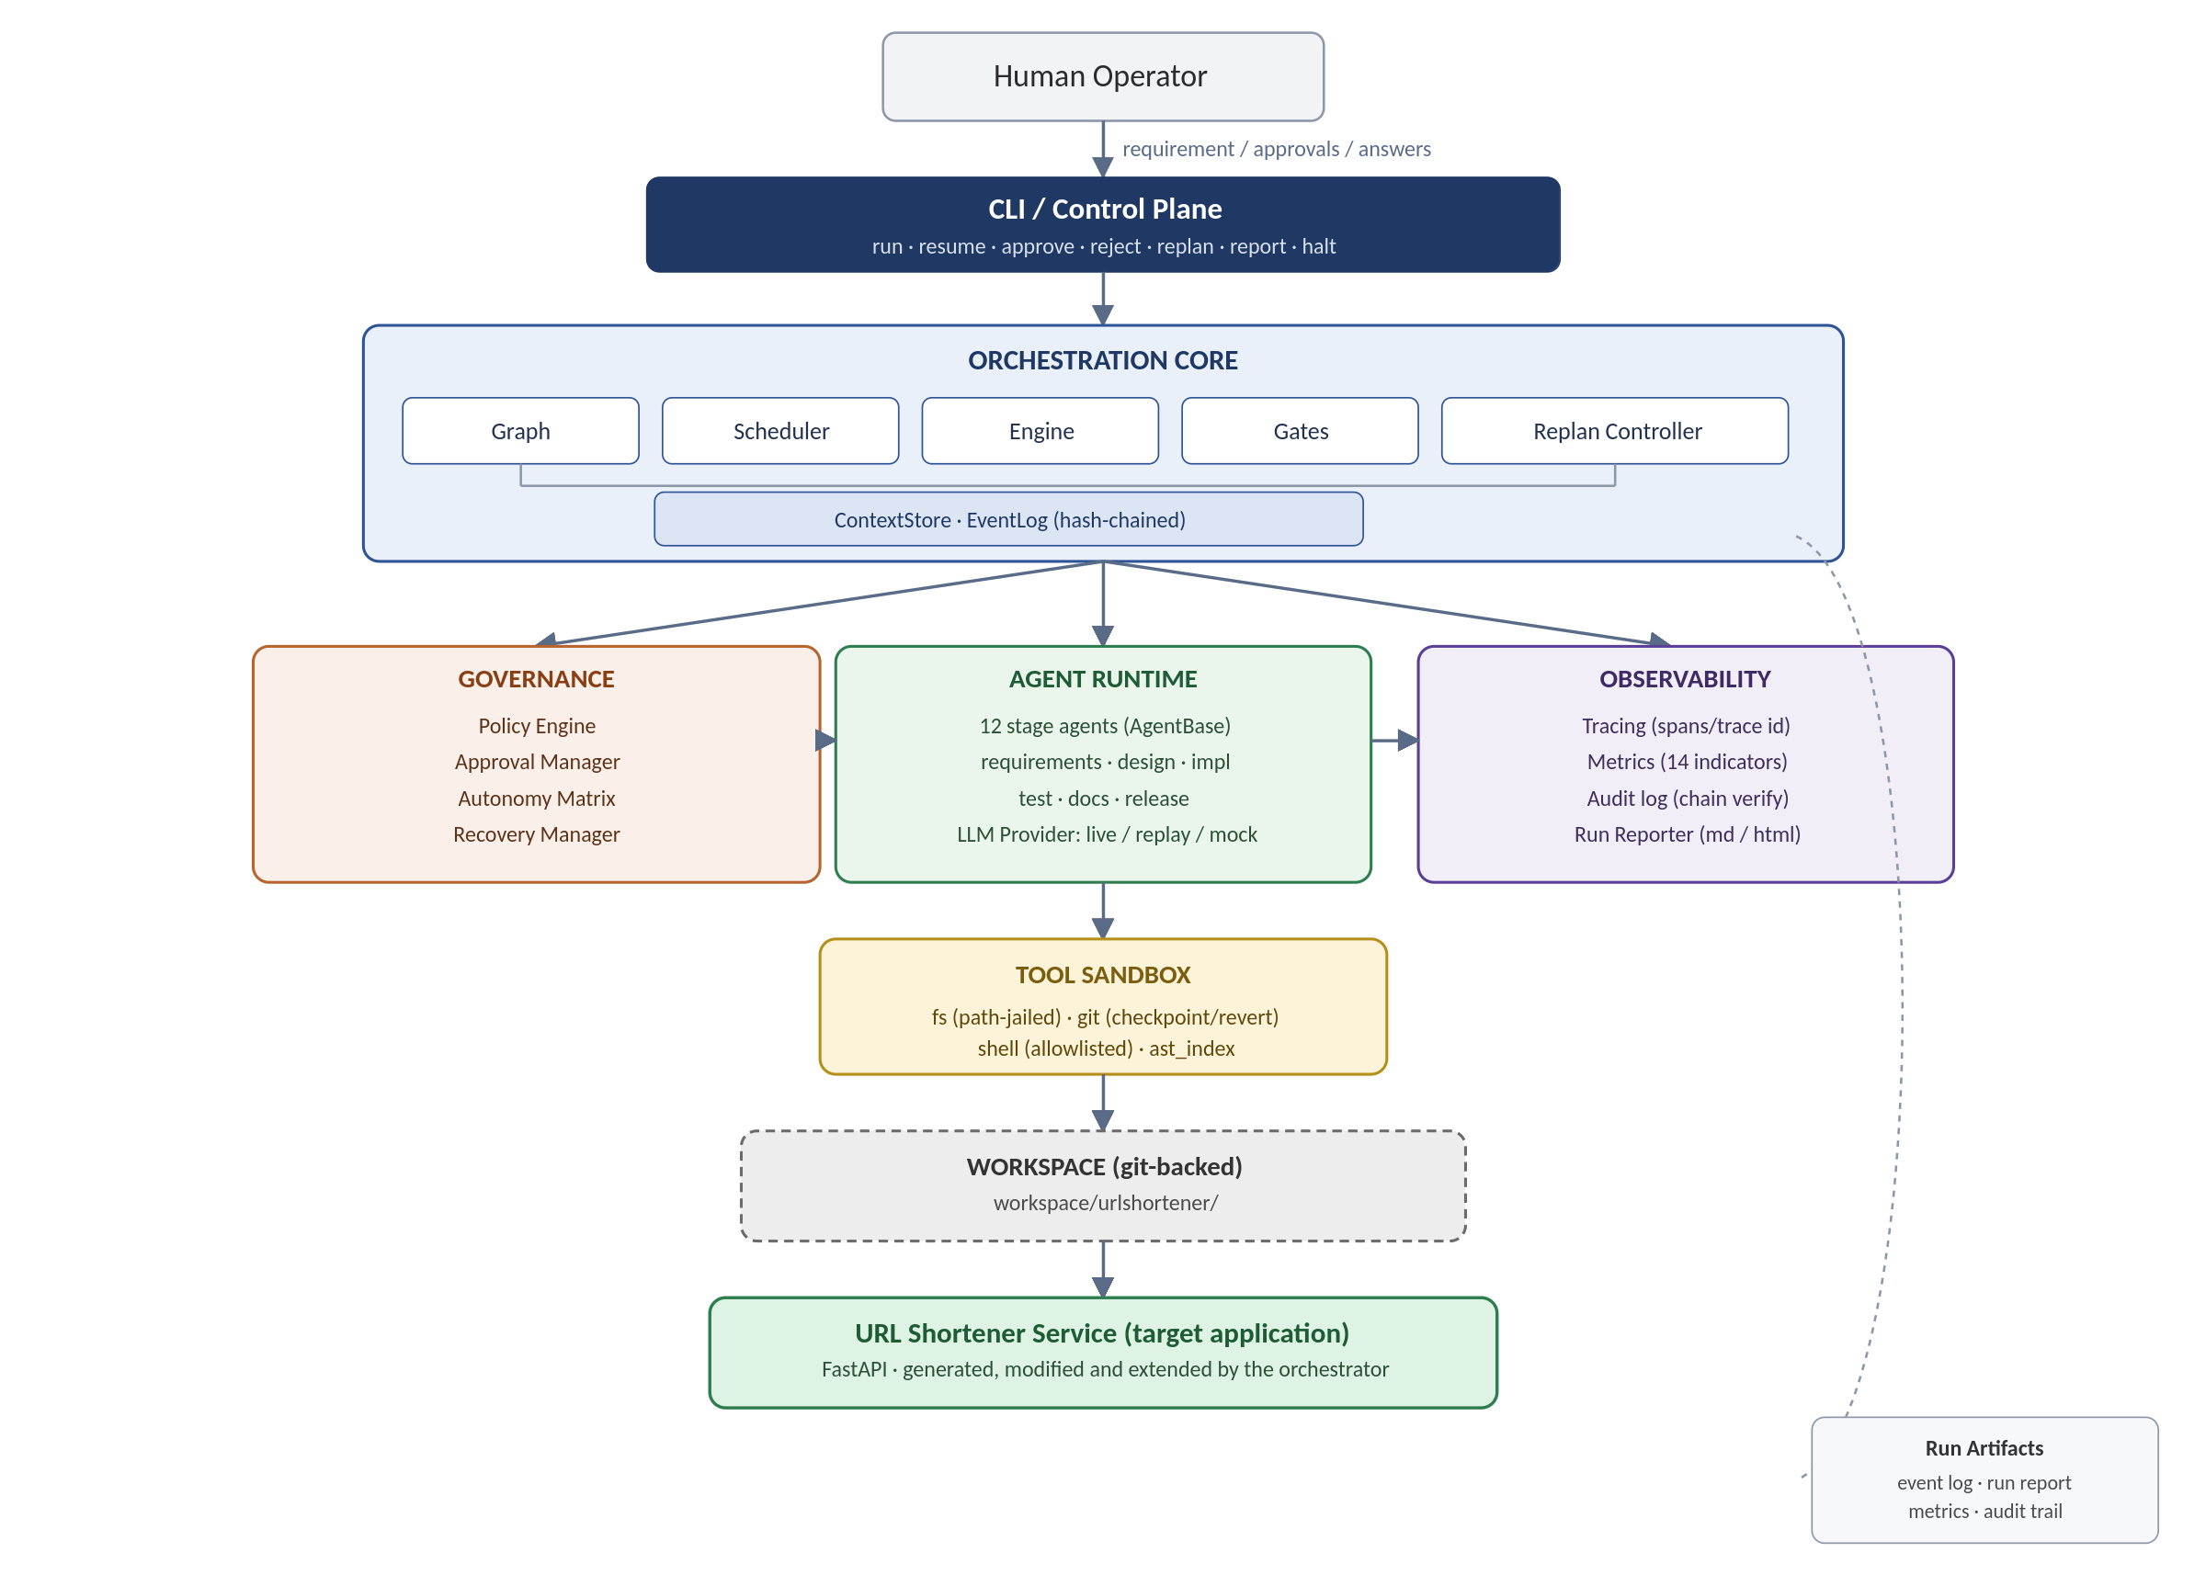
End-to-end flow: human operator → control plane → orchestration core → governance / agents / observability → tool sandbox → generated target application.

1. Components
Component | Responsibility
CLI / Control Plane | Entry point for a human operator: start runs, approve or reject checkpoints, trigger re-plans, pull reports, halt a run.
Orchestration Core | The dependency graph, scheduler, run engine, gates and re-plan controller. The single authority on what runs next and whether a result is accepted.
Governance | Policy engine, approval manager, autonomy matrix, recovery manager. Decides what is permitted and how failures are handled.
Agent Runtime | Twelve specialised agents (requirements, design, implementation, testing, docs, release) plus the pluggable LLM provider (live / replay / mock).
Tool Sandbox | Path-jailed filesystem access, git checkpoint/revert, an allowlisted shell, and an AST index for codebase reasoning. The only way any agent touches the workspace.
Observability | Tracing, reliability metrics, hash-chained audit log, and the human-readable run report.
Workspace / Target Application | The generated URL Shortener Service — the evidence that orchestrator output is real, production-shaped code.

2. Orchestration Model
The graph spans the full SDLC — requirements through release readiness — as data, not hardcoded control flow. Three properties make this more than a linear pipeline:
- Parallelism with synchronisation — design (architecture, data model, API contract) fans out and joins before implementation; verification and documentation run concurrently. Join nodes evaluate all/any/quorum policies and merge upstream context.
- Cross-stage context and lineage — agents never talk directly; they read and write through a versioned context store that tracks which artifact and decision led to which output, so a piece of generated code can be traced back to the requirement that motivated it.
- Non-linear, stateful execution — state is rebuilt from a hash-chained event log, so a run can pause for human approval and resume in a fresh process. When an upstream artifact changes, downstream nodes are invalidated and re-execute automatically — the mechanism behind dynamic re-planning.
Autonomy is bounded throughout: every agent has a ceiling (read-only, propose-only, gated-write, scoped-write) and every node declares the level its action requires, enforced at entry.

3. Control Flow
Each tick: compute the ready set (dependencies met, entry gate passed) → dispatch approved nodes concurrently → evaluate exit gates → route failures to recovery → apply any pending re-plan → update metrics. Nodes with no path forward pause for approval or, if deadlocked, safe-stop.
Failure type | Recovery route
Transient (timeout, rate limit) | Bounded retry with backoff.
Malformed model output | One repair attempt, then fallback.
Quality failure (tests, coverage, findings) | Fallback strategy, then rollback on repeat failure.
Policy denial | Immediate rollback and escalation to human approval.
Systemic (budget, audit-chain break, deadlock) | Immediate safe-stop.
Rollback reverts the workspace to its last git checkpoint and marks affected artifacts superseded rather than deleting them, preserving the audit trail of the failed attempt.

4. Key Decisions
Decision | Chosen | Why
Orchestration engine | Purpose-built graph engine over LangGraph / Temporal | The orchestration layer is what's being evaluated — a framework would hide the design under review.
System of record | Hash-chained event log, SQLite projection | Zero setup for a reviewer; audit-grade and swappable to Postgres later.
Approval mechanism | Asynchronous, persisted, resumable in a new process | Proves genuine statefulness rather than an in-memory prompt.
Rollback | Git revert to checkpoint | Reuses a proven mechanism; gives a human-readable diff of what was reverted.
LLM access | Pluggable: live / replay / mock | Reviewers without a network or API key still get a full, reproducible run.

