- What does the static keyword mean in Java? Explain the difference between static and non-static methods.
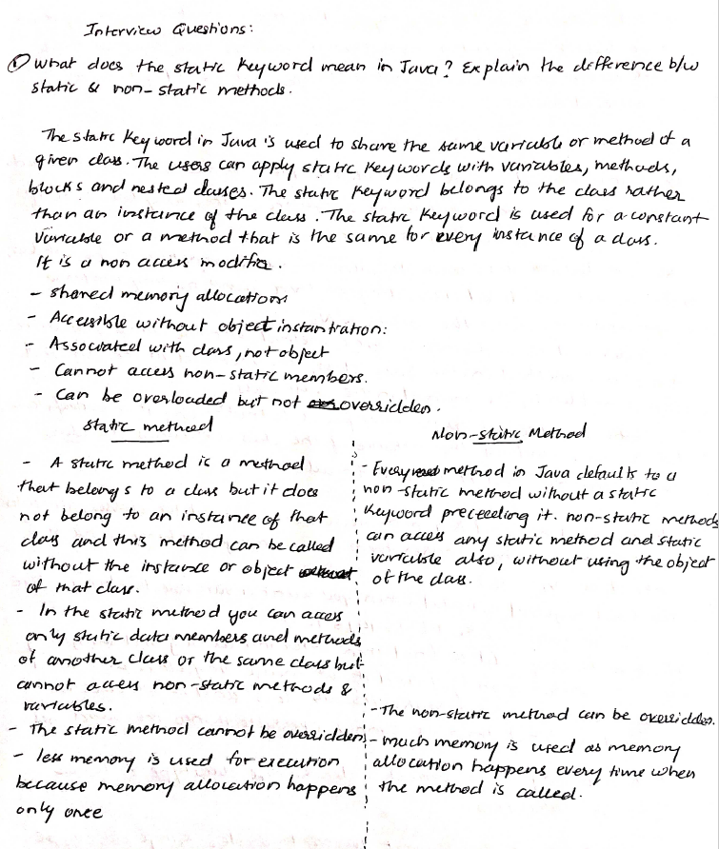

- What is the role of the static keyword in the context of memory management.



- Can static methods be overloaded and overridden in Java? How static variables shared across multiple instances of a class?

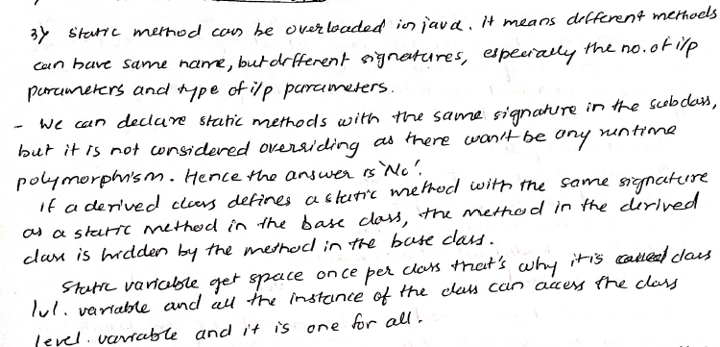

- What is the significance of the final keyword in Java?

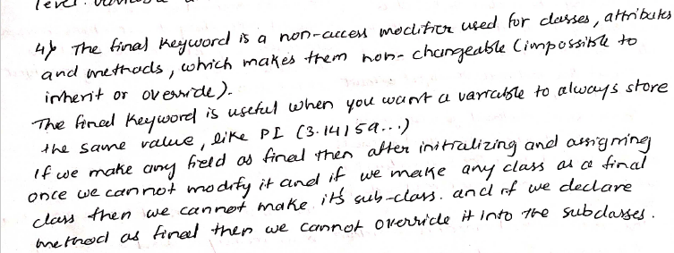

- What are narrowing and widening conversions in Java?


- Provide examples of narrowing and widening conversions between primitive data types.



- How does Java handle potential loss of precision during narrowing conversions?

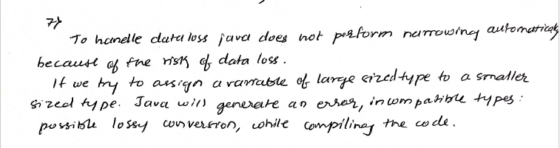

- Explain the concept of automatic widening conversion in Java.

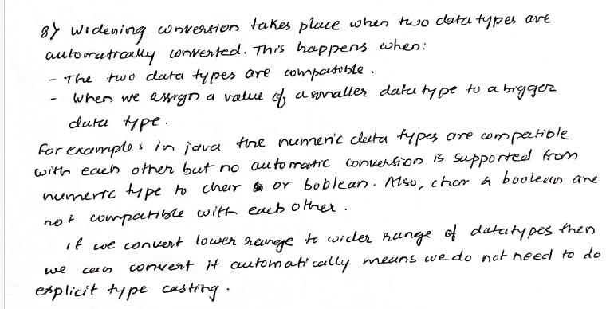

- What are the implications of narrowing and widening conversions on type compatibility and data loss?

