**Coordinate Geometry & Line Formula**

|  |  |
| --- | --- |
| **Coordinate Geometry & Lines Formulas for Class 11** | |
| Distance Formula | |P1P2|=(x2−x1)2+(y2−y1)2−−−−−−−−−−−−−−−−−−√ |
| Slope | m=riserun=ΔyΔx=y2−y1x2−x1 |
| Point-Slope Form | y−y1=m(x−x1) |
| Point-Point Form | y−y1=y2−y1x2−x1(x−x1) |
| Slope-Intercept Form | y=mx+b |
| Intercept-Intercept Form | xa+yb=1 |
| General Form | Ax+By+C=0 |
| Parallel & Perpendicular Lines | Parallel Lines m1=m2  Perpendicular Lines m1m2=−1 |
| Distance from a Point to a Line | d=|Ax0+By0+C|A2+B2−−−−−−√ |

**Algebra Formula**

|  |  |
| --- | --- |
| **Algebra Formulas For Class 11** | |
| Distributive Property | a×(b+c)=a×b+a×c |
| Commutative Property of Addition | a+b=b+a |
| Commutative Property of Multiplication | a×b=b×a |
| Associative Property of Addition | a+(b+c)=(a+b)+c |
| Associative Property of Multiplication | a×(b×c)=(a×b)×c |
| Additive Identity Property | a+0=a |
| Multiplicative Identity Property | a×1=a |
| Additive Inverse Property | a+(−a)=0 |
| Multiplicative Inverse Property | a⋅(1a)=1 |
| Zero Property of Multiplication | a×(0)=0 |

**Trigonometric Formula**

|  |
| --- |
| **Trigonometry Class 11 Formulas** |
| sin(−θ)=−sinθ |
| cos(−θ)=cosθ |
| tan(−θ)=−tanθ |
| cosec(−θ)=−cosecθ |
| sec(−θ)=secθ |
| cot(−θ)=−cotθ |
| **Product to Sum Formulas** |
| sinx siny=12[cos(x–y)−cos(x+y)] |
| cosxcosy=12[cos(x–y)+cos(x+y)] |
| sinxcosy=12[sin(x+y)+sin(x−y)] |
| cosxsiny=12[sin(x+y)–sin(x−y)] |
| **Sum to Product Formulas** |
| sinx+siny=2sin(x+y2)cos(x−y2) |
| sinx−siny=2cos(x+y2)sin(x−y2) |
| cosx+cosy=2cos(x+y2)cos(x−y2) |
| cosx−cosy=–2sin(x+y2)sin(x−y2) |

Maths Formulas For Class 11: Sets

A set is a well-collaborated collection of objects. A set consisting of definite elements is a finite set. Otherwise, it is an infinite set. You can find the essential symbols and properties for Sets below:

|  |  |
| --- | --- |
| **Symbol** | **Set** |
| N | The set of all the natural numbers |
| Z | The set of all the integers |
| Q | The set of all the rational numbers |
| R | The set of all the real numbers |
| Z+ | The set of all the positive numbers |
| Q+ | The set of all the positive rational numbers |
| R+ | The set of all the positive real numbers |

1. The union of two sets A and B are said to be contained elements that are either in set A and set B. The union of A and B is denoted as: A∪B.
2. The intersection of two sets A and B are said to be contained elements that are common in both the sets. The intersection of A and B is denoted as: A∩B.
3. The complement of a set A is the set of all elements given in the universal set U that are not contained in A. The complement of A is denoted as A′.
4. For any two sets A and B, the following holds true:
   * (i) (A∪B)′=A′∩B′
   * (ii) (A∩B)′=A′∪B′
5. If the finite sets A and B are given such that (A∩B)=ϕ, then: n(A∪B)=n(A)+n(B)
6. If (A∪B)=ϕ, then: n(A∪B)=n(A)+n(B)−n(A∩B)

Class 11 Maths Formulas: Relations And Functions

An ordered pair is a pair of elements grouped together in a certain order. A relation R towards a set A to a set B can be described as a subset of the cartesian product A × B which is obtained by describing a relationship between the first of its element x and the second of its element y given in the ordered pairs of A × B.

The below-mentioned properties will surely assist you in solving your Maths problems.

1. A cartesian product A × B of two sets A and B is given by:  
   A × B = { (a,b):aϵA,bϵB }
2. If (a , b) = (x , y); then a = x and b = y
3. If n(A) = x and n(B) = y, then n(A × B) = xy
4. A × ϕ = ϕ
5. The cartesian product: A × B ≠ B × A
6. A function f from the set A to the set B considers a specific relation type where every element x in the set A has one and only one image in the set B.  
   A function can be denoted as **f: A → B, where f(x) = y**
7. Algebra of functions: If the function f: X → R and g: X → R; we have:
   * (i) (f+g)(x)=f(x)+g(x),xϵX
   * (ii) (f–g)(x)=f(x)–g(x),xϵX
   * (iii) (f.g)(x)=f(x).g(x),xϵX
   * (iv) (kf)(x)=k(f(x)),xϵX, where k is a real number
   * (v)fg(x)=f(x)g(x),xϵX,g(x)≠0

Maths Formulas For Class 11: Trigonometric Functions

In Mathematics, trigonometric functions are the real functions which relate to an angle of a right-angled triangle forming some finite ratios of two side lengths. Find the important Maths formulas for Class 11 related to trigonometric functions below.

1. If in a circle of radius r, an arc of length l subtends an angle of θ radians, then l=r×θ.
2. Radian Measure = π180 × Degree Measure
3. Degree Measure = 180π × Radian Measure
4. cos2x+sin2x=1
5. 1+tan2x=sec2x
6. 1+cot2x=cosec2x
7. cos(2nπ+x)=cosx
8. sin(2nπ+x)=sinx
9. sin(−x)=−sinx
10. cos(−x)=−cosx
11. cos(π2−x)=sinx
12. sin(π2−x)=cosx
13. sin(x+y)=sinx×cosy+cosx×siny
14. cos(x+y)=cosx×cosy−sinx×siny
15. cos(x–y)=cosx×cosy+sinx×siny
16. sin(x–y)=sinx×cosy−cosx×siny
17. cos(π2+x)=−sinx
18. sin(π2+x)=cosx
19. cos(π−x)=−cosx
20. sin(π−x)=sinx
21. cos(π+x)=−cosx
22. sin(π+x)=−sinx
23. cos(2π−x)=cosx
24. sin(2π−x)=−sinx
25. If there are no angles x, y and (x ± y) is an odd multiple of (π / 2); then:
    * (i) tan(x+y)=tanx+tany1−tanxtany
    * (ii) tan(x−y)=tanx−tany1+tanxtany
26. If there are no angles x, y and (x ± y) is an odd multiple of π; then:
    * (i) cot(x+y)=cotxcoty−1coty+cotx
    * (ii) cot(x−y)=cotxcoty+1coty−cotx
27. cos2x=cos2x−sin2x=2cos2x−1=1−2sin2x=1−tan2x1+tan2x
28. sin2x=2sinx:cosx=2tanx1+tan2x
29. sin3x=3sinx−4sin3x
30. cos3x=4cos3x−3cosx
31. tan3x=3tanx−tan3x1−3tan2x
32. Addition and Subtraction of sin and cos
    * (i) cosx+cosy=2cosx+y2cosx−y2
    * (ii) cosx−cosy=−2sinx+y2sinx−y2
    * (iii) sinx+siny=2sinx+y2cosx−y2
    * (iv) sinx−siny=2cosx+y2sinx−y2
33. Multiplication of sin and cos
    * (i) 2cosxcosy=cos(x+y)+cos(x−y)
    * (ii) −2sinxsiny=cos(x+y)−cos(x−y)
    * (iii) 2sinxcosy=sin(x+y)+sin(x−y)
    * (iv) 2cosxsiny=sin(x+y)−sin(x−y)
34. sinx=0;givesx=nπ,wherenϵZ
35. cosx=0;givesx=(2n+1)π2,wherenϵZ
36. sinx=siny;impliesx=nπ+(−1)ny,wherenϵZ
37. cosx=cosy;impliesx=2nπ±y,wherenϵZ
38. tanx=tany;impliesx=nπ+y,wherenϵZ

Class 11 Maths Formulas: Complex Numbers And Quadratic Equations

A number that can be expressed in the form a + ib is known as the complex number; where a and b are the real numbers and i is the imaginary part of the complex number.

1. Let z1 = a + ib and z2 = c + id; then:
   * (i) z1 + z2 = (a + c) + i (b + d)
   * (ii) z1 . z2 = (ac – bd) – i (ad + bc)
2. If there is a non-zero complex number; z = a + ib; where (a ≠ 0, b ≠ 0), then there exists a complex number aa2+b2+i−ba2+b2; denoted by \(\frac{1}{z} or z–1 is known as the multiplicative inverse of z; such that  
   (a + ib) [ a2a2+b2+i−ba2+b2 ] = 1 + i 0 = 1
3. For every integer k, i4k = 1, i4k+1 = i, i4k+2 = -1, i4k+3 = -i
4. The conjugate of the complex number is z¯=a−ib
5. The polar form of the complex number z = x + iy is r(cosθ+isinθ); where r=x2+y2−−−−−−√ (the modulus of z)  
   cosθ=xr and sinθ=yr (θ is the argument of z)
6. A polynomial equation with n degree has n roots.
7. The solutions of the quadration equation ax2 + bx + c = 0 are:  
   x=−b±4ac−b2i√2a where a, b, c ∈ R, a ≠ 0, b2 – 4ac < 0

Maths Formulas For Class 11: Permutations And Combinations

If a certain event occurs in*‘m’* different ways followed by an event that occurs in *‘n’* different ways, then the total number of occurrence of the events can be given in *m × n* order. Find the important Maths formulas for class 11 as under:

1. The number of permutations of n different things taken r at a time is given by nPr =n!(n−r)! where 0 ≤ r ≤ n
2. n!=1×2×3×…×n
3. n!=n×(n−1)!
4. The number of permutations of n different things taken r at a time with repetition being allowed is given as: nr
5. The number of permutations of n objects taken all at a time, where p1 objects are of one kind, p2 objects of the second kind, …., pk objects of kth kind are given as: n!p1!p2!…pk!
6. The number of permutations of n different things taken r at a time is given by nCr =n!r!(n−r)! where 0 ≤ r ≤ n

Class 11 Maths Formulas: Binomial Theorem

A Binomial Theorem helps to expand a binomial given for any positive integral n.  
(a+b)n=nC0an+nC1an−1.b+nC2an−2.b2+…+nCn−1a.bn−1+nCnbn

1. The general term of an expansion (a + b)n is Tr+1=nCran−r.br
2. In the expansion of (a + b)n; if n is even, then the middle term is (n2+1)th term.
3. In the expansion of (a + b)n; if n is odd, then the middle terms are (n+12)th and (n+12+1)th terms

Maths Formulas For Class 11: Sequence And Series

An arithmetic progression (A.P.) is a sequence where the terms either increase or decrease regularly by the same constant. This constant is called the common difference (d). The first term is denoted by a and the last term of an AP is denoted by l.

1. The general term of an AP is an=a+(n−1)d
2. The sum of the first n terms of an AP is: Sn=n2[2a+(n−1)d]=n2(a+l)

A sequence is said to be following the rules of geometric progression or G.P. if the ratio of any term to its preceding term is specifically constant all the time. This constant factor is called the common ratio and is denoted by r.

1. The general term of an GP is given by: an=a.rn−1
2. The sum of the first n terms of a GP is: S_{n}=\frac{a(r^n-1)}{r-1}\: or\: \frac{a(1-r^n)}{1-r}; if r ≠ 1
3. The geometric mean (G.M.) of any two positive numbers a and b is given by ab−−√

Class 11 Maths Formulas: Straight Lines

1. Slope (m) of the intersecting lines through the points (x1, y1) and x2, y2) is given by m=y2−y1x2−x1=y1−y2x1−x2; where x1 ≠ x2
2. An acute angle θ between lines L1 and L2 with slopes m1 and m2 is given by tanθ=∣∣m2−m11+m1.m2∣∣; 1 + m1.m2 ≠ 0.
3. Equation of the line passing through the points (x1, y1) and (x2, y2) is given by: y−y1=y2−y1x2−x1(x−x1)
4. Equation of the line making a and b intercepts on the x- and y-axis respectively is: xa+yb=1
5. The perpendicular distance d of a line Ax + By + C = 0 from a point (x1, y1) is: d=|Ax1+By1+C|A2+B2√
6. The distance between the two parallel lines Ax + By + C1 and Ax + By + C2 is given by: d=|C1−C2|A2+B2√

Maths Formulas For Class 11: Conic Sections

A circle is a geometrical figure where all the points in a plane are located equidistant from the fixed point on a given plane.

1. The equation of the circle with the centre point (h, k) and radius r is given by (x – h)2 + (y – k)2 = r2
2. The equation of the parabola having focus at (a, 0) where a > 0 and directrix x = – a is given by: y2 = 4ax
3. The equation of an ellipse with foci on the x-axis is x2a2+y2b2=1
4. Length of the latus rectum of the ellipse x2a2+y2b2=1 is given by: 2b2a
5. The equation of a hyperbola with foci on the x-axis is x2a2−y2b2=1
6. Length of the latus rectum of the hyperbola x2a2−y2b2=1 is given by: 2b2a

Class 11 Maths Formulas: Introduction To Three Dimensional Geometry

The three planes determined by the pair of axes are known as coordinate planes with XY, YZ and ZX planes. Find the important Maths formulas for Class 11 below:

1. The distance of two points P(x1, y1, z1) and Q(x2, y2, z2) is:  
   PQ=(x2−x1)2+(y2−y1)2+(z2−z1)2−−−−−−−−−−−−−−−−−−−−−−−−−−−−√
2. The coordinates of a point R that divides the line segment joined by two points P(x1, y1, z1) and Q(x2, y2, z2) internally as well as externally in the ratio m : n is given by:  
   (mx2+nx1m+n,my2+ny1m+n,mz2+nz1m+n)and(mx2−nx1m−n,my2−ny1m−n,mz2−nz1m−n);
3. The coordinates of the mid-point of a given line segment joined by two points P(x1, y1, z1) and Q(x2, y2, z2) are (x1+x22,y1+y22,z1+z22)
4. The coordinates of the centroid of a given triangle with vertices (x1, y1, z1), (x2, y2, z2) and (x3, y3, z3) are (x1+x2+x33,y1+y2+y33,z1+z2+z33)

Maths Formulas For Class 11: Limits And Derivatives

A limit of a function at a certain point holds a common value of the left as well as the right hand limits, if they coincide with each other.

1. For functions f and g, the following property holds true:
   * (i) limx→a[f(x)±g(x)]=limx→af(x)±limx→ag(x)
   * (ii) limx→a[f(x).g(x)]=limx→af(x).limx→ag(x)
   * (iii) limx→a[f(x)g(x)]=limx→af(x)limx→ag(x)
2. Standard Limits
   * (i) limx→axn−anx−a=nan−1
   * (ii) limx→asinxx=1
   * (iii) limx→a1−cosxx=0
3. The derivative of a function f at a holds as: f′(a)=limx→af(a+h)−f(a)h
4. The derivative of a function f at a given point x holds as: f′(x)=∂f(x)∂x=limx→af(x+h)−f(x)h
5. For the functions u and v, the following holds true:
   * (i) (u±v)′=u′±v′
   * (ii) (uv)′=u′v+uv′
   * (iii) (uv)′=u′v−uv′v2
6. Standard Derivatives
   * (i) ∂∂x(xn)=nxn−1
   * (ii) ∂∂x(sinx)=cosx
   * (iii) ∂∂x(cosx)=−sinx

Class 11 Maths Formulas: Statistics

You will find the essential maths formulas for Class 11 of Statistics given below:

1. Mean Deviation for the ungrouped data:
   * (i) M.D.(x¯)=∑|xi−x¯|n
   * (ii) M.D.(M)=∑|xi−M|n
2. Mean Deviation for the grouped data:
   * (i) M.D.(x¯)=∑fi|xi−x¯|N
   * (ii) M.D.(M)=∑fi|xi−M|N
3. Variance and Standard Deviation for the ungrouped data:
   * (i) σ2=1N∑(xi−x¯)2
   * (ii) σ=1N∑(xi−x¯)2−−−−−−−−−−−√
4. Variance and Standard Deviation of a frequency distribution (discrete):
   * (i) σ2=1N∑fi(xi−x¯)2
   * (ii) σ=1N∑fi(xi−x¯)2−−−−−−−−−−−−−√
5. Variance and Standard Deviation of a frequency distribution (continuous):
   * (i) σ2=1N∑fi(xi−x¯)2
   * (ii) σ=1NN∑fix2i−(∑fixi)2−−−−−−−−−−−−−−−−−√
6. Coefficient of variation (C.V.) = σx¯×100 ; where x¯≠0

Relations and Functions Class 12 Notes Maths Chapter 1

March 30, 2021 by [Prasanna](https://www.learninsta.com/author/prasanna/)

By going through these CBSE [Class 12 Maths Notes](https://www.learninsta.com/class-12-maths-notes/) Chapter 1 Relations and Functions, students can recall all the concepts quickly.

Relations and Functions Notes Class 12 Maths Chapter 1

**RELATION**  
**1. Types of Relations**  
→ Empty Relation: A relation in a set A is known as empty relation, if no element of A is related to any element of A, i.e., R = Φ ⊆ A × A. e.g.

Let the set A = {1, 2,3,4,5) and R is given by  
R= {(a,b): a – b = 20}

There is no pair (a, b) that satisfies the condition  
a – b = 20.  
⇒ The relation R is the empty relation.

→ Universal Relation: A relation R in a set A is called a universal relation, if each element of A is related to every element of A, i.e.,  
R = A × A. e.g.  
Let the set A = {1, 2,3, 4,5} and R is given by R = {(a, b): ab > 0}  
Here, R = {(a, b): ab > 0} is the whole set A × A as all pairs (a, b) in A × A satisfy ab > 0.  
Thus, this is the universal relation.

→ A relation R in a set A is called  
(a) reflexive: if (a, a) ∈ R for every a ∈ A.  
(b) symmetric: ii (a, b) ∈ R implies that (b, a) ∈ R for all a, b ∈ A.  
(c) transitive: if (a, b) ∈ R and (b, c) e R implies that (a, c) ∈ R for all a,b,c ∈ A.

→ Equivalence Relation: A relation R in A is an equivalence relation if R is reflexive, symmetric, and transitive. For example:  
(1) Let T be the set of all triangles in a plane with R a relation in T given by  
R = ((T1, T2): T1 is similar to T2)  
(a) R is reflexive since every triangle is similar to itself.

(b) (T1, T2) ∈ R ⇒ T1 is similar to T2.  
(T2, T3) ∈ R ⇒ T2 is similar to T1  
Therefore, R is symmetric.

(c) (T1, T2) and (T2, T3) lies in R  
⇒ T1is similar to T2 and T2 is similar to T3, which means T1 is similar to T3,  
i.e., (T1, T3) lies in R.  
∴ R is transitive.  
Now R is reflexive, symmetric, and transitive, therefore R is an equivalence relation.

(2) Consider the set A = {1,2,3,4} and the relation R = {(1,1), (2, 2), (3,3), (4, 4), (1, 2), (2, 3), (3, 4)}.  
(a) Now (1,1), (2, 2), (3, 3), (4, 4) lie in R. Relation R is reflexive.  
(b) (1, 2) lies in R but (2,1) does not lie in it.  
∴ It is not symmetric.  
(c) (1,2), (2, 3) lie in R but (1, 3) does not lie in it. Therefore, R is not transitive.  
Here, R is reflexive but neither symmetric nor transitive. Therefore, R is not an equivalence relation.

**2. Equivalence Class [a] containing a**  
For an arbitrary equivalence relation R in an arbitrary set X, R divides X into mutually disjoint subsets Ai, which are known as partitions or sub-divisions of X satisfying:  
(a) All elements of Ai are related to each other for all i.  
(b) No element of Ai is related to any element of Aj, i ≠ j.  
(c) ∪ Aj = X and Ai ∩ A. = Φ, i ≠ j.

The subsets Af are said to be equivalence classes.  
Example: Let R be the relation defined in the set A = {p, q, s, t, e, o, u} by  
R = {(a, b): both a and b are either consonants or vowels,  
Here, R is an equivalence relation.  
(a) Any element ∈ A is either consonant or vowel,  
i.e., (a, a) ∈ R ⇒ R is reflexive.

(b) If (a, b) ∈ R ⇒ a and b both are either consonants or vowels ⇒ (b, a) e R.  
∴ R is symmetric.

(c) If (a, b) ∈ R and (b, c) ∈ R, then a, b; b, c both pairs are either consonants or vowels.  
i.e., a, b, c all are either consonants or vowels.  
⇒ (a, c) ∈ R.  
∴ R is transitive.  
Thus, R is an equivalence relation.

Further, all the elements of (p, q, s, t) are related to each other as all the elements of this subset are consonants.

Similarly, all the elements of {e, i, o, u } are related to each other as all of them are vowels. But no element of {p, q, s, t} can be related to any element of {e, i, o, u}, since the elements of {p, q, s, t} are all consonants and the elements of {e, i, o, u} are all vowels. {p, q, s, t} is an equivalence class.denoted by an element as {p}. Similarly, {e, i, o, u} is an equivalence class denoted by an element [e).

**FUNCTIONS**  
**1. Types of Functions**  
→ One-one (or Injective): A function f: X → Y is said to be one-one (or injective), if the images of the distinct elements of X under/are distinct, i.e., for every x1, x2 ∈ X, if f(x1) = f(x2) implies that x1 = x2.  
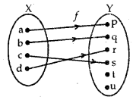  
Each element of X has a distinct image in Y. Such a function or a mapping is one-one.

→ Onto (or surjective): A function f: X →Y is called onto, if every element of Y is the image of some element of X under f, i.e., for all y ∈ Y, there exists an element x in X such that f(x) = y.  
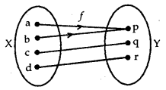  
Corresponding to each element of Y, there is a pre-image in X. Such a mapping is onto.

→ One-one and Onto (Bijective): A function f: X to Y is known as one-one and onto (or bijective), if f is both one-one and onto.  
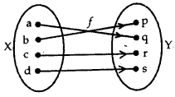  
Here,f is both one-one and onto. Therefore,f is said to be one-one onto function or bijective function.

**2. Composition of Functions**  
Let f: A → B and g: B → C be the two functions. The composition of f and g is defined as. gof: A → C, such that  
gof(x) = g{f(x)}, for all x ∈ A.  
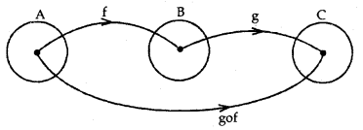  
A function f: X → Y is said to be invertible if there exists a function g: Y → X such that gof = Ix and fog = Iy. The function g is called the inverse of f. It is denoted by f-1.

Inverse or composite function: If f: X →Y and g: Y → Z be the two invertible functions, then gof is also invertible such that (gof)-1 = f-1og-1

**BINARY OPERATION**  
→ Binary Operation: A binary operation on a set A is a function X: A × A → A, defined by × (a,b) = a × b, e.g., ×: R × R → R is given by (a, b) → a + b. Here +, — and x are the functions but + : R × R →, R, written as (a, b) → ab is not a function. It is not a binary operation, since it is not defined for b = O.

→ Commutative Binary Operation: A binary operation × on the set A is commutative,if for every a,b ∈ A, a × b = b × a.

→ Associative Binary Operation: A binary operation × on the set A is associative, if (a × b) × c = a × (b × c).  
It may be noted that associative property, a × b × c × d, … is not defined unless brackets are used.

→ An Identity Element e for Binary Operation: Let ×: A × A → A be a binary operation. There exists an element e ∈ A such that a × e = a = e × a, for all a ∈ A.

The element e is known as the identity element. It should be noted that 0 is the identity element for addition but not for natural numbers N, since 0 ∉ N.

→ The inverse of an element a: Let ×: A × A → A be a binary operation with identity element e in A. An element a ∈ A is invertible w.r.t. binary operation ×, if there exists an element b in A such that a × b = e = b × a. The element b is said to be the inverse of a. It is denoted by a-1, e.g.,

– a is the inverse of a for the operation of addition +.  
1a (a ≠ 0) is the inverse of a for multiplication.

1. RELATIONS

(i) Relation. A relation R from a set A to a set B is a subset of A x B.

(ii) Classification of Relations : a  
(a) Reflexive Relation. A relation R in a set E is said to be reflexive if xRx ∀ x ∈ E.  
(b) Symmetric Relation. A relation R in a set E is said to be symmetric if:  
xRy = yRx ∀ x, y ∈ E.  
(c) Transitive Relation. A relation R in a set E is said to be transitive if:  
vRy and yRz ⇒ xRz ∀ x, y, z ∈ E.  
(d) Equivalence Relation. A relation R in a set E is said to be an equivalence relation if it is :

* reflexive
* symmetric and
* transitive.

2. FUNCTIONS

(i) Let X and Y be two non-empty sets. Then ‘f’ is a rule, which associates to each element x in X . a unique element y in Y.  
(a) The unique element y of Y is called the value of f at x.  
(b) The element x of X is called pre-image of y.  
(c) The set X is called the domain of f  
(d) The set of images of elements of X under f is called the range of f.

(ii) (a) Df = {x : x ∈ R, f(x) ∈ R}  
(b) Rf = {f(x):x ∈ Df}  
(c) f is one-one iff x1 = x2  
⇒ f(x1) = f(x2) for x1, x2 ∈ Df  
or iff x1 ≠ x2  
⇒ f(x1) ≠ f(x2) for x1, x2 ∈ Df  
(d) f is invertible iff f is one-one onto and Df-1 = Rf, Rf-1= DRf.

3. ALGEBRA OF FUNCTIONS

Let f and g be two functions. Then  
(i) (f+g) (x) =f(x) + g(x); Df+g = Df ∩ Dg  
(ii) (f- g) (x) = f(x) – g(x); Df-g = Df ∩ Dg  
(iii) (fg) (x) =f(x) g(x); Dfg = Df ∩ Dg  
(iv) (fg)x=f(x)g(x); Df/g = Df ∩ Dg – {x:x∈Dg, g(x) = 0}

Inverse Trigonometric Functions Class 12 Notes Maths Chapter 2

July 19, 2021 by [Prasanna](https://www.learninsta.com/author/prasanna/)

By going through these CBSE [Class 12 Maths Notes](https://www.learninsta.com/class-12-maths-notes/) Chapter 2 Inverse Trigonometric Functions, students can recall all the concepts quickly.

Inverse Trigonometric Functions Notes Class 12 Maths Chapter 2

[Inverse Function Calculator](https://onlinecalculator.guru/algebra/inverse-function-calculator/) is an online tool by Protonstalk to quickly and easily find out the inverse of any given function.

As we have learned in class XI, the domain and range of trigonometric functions are given below:  
Functions Domain Range  
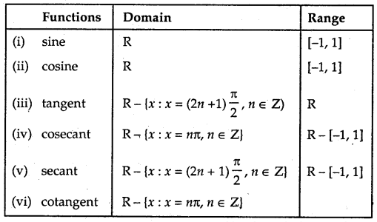  
→ Inverse Function: We know that if f: X →Y such that y = f(x) is one-one and onto, then we define another function g : Y → X such that x = g(y), where x ∈ X and y ∈ Y, which is also one-one and onto.

In such a case, Domain of g = Range of f and Range of g = Domain of f.  
g is called the inverse of f or g = f-1.  
∴ Inverse of g = g-1 = (f-1)-1 =f.

The graph of the sin-1 function is shown here.

**Principal Value Branch of Function sin-1:**  
It may be noted that for the domain [-1,1}, the range could be any one of the intervals. …..,  
[−3π2, −π2], [−π2, π2] or [π2, 3π2] …….  
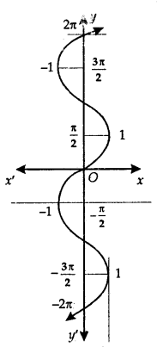  
Corresponding to each interval, we get a branch of the function sin-1.  
The branch with range [−π2, π2] is called the principal value branch.  
Thus, sin-1: [-1,1] → [−π2, π2]

**Principal Value Branch of Function cos-1:**  
The graph of the function cos-1 is as shown here.  
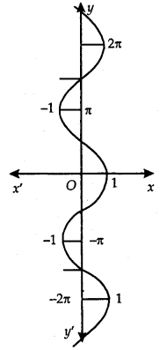  
The domain of the function cos-1 is [-1,1]. Its range is one of the intervals. ………., (-π, 0), (0, π), (π, 2π), ………… It is one-one and onto with the range [-1, 1]. The branch with range (0, π) is called the principal value branch of the function cos-1. Thus, cos-1: [-1,1] → [0, π].

**Principal Value Branch of Function tan-1:**  
The function tan-1 is defined whose domain is set of real numbers and range is one of the intervais. [ −3π2, −π2], [−π2, π2] or [π2, 3π2]…………

The graph of the function is as shown in the adjoining figure.  
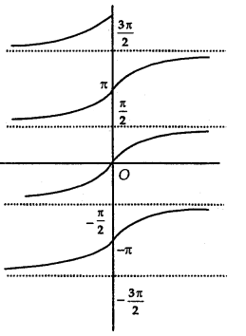  
The branch with range [−π2, π2] is called the principal value branch of function tan1. Thus, tan-1: R → [−π2, π2].

**Principal Value Branch of Function cosec-1:**  
The graph of function cosec-1 is as shown here. The function cosec-1 defined whose domain is R — (-1, 1) and the range is any one of the intervals …….., [ −3π2, −π2] – {π}, [−π2, π2] – {0}, [π2, 3π2] – {π}……..  
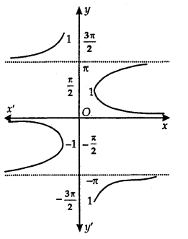  
The function corresponding to the range [−π2, π2] – {0} is called the principal value branch of cosec-1.  
Thus, cosec-1: R – (-1, 1) → [−π2, π2] – {0}.

**Principal Value Branch of Function sec-1:**  
The graph of function sec-1 is shown in adjoining figure. The sec-1 is defined as a function whose domain is R – (-1, 1) and the range is one of the intervals……. [- π, 0] – {−π2}, [0, π] – {π2}, [π, 2π] – {3π2}, ……………  
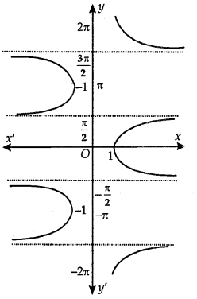  
The function corresponding to [0, π] – {π2} is known as the range [0, π] – {π2} is known as the principal value branch of sec-1.

Thus, sec-1: R – (-1,1) → [0, π] – {π2}

**Principal Value Branch of Function cot-1:**  
The graph of function cor’ is as shown here.  
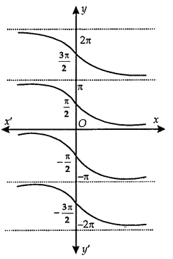  
The cot-1 function is defined as a function whose domain is R and the range is any of the intervals, …………  
(-π, 0), (0, π), (π, 2π), …………

The function corresponding to (0, π) is called the principal value branch of the function cot-1.  
Thus, cot-1: R → (0, π).

The principal value branch of trigonometric inverse functions are as follows:  
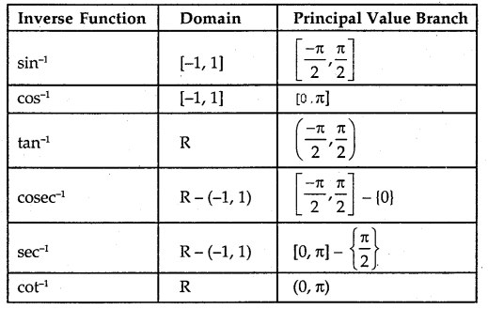  
→ Some Important Results:  
1. (a) sin-11x = cosec-1x, x ≥ 1, x ≤ -1  
(b) cos-1 1x = sec-1x, x ≥ l, x ≤ -1  
(c) tan-1 1x = cot-1x, x > 0  
(d) cosec-1 1x = sin-1x, x ∈ [-1,1]  
(e) sec-1 1x = cos-1x, x ∈ [-1,1]  
(f) cot-1 1x = tan-1x, x > 0.

2. (a) sin-1(-x) = – sin-1x, x ∈ [-1,1]  
(b) tan-1(-x) = – tan-1x, x ∈ R  
(c) cosec-1(-x) = – cosec-1x, | x | >1  
(d) cos-1(-x) = π – cos-1x, x ∈ [-1,1]  
(e) sec-1(-x) = π – sec-1x, x ∈ R  
(f) cot-1(-x) = π – cot-1x, x ∈ R

3. (a) sin-1x + cos-1x = x2, x ∈ [-1,1]  
(b tan-1x + cot-1x = x2, x ∈ R  
(c) cosec-1x + sec-1x = x2, | x | ≥ 1

4. (a) tan-1x + tan-1y = tan-1x+y1−xy, xy < 1  
(b) tan-1x – tan-1y = tan-1x−y1+xy, xy > -1  
(c) 2 tan-1x = tan-12x1−x2, | x | <1  
= sin-12x1+x2, | x | <0  
= cos-11−x21+x2 , x ≥ 0  
(d) 2sin-1x = sin-1[2x1−x2−−−−−√]  
(e) 2cos-1x = cos-1(2x2 – 1)

1. Table

|  |  |  |
| --- | --- | --- |
| Function | Principal Value Branch | |
|  | Domain | Range |
| (i) y = sin-1 x | – 1 ≤ x ≤ 1 | −π2 ≤ y ≤ π2 |
| (ii) y = cos-1 x | – 1 ≤ x ≤ 1 | 0 ≤ y ≤ π |
| (iii) y = tan-1x | – ∞ < x < ∞ | −π2 < y < π2 |
| (iv) y = cot-1 x | – ∞ < x ≤ -1 | 0 < y < π2 |
| (v) y = sec-1 x | 1 ≤  x < ∞ -∞ < x ≤ -1 | 0 ≤ y < π2 π2< y < π |
| (vi) y = cosec-1 x | 1 ≤ x < ∞ -∞ < x ≤ ∞ | 0 < y ≤ π2 −π2 ≤ y < 0 |

2. PROPERTIES :

(i) x = sin-1(sin x) = cos-1(cos x) = tan-1 (tan x); etc.  
(ii) (a) cosec-1x = sin-1 1x , x ≥ 1 or x ≤ -1  
(b) sec-1 x = cos-11x ,x ≥ 1 or x ≤ -1  
(c) cot-1x = tan-11x, x > 0.

(iii) (a) sin-1 (- x) = – sin-1x, x ∈ [-1,11  
(b) cos-1 (-x) = π – cos-1x, x ∈ [- 1, 1]  
(c) tan-1(- x) = – tan-1 x, x ∈ R  
(d) cot-1(-x) = π – cot-1 x, x ∈ R  
(e) sec-1 (-x) = π – sec-1 x, |x| ≥ 1  
(f) cosec-1 (- x) = – cosec-1 x, |x| ≥ 1

(iv) (a) sin-1 x + cos-1 x = π2, x ∈ (-1,1)  
(b) tan -1 x + cot-1x = π2 x ∈ R  
(c) sec-1x + cosec-1= π2, |x| ≥ 1  
(d) tan-1 x + tan-1 = tan-1 x+y1−xy, xy > -1  
(e) tan-1x – tan-1y = tan-1 x−y1+xy, xy > -1  
(f) 2tan-1 x = sin-1 2x1+x2 = cos-1 2x1−x2 = tan-1

(v) (a) sin -1x ± sin-1 y = sin -1 (x1−y2−−−−−√±y1−x2−−−−−√)  
(b) cos -1x ± cos-1y = cos -1 (xy∓1−x2−−−−−√1−y2−−−−−√)

Continuity and Differentiability Notes Class 12 Maths Chapter 5

**Continuity (Definition):** if f be a real-valued function on a subset of real numbers and let c be a point in its domain, then f is a continuous function at e, if  
Continuity and Differentiability Class 12 Notes Maths 1  
Obviously, if the left-hand limit and right-hand limit and value of the function at x = c exist and are equal to each other, i.e., if  
Continuity and Differentiability Class 12 Notes Maths 2  
then f is continuous at x = c.

**Algebra of continuous functions:**  
Let f and g be two real functions, continuous at x = c, then

1. Sum of two functions is continuous at x = c, i.e., (f + g) (x), defined as f(x) + g(x), is continuous at x = c.
2. Difference of two functions is continuous at x = c, i.e., (f – g) (x), defined as f(x) – g(x), is continuous at x = c.
3. Product of two functions is continuous at x = c, i.e., (f g) (x), defined as f(x) . g(x) is continuous at x = c.
4. Quotient of two functions is continuous at x = c, (provided it is defined at x = c), i.e.,  
   (fg)(x), defined as f(x)g(x) [g(x) ≠ 0], is continuous at x = c.

However, if f(x) = λ, then  
(a) λ.g, defined ty .g(x), is also continuous at x = c.  
(b) Similr1y, if λg is defined as λg (x) = λg(x) , then λg is also continuous at x = c.

→ Differentiability: The concept of differentiability has been introduced in the lower class. Let us recall some important results.

→ Differentiability (Definition): Let f be a real function and c is a point in its domain. The derivative of f at c is defined as  
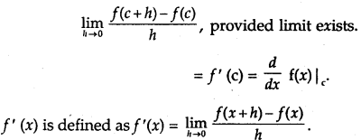  
Every differentiable function is continuous.

→ Algebra of Derivatives: Let u and v be two functions of x.

1. (u ± v)’ = u’ ± v’
2. (uv)’ = u’v + uv’
3. (uv)′=u′v−uv′v2, where v ≠ 0.

→ Derivative of Composite Function: Let t be a real valued function which is a composite of two functions u and v, i.e., f = vou. Put u(x) = t and f= v(t).  
∴ dfdx=dvdt⋅dtdx

→ Chain Rule: Let/be a real valued function which is a composite fimction of u, v and w, i.e., f(wov)ou.  
Put u(x) = t, v(t) = s and f = w(s). Then,  
dfdx=dwds⋅dsdt⋅dtdx.

→ Derivatives of Inverse Trigonometric Functions:

|  |  |  |
| --- | --- | --- |
| **Functions** | **Domain** | **Derivatives** |
| Sin-1x | [- 1, 1] | 11−x2√ |
| Cos-1x | [- 1, 1] | −11−x2√ |
| tan-1x | R | 11+x2 |
| Cot-1x | R | −11+x2 |
| Sec-1x | (-∞, – 1] ∪ [1, ∞) | 1xx2−1√ |
| Cosec-1x | (-∞, – 1] ∪ [1, ∞) | −1xx2−1√ |

Implicit Functions: An equation in form f(x, y) = 0, in which y is not expressible in terms of x, is called an implicit function of x and y.

Both sides of the equations are differentiated termwise. Then, from this equation, dydx is obtained. It may be noted that when a function of y occurs, then differentiate it w.r.t. y and multiply it by dydx.

e.g., To find dydx from cos2 y + sin xy = 1, we differentiate it as  
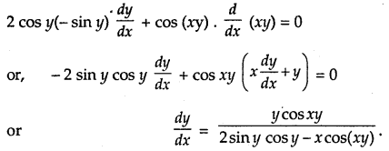

**Exponential Functions:**  
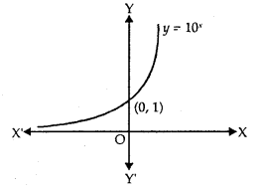  
The exponential function, with positive base b > 1, is the function y = bx.

1. The graph of y = 10x is shown in the figure.
2. Domain = R
3. Range = R+
4. The point (0,1) always lies on the graph.
5. It is an increasing function, i.e., as we move from left to right, the graph rises above.
6. As x → – ∞, y → 0.
7. ddx (ax) = ax log, a, ddx ex = ex.

**Logarithmic Functions:**  
Let b> 1 be a real number. bx = a may be written as logb a = x.  
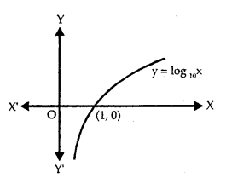

1. The graph of y = log10 x is shown in the figure.
2. Domain = R+, Range = R.
3. It is an increasing function.
4. As x → 0, y → ∞.
5. The function y = ex and y = loge x are the mirror images of each other in the line y = x.
6. ddx (loga x) = 1x l0ga e, ddx loge x = 1x

→ Other properties of Logarithm are:

1. logb pq = logb p + logb q
2. logb pq = loga p – loga q
3. logb px = x logb p – logb q
4. loga b = logaplogbp

→ Logarithmic Differentiation:  
Whenever the functions are given in the form

1. y = [u(x)]v(x) and
2. y = u(x)×v(x)w(x)

take log of both sides. Simplify and differentiate, e.g.,  
Let y = (cos x)sin x, log y = sin x log cos x

Differentiating, 1y dydx = cos x log Cos x + sin x . – sinxcosx  
∴ dydx = (cos x)sin y [cos x log cosx – sin x tan x].

→ Derivatives of Functions in Parametric Form: Let the given equations be x = f(t) and y = g(t), where t is the parameter. Then,  
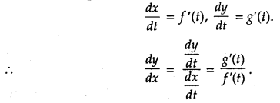  
→ Second Order Derivative:  
Let y = f(x), then dydx =f ‘(x).  
If f ‘(x) is differentiable, then it is again differentiated.  
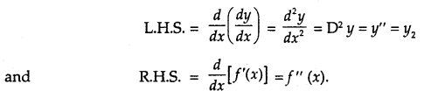

**Rolle’s Theorem:**  
Let f: [a, b] → R be continuous on closed interval [a, b] and differentiable on open interval (a, b) such that f(a) = f(b), where a and b are real numbers, then there exists some c ∈ (a, b) such that f ‘(c) = 0.  
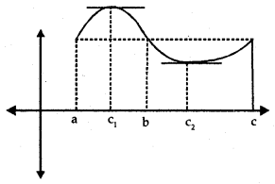  
From the figure, we observe that f(a) = f(b). There exists a point c1 ∈ (a, b) such that f ‘ (c) = 0, i.e., tangent at c1 is parallel to x-axis. Similarly, f(b) = f(c) → f ‘ (c2) = 0.

→ Mean Value Theorem: Let f: [a, b] → R be a continuous function on the closed interval [a, b] and differentiable in the open interval (a, b). Then, there exists some c ∈ (a, b) such that  
f ‘ (c) = f(b)−f(a)b−a

Now, we know that f(b)−f(a)b−a is the slope of secant drawn between A[a,f(a)] and B[b,f(b)]. We t k know that the slope of the line joining (x1, y1) and (x2, y2) is y2−y1x2−x1  
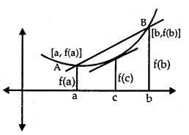  
The theorem states that there is a point c ∈ (a, b), where f ‘(c) is equal to the slope of AB.

In other words, there exists a point c ∈ (a, b) such that tangent at x = c is parallel to AB.

1. CONTINUITY  
(i) Left Continuity. A function ‘f ’ is left-continuous at x = c if limx→c− f (x) = f(c).

(ii) Right Continuity. A function ‘f ’ is right-continuous at x = c if limx→c+ f (x) = f(c).

(iii) Continuity at a point. A function ‘ f ’ is continuous at x = c if  
limx→c− (x) = limx→c+ f(x) = f(c).

2. (i) Polynominal functions  
(ii) Rational functions  
(iii) Exponential functions  
(iv) Trigonometric functions are all continuous at each point of their respective domain.

3. DIFFERENTIABILITY  
(i) Left Derivative. A function ‘f ’ is said to possess left derivative at x = c if limh→0f(c−h)−f(c)−h exists finitely.

(ii) Right Derivative. A function ‘f ’ is said to possess right derivative at x = c if  
limh→0f(c+h)−f(c)h exists finitely.  
(iii) Derivative. A function is said to possess derivative at x = c if limh→0f(c+h)−f(c)h exists finitely.

4. CONTINUITY AND DERIVABILITY  
A real valued function is finitely derivable at any point of its domain, it is necessarily continuous at that point. The converse is not true.

5. STANDARD RESULTS

(i) ddx (xn) = nxn-1 ∀ x ∈ R  
(ii) ddx ((ax + b)n = n(ax + b)n – 1 . a ∀ x ∈ R  
(iii) ddx(|x|)=x|x|, x ≠ 0

6. GENERAL THEOREMS  
(i) The derivative of a constant is zero.  
(ii) An additive constant vanishes on differentiation i.e. if f(x) = g(x) + c, where ‘c’ is any constant, then f'(x) = g'(x).  
(iii) If f(x) = ag(x), then f'(x) = ag'(x), where ‘a’ is a scalar.  
(iv) If f(x) = g(x) + h(x), then f'(x) = g'(x) + h'(x).

Extension.  
If f(x) = a1f1 ± a2f2 ……. ± anfn(x), then :  
f'(x) = a1f1‘(x) ± a2f2‘(x) ± ……. ± anfn‘(x)

(v) If f(x) = g(x)h(x), then f'(x) = g(x)h'(x) + g'(x)h(x)  
(vi) If f(x) = g(x)h(x), then f ‘(x) = h(x)g′(x)−g(x)h′(x)(h(x))2, h(x) ≠ 0.  
(vii) If f(x) = 1h(x), then f'(x) = −h(x)[h(x)]2, h'(x) ≠ 0

7. IMPORTANT RESULTS

(i) (a) ddx (sinx) = cos x and ddx (cos x) = – sin x ∀ x ∈ R  
(b) ddx (tan x) = sec2 x and ddx (sec x) = sec x tan x ∀ x ∈ R except odd multiples of π2  
(c) ddx(cot x) = – cosec2 x and ddx (cosec x) = -cosec x cot x ∀ x ∈ R except even multiple of π2

(ii)  
(a) ddx(sin-1x) = 11−x2√, |x| < 1  
(b) ddx(cos-1x) = −11−x2√, |x| < 1  
(c) ddx(tan-1x) = 11+x2 ∀ x ∈ R  
(d) ddx(cot-1x) = −11+x2 ∀ x ∈ R  
(e) ddx(sec-1x) = 1|x|x2−1√ x > 1 or x < -1  
(f) ddxcosec-1x) = −1|x|x2−1√, x > 1 or x < -1

(iii) (a) ddx (ax) = ax loge a, a > 0  
(b) ddx(ex) = ex  
(c) ddx(loga x) = 1x loga e, x > 0  
(d) ddx (log x) = 1x, x>0.

8. CHAIN RULE  
ddx (f(g(x)) = f'(g(x)).g'(x)

9. PARAMETRIC EQUATIONS  
dydx=dy/dtdx/dt, dxdt ≠ 0  
Or dydx=dydt×dtdx

10.MORE RESULTS

(i) dydx=1dxdy  
(ii) dydx×dxdy=1

11. ROLLE’S THEOREM  
If a function f(x) is :

(i) continuous in [a, b]  
(ii) derivable in (a, b)  
(iii) f (a) = f (b), then there exists at least one point ‘c’ in (a, b) such that f’ (c) = 0.

12. LAGRANGE’S MEAN VALUE THEROEM (LMV THEOREM OR MV THEOREM)  
If a function f(x) is :  
(i) continuous in [a, b]  
(ii) derivable in (a, b), then there exists at least one point ‘c’ in (a, b) such that f(b)−f(a)b−a=f′(c)

Integrals Class 12 Notes Maths Chapter 7

March 30, 2021 by [Prasanna](https://www.learninsta.com/author/prasanna/)

By going through these CBSE [Class 12 Maths Notes](https://www.learninsta.com/class-12-maths-notes/) Chapter 7 Integrals, students can recall all the concepts quickly.

Integrals Notes Class 12 Maths Chapter 7

→ Integration is the inverse process of differentiation. If we are given the derivative of a function and we have to find the function whose derivative is given, the process of finding the primitive or the original function is called the integration or anti-differentation.

Let ddx[F(x) + c] = F ‘(x) = f(x)  
⇒ F(x) + c is the antiderivative or integal of f(x). This may be written as ∫f(x)dx = F(x) + c,  
where c is an arbitrary constant called constant of integration.  
∫f(x) dx is called indefinite integral.

**Properties of Indefinite Integral.**

1. The processes of differentiation and integration are inverse processes of each other, i.e.,  
   ddx∫f(x) dx = f(x).
2. Indefinite integrals with the same derivatives belong to the same family of curves and so they are equivalent, i.e.,  
   in ∫f(x) dx = F(x) + c, [F(x) + c] denotes the same family of indefinite integrals of f(x).
3. ∫[f(x) + g(x)] dx = ∫f(x) dx + ∫g(x) dx.
4. ∫k f(x) dx = k ∫f(x) dx, where k is real number.
5. If k1, k2,………… kn are the real numbers, then ∫[k1 f1(x)+ k2f2(x) +………..+ knfn(x)] dx = k1∫f1(x)dx +k2∫f2(x) dx + +kn∫fn(x)dx.

→ We know the formulae for the derivatives of many functions. Corresponding integrals are given below:

|  |  |
| --- | --- |
| **Derivatives** | **Integrals** |
| 1. ddx(xn+1n+1) Where n = 0, ddx(x) = 1 | 1. ∫xn dx = xn+1n+1 + C ∫dx = x + C |
| Trigonometric Functions 2. ddx(sin x) = cos x | 2. ∫cos x dx = sin x + C |
| 3. ddx(tan x ) = sin x | 3. ∫sin x dx = – cos x + C |
| 4. ddx(- cosec x) = cosec x cot x | 4. ∫sec2 x dx = tan x + C |
| 5. ddx(- cosec x) = cosec x cot x | 5. ∫cosec x cot x dx = – cosec x + C |
| 6. ddx(sec x) = sec x tan x | 6. ∫sec x tan x dx = sec x + C |
| 7. ddx(- cot x) = cosec2 x | 7. ∫cosec2 x dx = – cot x + C |
| Inverse Trigonometric Functions 8. ddx(sin-1x) = 11−x2√ | 8. ∫11−x2√ dx = sin-1 x + C |
| 9. ddx(- cos-1x) = + 11−x2√ | 9. ∫11−x2√ dx = – cos-1x + C |
| 10. ddx(tan-1x) = 11+x2 | 10. ∫11+x2 dx = tan-1x + C |
| 11. ddx(- cot-1x) = 11+x2 | 11. ∫11+x2 dx = – cot-1x + C |
| 12. ddx(sec-1x) = 1xx2−1√ | 12. ∫1xx2−1√ dx = sec-1x + C |
| 13. ddx(- cosec-1 x) = 1xx2−1√ | 13. ∫1xx2−1√ dx = – cosec-1x + C |
| Exponential Functions 14. ddxex = ex | 14. ∫ex dx = ex + C |
| 15. ddx(axloga)  =ax | 15. ∫ax dx = axloga + C |
| Logarithmic Functions 16. ddx(loge x) = 1x | 16. ∫1x dx = loge x + C |
| 17. 12(loga x) = 1xloga e | 17. ∫1xloga e dx = loga x + C |

**Geometrical Interpretation of Indefinite Integral:**  
∫f(x) dx = F(x) + C = y (say).  
y = F(x) + C represents a family of curves. By giving different values to C, we get different members of family. These members can be obtained by shifting any of the curves parallel to itself.

**Comparison between Differentiation and Integration:**

|  |  |
| --- | --- |
| **Differentiation** | **Integration** |
| 1. It is an operation on function. | 1. It is an operation on function. |
| 2. ddx[k1f1(x)+k2f2(x)+…+knfn(x)] = k1 ddxf1 (x) + k2 ddxf2(x) + ……….+ kn ddxfn (x) | 2. ∫ k1 ddxf1 (x) + k2 ddxf2 (x) + ……….+ kn ddxfn (x) = k1∫f21(x) dx + k2∫f2 (x) dx + ……… + kn∫fn (x) dx |
| 3. Some functions are not differentiable. | 3. All functions are not integrable. |
| 4. The derivative of a function, if it exists, is unique. | 4. The integral of a function is not unique. |
| 5. ¡f a polynomial function of a degree n is differentiated, we obtain a polynomial of degree n – 1. | 5. If a polynomial function of a degree n is integrated, we get a polynomial of degree n + 1. |
| 6. We can obtain a derivative at a point. | 6. Integral of a function may be obtained over an interval in which f is defined. |
| 7. Slope of tangent at a point x = x1 is f ‘(x1). | 7. Integral of a function represents a family of curves. |
| 8. If the distance traversed at any time f is known, we can find velocity and acceleration. | 8. When the velocity or acceleration at any time t is known, we can find the distance traversed in time t, |
| 9. Differentiation is a process involving limits. | 9. Integration too involves limits. |

**Integration by Substitution:**  
Let I = ∫f(x) dx. This integral can be transformed into another form by changing the independent variable x to t by putting x=g(t).  
∴ dxdt = g'(t) or dx = g'(t) dt  
∴ I = ∫f[g(t)]g'(t) dt

Note: While making a substitution, it should be kept in mind that the f[g(t)] is in the form of some standard formula, whereas g'(t) is a factor, along with f[g(t)] e.g.  
Consider the integral I = ∫x2 cos(x3 + 2)dx  
If we put x3 + 2 = t, its derivative 3x2 is a factor and cos t can easily be integrated.  
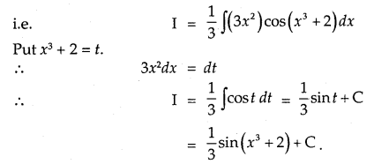  
**Some Results:**

1. ∫tan x = log|sec x| + C
2. ∫cot x = log|sin x| + C
3. ∫sec x = log|sec x + tan x| + C
4. ∫cosec x dx = log|cosec x – cot x| + C

→ Use of Trigonometric Identities:  
Use following trigonometric identities for integrating the functions such as sin2x.cos2x, sin3x, cos3x, sin x cos x, etc.

1. sin2 x = 1−cos2x2, cos2 x = 1+cos2x2
2. sin3 x = 3sinx−sin3x4, cos2 x = 3cosx+cos3x4
3. 2sinA cosB = sin(A + B) + sin(A – B)  
   2cosA sinB = sin(A + B) – sin(A – B)  
   2cosA cosB = cos(A + B) + cos(A – B)  
   2sinA sinB = cos(A – B) – cos(A + B)

**Some more Integrals:**  
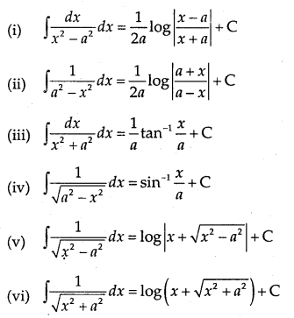  
→ How to integrate when the integral has ax2 + bx + c or ax2+bx+c−−−−−−−−−−√ in the denominator?  
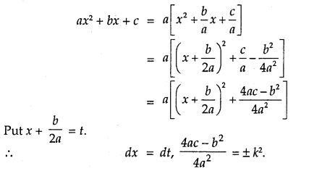  
So, ax2 + bx + c changes to t2 ± k2.  
Thus, 1ax2+bx+c converts into the form 1t2±k2 and  
1ax2+bx+c√ converts into the form 1t2±k˙2√.

→ To find the integration of type ∫px+qax2+bx+c dx or ∫px+qax2+bx+c√ dx:  
Put px + q = Addx(ax2 + bx + c) + B

Compare the two sides and find the value of A and B.  
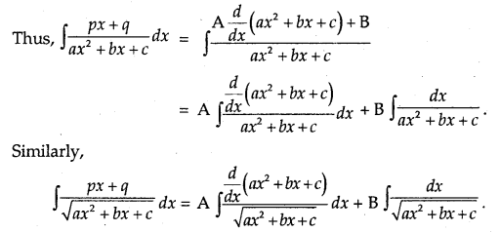  
**Partial Fractions of Rational Functions.**  
(a) Let P(x)Q(x) be a rational function, where P(x) and Q(x) are  
polynomials, where Q(x) ≠ 0.

1. If degree of P(x) is less than degree of Q(x), then P(x)Q(x) called a proper rational function.
2. If degree of P(x) is greater than the degree of Q(x), then P(x)Q(x) is known as an improper rational function.

This can be expressed in the form f(x) + P1(x)Q(x) by dividing P(x) by Q(x), so that degree of P1(x) is less than the degree of Q(x).

(b) 1. Let P(x)Q(x) be a proper rational function. Find the factors of Q(x). Let these factors be linear.  
P(x)  
Suppose Q(x) = (x + a)(x + b)(x + c), Then, P(x)Q(x) is written as  
P(x)Q(x)=Ax+a+Bx+b+Cx+c  
or  
P(x) = A(x + b)(x + c) + B(x + a)(x + e) + C(x+a)(x+ b)

It is an identity which is true for all values of x ∈ R.  
To find A,put x =-a.  
To find B, put x = – b.  
To find C, put x = – c.  
Thus, the fractions so obtained on the R.H.S. are the partial fractions. e.g.  
Let us find the partial fraction of 1(x−1)(x−2)

∴ 1(x−1)(x−2)=Ax−1+Bx−2  
1 = A(x – 2) + B(x – 1)  
Put x = 1, 1 = A(1 – 2) = – A  
∴ A = -1

Put x = 2, 1 = B(2 – 1) = B  
∴ B = 1

1(x−1)(x−2)=−1x−1+1x−2

2. Let the linear factor(s) be repeated. Q(x) = (x + a)(x + b)2.  
Then,  
P(x)Q(x)=Ax+a+Bx+b+C(x+b)2  
Also, P(x) = A(x + b)2 + B(x + n)(x + b) + C(x + a)

3. Suppose one of the factors of Q(x) be quadratic.  
Let Q(x) = (x + a)(x2 + bx + c). Then,  
P(x)Q(x)=Ax+a+Bx+Cx2+bx+c  
Also, P(x) A(x2 + b + c) ÷ (x + a)(Bx + c)  
Put x = – a, value of A is obtained.  
Put x =0, 1, -1, etc., and obtain equations involving A, B, C.

Substitute the value of A in these equations. Then, solve them to find the values of B and C.  
OR  
Compare the co-efficients of x2, x and constant. Solve the equations so obtained e.g.: Let us find the partial fractions of  
1(x−1)(x2+1)  
1(x−1)(x2+1)=Ax−1+Bx+Cx2+1  
∴ 1 = A(x2 + 1) + (x – 1)(Bx + C)  
1 = A(x2 + 1) + B(x2 – x) + C(x – 1)  
Put x=1, I =A(1 + 1) = 2A  
∴ A = 12.

Comparing the coefficients of x2, we get  
O = A + B  
∴ B = -A = – 12

Comparing the coefficients of x, we get  
O = -B + C  
∴ C = B = –12.  
∴ 1(x−1)(x2+1)=12(x−1)−x+12(x2+1).

Note: It is obvious that by converting the rational function into partial fractions, we can easily integrate the given rational function.

**Integration by Parts**  
Let u and v be the functions of x, then  
∫uv dx = u∫v dx – ∫u'[∫vdx]dx  
= u × Integral of v – Integral of (derivative of u × Integral of v]

Note: Out of two functions, which function is to be considered as first. Usually, we proceed as follows:  
∫xn f(x) dx xn = u is First function.  
∫(Inverse trig, function) × f(x) dx

Inverse trig. function = u is First function.  
∫(log x)f(x) dx, Take log x = u as first function.

**Some Integrals:**  
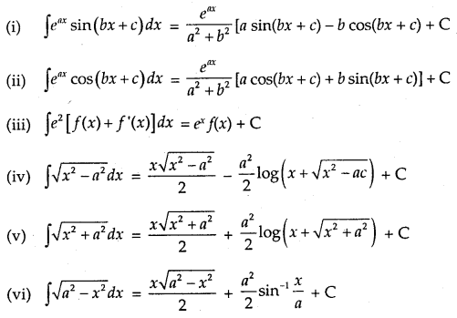  
**Definite Integral as the Limit of Sum**  
Definite integral as a limit of a sum is defined as  
Integrals Class 12 Notes Maths 6  
where h = b−an. As h → 0, n → ∞.

Note: Some useful series to find the definite integral as the limit of the sum.  
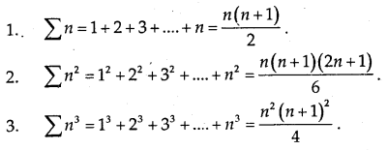  
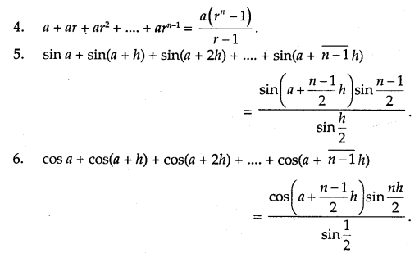  
**Area Function:**  
∫abf(x) dx is defined as the area of the region bounded by the curve y = f(x), a ≤ x ≤ b,the x-axis and the ordinates x = a and x = b. Let x be a given point in [a, b]. Then,  
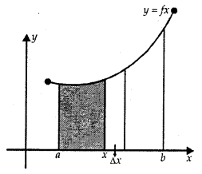  
∫ab f(x) dx represents the area of the shaded region. It is as shmmed that f(x) > 0 for x ∈ [a, b].  
This function is denoted by A(x) which is known as area function. i.e.,  
A(x) = ∫ax f(x) dx.

→ First Fundamental Theorem of Integral Calculus  
Let f be a continuous function on the closed interval [a, b] and let A(x) be the area function. Then, A'(x) =f(x) for all x E [a, b].

→ Second Fundamental Theorem of Integral Calculus  
Let f be a continuous function defined on closed interval [a, b] and F be antiderivative of f Then,  
∫a b f(x) = [F(x)]ba = F(b) — F(a).

→ Evaluation of Definite Integral by Substitution

1. To evaluate ∫a b f(x) dx, let the substitution be x = g(t) such that dx = g'(t) dt.
2. Let t = t1 at x = a, t = t2 at x = b.

The new limits are t1 to t.  
∴ ∫ab f(x) dx = ∫t1 t2 f[g(t)g'(t) dt  
= F(t2) – F(t1), where  
∫f[g(t)]g'(t) dt = F(t).

**Properties of Definite Integrals:**  
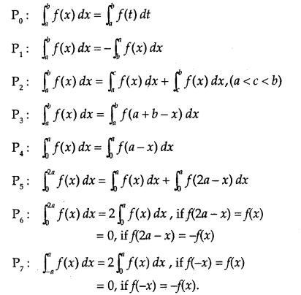  
1. DEFINITION  
If ddx f(x) = F(x), then ∫F(x) dx = f(x) + c, where ‘c’ is a constant of integration.

2. STANDARD RESULTS

(i). Power Rule. ∫ xn dx = xn+1n+1 + c, provided n ≠ – 1  
(ii) ∫ 1x dx = log |x| + c, x ≠ 0  
(iii) ∫axdx = axloga + c, a > 0, a ≠ 1 for all x ∈ R  
(iv) ∫ ex dx = ex + c ∀ x ∈ R  
(v) ∫ sin x dx= -cosx+c ∀ x ∈ R  
(vi) ∫ cos x dx = sin x + c ∀ x ∈ R  
(vii) ∫ sec2 xdx = tan x + c, x ≠ an odd multiple of π2  
(viii) ∫ cosec2 x = – cot x + c, x ≠ an even multiple of π2  
(ix) ∫ sec x tan x dx = sec x + c, x ≠ an odd multiple of π2  
(x) ∫ cosec x cot x dx = – cosec x + c,x ≠ an even multiple of π2  
(xi) ∫ tan x dx – – log | cos x | + c = log |sec x| + c, x ≠ x an odd multiple of π2  
(xii) ∫ cot x dx = log |sin x| + c, x ≠ an even multiple of π2  
(xiii) ∫ sec x dx = log |sec x + tan x| + c, x ≠ an odd multiple of π2  
(xiv) ∫ cosec x dx =  log |cosec x – cot x| + c, x ≠ an even multiple of π2.

3. FUNDAMENTAL THEOREMS

(i) ∫ a f(x) dx = a ∫ f(x)dx, where ‘a ’ is any real constant  
(ii) ∫ [f1(x) ± f2(x)]dx = ∫ f1(x)dx ± ∫ f2(x)dx  
(iii) ddx[∫f(x)dx] = f(x)  
(iv) ∫f′(x)f(x)dx = log |f(x)| + c  
(v) ∫ f(x))n f'(x)dx = ((f(x))n+1n+1 + c, n ≠ -1  
(vi) ∫ 1a2−x2√dx = sin-1xa + c  
(vii) ∫ 1a2−x2√dx = 1atan−1xa + c  
(viii) ∫ 1a2+x2√dx = log|x + a2+x2−−−−−−√|+ c  
(ix) ∫ dxx2−a2√ = log|x + x2−a2−−−−−−√ |+ c  
(x) ∫ a2−x2−−−−−−√dx=x2a2−x2−−−−−−√+a22sin−1xa+c  
(xi) ∫ a2+x2−−−−−−√dx=x2a2+x2−−−−−−√+a22log∣∣x+a2+x2−−−−−−√∣∣+c  
(xii) ∫ x2−a2−−−−−−√dx=x2x2−a2−−−−−−√−a22log∣∣x+x2−a2−−−−−−√∣∣+c  
(xiii) ∫ 1a2−x2dx = 12alog∣∣a+xa−x∣∣+ c  
(xiv) ∫ 1x2−a2dx = 12alog∣∣x−ax+a∣∣+ c

4. IMPORTANT RULES

(i) Rule to integrate ∫ sinm x cosn x dx.  
(a) If the index of sin x is a positive odd integer, put cos x = t.  
(b) If the index of cos x is a positive odd integer, put sin x = t.

(ii) Rule to integrate : ∫1asin2x+bcos2xdx,∫1a+bcos2xdx ; etc.  
a sin x + b cos x J a + b cos x  
(a) Divide the numerator and denominator by cos2x  
(b) Replace sec2x, if any, in the denominator by 1 + tan2x  
(c) Put tan x = t so that sec2x dx = dt.

(iii) Integration of Parts.  
Integral of the product of two functions = First function x Integral of second – Integral [(diff. coeff. of first) x (integral of second)].

(iv) Rule to integrate ∫1 linear  linear √dx or ∫1 quadratic  linear √dx Put  linear −−−−−−√=t

(v) Rule of integrate ∫1 linear  quadratic √dx Put linear = 1t

(vi) Rule to integrate ∫xdx (Pure Quad.)  Pure Quad √. Put  Pure Quad −−−−−−−−−−√ = t

(vii) Rule to integrate ∫dx (Pure Quad.)  Pure Quad √ Put x = 1t and  Pure Quad −−−−−−−−−−√ = u.

5. Integral As The Limit of a sum

∫ba f(x)dx = limh→0 h[f(a)+f(a + h)+f(a + 2h)+… + f(a + n−1¯¯¯¯¯¯¯¯¯¯¯h)], where h = b−an.

6. FUNDAMENTAL THEOREM OF INTEGRAL CALCULUS

∫baf(x) dx = F(b) – F(a), where ∫ f(x) dx = F(x).

7. PROPERTIES OF DEFINITE INTEGRALS

I. ∫ba f(x)dx = ∫ba f(t) dt

II. ∫ba f(x)dx = –∫aaf(x)dx. Particular case: ∫aaf(x)dx = 0

III. ∫ba f(x)dx = ∫ba f(a + b – x)dx.

IV. ∫ba f(x)dx = ∫caf(x)dx + f(x)dx = ∫bc f(x)dx, where a < b < c

V. ∫a0 f(x)dx = ∫ba f(a – x)dx

VI. ∫a−a f(x)dx = 0 if f(-x) = -f(x)  
= 2∫a0 f(x)dx if f(-x) = f(x)

VII. ∫2a0 f(x)dx = ∫a0 f(x)dx =∫a0 f(2a – x)dx

VIII. ∫2a0 f(x)dx = 2∫a0 f(x) dx  
= 0

f(2a-x)dx = f(x)  
if (2a – x) = f(x)

Probability Notes Class 12 Maths Chapter 13

**1. Conditional Probability:**  
Let E and F be two events with a random experiment. Then, the probability of occurrence of E under the condition that F has already occurred and P(F) ≠ 0 is called the conditional probability. It is denoted by P(E/F).

The conditional probability P(E/F) is given by  
P(E/F) = P(E∩F)P(F) , when P(F) ≠ 0.

→ Properties:

1. 0 ≤ P(E/F) ≤ 1
2. P(F/F) = 1
3. P(A ∪ B/F) = P(A/F) + P(B/F) – P(A n B/F)  
   If A and B are disjoint events,  
   then P(A ∪ B/F) = P(A/F) + P(B/F).
4. P(E/F) = 1 – P(E/F)

**2. Multiplications Probability:**  
1. Multiplication Theorem on Probability:  
Let E and F be two events associated with sample space S. P(E ∩ F) denotes the probability of the event that both E and F occur, which is given by P(E ∩ F) = P(E) P(F/E) = P(F) P(E/F) provided P(E) ≠ 0 and P(F) ≠ 0.  
This result is known as the multiplication theorem on probability.

2. Multiplication rule of probability for more than two events:  
Let E, F and G be the three events of sample space. Then, P(E ∩F ∩G) = P(E).P(F/E) P[G/(E ∩ F)]

**3. Independent Events:**

1. Two events E and F are said to be independent, if P(E/F) = P(E) and P(F/E) = P(F), provided P(E) ≠ 0 and P(F) ≠ 0.  
   We know that P(E ∩ F)= P(E). P(F/E) and P(E ∩ F) = P(F). P(E/F).
2. Events E and F are independent if P(E ∩ F) = P(E) × P(F).
3. Three events E, F and G are said to be independent or mutually independent, if  
   P(E∩F∩G)= P(E). P(F). P(G)

**4. Partition of a Sample Space:**  
A set of events E1, E2,……….., En is said to represent a partition of sample S, if

1. Ei ∩ Fj = Φ, if i ≠ j, i, j = 1, 2,……….. ,n .
2. E1 ∪ E2 ∪ E3 ∪ …. ∪ En = S
3. P(Ei) > 0 for all i = 1, 2,……., n

For example, E and E’ (complement of E) form a partition of sample space S, because  
E∩E’ = Φ and E∪E’ = S.

**5. Theorem of Total Probability:**  
Let E1, E2,…….., En be a partition of sample space and each event has a non-zero probability.  
If A be any event associated with S, then  
P(A) = P(E1) P(A/E1) + P(E2) P(A/E2) + P(E3) P(A/E3) +…….. + P(En) P(A/En)  
Probability Class 12 Notes Maths 1  
**6. Bayes’ Theorem:**  
Let E1, E2,…………, En be the n events forming a partition of sample space S, i.e., E1, E2,………, E( are pairwise disjoint and E1∪ E2 ∪………. ∪  
En = S and A is any event of non-zero probability, then  
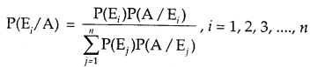  
**7. A Few Terminologies:**

1. Hypothesis: When Bayes’ Theorem is applied, the events E1, E2,……………., En is said to be a hypothesis.
2. Priori Probability: The probabilities P(E1), P(E2),…………., P(En) is called priori.
3. Posteriori Probability: The conditional probability P(E./A) is known as the posterior probability of hypothesis E.

**8. Random Variable:**  
A random variable is a real-valued function whose domain is the sample space of a random experiment.  
For example, let us consider the experiment of tossing a coin three times.

The sample space of the experiment is  
S{TTT, TTH, THT, HTT, HHT, HTH, THH, HHH}

If x denotes the number of heads obtained, then X is the random variable for each outcome.  
X(0) = {TTT}  
X(1) = {TTH, THT, HTT}  
X(2) = {HHT, HTH, THH}  
X(3) = {HHH}

**9. Probability Distribution of a Random Variable:**  
Let real numbers x1, x2,…………., xn be the possible values of random variable and p1, p2,……………, pn be probabilities corresponding to each value of the random variable X. Then the probability distribution is  
Probability Class 12 Notes Maths 3  
It may be noted that

1. pi > 0
2. Sum of probabilities p1 + p2 +………….+ pn = 1

Example: Three cards are drawn successively with replacement from a well-shuffled pack of 52 cards. A random variable denotes the number of spades on three cards. Determine the probability distribution of X.  
P(S) = P(Drawing a spade) = 1352=14  
P(F) = P(Drawing not a space = 1 – 14=34  
P(X = 0) =P(FFF) = (34)3=2764  
P(X = 1) = 3 × (14×34×34)=2764

∵ X = 1 ⇒{SFF, FSF, FFS}  
X = 2 ⇒ {SSF, SFS, FSS}  
∴ P(X – 2) = 3 × (14×14×34)=964

When X = 3 ⇒ {SSS}  
P(X = 3) = 14×14×14=164  
∴ Probability distribution is  
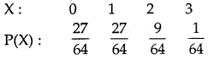  
**10. Mean of Random Variable:**  
Let X be the random variable whose possible values are x1, x2,……….,xn. If p1, p2,……….., pn are the corresponding probabilities, then the mean of X denoted by p is given by  
https://www.learninsta.com/wp-content/uploads/2021/03/Probability-Class-12-Notes-Maths-5.png|  
The mean of a random variable X is also called the expected value of X, denoted by E(x).  
For the experiment of drawing a spade in three cards, the expected value ‘  
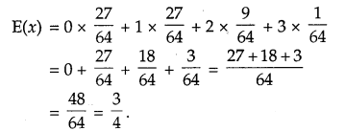  
**11. Variance of a Random Variable:**  
Let X be the random variable with possible values of X: x1 x2,……xn occur whose probabilities are p1, p2,………., pn respectively.  
Let μ = E(x) be the mean of X. The variance of X, denoted by Var (X) or σx2, is defined as  
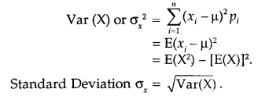  
**12. Bernoulli Trial:**  
Trials of a random experiment are said to be Bernoulli’s Trials if they satisfy the following conditions:

1. The trials should be independent.
2. Each trial has exactly two outcomes viz. success or failure.
3. The probability of success remains the same in each trial.
4. The number of trials is finite.

Example: An urn contains 6 red and 5 white balls. Four balls are drawn successively. Find whether the trials of drawing balls are Bernoulli trials when after each draw the ball draw is

1. replaced
2. not replaced in the urn.

1. If drawing a red ball with replacement is a success, in each trial the probability of success = 611.  
Therefore, drawing a ball with replacement is a Bernoulli trial.

2. In the second attempt, when the ball is not replaced, the probability of success = 510.

In thired attempt, the probability of success = 49.  
Thus, probability changes at each trial. Hence, in this case, it is not a Bernoulli trial.

**13. Binomial Distribution:**  
The probability distribution of a number of successes in an experiment consisting of n Bernoulli trials is obtained by binomial expansion of (q + p)n.  
Such a probability distribution may be written as:  
Probability Class 12 Notes Maths 8  
This probability distribution is called binomial distribution with parameters n and p.

**14. Probability Function:**  
The probability of x success is denoted by P(x). In a binomial distribution P(x) is given by  
P(x) = nCx qn-x px, x = 0,1, 2,…., n and q = 1 – p.  
The function P(x) is known as the probability function of the binomial distribution.

1. DEFINITIONS

(i) Random Experiment of Trial. The performance of an experiment is called a trial.  
(ii) Event. The possible outcomes of a trial are called events.  
(iii) Equally likely Events. The events are said to be equally likely if there is no reason to expect  
any one in preference to any other.  
(iv ) Exhaustive Events. It is the total number of all possible outcomes of any trial.  
(v) Mutually Exclusive Events. Two or more events are said to be mutually exclusive if they  
cannot happen simultaneously in a trial. s:  
(vi) Favourable Events. The cases which ensure the occurrence of the events are called favourable.  
(vii) Sample Space. The set of all possible outcomes of an experiment is called a sample space.  
( viii) Probability of occurrences of event A, denoted by P (A), is defined as :  
P(A) =  No. of favourable cases  No. of exhaustive cases =n( A)n( S)

2. THEOREMS .

(i) In a random experiment, if S be the sample space and A an event, then :  
(I) P (A) ≥ 0. (II) P (Φ) = 0 and (III) P (S) = 1.  
(ii) If A and B are mutually exclusive events, then P (A ∩ B) = 0.  
(iii) If A and B are two mutually exclusive events, then P (A) + P (B) – 1.  
(iv) If A and B are mutually exclusive events, then : P (A ∪ B) = P ( A) + P ( B). s  
(v) For any two events A and B. P (A ∪ B) = P (A) + P (B) – P (A ∩ B).  
(vi) For each event A. P (A¯¯¯¯) = 1 – P (A), where (A¯¯¯¯) is the complementary event. 1;  
( vii) 0 ≤ P (A) ≤ 1.

3. MORE DEFINITIONS  
(i) Compound Event. The simultaneous happening of two or more events is called a compound event if they occur in connection with each other. I

(ii) Conditional Probability. Let A and B be two events associated with the same sample spat e then  
P (A/B) = No.ofelementaryeventsfavourabletoBwhicharealsofavourabletoANo.ofelementaryeventsfavourabletoB  
Theorem. P (A/B) = P(A∩B)P(B)  
P(B/A) = P(A∩B)P(A)

(iii) Independent Events. Two events are said to be independent if the occurrence of one does not a depend upon the occurrence of the other.  
Theorem. P (A ∩ B) = P (A) P (B) when A, B are independent.

4. If A1, A1, …………Ar be r events, then the probability when at least one event happens  
= 1 – P(A1¯¯¯¯¯¯¯)P(A2¯¯¯¯¯¯¯)…⋅P(A¯¯¯¯r)

5. BAYES’ FORMULA  
If E1, E2,…., En are mutually exclusive and exhaustive events and A is any event that occurs with E1, E2, …. , En, then :  
P(E1/A) = P(E1)P(A/E1)P(E1)P(A/E1)+P(E2)P(A/E2)+………+P(En)P(A/En)

6. MEAN AND VARIANCE OF RANDOM VARIABLE.  
Mean (μ) = Σxipi  
Variance (σ2) = Σ(xi – μ)2pi = Σxi2 pi – μ2